Index numbers of sold production of industry in July 2023^{a)}
In July 2023, sold production of industry was by 2.7% lower than in July 2022, when an increase was recorded by 7.1% as compared to the corresponding period of the previous year, whereas in comparison with June 2023, it decreased by 8.5%. In the period January-July of 2023, sold production of industry was by 1.9% lower than in the corresponding period of 2022, which saw an increase by 12.9% as compared to the corresponding period of 2021.
2.7%
Decrease in sold production of industry as compared to July 2022

After seasonal adjustment, a decrease in sold industrial production in July 2023 amounted to 2.0% per year

After eliminating the seasonal factors, in July 2023 sold production of industry reached the level lower by 2.0% than in the corresponding month of 2022 and by 1.0% lower as compared to June 2023.
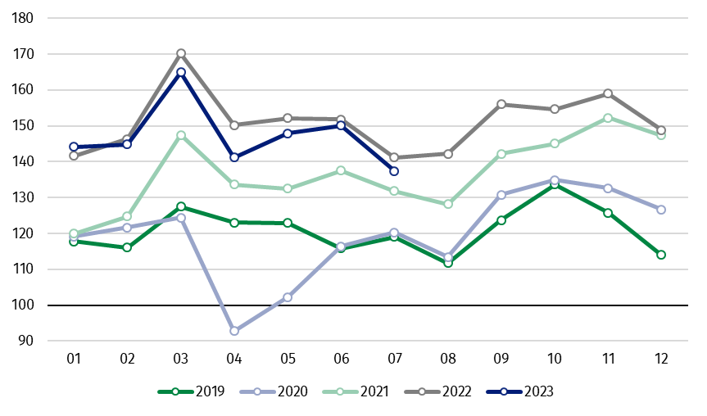
Chart 1. Sold production of industry (average monthly level in 2015=100)

In July 2023, among the main industrial groupings there was a decrease per year in the production of durable consumer goods – by 12.4%, energy – by 10.5%, intermediate goods – by 7.8%. An increase was observed in the production of capital goods – by 10.2% and slight in non-durable consumer goods – by 1.0%.

^{a)} Reported data; comprise enterprises with 10 or more persons employed.

Table 1. Index numbers of sold production of industry ^{a)} (constant prices)
SPECIFICATION | 2023
SPECIFICATION | 06 | 07 | 06 | 07 | 01-07 | 06 | 07
SPECIFICATION | previous month =100 |  | previous year =100 |  |  | monthly average  of 2015 =100
INDUSTRY | 101.5* | 91.5 | 98.9* | 97.3 | 98.1 | 150.1* | 137.4
Mining and quarrying | 105.4* | 96.2 | 87.0* | 89.8 | 91.1 | 92.2* | 88.7
Manufacturing | 102.0* | 90.7 | 99.7* | 97.6 | 99.5 | 156.4* | 142.0
Electricity, gas, steam and air conditioning supply | 91.9* | 100.2 | 92.1* | 95.7 | 85.5 | 107.6* | 107.7
Water supply; sewerage waste management and remediation activities | 102.6* | 95.6 | 98.6* | 99.0 | 98.4 | 157.8* | 150.9
^{a)} Data including final information on production and prices in June and reported data in July.
* Data revised.
Share of production value of industry divisions, which saw a decrease in comparison to July 2022, stood at 80.2%

According to the preliminary data, in July 2023 as compared to July 2022, a decrease in sold production (in constant prices) was reported in 24 (out of 34) industry divisions, among others, in mining of coal and lignite – by 27.7%, in manufacture of chemicals and chemical products – by 19.6%, manufacture of products of wood, cork, straw and wicker – by 15.5%, manufacture of paper and paper products – by 11.5%, manufacture of furniture – by 11.1%, manufacture of basic metals – by 10.4%, manufacture of other non-metallic mineral products – by 8.8%.
An increase in sold production of industry, as compared to July 2022, was recorded in 10 divisions, among others, in repair and installation of machinery and equipment – by 20.7%, in manufacture of motor vehicles, trailers and semi-trailers – by 15.0%, manufacture of other transport equipment – by 8.1%, manufacture of machinery and equipment – by 4.9%.

Chart 2. Index numbers of sold production of industry by selected NACE divisions (constant
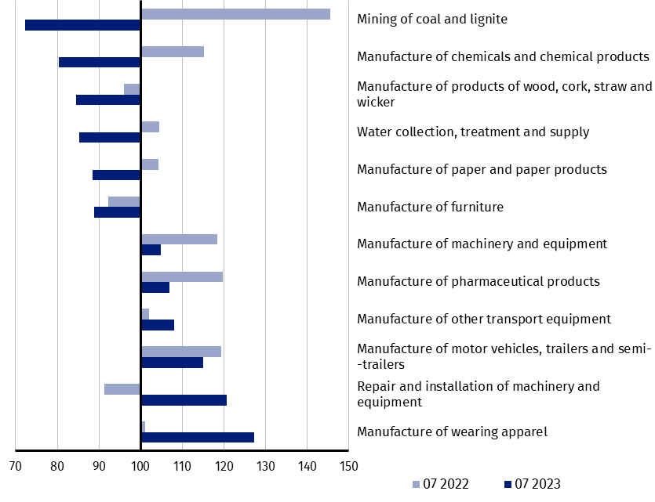
prices; previous year =100)
As compared to June 2023, a decrease in sold production (in constant prices) in July 2023 was recorded in 29 (out of 34) industry divisions, among others, in repair and installation of machinery and equipment – by 20.5%, in manufacture of electrical equipment – by 17.5%, manufacture of machinery and equipment – by 17.1%, manufacture of furniture – by 15.0%, manufacture of motor vehicles, trailers and semi-trailers – by 14.5%, manufacture of products of wood, cork, straw and wicker – by 12.5%, manufacture of metal products – by 11.3%, manufacture of computer, electronic and optical products – by 9.1%, manufacture of rubber and plastic products – by 9.0%.
An increase in sold production of industry, as compared to June 2023, was recorded in 5 divisions, among others, in mining of coal and lignite – by 8.3%.

Chart 3. Index numbers of sold production of industry by selected NACE divisions (constant
prices; previous month =100)

In case of quoting Statistics Poland data, please provide information: “Source of data: Statistics Poland”, and in case of publishing calculations made on data published by Statistics Poland, please include the following disclaimer: “Own study based on figures from Statistics Poland”
Prepared by:  Enterprises Department  Director Katarzyna Walkowska  Phone: (+48 22) 608 31 25 | Issued by:  The Spokesperson for the President  of Statistics Poland  Karolina Banaszek  Phone: (+48) 695 255 011
Press Office  Phone: (+48 22) 608 38 04  e-mail: obslugaprasowa@stat.gov.pl |   www.stat.gov.pl/en/

@StatPoland

@GlownyUrzadStatystyczny

gus_stat

glownyurzadstatystycznygus

glownyurzadstatystyczny

Related information
Statistical Bulletin
Socio-economic situation of the country

Data available in databases
Knowledge Database - Industrial Production
Macroeconomic Data Bank
Macroeconomic indicators
Local Data Bank

Terms used in official statistics
Sold production of industry
Seasonally un-adjustedindex of sold production of industry
Seasonally adjustedindex of sold production of industry
Production of capital goods
Production of non-durable consumer goods
Production of durable consumer goods
Production of intermediate goods
Production of goods related to energy

