Index numbers of sold production of industry in August 2023^{a)}
In August 2023, sold production of industry was by 2.0% lower than in August 2022, when an increase was recorded by 10.9% as compared to the corresponding period of the previous year, whereas in comparison with July 2023, it increased by 1.0%. In the period January-August of 2023, sold production of industry was by 1.9% lower than in the corresponding period of 2022, which saw an increase by 12.9% as compared to the corresponding period of 2021.
2.0%
Decrease in sold production of industry as compared to August 2022

After seasonal adjustment, a decrease in sold industrial production in August 2023 amounted to 1.8% per year

After eliminating the seasonal factors, in August 2023 sold production of industry reached the level lower by 1.8% than in the corresponding month of 2022 and by 0.6% higher as compared to July 2023.
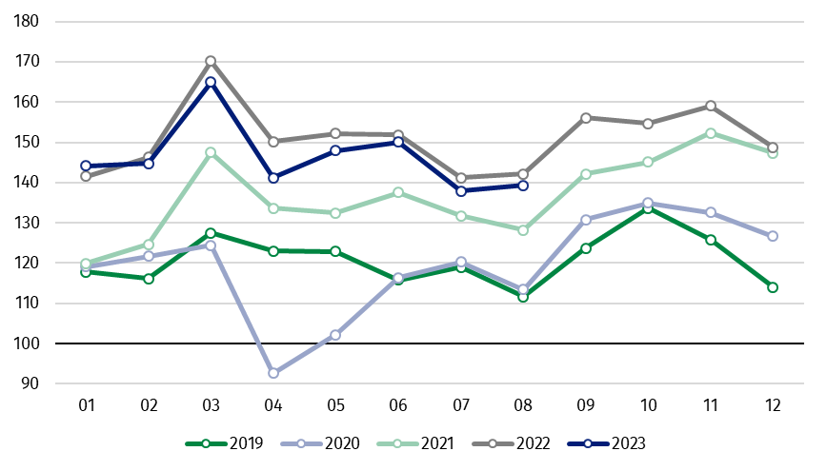
Chart 1. Sold production of industry (average monthly level in 2015=100)

In August 2023, among the main industrial groupings there was a decrease per year in the production of intermediate goods – by 7.8%, durable consumer goods – by 6.4%, energy – by 4.4% and slight in non-durable consumer goods – by 0.9%. An increase was observed in the production of capital goods – by 10.5%.

^{a)} Reported data; comprise enterprises with 10 or more persons employed.

Table 1. Index numbers of sold production of industry ^{a)} (constant prices)
SPECIFICATION | 2023
SPECIFICATION | 07 | 08 | 07 | 08 | 01-08 | 07 | 08
SPECIFICATION | previous month =100 |  | previous year =100 |  |  | monthly average  of 2015 =100
INDUSTRY | 91.9* | 101.0 | 97.7* | 98.0 | 98.1 | 137.9* | 139.3
Mining and quarrying | 96.3* | 102.2 | 89.9* | 92.5 | 91.3 | 88.8* | 90.7
Manufacturing | 91.0* | 100.8 | 97.9* | 97.9 | 99.3 | 142.4* | 143.6
Electricity, gas, steam and air conditioning supply | 101.3* | 103.1 | 96.8* | 101.7 | 88.0 | 109.0* | 112.4
Water supply; sewerage waste management and remediation activities | 96.0* | 100.9 | 99.4* | 96.6 | 97.9 | 151.5* | 152.9
^{a)} Data including final information on production and prices in July and reported data in August.
* Data revised.
Share of production value of industry divisions, which saw a decrease in comparison to August 2022, stood at 72.3%

According to the preliminary data, in August 2023 as compared to August 2022, a decrease in sold production (in constant prices) was reported in 23 (out of 34) industry divisions, among others, in mining of coal and lignite – by 19.9%, in manufacture of basic metals – by 17.9%, manufacture of paper and paper products – by 12.3%, manufacture of computer, electronic and optical products – by 12.2%, manufacture of products of wood, cork, straw and wicker – by 11.1%, manufacture of other non-metallic mineral products – by 8.5%, manufacture of electrical equipment – by 7.3%, manufacture of chemicals and chemical products – by 7.0%.
An increase in sold production of industry, as compared to August 2022, was recorded in 11 divisions, among others, in repair and installation of machinery and equipment – by 22.0%, in manufacture of other transport equipment – by 15.3%, manufacture of motor vehicles, trailers and semi-trailers – by 14.0%, manufacture of machinery and equipment – by 9.9%.

Chart 2. Index numbers of sold production of industry by selected NACE divisions (constant
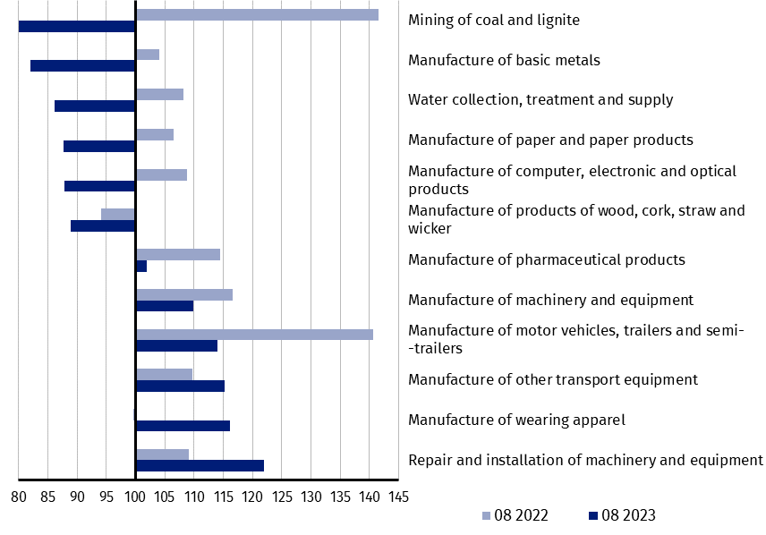
prices; previous year =100)
As compared to July 2023, an increase in sold production (in constant prices) in August 2023 was recorded in 21 (out of 34) industry divisions, among others, in manufacture of furniture – by 24.1%, manufacture of chemicals and chemical products – by 9.3%, manufacture of products of wood, cork, straw and wicker – by 6.5%, in repair and installation of machinery and equipment – by 5.4%, in manufacture of food products – by 4.1%, manufacture of paper and paper products – by 3.9%, manufacture of metal products – by 3.7%.
A decrease in sold production of industry, as compared to July 2023, was recorded in 13 divisions, among others, in manufacture of motor vehicles, trailers and semi-trailers – by 13.7%, manufacture of basic metals – by 2.6%, manufacture of electrical equipment – by 2.2%, manufacture of rubber and plastic products – by 1.8%.

Chart 3. Index numbers of sold production of industry by selected NACE divisions (constant
prices; previous month =100)

In case of quoting Statistics Poland data, please provide information: “Source of data: Statistics Poland”, and in case of publishing calculations made on data published by Statistics Poland, please include the following disclaimer: “Own study based on figures from Statistics Poland”
Prepared by:  Enterprises Department  Director Katarzyna Walkowska  Phone: (+48 22) 608 31 25 | Issued by:  The Spokesperson for the President  of Statistics Poland  Karolina Banaszek  Phone: (+48) 695 255 011
Press Office  Phone: (+48 22) 608 38 04  e-mail: obslugaprasowa@stat.gov.pl |   www.stat.gov.pl/en/

@StatPoland

@GlownyUrzadStatystyczny

gus_stat

glownyurzadstatystycznygus

glownyurzadstatystyczny

Related information
Statistical Bulletin
Socio-economic situation of the country

Data available in databases
Knowledge Database - Industrial Production
Macroeconomic Data Bank
Macroeconomic indicators
Local Data Bank

Terms used in official statistics
Sold production of industry
Seasonally un-adjustedindex of sold production of industry
Seasonally adjustedindex of sold production of industry
Production of capital goods
Production of non-durable consumer goods
Production of durable consumer goods
Production of intermediate goods
Production of goods related to energy

