Index numbers of sold production of industry in November 2023^{a)}
In November 2023, sold production of industry was by 0.7% lower than in November 2022, when an increase was recorded by 4.5% as compared to the corresponding period of the previous year, whereas in comparison with October 2023, it increased by 0.2%. In the period January-November of 2023, sold production of industry was by 1.4% lower than in the corresponding period of 2022, which saw an increase by 10.9% as compared to the corresponding period of 2021.
0.7%
Decrease in sold production of industry as compared to November 2022

After seasonal adjustment, a decrease in sold industrial production in November 2023 amounted to 3.3% per year

After eliminating the seasonal factors, in November 2023 sold production of industry reached the level lower by 3.3% than in the corresponding month of 2022 and by 0.3% lower as compared to October 2023.
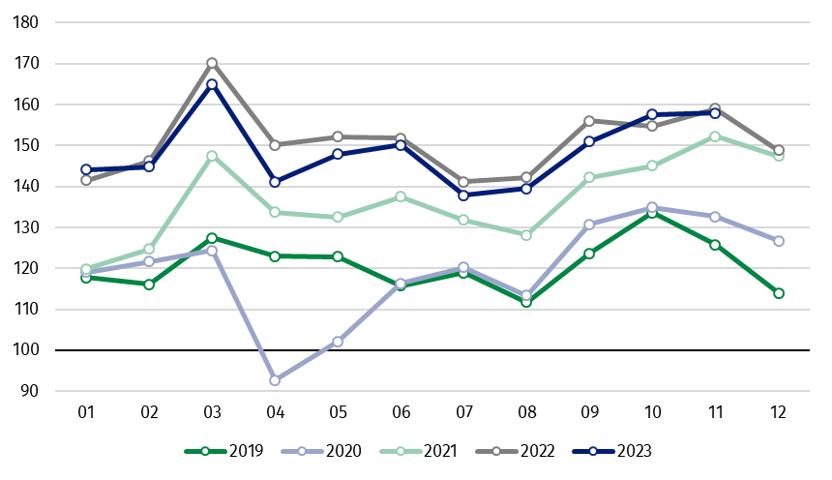
Chart 1. Sold production of industry (average monthly level in 2015=100)

In November 2023, among the main industrial groupings there was a decrease per year in the production of durable consumer goods – by 7.7% and intermediate goods – by 7.6%. An increase was observed in the production of capital goods – by 7.0%, energy – by 4.5% and non- -durable consumer goods – by 1.8%.

^{a)} Reported data; comprise enterprises with 10 or more persons employed.

Table 1. Index numbers of sold production of industry ^{a)} (constant prices)
SPECIFICATION | 2023
SPECIFICATION | 10 | 11 | 10 | 11 | 01-11 | 10 | 11
SPECIFICATION | previous month =100 |  | previous year =100 |  |  | monthly average  of 2015 =100
INDUSTRY | 104.4* | 100.2 | 101.9* | 99.3 | 98.6 | 157.6* | 157.9
Mining and quarrying | 103.3 | 96.0 | 105.7 | 101.6 | 94.6 | 100.8 | 96.7
Manufacturing | 102.9* | 99.1 | 100.7* | 98.0 | 99.1 | 161.3* | 159.8
Electricity, gas, steam and air conditioning supply | 127.5* | 115.3 | 114.6* | 111.9 | 93.5 | 144.3* | 166.3
Water supply; sewerage waste management and remediation activities | 103.0 | 98.6 | 105.0 | 104.6 | 99.8 | 158.9 | 156.6
^{a)} Data including final information on production and prices in October and reported data in November.
* Data revised.
Share of production value of industry divisions, which saw a decrease in comparison to November 2022, stood at 43.5%

According to the preliminary data, in November 2023 as compared to November 2022, a decrease in sold production (in constant prices) was reported in 17 (out of 34) industry divisions, among others, in manufacture of electrical equipment – by 26.5%,
manufacture of computer, electronic and optical products – by 13.0%, manufacture of other non-metallic mineral products – by 11.6%, in mining of coal and lignite – by 8.5%, in manufacture of products of wood, cork, straw and wicker – by 7.7%, manufacture of machinery and equipment – by 6.6%, manufacture of paper and paper products – by 5.4%, manufacture of basic metals – by 5.0%.
An increase in sold production of industry, as compared to November 2022, was recorded in 17 divisions, among others, in manufacture of other transport equipment – by 31.9%, in repair and installation of machinery and equipment – by 20.5%, in electricity, gas, steam and air conditioning supply – by 11.9%, in manufacture of motor vehicles, trailers and semi- -trailers – by 10.2%.

Chart 2. Index numbers of sold production of industry by selected NACE divisions (constant
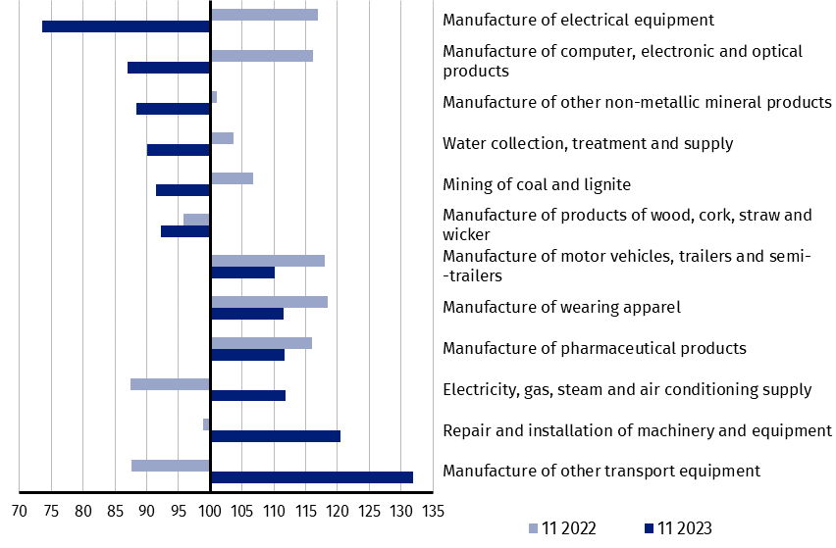
prices; previous year =100)
As compared to October 2023, an increase in sold production (in constant prices) in November 2023 was recorded in 16 (out of 34) industry divisions, among others, in manufacture of other transport equipment – by 25.7%, in electricity, gas, steam and air conditioning supply – by 15.3%, in manufacture of motor vehicles, trailers and semi-trailers – by 12.2%, manufacture of beverages – by 6.3%, manufacture of computer, electronic and optical products – by 3.9%.
A decrease in sold production of industry, as compared to October 2023, was recorded in 18 divisions, among others, in manufacture of electrical equipment – by 10.1%, in mining of coal and lignite – by 10.0%, in manufacture of other non-metallic mineral products – by 9.8%,
manufacture of rubber and plastic products – by 5.9%, manufacture of products of wood, cork, straw and wicker – by 5.1%, manufacture of basic metals – by 4.9%

Chart 3. Index numbers of sold production of industry by selected NACE divisions (constant
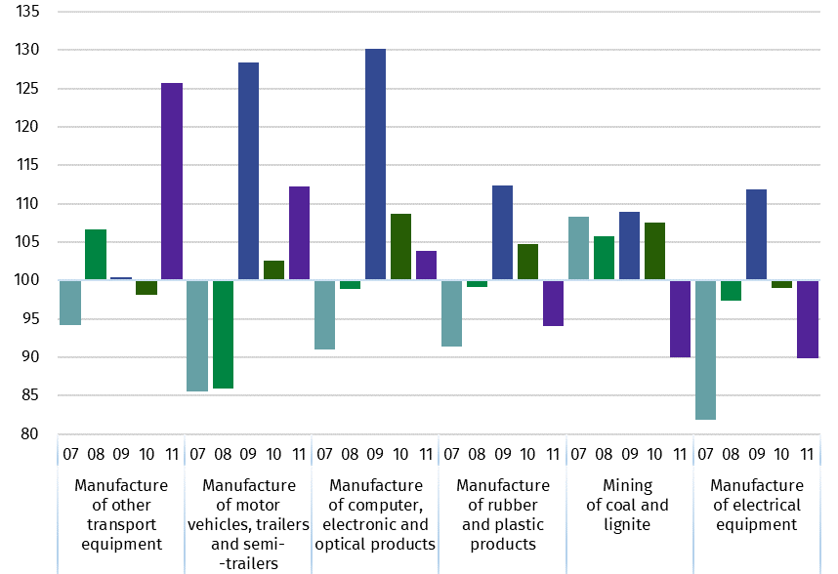
prices; previous month =100)

In case of quoting Statistics Poland data, please provide information: “Source of data: Statistics Poland”, and in case of publishing calculations made on data published by Statistics Poland, please include the following disclaimer: “Own study based on figures from Statistics Poland”.
Prepared by:  Enterprises Department  Director Katarzyna Walkowska  Phone: (+48 22) 608 31 25 | Issued by:  The Spokesperson for the President  of Statistics Poland  Karolina Banaszek  Phone: (+48) 695 255 011
Press Office  Phone: (+48 22) 608 38 04  e-mail: obslugaprasowa@stat.gov.pl |   stat.gov.pl

@GUS_STAT

@GlownyUrzadStatystyczny

gus_stat

glownyurzadstatystycznygus

glownyurzadstatystyczny

Related information
Statistical Bulletin
Socio-economic situation of the country

Data available in databases
Knowledge Database - Industrial Production
Macroeconomic Data Bank
Macroeconomic indicators
Local Data Bank

Terms used in official statistics
Sold production of industry
Seasonally un-adjustedindex of sold production of industry
Seasonally adjustedindex of sold production of industry
Production of capital goods
Production of non-durable consumer goods
Production of durable consumer goods
Production of intermediate goods
Production of goods related to energy

