General government deficit and debt in 2022
1 3,7%
General government deficit in 2022 in relation to GDP

According to the EDP notification, in 2022 the general government deficit was equal 112 833 mln zl (3,7% of GDP), while the general government debt amounted to 1 512 154 mln zl (49,3% of GDP).

On 30 September 2023, in accordance with the Council Regulation (EC) No. 479/2009 of 25 May 2009 on the application of the Protocol on the excessive deficit procedure annexed to the Treaty establishing European Community with amendments, the President of the Statistics Poland provided the general government deficit and debt data for years 2019-2022 (EDP notification) to the European Commission (Eurostat).
The data have been developed in accordance with the methodology of the European System of National and Regional Accounts in the European Union introduced by the Regulation (EU) No. 549/2013 of the European Parliament and of the Council of 21 May 2013 (ESA2010) with amendments and the guidelines contained in the Manual on Government Deficit and Debt, Implementation of ESA2010 (MGDD, 2022 edition).

Table 1. General government deficit and debt in years 2019-2022 (mln zl)
Specification | 2019 | 2020 | 2021 | 2022
Gross domestic product (GDP) | 2 288 492 | 2 337 672 | 2 631 302 | 3 067 495*
General government deficit/surplus | -17 009 | -161 834 | -48 195 | -112 833*
% GDP | -0,7% | -6,9% | -1,8% | -3,7%
Central government deficit/surplus | - 25 208 | -183 725 | -49 006 | -99 693*
% GDP | -1,1% | -7,9% | -1,9% | -3,2%
Local government deficit/surplus | -4 686 | 4 463 | 14 918 | -12 989*
% GDP | -0,2% | 0,2% | 0,6% | -0,4%
Social security funds deficit/surplus | 12 885 | 17 428 | -14 107 | -1 151*
% GDP | 0,6% | 0,7% | -0,5% | 0,0%
General government debt | 1 046 022 | 1 336 558 | 1 410 509* | 1 512 154*
% GDP | 45,7% | 57,2% | 53,6 | 49,3%*
Chart 1. General government deficit in % of GDP
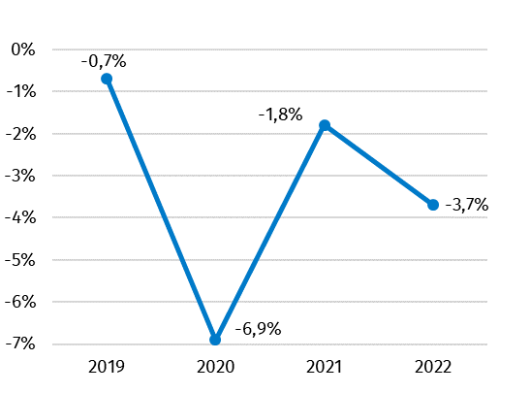

Chart 2. General government debt in % of GDP

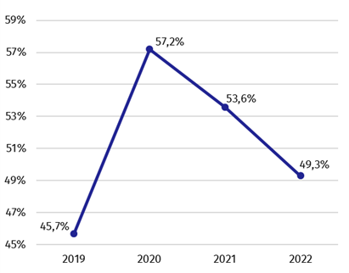

Data in 2022 year have been revised in relation to the previously published (April 2023) mainly due to updated data sources and changes in the scope of general government sector.
Together with the EDP data, a table containing data on measures taken in context of the COVID-19 epidemic was submitted to Eurostat. According to the final data, the general government expenditures aimed at stopping the consequences of the epidemic COVID-19 and combating these effects as well as supporting the entities affected by them amounted in 2022 year 22 648* mln zl.
Along with the EDP notification, the Statistics Poland sent to the European Commission information about revenues and expenditures of the general government sector divided into transactions, according to the European System of National and Regional Accounts (ESA2010).
Table 2. Total revenues and expenditures of the general government sector according to ESA2010 in years 2019-2022 (mln zl)
Specification | 2019 | 2020 | 2021 | 2022
Total revenues | 941 316 | 966 031 | 1 111 992 | 1 233 728*
% GDP | 41,1% | 41,3% | 42,3% | 40,2%*
Total expenditures | 958 326 | 1 127 866 | 1 160 18* | 1 346 561*
% GDP | 41,9% | 48,2% | 44,1% | 43,9%*
Chart 3. Total revenues and expenditures of the general government sector in % of GDP
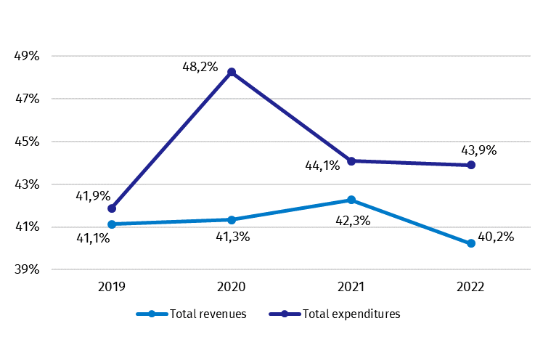

Similarly, as in case of deficit and debt, data on the general government revenues and expenditures in 2022 year have been revised in relation to the previously published (April 2023).
The revision of the general government revenues caused their growth in 2022 year of 8 696 mln zl (0,4 percentage point in relation to GDP). The biggest increase of revenues in 2022 year was observed in transactions: market output and output for own final use and other current transfers. The expenditures in 2022 year increased by 6 392 mln zl (0,4 percentage point in relation to GDP). The changes of expenditures mainly were in transactions: social benefits other than social transfers in kind, social transfers in kind and other current transfers.
Detailed data on revenues and expenditures of the general government sector divided into ESA2010 transactions are presented in Annex 1.
Information on the general government deficit and debt of all EU Member States will be available on 23 October 2023 at 11 a.m. on the Eurostat website:
http://epp.eurostat.ec.europa.eu/portal/page/portal/eurostat/home.
Inventory of the methods, procedures and sources used for the compilation of deficit and debt data and the underlying government sector accounts according to ESA2010 prepared according to the European Commission’s guidelines in English version is available on Eurostat website:

http://ec.europa.eu/eurostat/web/government-finance-statistics/excessive-deficit-procedure/edp-inventories.

In case of quoting Statistics Poland data, please provide information: “Source of data: Statistics Poland”, and in case of publishing calculations made on data published by Statistics Poland, please include the following disclaimer: “Own study based on figures from Statistics Poland”.

Prepared by:  National Accounts Department  Director Anita Perzyna  Phone: (+48 22) 608 31 17 | Issued by:  The Spokesperson for the President  of Statistics Poland  Karolina Banaszek  Phone: (+48) 695 255 011
Press Office  Phone: (+48 22) 608 38 04  e-mail: obslugaprasowa@stat.gov.pl |   stat.gov.pl/en/

@StatPoland

@GlownyUrzadStatystyczny

gus_stat

glownyurzadstatystycznygus

glownyurzadstatystyczny
Related studies
General government deficit and debt in 2022

Subject available in databases
Knowledge Databases – National Accounts

Important concepts available in the dictionary
Gross domestic product

* Data have been revised in relation to the previously published on 21.04.2023. The manual is available on the website: https://ec.europa.eu/eurostat/documents/3859598/16029761/KS-GQ-23-002-EN-N.pdf/77a75b07-61c3-7d34-5243-70d09bc00e44?version=3.0&t=1677163672121

