Spring assessment of the condition of agricultural and horticultural crops in 2023
31.05.2023
The current year's sown area of basic cereals with cereal mixtures is preliminary estimated to be larger than last year's (after taking into account the area plowed up due to winter damage) at about 5.9 million hectares (an increase of about 0.4%). According to preliminary estimates, the area under rape and turnip rape is expected to decrease by about 3.6%. Winter and spring losses in winter cereal sown areas were small, amounting to about 0.2% for: winter cereal mixtures and about 0.1% for winter barley. In winter wheat, rye and winter triticale plantations, winter losses were less than 0.1%.
0.4%
increase in the sown area of basic cereals with cereal mixtures compared to the 2022 sown area
Spring vegetation of winter crops and permanent grasslands in 2023 began in most parts of the country in early March. Agrometeorological conditions during spring were generally unfavorable for plant growth and development. The rainfall recorded in the first quarter of 2023 contributed to good and, in places, even excess moisture in the topsoil. In many areas of the country, excessive soil moisture hindered or prevented spring field work and caused delays in the start of sowing spring cereals and vegetables. Cold days and night frosts in March and the first half of April hampered the emergence of spring cereals and slowed the growth of winter cereals, rape and permanent grasslands.
Excessive soil moisture during spring in many areas of the country caused delays in the start of sowing spring cereals

The condition of fruit trees and bushes as well as plants on berry plantations at the beginning of the growing season was usually good, and the recorded frost damage was local. Due to low air temperatures, plants blooming was delayed. It was usually weaker than in the previous year, as well. The flights of pollinators were also less intense, which resulted in a decrease in the number of set fruits.
Preliminary estimates of the area of certain crops for harvest in 2023
The area of winter basic cereals with cereal mixtures was estimated at about 4.5 million hectares
The area of winter basic cereals with cereal mixtures was estimated at about 4.5 million hectares, about 0.3% less than the sown area in the previous growing season, including:
- winter wheat over 2.3 million hectares,
- rye about 0.7 million hectares,
- winter triticale about 1.2 million hectares,
- winter barley more than 0.3 million hectares.

It is preliminary estimated that spring basic cereals with cereal mixtures were sown on about 1.4 million hectares, about 2.8% more than the sown area last year, of which:
The area of spring basic cereals with cereal mixtures was estimated at about 1.4 million hectares
- spring wheat about 0.2 million ha,
- spring barley about 0.4 million ha,
- oats about 0.5 million ha,
- spring triticale about 0.1 million ha,
- spring cereal mixtures about 0.3 million ha.
The area under potatoes is expected to be about 0.2 million hectares. The area under sugar beets is also estimated at about 0.2 million hectares.
The course of agrometeorological conditions during the winter of 2022/2023
The course of weather conditions during the winter was generally favorable for overwintering plants
Air and soil temperatures in November supported vegetation and created good conditions for the emergence, growth and development of late-sown winter crops. It also enabled autumn field work and harvesting of root and fodder crops. Winter crops sown at optimum agrotechnical dates in November were tillering. Daily fluctuations in air temperature favored hardening of plants.
Table 1. Air temperature and precipitation from autumn 2022 to spring 2023
Specification | National average air temperature |  | National average rainfall totals
Specification | ºC | deviation from the norm ^{a)} | mm | % norm ^{a)}
AUTUMN ^{b)} 2022
September | 12.4 | -1.4 | 69.3 | 117.6
October | 11.2 | 2.5 | 26.6 | 57.1
November | 4.3 | 0.3 | 19.7 | 51.5
WINTER ^{b)} 2022/2023
December | 0.5 | 0.4 | 45.3 | 123.9
January | 2.9 | 4.1 | 51.7 | 146.2
February | 1.5 | 1.7 | 40.7 | 129.0
SPRING ^{b)} 2023
March | 4.6 | 1.5 | 38.9 | 103.1
April | 7.7 | -1.0 | 41.8 | 110.9
a) From 2021 IMiGW adopts as the average norm from years 1991-2020.
b) Monthly averages /Statistics Poland calculations based on IMiGW data/.
In the first and second decade of December, the large drops in air temperature at the ground surface, which in some places reached -17°C and below, did not cause excessive cooling of the soil at the depth of the tillering node, thanks to the melting snow cover. In the third decade of December, as a result of warming temperatures (in some places the air temperature rose to as much as 18°C), melting snow combined with rainfall caused water-logging in the fields in some places. The high air temperature in January and February, which was high for the time of year, disturbed the winter resting period of the plants, while melting snow and rain and sleet ensured good soil moisture. As a result of diurnal fluctuations in air temperature, repeated freezing and thawing of the topsoil layer could weaken the root system of plants.
The weather pattern in March varied. At the beginning of the month, vegetation of winter plants and permanent grassland started. The cool days with frosts recorded during the month were not conducive to intensive plant growth. The rainfall occurring in March contributed to a good and, in places, even excessive wetting of the topsoil, which made spring fieldworks difficult or impossible. Locally, at the end of the month, sowing of oats, spring wheat and spring barley began on evenly moistened fields. Agro-meteorological conditions in April were generally unfavourable for agriculture. Cool days with rainfall and drops in air temperature at the ground even below -8°C in some places slowed down plant growth and development, mainly in the first half of the month. Moisture in the topsoil throughout the country secured the water needs of plants, and in places where rainfall was intense, there was an excess of water in the fields, which made field work much more difficult. The cool days occurring at the beginning of May adversely affected the rate of plant growth and development. The rainfall recorded mainly in the second decade of the month, locally intensive and heavy, caused excessive soil moisture and waterlogging in many areas of the country (mainly in the southern and south-eastern parts). Field work was hampered. In the third decade of May, pronounced warming accelerated plant growth and development.

Assessment of the condition of agricultural crops

Winter crops
An assessment carried out in the first decade of May 2023 by Statistics Poland field appraisers shows that the state of winter cereal sowings is better than last year.
Table 2. Spring assessment of winter crops
Years | Wheat | Rye | Barley | Triticale | Rape and turnip rape
Years | in qualifying grades ^{a)}
2006-2010^{b} | 3.7 | 3.5 | 3.5 | 3.6 | 3.6
2011-2015^{b} | 3.7 | 3.5 | 3.5 | 3.6 | 3.5
2016-2020^{b} | 3.7 | 3.6 | 3.6 | 3.6 | 3.5
2020 | 3.6 | 3.5 | 3.6 | 3.6 | 3.6
2021 | 3.7 | 3.7 | 3.7 | 3.7 | 3.7
2022 | 3.8 | 3.8 | 3.8 | 3.8 | 3.8
2023 | 3.9 | 3.9 | 3.9 | 3.9 | 3.9
a) A grade of „5” indicates very good condition, „4”– good, „3”– sufficient, „2” – poor, „1”– bad, disaster.
b/ Annual average.
The condition of winter cereals and winter rape and turnip rape was assessed at 3.9 qualification grades, 0.1 qualification grade higher than last year's assessment.

Spring crops
Spring cereals were sown on time or with a slight delay in most voivodeships. Due to the cool spring weather and, in a large part of the country, excessive soil moisture after winter, the start of spring field works related to the preparation of sites for spring cereals was delayed. In many areas of the country, intensive field work was not carried out until the end of March. Thus, sowing of spring cereals was hampered, plant emergence was delayed and uneven.
Improved agro-meteorological conditions in May had a favourable effect on the vegetation of spring sowings. Rainfall secured the water needs of the plants and the increase in air temperature had a favourable effect on the acceleration of plant vegetation, which was delayed this year.
The condition of spring cereals was assessed at 3.6 - 3.7 qualification degrees, i.e. 0.1 - 0.2 qualification degrees higher than last year's assessment, and the condition of spring rape and turnip rape was assessed at 3.6 qualification degrees, i.e. 0.1 qualification degree higher than last year's assessment.
Table 3. Spring condition assessment for spring crops
Years | Wheat | Barley | Oats | Triticale | Cereals mixtures | Rape and turnip rape
Years | in qualifying grades ^{a)}
2006-2010^{b} | 3.4 | 3.4 | 3.4 | 3.4 | 3.4 | 3.3
2011-2015 ^{b} | 3.5 | 3.5 | 3.5 | 3.5 | 3.5 | 3.4
2016-2020 ^{b} | 3.4 | 3.5 | 3.5 | 3.4 | 3.4 | 3.4
2020 | 3.2 | 3.2 | 3.2 | 3.1 | 3.1 | 3.2
2021 | 3.4 | 3.4 | 3.5 | 3.4 | 3.4 | 3.5
2022 | 3.5 | 3.5 | 3.5 | 3.5 | 3.5 | 3.5
2023 | 3.7 | 3.6 | 3.7 | 3.6 | 3.6 | 3.6
a) A grade of „5” indicates very good condition, „4”– good, „3”– sufficient, „2” – poor, „1”– bad, disaster.
b/ Annual average.

Permanent grassland and clover plantations
The winter did not cause damage to permanent grasslands and their post-winter condition was generally good, currently rated higher than last year. The unfavourable phenomena for permanent grassland vegetation occurring during spring were the cool days and nights in April. They resulted in worse grass tillering and a temporarily lower intensity of green mass growth.
In the voivodeship cross-section, assessments of the condition of permanent meadows ranged from 4.5 degrees in the Lubelskie Voivodeship to 3.5 degrees in the Świętokrzyskie and Warmińsko-Mazurskie Voivodeships. In the voivodeship cross-section, assessments of the condition of pastures ranged from 4.5 degrees in the Lubelskie Voivodeship to 3.5 degrees in the Śląskie, Świętokrzyskie and Warmińsko-Mazurskie Voivodeships. Assessments of the condition of red clover in pure sowing and in mixtures with grasses ranged from 4.5 degrees in the Lubelskie Voivodeship to 3.3 degrees in the Małopolskie Voivodeship.

Table 4. Condition assessment of permanent grassland and red clover
Years | Meadows | Pastures | Clover ^{a)}
Years | in qualifying grades ^{a)}
2006 – 2010^{c)} | 3.4 | 3.3 | 3.6
2011 – 2015^{c)} | 3.6 | 3.5 | 3.6
2016-2020 ^{b)} | 3.6 | 3.5 | 3.5
2020 | 3.3 | 3.2 | 3.5
2021 | 3.6 | 3.6 | 3.6
2022 | 3.6 | 3.6 | 3.7
2023 | 3.8 | 3.8 | 3.8
a/ Red clover in pure sowing and in mixtures with grasses.
b/ A grade of „5” indicates very good condition, „4”– good, „3”– sufficient, „2” – poor, „1”– bad, disaster.
c/ Annual average.

Assessment of the extent of winter crop losses
This year, total losses in the sown area of winter crops were low, at a lower level than last year, and their condition assessed very early in the spring was generally good.
A total of approximately 2.0 thousand hectares of winter cereal area sown in autumn 2022 is eligible for ploughing
It is estimated that by mid-May a total of approximately 2.0 thousand hectares of area sown with winter cereals, i.e. less than 0.1% of the winter cereal area, had been ploughed and qualified for ploughing, including:
- around 0.8 thousand ha of winter wheat (in 2022 - 1.4 thousand ha),
- rye approximately 0.3 thousand ha (in 2022 - 0.5 thousand ha),
- winter barley approx. 0.4 thousand ha (in 2022 - 0.5 thousand ha),
- winter triticale approximately 0.4 thousand ha (in 2022 - 1.0 thousand ha).
The area of winter rape and turnip rape ploughed and qualified for ploughing amounted to approximately 1.3 thousand ha, i.e. 0.1 % of the area sown in the autumn (in 2022 - approximately 1.1 thousand ha ploughed).
According to the assessment of field appraiser of Statistics Poland, the main reasons for ploughing up winter crop plantations this year were damage caused by game and low plant density per 1 m2. The highest winter and spring losses in winter cereal crops were recorded in the Warmińsko-Mazurskie, Podlaskie and Mazowieckie Voivodships, while in rapeseed and colza crops in the Podlaskie Voivodship (damage caused by game and low plant density per 1 m2).

Losses in stored agricultural and horticultural crops
Approximately 4.0 million tonnes of potatoes are destined for storage during the winter of 2022/2023, i.e. around 58% of the 2022 harvest. Losses in stored potatoes are estimated to be slightly lower than in the previous year - at around 11% of the total weight allocated for storage. The highest losses in stored potatoes were reported in the following voivodeships: Podkarpackie Voivodeship - approx. 14.0% and Zachodniopomorskie Voivodeship - approx. 13.0%, and the lowest in the following voivodeships: Łódzkie and Pomorskie Voivodeships - approx. 9.0% each and Kujawsko-Pomorskie Voivodeship - approx. 7.0%.
Table 5. Losses in stored crops
Years | Potatos | Cabbage | Onion | Carrots | Beetroot | Parsley | Celery | Leeks
Years | as a % of the total quantity of stored crops
2006- 2010^{a)} | 12 | 17 | 13 | 15 | 11 | 16 | 15 | 12
2011- 2015^{a)} | 11 | 17 | 14 | 14 | 12 | 15 | 15 | 12
2016-2020 ^{b)} | 11 | 13 | 12 | 12 | 11 | 13 | 13 | 12
2020 | 11 | 12 | 11 | 12 | 10 | 12 | 11 | 12
2021 | 11 | 11 | 11 | 13 | 10 | 12 | 11 | 10
2022 | 12 | 11 | 11 | 12 | 10 | 11 | 11 | 10
2023 | 11 | 11 | 12 | 13 | 10 | 11 | 11 | 11
a/ Annual average
Losses in stored vegetables remained at a relatively low level, similar to last year. Their amount was the lowest in the Mazowieckie and Świętokrzyskie Voivodships, and the highest losses were recorded in the Wielkopolskie, Podlaskie and Dolnośląskie Voivodships. In the current season, compared to the previous one, the share of stored beetroots, celeriac, parsley and leeks increased, while a decrease was recorded in the case of onions.
The share of harvested apples sent to storage in the current season was slightly less than in the previous one, while losses incurred during apple storage were at a similar level. The largest losses were recorded in the Małopolskie, Podlaskie and Wielkopolskie Voivodships and the smallest in the Podkarpackie and Kujawsko-Pomorskie Voivodships.
Assessment of overwintering of trees, fruit bushes and berry plantations and the condition of horticultural crops
The course of winter in the 2022/23 season was mild in most regions of the country, with frost damage to plants occurring only sporadically. Frequent and abundant precipitation from October to February replenished soil water reserves and enabled plants to start the growing season in good condition. After the relatively warm first two months of 2023, the air temperature dropped in March and April, leading to a delay in plant development. This was conducive to protecting flower buds from overblooming. However, falling temperatures in the first half of May led to flower damage in some regions of the country. Losses were recorded especially in plantations located in depressions in the area, which are conducive to sustained low temperatures. The low temperatures and frequent rainfall made it difficult to carry out protection measures, so the pressure of fungal diseases increased during this period. Due to the unfavourable weather conditions, pollinator activity was relatively low, which resulted in a decrease in the amount of fruit set. The second factor limiting the number of fruit set was the intensive fruiting in the previous year, observed above all in case of apple trees. The increase in temperatures in the second half of May resulted in increased plant pest activity.
The mild course of winter and only short-term temperature drops did not cause damage to strawberry plantations. However, slight losses in the form of freezing of flower buds were recorded in some regions of the country after frosts occurring at the end of April and in May.
The sowing of field vegetables in this year, in the majority of the country took place on the recommended dates, and slight delays were recorded only locally. Due to the decrease in air temperature in May, the emergence of vegetables on many plantations was uneven and stretched over time. Vegetables planted in this period from seedlings required the use of additional covers in some parts of the country. However, no serious frost losses were recorded. Vegetables grown under cover are currently in the best condition. Despite the slowdown in physiological activity observed in May, the plants remain in good condition due to the large amount of groundwater. Under such conditions, an increase in air temperatures in the coming weeks may result in a rapid increase in plant weight.

In the current season, the level of supply of seed material corresponded to the needs of producers, but severe problem is the increase in its prices. A significant increase in prices is also a factor that seriously limits the amount of purchased mineral fertilizers and plant protection products. This may result in lower yields.
Agricultural and horticultural crop area forecasting using satellite remote sensing
In terms of work on forecasting the area of agricultural and horticultural crops, efforts to use satellite imagery have been carried out for many years. The new data acquisition system is the basis of a new methodology for agricultural research.
Within the framework of the "Spring assessment of the condition of agricultural and horticultural crops", an estimation of the sown area of winter crops (without distinguishing between crop species) was made using satellite remote sensing methods.
Map 1. Estimation of sown area with winter crops
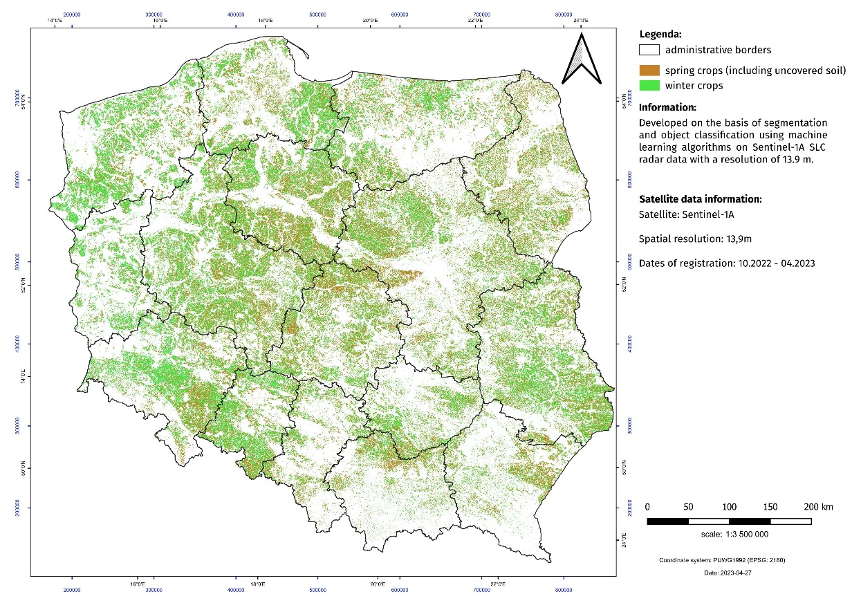
Sentinel-1A optical images (observation period from 15.10.2022 to 27.04.2023) formed the basis for the estimation. The estimation was based on segmentation and cla-sification of the object-oriented T2 coherence matrix and the parameters of the polaryme-tric H/α decomposition using machine learning algorithms (Random Forest). The classification accuracy will be validated against in situ data. A total of 230 satellite scenes of 250 km wide SLC (Single Look Com-plex) radar data were used. A crop database developed using photo-interpretation methods based on Sentinel-2 data was used to teach the system and perform the classification.

When publishing Statistics Poland data, please provide information “Data source – Statistics
Poland”, and when publishing calculations on data published by Statistics Poland, please
include the disclaimer “Own calculations on the basis of Statistics Poland data”.

Prepared by:  Agriculture Department  Director Artur Łączyński  Phone: (+48 22) 608 34 62 | Issued by:  The Spokesperson for the President  of Statistics Poland  Karolina Banaszek  Phone: (+48) 695 255 011
Press Office  Phone: (+48 22) 608 38 04  e-mail: obslugaprasowa@stat.gov.pl |   www.stat.gov.pl/en/

@StatPoland

@GlownyUrzadStatystyczny

gus_stat

glownyurzadstatystycznygus

glownyurzadstatystyczny
Related information

Land use and sown area in 2019

Production of agricultural and horticultural crops in 2021

Data available in databases
BDL: Sown area

Terms used inn official statistics

Crop area

The information includes the results of the spring crop condition assessment conducted in the first half of May 2023. The assessment was based on expert opinions of Statistics Poland's field appraisers prepared on the basis of vetting of fields, meadows and orchards. The spring crop condition assessment also includes an estimate of the sown area of major agricultural crops using satellite remote sensing methods and an estimate of winter and spring losses.

