Average paid employment, wages and salaries in the national economy in 2022 – preliminary data
According to preliminary data, in 2022, the average paid employment in the national economy was 11.0 million full-time equivalent employees. There were 1.4% more of them compared with the previous year.
1.4%
Increase in the average paid employment in 2022 in the national economy compared with the previous year

Average paid employment in the national economy
Average paid employment
includes full-time employees
and part-time employees
converted into full-time
equivalent employees
In 2022, the most full-time equivalent employees were concentrated in the Manufacturing section – 23.2% of total average paid employment. Compared with 2021, the average paid employment decreased in five sections, with the highest decrease recorded in the Electricity, gas, steam and air conditioning supply section and Agriculture, forestry and fishing section (1.2% each). Compared with 2021, the average paid employment increased the most in the Information and communication section (by 10.2%) and Accommodation and catering∆ section (by 7.1%).
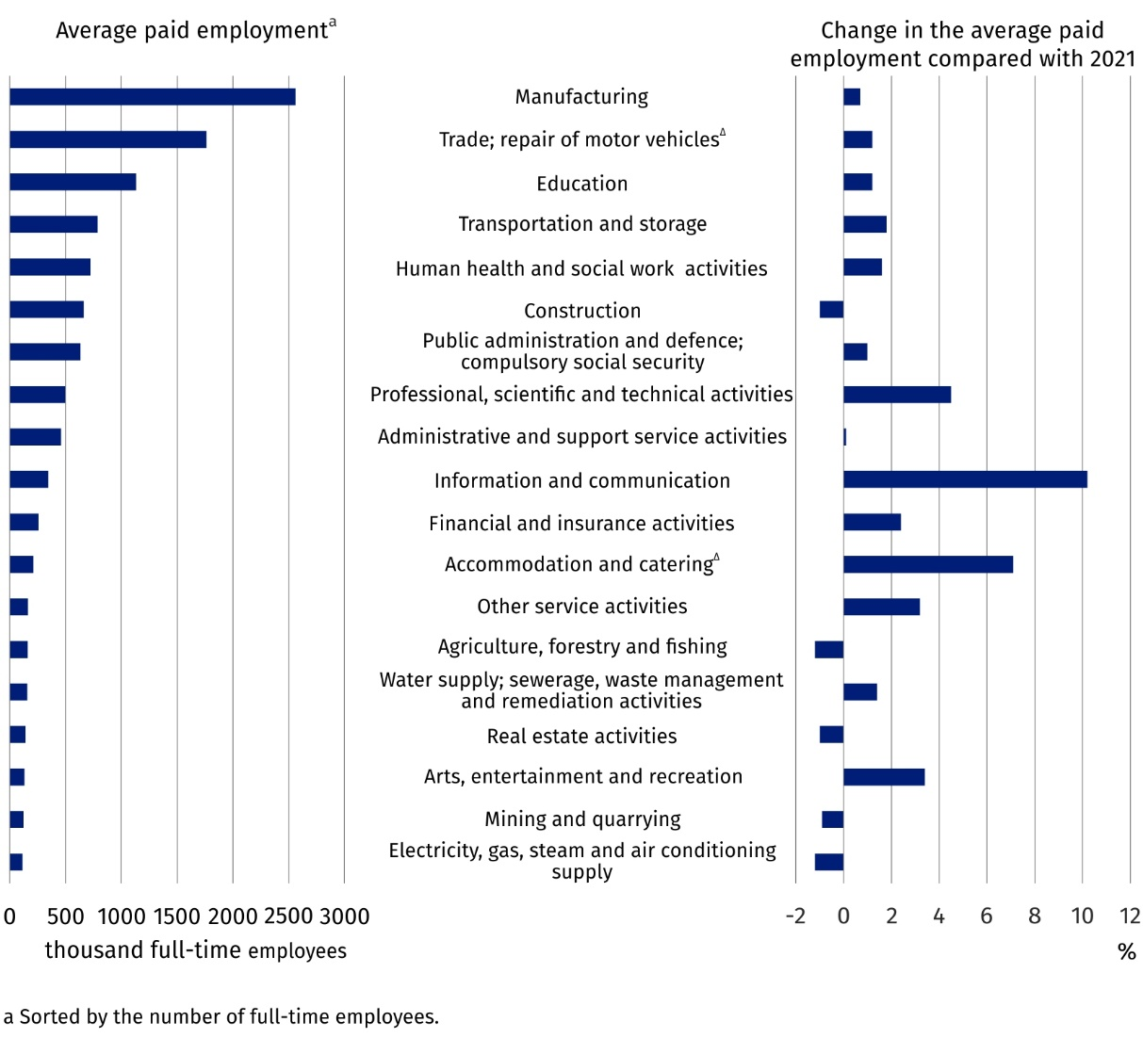
Chart 1. Average paid employment in the national economy by PKD/NACE section in 2022
– preliminary data

Average monthly gross wages and salaries in the national economy
According to preliminary data, the average monthly gross wage and salary in the national economy in Poland in 2022 was PLN 6 346.15. Compared with 2021 it increased nominally by 11.7%. This is a larger increase than that recorded in 2021 compared with 2020 – the average monthly gross wage and salary then increased by 8.7%.
The average monthly gross wage and salary by PKD/NACE section remained differentiated. In 2022, it ranged from PLN 4 127.68 in the Accommodation and catering∆ section to PLN 11 101.46 in the Mining and quarrying section. These values were respectively 35.0% lower and 74.9% higher than the average monthly gross wage and salary in Poland.
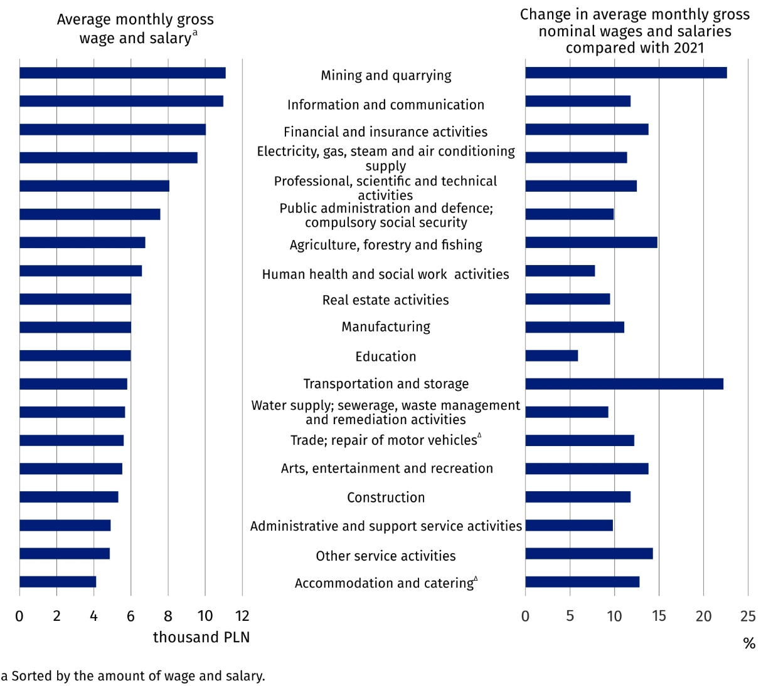
Chart 2. Average monthly gross wages and salaries in the national economy by PKD/NACE section in 2022 – preliminary data
In 2022, the average monthly nominal gross wage and salary increased by 11.7% compared with 2021
In all PKD/NACE sections, increases in the average monthly nominal gross wage and salary compared with 2021 were recorded. The increases ranged from 5.9% in the Education section to 22.6% in the Mining and quarrying section.

Minimum gross wage and salary
In 2022, the minimum gross wage and salary increased by PLN 210.00 compared with 2021 and amounted to PLN 3 010.00. It accounted for 47.9% of the average monthly gross wage and salary without annual awards. According to preliminary data, in December 2022, wages and salaries that were equal to or lower than the minimum gross wage and salary were paid to 402.6 thousand employees.

In this news release abbreviated names of NACE, Rev. 2 sections were used. Abbreviations are marked with a ‘Δ’ symbol. Full names are available on the Eurostat website at: https://ec.europa.eu/eurostat/data/classifications

In the case of quoting Statistics Poland data, please provide information: ‘Source of data: Statistics Poland’, and in the case of publishing calculations made on data published by Statistics Poland, please provide information: ‘Own elaboration based on Statistics Poland data.’
Prepared by:  Statistical Office in Bydgoszcz  Director Wiesława Gierańczyk, Ph.D.  Phone: (+48 52) 366 93 90 | Issued by:  The Spokesperson for the President  of Statistics Poland  Karolina Banaszek  Phone: (+48) 695 255 011
Press Office  Phone: (+48 22) 608 38 04  e-mail: obslugaprasowa@stat.gov.pl |   stat.gov.pl/en/

@GUS_STAT

@GlownyUrzadStatystyczny

gus_stat

glownyurzadstatystycznygus

glownyurzadstatystyczny
Related information
Yearbook of Labour Statistics 2021
Other publications related to the labour market
Data available in databases
Local Data Bank -> Labour market
Strateg -> Statistics by theme -> Labour market
Knowledge Databases -> Labour market
Terms used in official statistics
Average paid employment
Average monthly gross wages and salaries

Without profit for distribution or balance surpluses in cooperatives and annual extra wages and salaries for employees of budgetary sphere units.
Data concern national economy entities with 10 or more employed persons and budgetary sphere units regardless of the number of employed persons.

