Accidents at work in 2022 – preliminary data
66,606 persons injured in accidents at work were reported in 2022, by 3.2% fewer than in 2021.
The number of injured persons per 1,000 employed persons (the incidence rate) decreased from 5.10 to 4.66.
The number of persons injured in accidents at work and the incidence rate decreased compared to 2021
4.66
Incidence rate in 2022
In 2022, the largest number of victims were recorded in accidents at work with other effects - 66,061 (a 3.1% decrease compared to 2021). 180 persons were injured in fatal accidents, while 365 persons sustained injuries in serious accidents ( a decrease of 17.4% and 2.4% respectively).
The highest incidence rate was recorded for Śląskie (5.89), Warmińsko-Mazurskie (5.86)
and Zachodniopomorskie (5.71) Voivodships, the lowest for Mazowieckie (3.44), Małopolskie (3.46) and Podkarpackie (3.79).
Map 1. Persons injured in accidents at work per 1,000 employed persons ª
(excluding private farms in agriculture) in 2022
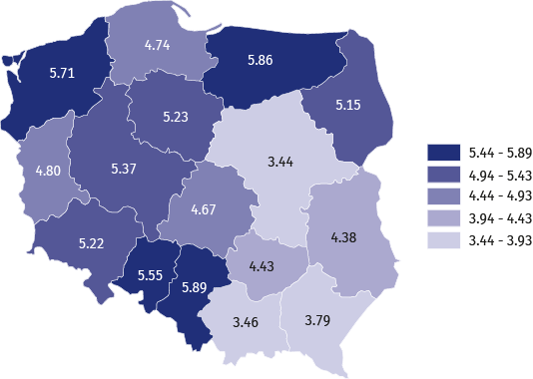
a The incidence rate was calculated using preliminary data on the number of employees; civilian employees
of budgetary entities conducting activity within the scope of national defence and public safety were not included in the breakdown by voivodships.
The highest incidence rate was recorded for Śląskie Voivodship, while the lowest for Mazowieckie Voivodship
In the breakdown by types of economic activity, the highest incidence rate was recorded
in the sections: mining and quarrying (14.78), water supply; sewerage, waste management
and remediation activities (12.13) and manufacturing (7.68), while the lowest in the sections: information and communication (0.78), agriculture, forestry and fishing (1.10) and financial and insurance activities (1.21).
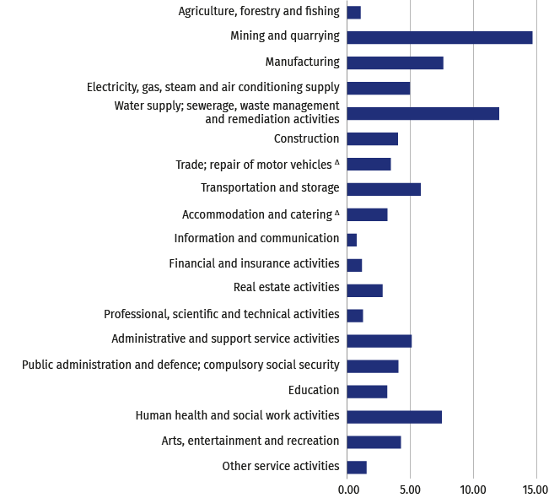
Chart 1. Persons injured in accidents at work per 1,000 employed persons by sections
in 2022 (excluding private farms in agriculture)
The highest incidence rate was recorded in the section mining and quarrying,
the lowest in the section information and communication

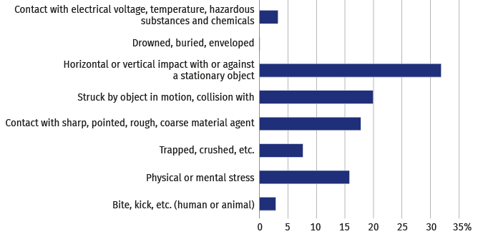
Chart 2. Persons injured in accidents at work by contact-modes of injury in 2022
Horizontal or vertical impact with or against a stationary object was the prevalent group of contact-modes
of injuries (32.1%)

Chart 3. Causes of accidents at work in 2022
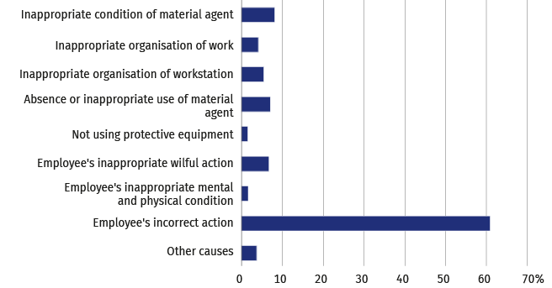
Employee's incorrect action was the cause of 61.1%
of the accidents at work
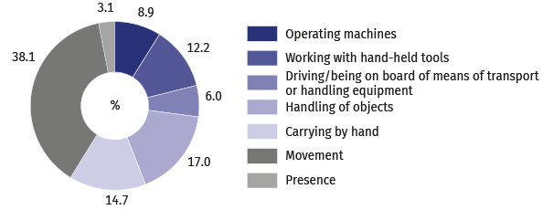
Chart 4. Persons injured in accidents at work by a specific physical activity performed
by the victim at the time of the accident in 2022
Movement was the most frequent specific physical activity performed
by the victim at the time
of the accident (38.1%)

Chart 5. Persons injured in accidents at work by part of body injured in 2022
79.3% of the persons injured in accidents at work sustained an extremity injury
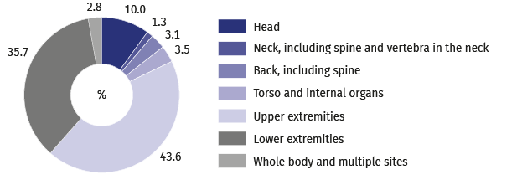
Tables are available on the website in .xlsx format.
When citing data from the Statistics Poland please provide the following information: "Statistics Poland`s data". When publishing calculations made on data published by the Statistics Poland, provide the following information: "Own study based on the Statistics Poland's data".
METHODOLOGICAL NOTES
The publication includes information on accidents at work of persons employed in the national economy excluding budgetary entities conducting activity within the scope of the national defence and public safety for which information on accidents at work concerns only civilian employees.
Data regarding accidents at work, excluding private farms in agriculture are obtained from the “Statistical accident report” Z-KW and cover all accidents at work, as well as accidents considered equivalent to accidents at work, regardless whether incapacity for work was reported (due to hospitalisation of an injured person, or rejection of a sick leave, etc.).
Data on accidents at work on private farms in agriculture were compiled on the basis of reports of the Agricultural Social Insurance Fund (ASIF) and are related only to the accidents in respect of which one-off compensations were granted
in a given period.
Each accident, regardless whether the victim was injured during a single or multiple casualty incident, is counted as one accident at work.
Incidence rate is the number of persons injured per 1,000 persons employed. The ratio was calculated using the average number of employed persons expressed as an arithmetic mean for two consecutive dates, as of 31 December of the year preceding the surveyed year and of the surveyed year.
Information on days lost includes the total number of calendar days of incapacity for work due to work-related accidents, estimated on the basis of sick leaves.
Pursuant to art. 3 of the Act of 30 October 2002 on Social Insurance in Respect of Accidents at Work and Occupational Diseases (consolidated text Journal of Laws of 2022, item 2189):
- accident at work is understood as a sudden incident, caused by external reason, leading to injury or death, which occurred in connection with work:
- during or in connection with performance of ordinary activities or the superiors’ instructions by the employee
and activities on behalf of the employers, even without instructions,
- when the employee remains at the disposal of the employer on the way between the seat of the employer
and the place of performing the obligation arising from the employment relationship;
- every accident is considered equivalent to an accident at work, as regards entitlement to benefits defined in the law on social insurance against accidents at work and occupational diseases, if the employee had such an accident: during a business trip; during training within the scope of the national self-defence; when performing tasks ordered by trade union organisations operating at the employer’s;
- accident at work is also understood as a sudden incident, causing injury or death, which happened within
the term of accident insurance in the course of: practising sports during competitions and training by a person receiving sport scholarship; performance of paid work while serving the sentence of imprisonment or temporary detentions; exercising the Mandate of a Deputy or Senator who receives a salary; doing – on the basis of appointment issued by powiat labour office or other supervising entity – training or internship connected with
a scholarship received by school leavers; performance of work by members of agricultural producers’ cooperatives, farmers’ cooperatives and by other persons considered equivalent to members of cooperative, for the benefit of these cooperatives; performance or cooperation in performance of work on the basis of agency agreements, contracts of mandate or contracts of services; performance of usual activities related to running, or cooperation in running, a non-agricultural economic activity; performance of religious activities or activities connected with entrusted pastoral or monastic functions by clergymen; serving supplementary forms of military service; education of students receiving scholarship at the National School of Public Administration.
Fatal accident at work is an accident which leads to the death of a victim at the site of the accident or within 6 months of the accident.
Serious accident at work is an accident which results in serious bodily harm, i.e. loss of sight, hearing, speech, ability
to procreate, other bodily harm or health-related problems, which disrupts primary bodily functions or results in an incurable and life-threatening disease, permanent mental illness, a permanent, total or significant incapacity for work
in the occupation, or a permanent significant disfigurement or distortion of the body.
The methodology of the survey on accidents at work is explained in more detail in the annual publication titled "Accidents at work", available on the website of Statistics Poland.
The data presented in this release are preliminary. The final data covering the year 2022 will be available
in a publication coming out in November 2023.

Prepared by:
Statistical Office in Gdańsk
Director Jerzy Auksztol
Office: phone (+48 58) 76 83 130
Press Office
Office: phone (+48 22) 608 34 91, 22 608 38 04
e-mail: obslugaprasowa@stat.gov.pl
Issued by:
Related information
Accidents at work in 2021
Accidents at work in January-September 2022–preliminary data
Other studies regarding working conditions
Data available in databases
Local Data Bank -> Labour Market -> Working Conditions
The Spokesperson for the President
of Statistics Poland
Karolina Banaszek
Mobile: (+48) 695 255 011

www.stat.gov.pl/en/

@StatPoland


@GlownyUrzadStatystyczny
gus_stat

glownyurzadstatystycznygus

glownyurzadstatystyczny

