Higher education in the 2022/2023 academic year (preliminary data)
As of 31 December 2022, there were
1,223.6 thousand people enrolled in higher education institutions in Poland, by 5.5 thousand more than in 2021. 292.6 thousand graduates received diplomas in the 2021/22 academic year, by 4.8 thousand fewer than
in 2020/21.
0.4%
Increase in the number of students compared to the 2021/22 academic year
According to the POL-on register, 359 higher education institutions operated in Poland
in the 2022/23 academic year. This study covers 341 HEIs which filed statistical reports.
The number of students decreased from 1,405.1 thousand to 1,204.0 thousand in the
2015/16-2019/20 academic years, but it has increased to 1,223.6 thousand people since
the 2020/21 academic year. A steady decline, from 364.6 thousand people in the 2015/16 academic year to 292.6 thousand in 2021/22, was also recorded in the number of graduates (a slight increase was recorded only in the 2016/17 and 2020/21 academic years).

Chart 1. Students and graduates (including foreigners)
Compared to the 2015/16 academic year, the number of students decreased by 12.9% while the number of graduates fell by 19.8%

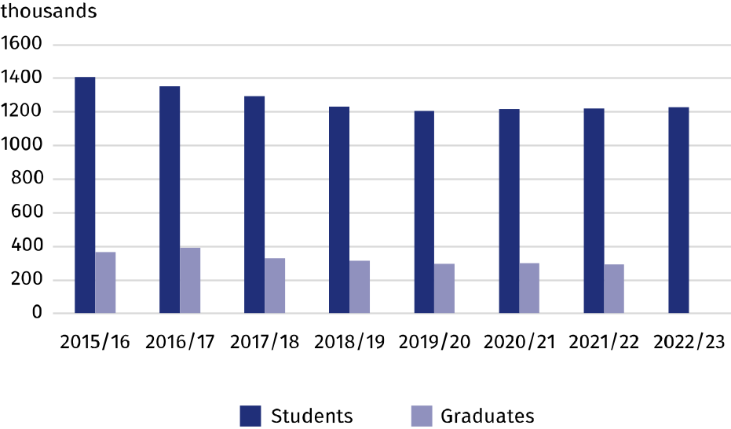
Students
64.3% of students were enrolled in full-time programmes
Women accounted for 58.2% of students in the 2022/23 academic year. 786.2 thousand people were enrolled in full-time programmes (64.3% of students), while 437.4 thousand people studied part-time. First-cycle studies were chosen by 61.4% of all students
(751.6 thousand people), second-cycle programmes by 21.1% and long-cycle programmes by 17.1%. The most (274.6 thousand) people studied in Mazowieckie Voivodship, while the fewest (11.3 thousand) in Lubuskie Voivodship.
Business, administration and law with 22.7% of all students was the most frequently chosen broad field, followed by Health and welfare (13.3% respectively), Engineering, manufacturing and construction (13.2%), and Social sciences, journalism and information (13.0%).
105.4 thousand foreigners, including 48.7 thousand women, studied in Poland, by 17.9% more than in the previous year (this applies to people studying in Poland for at least one academic year). Most of the foreigners came from European countries, primarily from Ukraine (48.1 thousand, 45.6% of all foreigners), Belarus (12.0 thousand – 11.4%) and Türkiye (3.8 thousand – 3.6%). Full-time studies were undertaken by 94.5 thousand foreigners (89.6%). Higher education institutions in Mazowieckie Voivodship concentrated more than
a quarter of all foreigners (31.5 thousand).
Higher education institutions in Mazowieckie Voivodship were the most popular with foreign students

Table 1. Students by voivodships in the 2022/23 academic year
SPECIFICATION | Total | Of which females | In |  | Of total number  – foreigners
SPECIFICATION | Total | Of which females | full-time programmes | part-time programmes | Of total number  – foreigners
POLAND | 1223629 | 711584 | 786245 | 437384 | 105404
Dolnośląskie | 114712 | 64409 | 72158 | 42554 | 9194
Kujawsko-pomorskie | 57213 | 35806 | 32285 | 24928 | 3603
Lubelskie | 65256 | 39179 | 49773 | 15483 | 9637
Lubuskie | 11268 | 6361 | 7074 | 4194 | 334
Łódzkie | 74171 | 44571 | 44393 | 29778 | 7580
Małopolskie | 144221 | 85259 | 106197 | 38024 | 8733
Mazowieckie | 274620 | 155305 | 161348 | 113272 | 31505
Opolskie | 18179 | 9759 | 13767 | 4412 | 2917
Podkarpackie | 42233 | 23773 | 30352 | 11881 | 3086
Podlaskie | 28825 | 17381 | 20720 | 8105 | 1766
Pomorskie | 86439 | 51120 | 51919 | 34520 | 5683
Śląskie | 107362 | 62309 | 70794 | 36568 | 7725
Świętokrzyskie | 21583 | 13540 | 13760 | 7823 | 1112
Warmińsko-mazurskie | 21684 | 12682 | 16095 | 5589 | 588
Wielkopolskie | 124105 | 72214 | 72436 | 51669 | 9545
Zachodniopomorskie | 31758 | 17916 | 23174 | 8584 | 2396

Graduates
In the 2021/22 academic year, 292.6 thousand people obtained higher education diplomas, including 183.8 thousand (62.8%) women. Most of the graduates (183.8 thousand) completed long-cycle and first-cycle programmes, while 37.2% were graduates of second-cycle studies.
188.4 thousand graduates completed full-time programmes (64.4%), while 104.2 thousand – part-time programmes
Graduates most often completed their studies in the following broad fields: Business, administration and law (24.3%), Engineering, manufacturing and construction (15.2%), Health and welfare (12.5%) and Social sciences, journalism and information (10.8%).
The most of 15.8 thousand foreign graduates came from Ukraine (43.6%), Belarus (11.8%) and India (3.4%). More than half of the foreign graduates were women (56.7%). 89.6% of foreigners completed full-time studies, mostly Business, administration and law (33.2% of the total number of foreign graduates).

Table 2. Graduates by broad fields of education in the 2021/22 academic year
SPECIFICATION | Total | Of which females
Total | 292605 | 183817
Education | 19909 | 16533
Arts and humanities | 26524 | 19232
Social sciences, journalism and information | 31690 | 22118
Business, administration and law | 71112 | 46989
Natural sciences, mathematics and statistics | 10978 | 7768
Information and Communication Technologies (ICTs) | 13512 | 2131
Engineering, manufacturing and construction | 44431 | 17415
Agriculture, forestry, fisheries and veterinary | 5403 | 3185
Health and welfare | 36533 | 29582
Services | 25466 | 15450
Individual inter-field studies | 7047 | 3414
When citing data from the Statistics Poland please provide the following information: "Statistics Poland's data". When publishing calculations made on data published by the Statistics Poland, provide the following information: "Own study based on the Statistics Poland's data".
Prepared by:  Statistical Office in Gdańsk  Director Jerzy Auksztol  Phone (+48 58) 76 83 130 | Issued by:  The Spokesperson for the President  of Statistics Poland  Karolina Banaszek  Phone: (+48) 695 255 011
Press Office  Phone: (+48 22) 608 38 04  e-mail: obslugaprasowa@stat.gov.pl |   www.stat.gov.pl/en/

@GUS_STAT

@GlownyUrzadStatystyczny

gus_stat

glownyurzadstatystycznygus

glownyurzadstatystyczny
Related information
Higher education and its finances in 2021
Data available in databases
Local Data Bank - Higher education
Terms used in official statistics
Student
Degree programmes
Full-time programmes
Part-time programmes

