Therapeutic activities of health resort facilities and inpatient rehabilitation facilities in 2022
At the end of 2022, there were operating 254 health resort facilities. 819.9 thousand patients were admitted to health resort facilities during a year, of which 742.0 thousand were inpatients. 74.5 thousand inpatients were treated in 44 inpatient rehabilitation facilities.
40.0%
Increase in the number of inpatients in health resort facilities compared to 2021

Health resort facilities
742.0 thousand inpatients and 77.9 thousand outpatients were treated in health resort facilities
At the end of 2022, there were operating 41 health resort hospitals (of which 3 for children), 184 health resort sanatoriums (of which 3 for children and 1 sanatorium in underground mining excavations), 6 outpatient health resort units and 23 natural healing centres which conduct their treatment in health resort complexes.
At the end of the year there were almost 45.6 thousand health resort beds in health resort hospitals and sanatoriums (the increase by 155 beds compared to 2021). 742.0 thousand inpatients were treated during the year (by 40.0% more in relation to the previous year). Women accounted for 60.7% of the total inpatients being treated, while people aged 65 years and more – 56.0%. Average stay of inpatients was 16.1 days.
The most inpatients were treated in health resort facilities in Zachodniopomorskie Voivoship (180.0 thousand persons) followed by Kujawsko-Pomorskie (153.2 thousand), Dolnośląskie (94.6 thousand) and Małopolskie (91.5 thousand). In total, 70.0% of inpatients were admitted in these mentioned voivodships.
At the national level the share of foreigners in inpatients was 5.4%. The vast majority of foreigners (96.0%) were admitted to health resort facilities in three voivodships: Zachodniopomorskie, Dolnośląskie and Pomorskie.

Table 1. Activities of health resort facilities by type of facility in 2022
Specification | Health resort hospitals | Health resort sanatoriums | Outpatient health resort units | Natural healing centres
Health resort facilities (as of 31 December) | 41 | 184 | 6 | 23
Beds in thousands (as of 31 December) | 8.4 | 37.2 | – | –
Inpatients in thousands | 116.8 | 625.2 | – | –
Average stay of inpatients (in days) | 19.3 | 15.5 | – | –
Outpatients in thousands | 5.5 | 25.4 | 14.5 | 32.5
In 2022, 57.7% of inpatients were subsidized by National Health Fund (by 4.3 pp more than in 2021). However, self-pay inpatients were 36.1% of inpatients (by 2.7 pp less than in the previous year).

Chart 1. The structure of inpatients treated in health resort facilities by type of financing in 2022
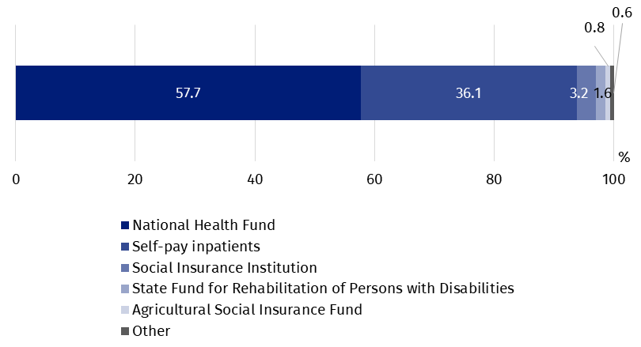
In 2022, 77.9 thousand outpatients were treated in health resort facilities (by 11.2% more than in the previous year). Above 74.3% of patients were admitted to outpatient health resort units and natural healing centres.

Table 2. Activities of health resort facilities by voivodships in 2022
The most inpatients were treated in health resort facilities in Zachodniopomorskie Voivodship (180.0 thousand persons)
Voivodships | Beds (as of 31 December) | Inpatients | Outpatients | Average stay of inpatients (in days)
Voivodships | in thousands |  |  | Average stay of inpatients (in days)
Polska | 45.6 | 742.0 | 77.9 | 16.1
Dolnośląskie | 5.7 | 94.6 | 25.0 | 16.2
Kujawsko-pomorskie | 8.6 | 153.2 | 15.0 | 16.4
Lubelskie | 1.3 | 21.7 | 3.4 | 17.8
Łódzkie | 0.1 | 1.9 | 0.6 | 17.1
Małopolskie | 5.9 | 91.5 | 12.5 | 17.7
Mazowieckie | 0.2 | 2.2 | 0.6 | 22.3
Podkarpackie | 4.2 | 58.4 | 3.9 | 18.7
Podlaskie | 0.5 | 8.8 | 0.1 | 12.6
Pomorskie | 2.0 | 25.9 | 3.9 | 14.9
Śląskie | 2.6 | 35.8 | 0.8 | 18.2
Świętokrzyskie | 3.2 | 62.6 | 6.1 | 14.6
Warmińsko-mazurskie | 0.5 | 5.4 | – | 18.9
Zachodniopomorskie | 10.9 | 180.0 | 6.1 | 14.2
Note: In three voivodships (Lubuskie, Opolskie, Wielkopolskie) the health resort facilities do not occur.
In 2022, 35.1 million medical services were provided in health resort facilities (by 34.9% more than in 2021). As in the previous year, most medical services belonged to natural healing services (26.3%), among which peat treatments and mineral baths predominated. Kinesiotherapy (19.6%), electrotherapy (11.9%), massage (10.2%) and hydrotherapy (9.4%) were also popular.
35.1 million medical services were provided in health resort facilities

Chart 2. Medical services provided in health resort facilities in 2022

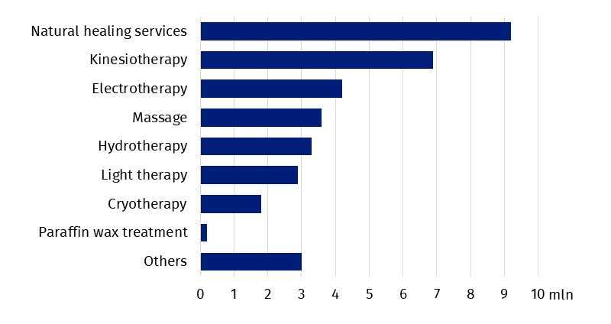Inpatient rehabilitation facilities
As the end of 2022, 44 inpatient rehabilitation facilities were operating in which there were 4.5 thousand health resort beds. During the year 74.5 thousand patients were admitted (by 22.2% more than in the previous year), of whom 66.9 thousand inpatients and 7.6 thousand outpatients.
74.5 thousand patients were treated in inpatient rehabilitation facilities
Women accounted for 55.1% of the total inpatients being treated, while people aged 65 years and more – 41.8%. Average stay of inpatients was 11.5 days.

Chart 3. The structure of inpatients treated in inpatient rehabilitation facilities by type of financing in 2022
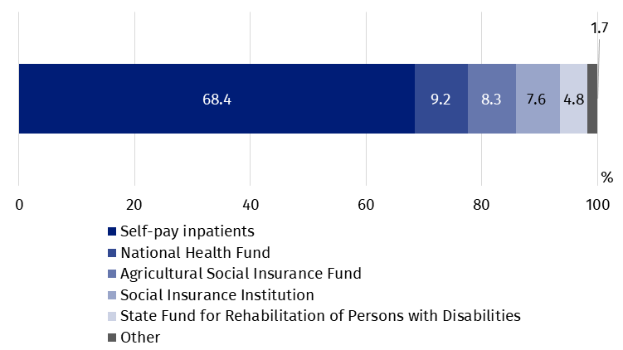
In inpatient rehabilitation facilities, most inpatients treated belonged to self-pay inpatients – 45.8 thousand persons. Among institutions subsidized inpatients, the National Health Fund subsidized 6.1 thousand persons, the Agricultural Social Insurance Fund – 5.5 thousand and the Social Insurance Institution – 5.1 thousand.
2.4 million medical services were provided in inpatient rehabilitation facilities during 2022 (by 14.2% more than in previous year), most of them belonged to kinesiotherapy (31.8%).
In the case of quoting data from the Statistics Poland, please provide information: "Statistics Poland data source", and in the case of publishing calculations made on data published by the Statistics Poland, please provide information: "Own study based on Statistics Poland data".

Prepared by:  Statistical Office in Kraków  Director Agnieszka Szlubowska  Phone: (+48 12) 420 40 50 | Issued by:  The Spokesperson for the President  of Statistics Poland  Karolina Banaszek  Phone: (+48) 695 255 011
Press Office  Phone: (+48 22) 608 38 04  e-mail: obslugaprasowa@stat.gov.pl |   stat.gov.pl/en/

@StatPoland

@GlownyUrzadStatystyczny

gus_stat

glownyurzadstatystycznygus

glownyurzadstatystyczny
Related information
Health and health care in 2021
Methodological report. Health and health care statistics − Statistics Poland’s reports
Data available in databases
Local Data Bank -> Health care, social welfare and benefits to the family
Analytical Platform – SWAID – Knowledge Databases -> Health and Health care
Terms used in official statistics
Patient in health resort
Health resort treatment
Inpatient rehabilitation facility
Health resort facility

Medical services provided in natural healing centres operating as a functional unit of the health resort hospital, sanatorium or outpatient health resort unit, are counted together with the main unit.

