Energy efficiency in the years 2011–2021
Poland's energy efficiency increased by 0.5% in 2021 compared to 2020. Between 2011 and 2021, the annual cumulative growth rate of energy efficiency amounted to 0.9%. Primary energy intensity of GDP decreased by an average of 2.6% per year during this period, while final energy intensity of GDP decreased by 1.5%. The fastest rate of energy efficiency improvement was observed in transport (by 2.3%).
0.5%
An increase of energy efficiency in Poland in 2021 compared to 2020.

Total primary energy consumption increased between 2011 and 2021 from 96.6 Mtoe to
104.0 Mtoe (i.e. cumulative annual growth rate - 0.7%). In contrast, final energy consumption increased from 64.7 to 75.2 Mtoe during the analysed period (i.e. a cumulative annual growth rate of - 1.5%). Both total and final consumption reached its peak in 2018 (104.1 Mtoe and 74.9 Mtoe respectively).
In 2021 total primary energy consumption amounted to 104.0 Mtoe, while final energy consumption to 75.2 Mtoe
Chart 1. Total primary energy consumption and final energy consumption 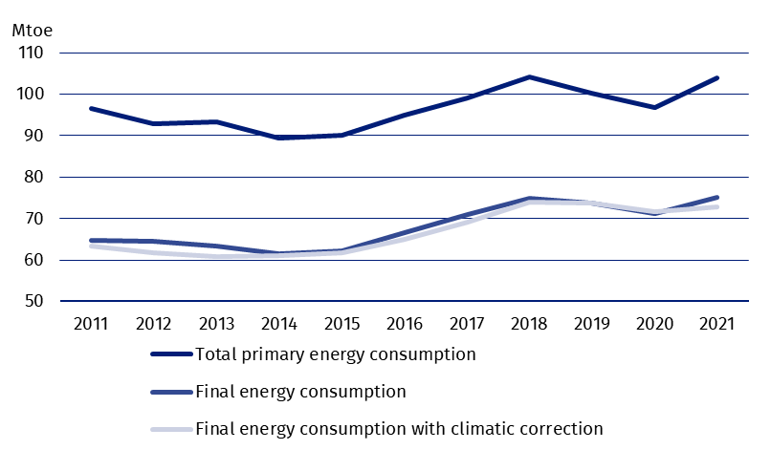
Primary energy intensity of GDP in 2021 increased by 10.5% compared to the previous year, while final energy intensity of GDP increased by 9.8%.
Compared to 2011, the primary energy intensity of GDP in 2021 decreased by 20.3% and final energy intensity of GDP by 13.8%. With climatic corrections, the rate of improvement was slightly higher (21.0% and 15% respectively).
Table 1. The annual cumulative growth rate of energy efficiency of GDP (%/year)
Rate of improvement | 2012–2016 | 2017–2021 | 2012–2021
Primary energy intensity of GDP | -3,98 | -0,49 | -2,25
Primary energy intensity of GDP  with climatic corrections | -3,95 | -0,70 | -2,33
Final energy intensity of GDP | -3,31 | 0,38 | -1,48
Final energy intensity of GDP  with climatic corrections | -3,26 | 0,07 | -1,61

Households
In 2021 household energy consumption accounted for 20.2% of final energy consumption. The most commonly consumed energy carrier was solid fossil fuels with a share of 21.9% in 2021. This was followed by natural gas (20.6%), heat (18.3%) electricity (11.9%) liquid fuels (2.8%). The consumption of other energy carriers, which included solid biofuels and ambient heat, was 24.4%. The consumption of other energy carriers, which included solid biofuels and ambient heat, amounted to 24.4%.
The most important direction of energy use was space heating, with a 65.4% share in 2021. Water heating consumed 17.1% of energy, lighting and electrical appliances 9.2% and preparing meals 8.3%.
Table 2. Structure of energy consumption in households by directions of use
in 2016-2021 (%)
In 2021 space heating accounted for 65.4% of energy consumed by households
Specification | 2016 | 2017 | 2018 | 2019 | 2020 | 2021
Total | 100.0 | 100.0 | 100.0 | 100.0 | 100.0 | 100.0
Space heating | 66.5 | 66.1 | 68.5 | 66.4 | 66.1 | 65,4
Water heating | 15.9 | 16.2 | 15.5 | 16.1 | 16.3 | 17.1
Cooking | 8.0 | 8.0 | 7.4 | 8.1 | 8.1 | 8.3
Lighting and electrical appliances | 9.7 | 9.7 | 8.6 | 8.7 | 9.3 | 9.2

The household energy consumption rate per m² showed a decreasing trend. The volume of consumption in 2021 amounted to 21.8 kgoe/m², compared with 22.0 kgoe/m² in 2011 (cumulative annual decrease of 0.1%/year). Adjusted for climatic corrections, consumption per m2 decreased by 0.4%/year.
Chart 2. Energy consumption in households per m²
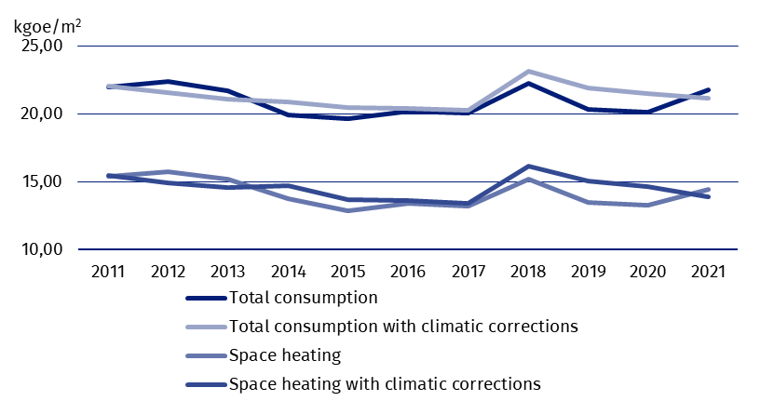

Industry
Final energy consumption in industry reached its lowest value in 2012 (14.8 Mtoe). In the following years slight fluctuations in consumption were observed, with a significant increase from 2016 onwards, up to 17.9 Mtoe in 2019. In 2021, energy consumption in industry increased by 2.3% in comparison to the previous year and amounted to 17.3 Mtoe.
In 2021, compared to 2011, consumption of electricity increased by 27.6%. Increases were also recorded in the consumption of natural gas (by 33.6%), heat (by 53.6%) and other energy carriers (by 40.3%). A decrease in consumption of liquid fuels (down 4.9%) and coal (down 18.4%) was also observed.
The highest rate of reduction in energy intensity of value added in 2021 compared to 2012 was recorded in the machinery and mineral industry, slightly lower in the primary metals, and the lowest in the textile industry.

Table 3. Average annual rate of changes of energy intensity of industry in the years
2012–2021 (in %)ª
Specification | Average annual rate of changes
Food | -1,4
Textile | -0,2
Wood | -1,4
Paper | -1,5
Chemical | -1,4
Mineral | -3,7
Primary metals | -3,1
Machinery | -4,1
Transport equipment | -0,8
Other | -2,1
ª Provisional data
Between 2017 and 2021, structural changes resulted in a reduction in the energy intensity of the manufacturing industry by 0.7%/year
Between 2017 and 2021, the cumulative growth rate of energy intensity of manufacturing industry amounted to 0.25%/year. Structural changes contributed to its decrease by 0.7%/year, while energy intensity in a fixed structure, i.e. after eliminating the impact of changing shares of individual industries in the total volume of manufacturing industry, decreased by 0.5%/year.
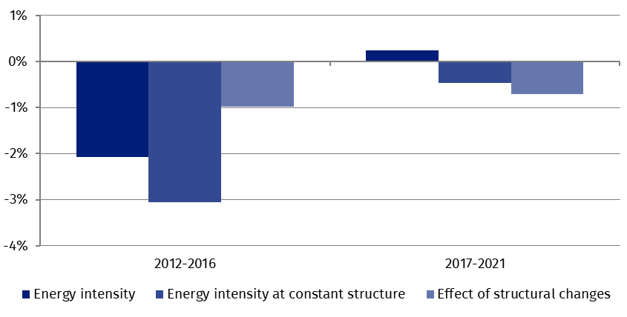
Chart 3. Energy intensity of manufacturing – role of structural changes (%/year)

ODEX indicator
The ODEX indicator (base year 2000=100) decreased from 77.5 to 70.7 points between 2011 and 2021. The cumulative rate of improvement amounted to 0.9%/year. The fastest rate of improvement (by 1.3%/year) was in industry, for which the value of indicator was 45.7 points in 2021. The slowest rate of improvement was observed in the transport sector, where the annual improvement between 2012 and 2021 amounted to 0.9%. In the household sector, the average rate of improvement was 1.2%, with the value of indicator of 75.9 points.
The fastest rate of improvement (1.3%/year) was recorded in in industry, the slowest - in transport (0.9%/year)
Chart 4. ODEX indicator
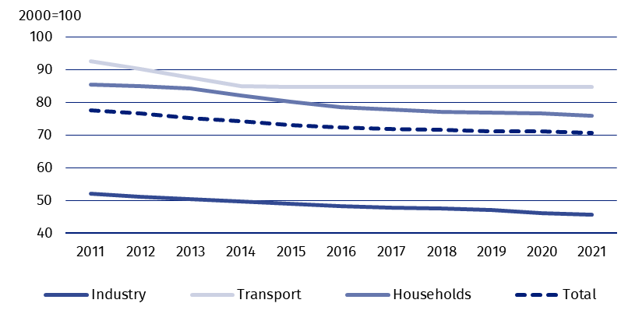

Decomposition of energy consumption
Economic activity had the greatest impact on the increase in energy demand
The largest impact on the change in consumption came from economic activity contributing to an increase in energy demand by 11.7 Mtoe in 2021 compared to 2011. For households, the factors contributing to the increase in energy demand were an increase in the number of dwellings and a change in lifestyle (larger dwellings) as well as weather conditions. Structural changes in industry reduced energy consumption by 0.4 Mtoe, while transport increased by 1.6 Mtoe. Energy savings amounted to 5.8 Mtoe, the largest was achieved in households (2.4 Mtoe). Weather conditions increased energy consumption by 1 Mtoe and other factors decreased energy consumption by 0.1 Mtoe.
Table 4. Influence of factors on the change in final energy consumption from
2011 to 2021 (Mtoe)
Specification | Industry | Households | Transport | Services |  | Agriculture | Total
Consumption change | 2,4 | 1,7 | 6,1 | 0,0 |  | 0,1 | 10,3
FACTORS
Activity | 5,2 | - | 3,8 |  | 3,2 | -0,5 | 11,7
Stock of dwellings | - | 1,3 | - |  | - | - | 1,3
Lifestyle | - | 1,1 | - |  | - | - | 1,1
Structural changes | -0,4 | - | 1,6 |  | - | - | 1,2
Energy savings | -2,0 | -2,4 | -1,4 |  | 0,0 | - | -5,8
Weather conditions | - | 0,7 | - |  | 0,3 | - | 1,0
Others | -0,5 | 1,1 | 2,1 |  | -3,4 | 0,5 | -0,2
When quoting Statistics Poland data, please provide information: “Source of data: Statistics Poland”, and when publishing calculations made on data published by Statistics Poland, please provide information: “Own study based on Statistics Poland data”.

Prepared by:  Statistical Office in Rzeszów  Director Marek Cierpiał-Wolan  Phone: (+48 48) 17 853 52 10 | Issued by:  The Spokesperson for the President  of Statistics Poland  Karolina Banaszek  Phone: (+48) 695 255 011
Press Office  Phone: (+48 22) 608 38 04  e-mail: obslugaprasowa@stat.gov.pl |   stat.gov.pl/en/

@StatPoland

@GlownyUrzadStatystyczny

gus_stat

glownyurzadstatystycznygus

glownyurzadstatystyczny
Related information
Energy statistics

Data available in databases
Knowledge Database – Energy statistcs
Poland macroeconomic indicators
Macroeconomic Data Bank
Terms used inn official statistics
Primary energy
Derived energy
Energy consumption

