Activities of associations and similar social organi-zations, foundations, faith-based charities, country housewives associations as well as business and professional associations in 2022 – preliminary re-sults
In 2022, in Poland there were 103.4 thousand non-profit organizations, which affiliated 8,3 million members. They had 153.4 thousand full-time jobs, which accounted for 1.4% of the average employment in the national economy. In connection with the hostilities in Ukraine, the organizations provided assistance to 17.5 million people and transferred material and financial
support worth PLN 1.6 billion.
8,6%
increase in the number of non-profit organizations in 2020-2022

Active organizations
In 2022, in Poland there were 103.4 thousand non-profit organizations, including 9.5 thous. units with the status of public benefit organization.

In 2022, 103.4 thous. non-profit organizations (8.2 thous. more than in 2020) were active in Poland, among which the most numerous group were associations and similar social organizations (68.9 thous.). The collective of foundations and country housewives associations numbered respectively 19.3 thous. and 11.3 thous. units. The least numerous group were faith-based charities and business and professional associations (2.0 thous. each).
The status of public benefit organization had 9.5 thous. units. In turn, social economy entities accounted for 99.3% of active organizations (102.6 thous). As at December 31, 2022,
0.5 thous. among surveyed organizations, were on the list of social enterprises kept by the Ministry of Family and Social Policy.
Chart 1. Number of active non-profit organizations in 2022
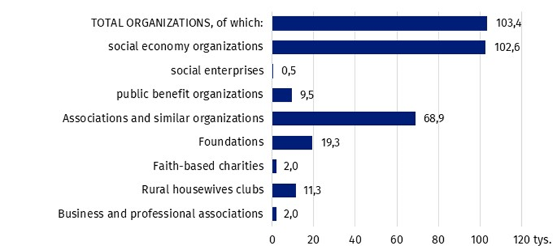
Apart from non-profit organizations with legal personality, there were also less formalized social organizations. According to the data of powiat-level local governments and city offices with poviat status, in 2022 there were 10.5 thous. ordinary associations registered in the country.
Map 1. Number of active non-profit organizations in 2022 by voivodeships and regions

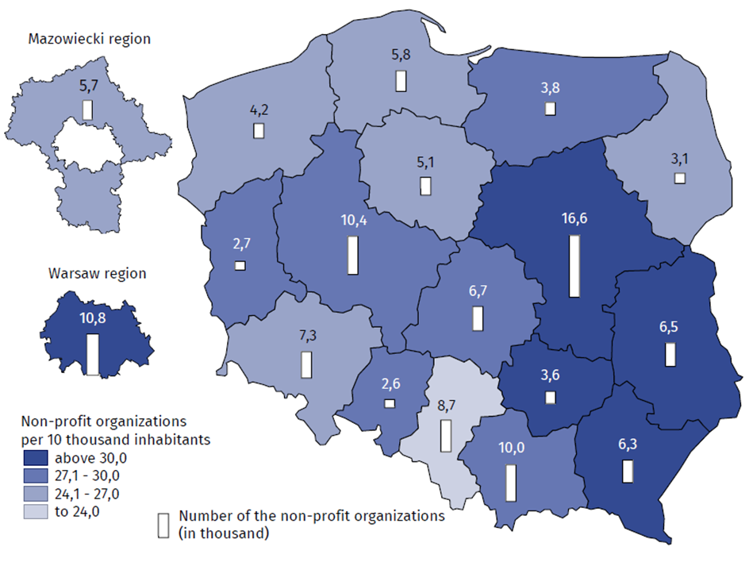

The field of statutory activity
More than half of the organizations were active in the field of sport, tourism and recreation, hobby, rescue services, as well as culture and arts.
In 2022, as part of their statutory activities, most organizations dealt with sports, tourism, recreation, and hobbies (27.4%). Relatively often, non-profit organizations indicated rescue services (14.3%), culture and arts (13.4%), education and research (10.0%), as the main field of their activity. The lowest percentage of non-profit organizations focused their activities on the area of employment assistance (1.0%).
Chart 2. Structure of the surveyed non-profit organizations according to the main area of statutory activity in 2022
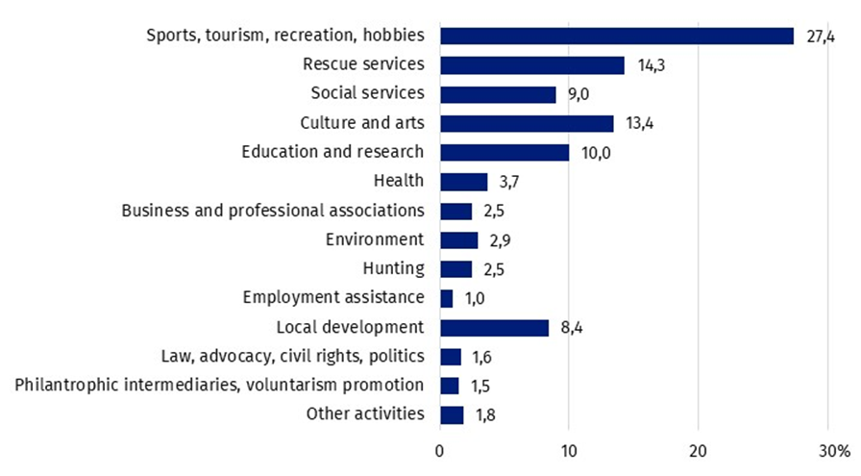
Nearly 27% of organizations with the status of public benefit organization, claimed to carry out their main activities in the field of social and humanitarian aid, and in the area of health care, it was almost 12% of organizations. Among non-profit organizations in general, these rates were almost three times lower (9.0% and 3.7%, respectively).
The vast majority of non-profit organizations conducted only unpaid statutory activities - 79.0%. The remaining entities declared to conduct paid statutory activity or business activity, of which 3.5% were organizations conducting simultaneously, both indicated types of activity.

Membership base
At the end of 2022, 8.3 million memberships were affiliated to active non-profit organizations.
Active non-profit organizations showed, that at the end of 2022, they had a total of 8.3 million memberships of natural persons (same as in 2020). Half of the organizations affiliated no more than 20 members.
Chart 3. Structure of the number of memberships of naturals personsª in non-profit organizations by type of organization in 2022.

ª For foundations and other organizations not affiliated natural persons, the number of members of the organization's collegial bodies (board of directors, council, etc.) is included.
The greatest membership potential was characteristic of associations and similar social organizations - they accounted for the vast majority of memberships of natural persons, declared by non-profit entities (79.9%). Another important group in terms of membership base, were business and professional associations - they accounted for 14.4% of all members of natural persons.

Labour resources
The vast majority of non-profit organizations in 2022, operated solely on the basis of community service. 61.2% of them declared that they did not use paid personnel, i.e. 0.4 percentage points lower than in 2020.
In non-profit organizations using paid work, employment only under civil law contracts (contract of mandate, contract for specific work, etc.) was much more frequent - 24.9% than full-time employment - 13.9%.
In 2022, 3.0 million people performed social work for the organizations and at the end of 2022, organizations employed 187.0 thous. of full-time employees.

Chart 4. Structure of non-profit organizations by having paid personnel in 2022

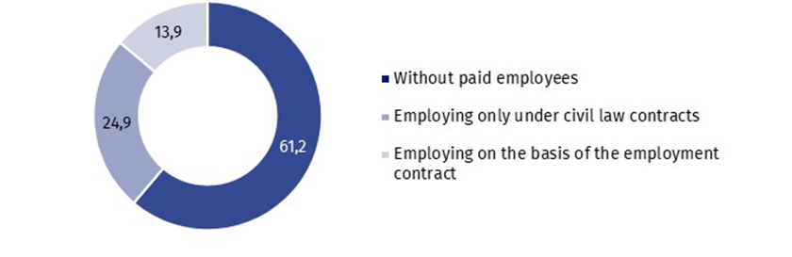
95.1% of organizations declared the use of volunteer work in 2022. Community service was most often used among associations and similar social organizations (96.6%) and least often among faith-based charities (48.0%).
In total, 3.0 million people (both members of the organization and non-members) provided volunteer work in 2022.
At the end of 2022, 187.0 thous. people were employed in non-profit organizations, on the basis of an employment contract, including for 155.5 thous. people this work was the main place of employment. The average number of employees in employing organizations was 13.
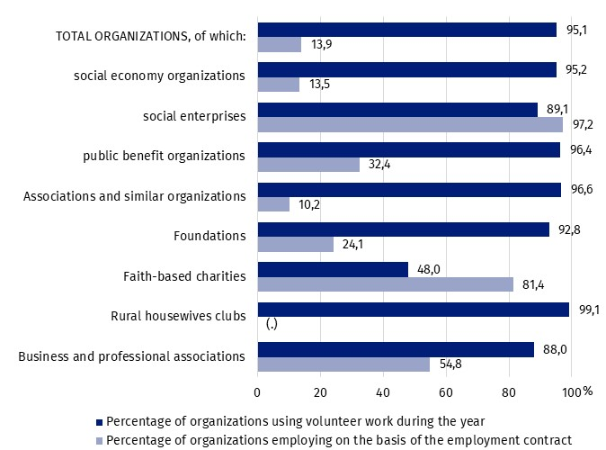
Chart 5. The percentage of non-profit organizations using volunteer work and employing on the basis of an employmentcontract in 2022 by type of organization

(.) lack of information, necessity of statistical secrecy, filling in the items is impossible or inexpedient or lack of reliable information
The share of employment in the surveyed organizations accounted for 1.2% of the average number of people working in the national economy, as at the end of December 2022. In turn, in employment based on an employment contract, this share was higher and amounted to 1.6%. The average full-time employment in 2022 amounted to 153.4 thous. full-time jobs, which constituted 1.4% of the average full-time employment during the year.
Non-profit organizations also employed personnel on the basis of civil law contracts. In 2022, there were 439.0 thous. such people, of which for 41.0 thous. (i.e. 9.3%) it was the main source of income.

Revenues
The sum of revenues obtained by non-profit organizations in 2022 amounted to PLN 47.0 billion.
In 2022, the total sum of revenues obtained by non-profit organizations amounted to PLN 47.0 billion (12.6 billion more than in 2020). The two most numerous groups of entities - associations and similar social organizations and foundations - achieved revenues of PLN 39.0 billion, which constituted 82.9% of all financial resources collected by non-profit organizations.
The average revenue of one non-profit organization was PLN 454.5 thous. Faith-based charities achieved the highest average value of revenue, amounting to PLN 2,519.2 thous., while the lowest value was recorded by country housewives associations - PLN 9.1 thous.
More than half of the revenues generated by non-profit organizations, came from non-market sources (59.4%). In this category, public funds had the largest share (41.5%), including co-financing from local government administration (18.4%). The share of revenues from market sources was 31.1%. Revenues from paid statutory activity (16.1%) and economic activity (12.8%) dominated here. Membership fees and other financial resources accounted for 9.5% of all revenues generated by non-profit organizations.

Involvement in providing support for the benefit of Ukraine
In 2022, 30.3 thous. non-profit organizations (29.3%) took additional actions, for the benefit of those in need, due to hostilities in Ukraine. Among involved organizations 96.0% conducted activities in Poland, and 10.1% in Ukraine.
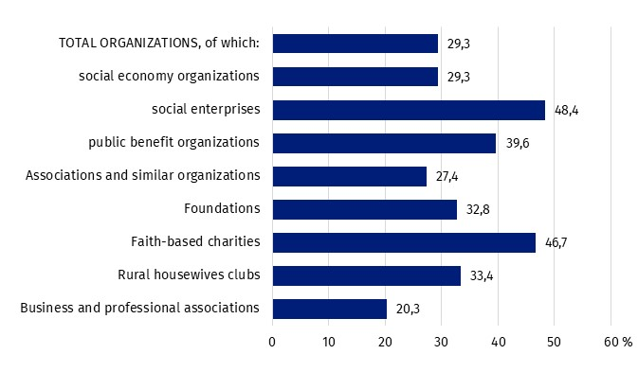
Chart 6. Percentage of non-profit organizations involved in support due to hostilities in Ukraine in 2022

Taking into account the type of entity providing support, taking into account the legal form,
faith-based charities were most often involved (46.7%), followed by rural housewives clubs (33.4%). Compared to other groups, there were also high involvement of social enterprises (48.4%).
The main recipients of the support provided by social economy entities, due to hostilities carried out in Ukraine, were natural persons - they were supported by 73.9% of non-profit organizations declaring their involvement in support. In total, those entities provided support for approximately 17.5 million recipients who were natural persons (one person could be a recipient of more than one entity).
Non-profit organizations also provided support for other non-governmental organizations – associations, foundations, church organizations and similar (20.4%), self-government/local administration bodies (11.5%) or health care institutions (6.7%).
One of the most important forms of support provided due to hostilities in Ukraine was providing material support (58.2%). The estimated value of material support provided amounted to PLN 1.2 billion.
The second important element of the support was the providing food support - every fifth (20.2%) non-profit organization provided support in this form. In addition, the organizations offered child care or educational support (18.4%), helped provide accommodations (14.4%), and provided medical assistance or health care (5.8%).
Financial resources were provided by 12.8% of the non-profit organizations involved in the support, in the total amount of PLN 469.7 million.
Methodological information
The new release was created on the basis of the preliminary results of the research: Associations, foundations, business and professional associations and faith-based charities, implemented in 2023. The study covered: associations and similar social organizations, foundations, faith-based charities conducting social activity, country housewives associations (SOF-1 form) and business and professional associations (SOF-4s form).
The selection of units for the survey carried out on the SOF-1 form, was carried out in two stages: first, purposive selection was used (units that met at least one of the following conditions: employed more than 5 people; had a tax revenue of more than PLN 1 million in 2021; had registered business activity and, at the same time, tax revenue for 2021. above PLN 100 thous.; public benefit organizations; ESF project proponents; social religious entities; associations of national minorities, ethnic minorities and foreigners; provided institutionalized social services), and then a stratified random sample was drawn within each province and legal form. The survey on the SOF-4s form was complete, so all business and professional self-government units selected from the frame, were included in the survey file. Finally, 33,5 thous. non-profit organizations were obliged to fullfill the SOF-1 and SOF-4s forms.
Detailed information on the selection of units for the files and the method of constructing analytical weights, enabling generalization of the obtained data, is included in the Methodological report Non-profit organizations: associations, foundations, business and professional associations and faith-based charities.

In the case of quoting data of Statistics Poland, please provide annotation: "Source data of Statistics Poland". When publishing calculations made on the data published by Statistics Poland, please include the following information: "Own elaboration based on data from Statistics Poland".

Prepared by:  Social Surveys and Labour Market Department  Director Dr Piotr Łysoń  Tel. 22 449 40 27  Statistical Office in Kraków  Director Agnieszka Szlubowska  Tel: 12 420 40 50 | Issued by:  The Spokesperson for the President of  Statistics Poland  Karolina Banaszek  Tel: 695 255 011
Press Office  Tel: 22 608 38 04  e-mail: obslugaprasowa@stat.gov.pl |   stat.gov.pl

@GUS_STAT

@GlownyUrzadStatystyczny

gus_stat

glownyurzadstatystycznygus

glownyurzadstatystyczny

Community service, also known as volunteer work, is work performed voluntarily and without remuneration, both by members of the organization and non-members.
Data on the number of employed persons and persons employed on the basis of an employment relationship in the national economy as at December 31, from: Statistical Yearbook of Poland 2023, GUS, Warsaw, p. 127.
Average employment data for: Concise Statistical Yearbook of Poland 2023, p. 131.

