Blood donation in 2022
Blood donors donated in total in 2022
1 302.9 thousand whole blood donations, which is 41.9 thousand more donations than in 2021
3.3%
Increase in donations of whole blood collected in 2022 compared to 2021

In 2022, 1 302.9 thousand donations of blood and its components were collected

In 2022, 1 302.9 thousand donations of blood and its components were collected in Poland (in 2021 – 1 261.0 thousand). In the same year, 21 Regional Blood Donation Centres as well as the Blood Donation Centre of the Ministry of Interior and Administration and the Military Blood Donation Centre were involved in the collection of blood and its components
in Poland.

Table 1. Blood donors, collected blood and prepared blood components
Specification | 2021 | 2022
Specification | in thousands
Blood donors | 615.9 | 622.1
Collected whole blood in donations | 1 261.0 | 1 302.9
Red blood cell concentrates in unitsª | 1 231.5 | 1 266.3
Fresh frozen plasma in units^{b} | 1 514.0 | 1 538.7
ª One unit of red blood cell concentrate equals approximately 250 ml, one litre of red blood cell concentrate equals approximately 4 units.
^{B} One unit of fresh frozen plasma equals approximately 200 ml, one litre of plasma equals approximately
5 units.
Source: The National Blood Centre, including: Ministry of the Interior and Administration and Ministry
of National Defence.
In 2022, the population
of blood donors
in Poland amounted
to 622.1 thousand people
thousand.
In 2022, the population of blood donors amounted to 622.1 thousand people (including
621.9 thousand honorary blood donors), which is an increase of 6.1 thousand people compared to 2021. Among the donors, slightly above 78% were those who donated blood more than once, i.e. multiple permanent and repeated donors (73.3% in 2021). The majority of blood donors are aged 25 to 44 (63.8%). People aged 18 to 24 accounted for 18.1% of all blood donors, and those aged 45 to 64 – 18.0%.

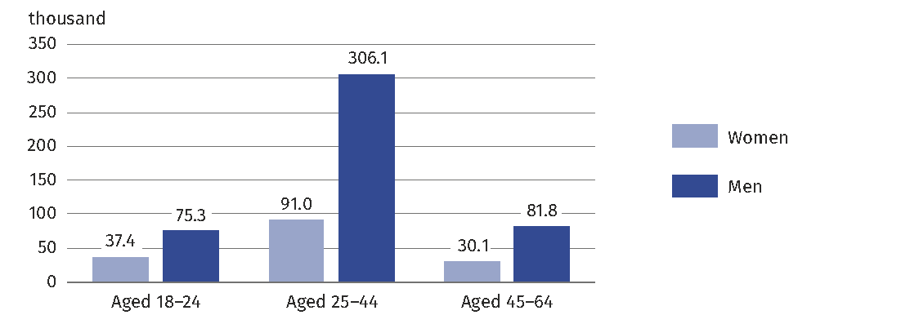
Chart 1. Blood donors by sex and age in 2022
As of 31 December

The information available in the voivodship breakdown (without data on the activities
of the units subordinated to the Ministry of the Interior and Administration or the Ministry
of Defence) makes it possible to believe that the involvement in the idea of blood donation in the spatial arrangement has not changed significantly. As in the previous year, most blood was collected in the largest voivodships in terms of population: Śląskie, Mazowieckie
and Wielkopolskie, where a total of 205.9 thousand blood donors were registered,
which represented 34.3% of all registered blood donors. The inhabitants of these 3 voivodships gave a total of 437.1 thousand whole blood donations (34.6% of whole blood collected
in Poland).
The highest number of donors per 10 thousand population (257.0) occurred in the Podlaskie Voivodship, where all donations were made in units, over which organizational supervision
is performed by the National Blood Centre, and the smallest one in Mazowieckie Voivodship (127.5 blood donors per 10 thousand population).

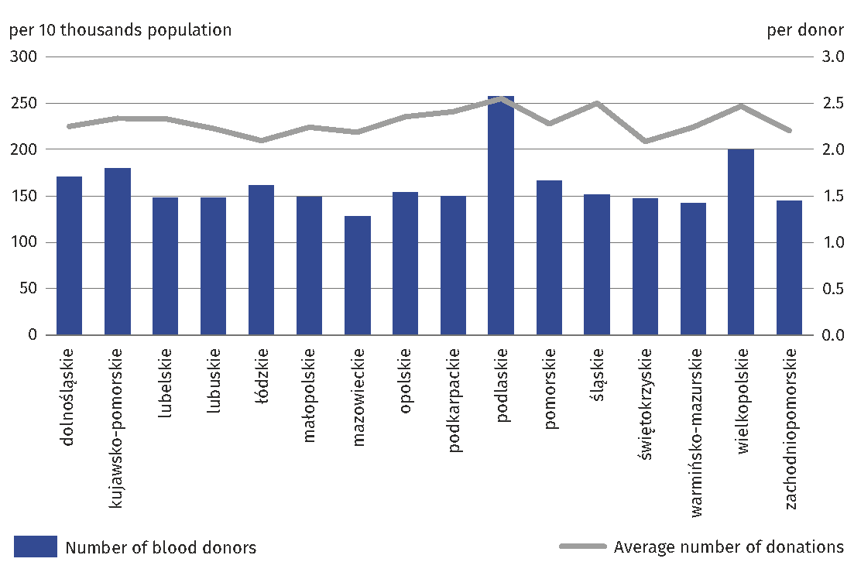
Chart 2. Blood donors by voivodships in 2022
As of 31 December

Excluding data of the Ministry of National Defence and the Ministry of Interior and Administration.

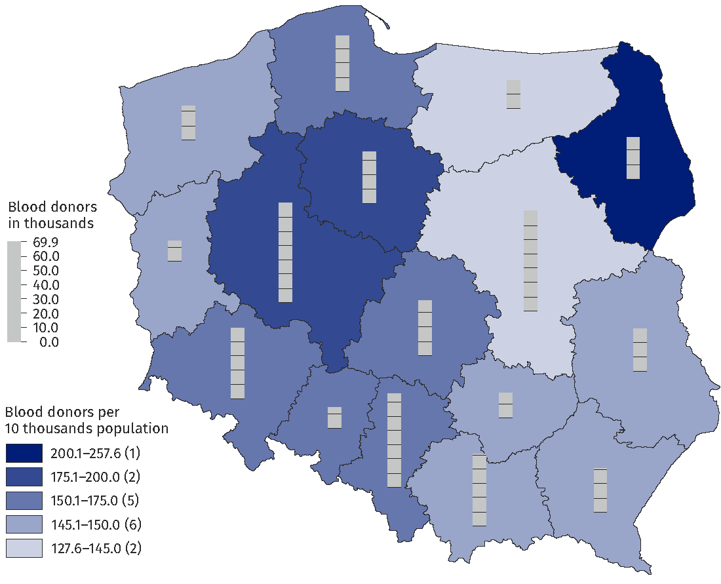
Map 1. Blood donors by locations of institutions collecting blood and voivodships in 2022
As of 31 December

Excluding data of the Ministry of National Defence and the Ministry of Interior and Administration.

Compared to the previous year in Poland, the total number of donors, whole blood collected and blood units produced increased slightly.
The largest increase in the number of blood donors compared to 2021 was recorded in the Blood Donation Centre of the Ministry of Interior and Administration (an increase of 9.7%) and the Regional Blood Donation Centre located in the Małopolskie Voivodship (an increase of 5.8%).
In the Regional Blood Donation Centres located in the Lubuskie, Dolnośląskie
and Mazowieckie Voivodships, a decrease in the number of blood donors was recorded
(the decrease in blood donors in these voivodships was respectively: 10.2%, 2.7% and 2.0%).
The largest increase in total blood donations compared to 2021 was observed in the Blood Donation Centre of the Ministry of Interior and Administration (an increase of 14.8%)
and in the Regional Blood Donation Centre located in the Małopolskie Voivodship
(an increase of 7.7%). The smallest increase was observed in the Regional Blood Donation Centres located in the Dolnośląskie Voivodship (an increase of 0.1%) and in the Opolskie Voivodship (an increase of 0.2%). On the other hand, in the Regional Blood Donation Centre located in Mazowieckie Voivodship, a decrease in the number of blood donation was observed (a decrease of 0.8%).
In 2022, there were 23 blood centres and blood transfusion centres (including 21 regional and 2 departmental ones – one under the responsibility of the Ministry of National Defence and the Ministry of Interior and Administration) and 135 collection sites (including 7 under the responsibility of the Ministry of National Defence). The number of centres and collection sites changed slightly compared to 2021. Only one collection site within the Regional Blood Donation Centre in Szczecin was liquidated.
In 2022, there were
23 blood centres
and blood transfusion centres

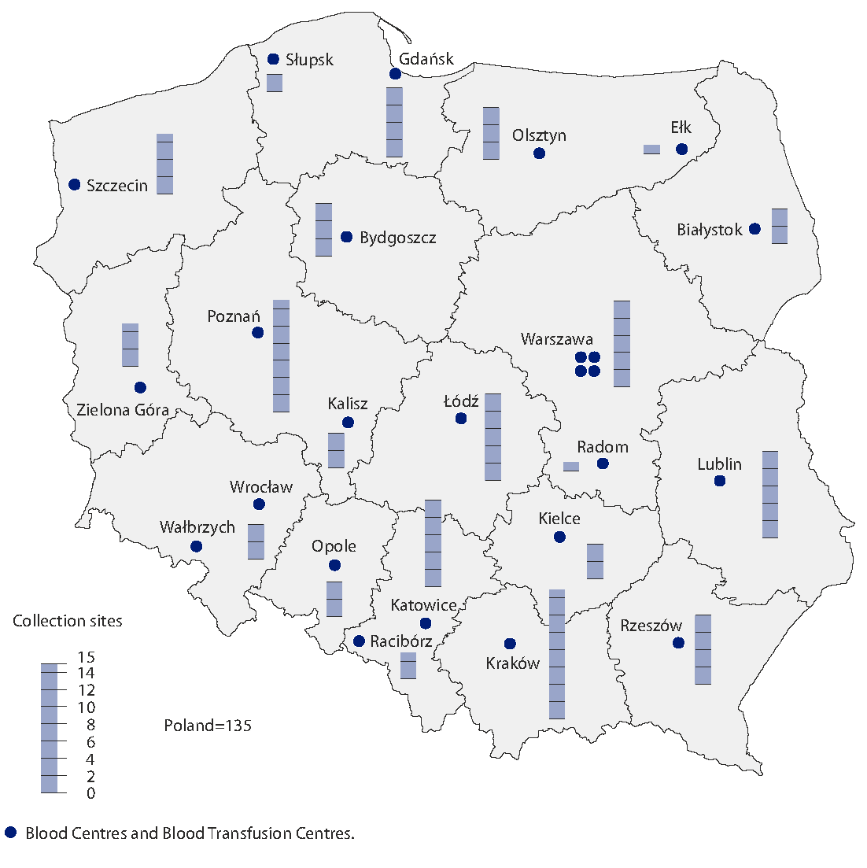
Map 2. Blood Donation and Blood Transfusion Centres and collection sites in 2022
As of 31 December

The number of units of fresh-frozen plasma (FFP) produced from COVID-19 convalescents, compared to 2021, remained at a similar level, i.e. 1 538.7 thousand in 2022
and 1 514.0 thousand a year before. The main impact on the situation was the significant persisting demand for plasma from convalescents, i.e. people who had been sick
with COVID-19 or infected with SARS-CoV-2 and were considered healthy. The collected plasma with anti-SARS-CoV-2 antibodies, as in the previous year, was used in the treatment of COVID-19 patients.

Prepared by:  Social Surveys and Labour Market Department  Director Piotr Łysoń, Ph.D.  Phone: (+48 22) 449 40 27 | Issued by:  The Spokesperson for the President  of Statistics Poland  Karolina Banaszek  Phone: (+48) 695 255 011
Press Office  Phone: (+48 22) 608 38 04  e-mail: obslugaprasowa@stat.gov.pl |   stat.gov.pl/en/

@StatPoland

@GlownyUrzadStatystyczny

gus_stat

glownyurzadstatystycznygus

glownyurzadstatystyczny
Related information
Health and health care in 2021
Methodological report. Health and health care statistics − Statistics Poland’s reports
Terms used in official statistics
The Blood Donation Centers
Donation
Organisational units of public blood service
Blood donor
Blood donation
Fresh frozen plasma

Approximately 450 ml of whole blood is collected at a time.
According to the information obtained at the National Blood Centre, in the case of multiple permanent donors, this is the number of donors who regularly donate blood and its components, and in the case of multiple repeated donors it is the number of donors who volunteered to donate blood/its components after 24 months since the last donation.
A total of 21 600 blood donors were registered in the blood donation centres under the Ministry of National Defence and the Ministry of Interior and Administration, and 38 114 whole blood donations were obtained, which accounted for 3.5% of all blood donors and 2.9% of all whole blood donations, respectively.

