Labour cost index in the quarters of 2022
In the fourth quarter of 2022, the labour cost index increased by 0.2% compared to the third quarter of the same year, and compared to the fourth quarter of 2021, it increased by 11.6%.
8.2%
Increase in the labour cost index in the fourth quarter of 2022
in relation to the first quarter
of 2022

Labour cost index
Labour costs are expenses incurred by the employer related to the employment of employees. They consist of wages and salaries, social security contributions and taxes paid by the employer, decreased by subsidies received.
Labour cost index is a Euro indicator, one of the European Economic Indicators (PEEI), which describes the current macroeconomic situation of the European Union
The Labour cost index (LCI) shows the development of labour costs incurred by the employer. It is a quarterly index that includes total labour costs per hour worked in PKD/NACE sections from B to S. It can be published in three forms: as a nominal value, a change in relation to the previous period or a change in relation to the corresponding period of the previous year. From a technical point of view, this is the Laspeyres index of hourly labour costs recorded in the reference quarter in relation to hourly costs in the base year. The base year is revised in 4-year cycle. The basis for determining the index in 2022 was 2016. Due to the impact of calendar effects and seasonal fluctuations on employment and time worked, the LCI indicators are subject to the procedure of working days compensation and seasonal adjustments.
$$Labour cost index =\frac{ \frac{labour cost in the current period}{number of hours worked in the current period} }{\frac{labour cost in the base period}{number of hours worked in the base period}} ∙100$$
In 2022, the number of hours worked and labour costs increased in Poland. In the fourth quarter of 2022, the number of hours worked was 2.3% higher than a year earlier, and labour costs in the same period increased by 14.2%. Between the first and fourth quarter of 2022, the labour cost index increased by 8.3%. The lowest values of LCI were achieved in the second quarter of the year under review, while in the third and fourth quarters the values of the index were about 9% higher than in the second quarter.

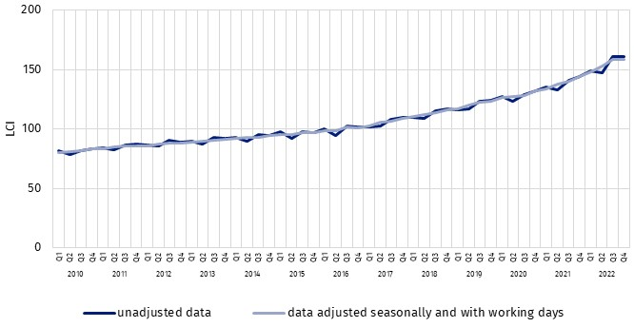
Chart 1. Labour cost index (data unadjusted and adjusted seasonally and with working days)
In the fourth quarter of 2022 the increase of LCI was recorded in almost all kinds of activities – with the exception of financial and insurance activities, in which the index was 4.0% lower than in the first quarter of this year.

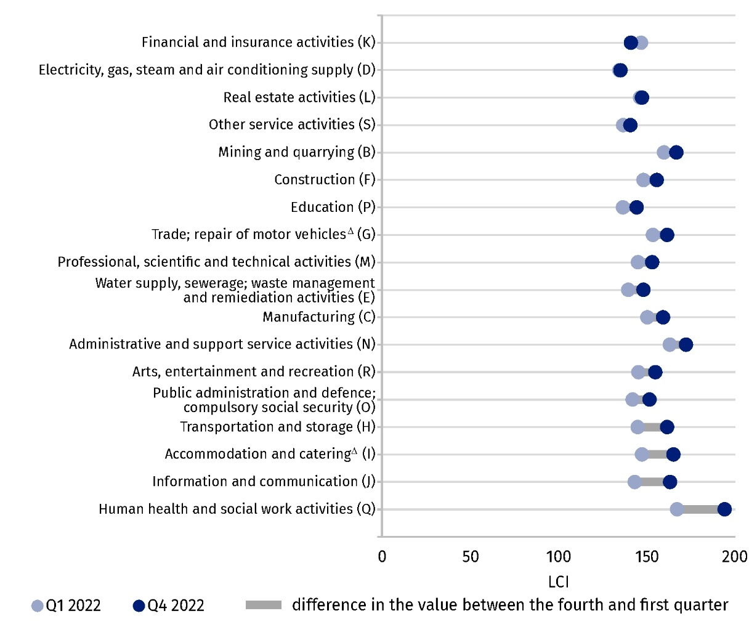
Chart 2. Labour cost index by PKD/NACE ª sections in the first and fourth quarters of 2022
(data adjusted seasonally and with working days)
a PKD/NACE sections sorted by the difference in the value of LCI between the fourth and first quarter of 2022
In the remaining sections, the increase in LCI ranged from 0.6% in the Electricity, gas, steam and air conditioning supply section to 16.2% in the Human health and social work activities section.

Poland compared to the European Union
The survey of labour costs in Poland and European Union countries, carried out on the basis of methodological arrangements resulting from international implementing regulations, enables the comparison of LCI.
In the fourth quarter of 2022. Poland was among the European Union countries with the highest values of the Labour cost index

Table 1. Labour cost index for Poland and groups of European countries in the quarters
of 2022 (data adjusted seasonally and with working days)
AGREGACJA  TERYTORIALNA | Q1 | Q2 | Q3 | Q4
POLAND | 148.6 | 153.2 | 158.5 | 158.6
European Union  countries (27 counties) | 117.2 | 117.6 | 118.6 | 121.9
Euro area countries  (19 countries) | 115.1 | 115.2 | 116.1 | 119.6
Source of data: Eurostat
Data for 2022 show that in the fourth quarter the labour cost index in Poland was about 30% higher than the average for the entire EU. In Western and Northern European countries LCIs were lower than in Poland (the lowest value of the index was recorded in Finland – 110.0), and higher the EU countries located east and south-east of Poland (the lowest index occurred in Romania – 202.3).

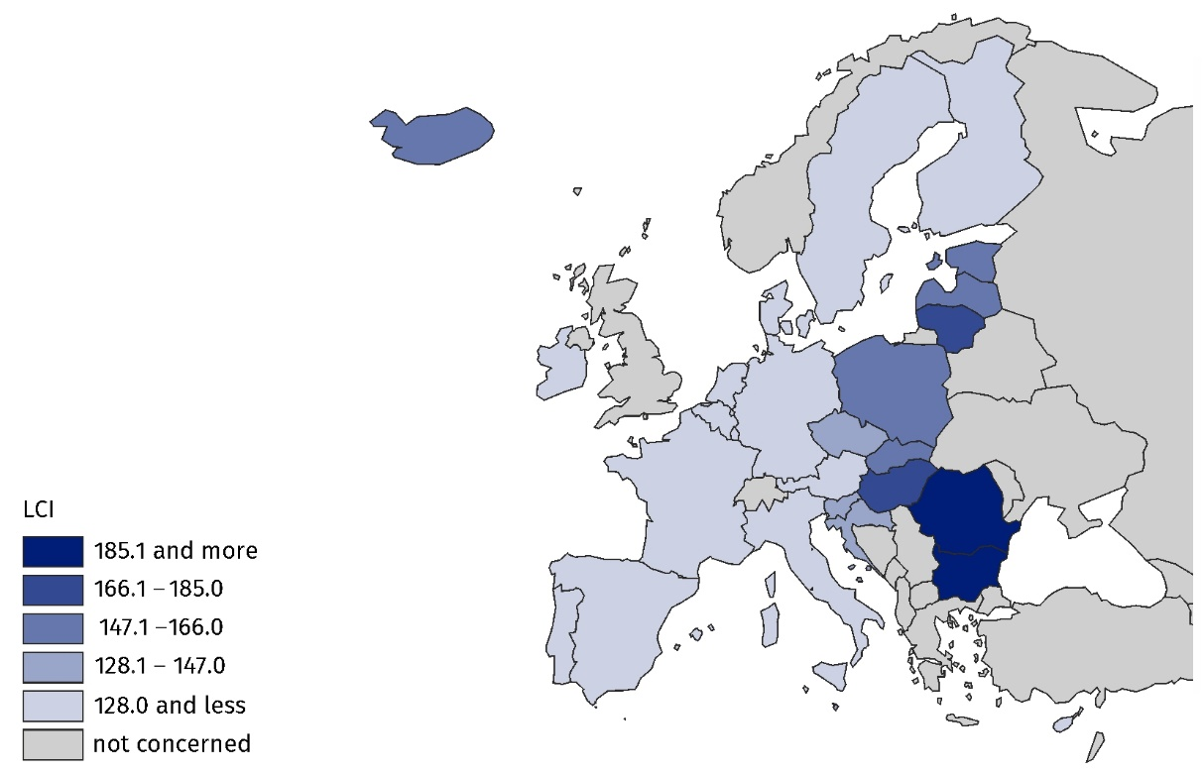
Map 1. Labour cost index for the European countries in the fourth quarter of 2022
(data adjusted seasonally and with working days)
Source of data: Eurostat
Taking into account the distribution of the labour cost index by kinds of activity, it can be noted that, compared to the European Union, the values of quarterly LCI in Poland are much higher and more diversified.

Chart 3. Labour cost index by PKD/NACE sections in the fourth quarter of 2022 for Poland
and the European Union (27 countries) (data adjusted seasonally and with working days)
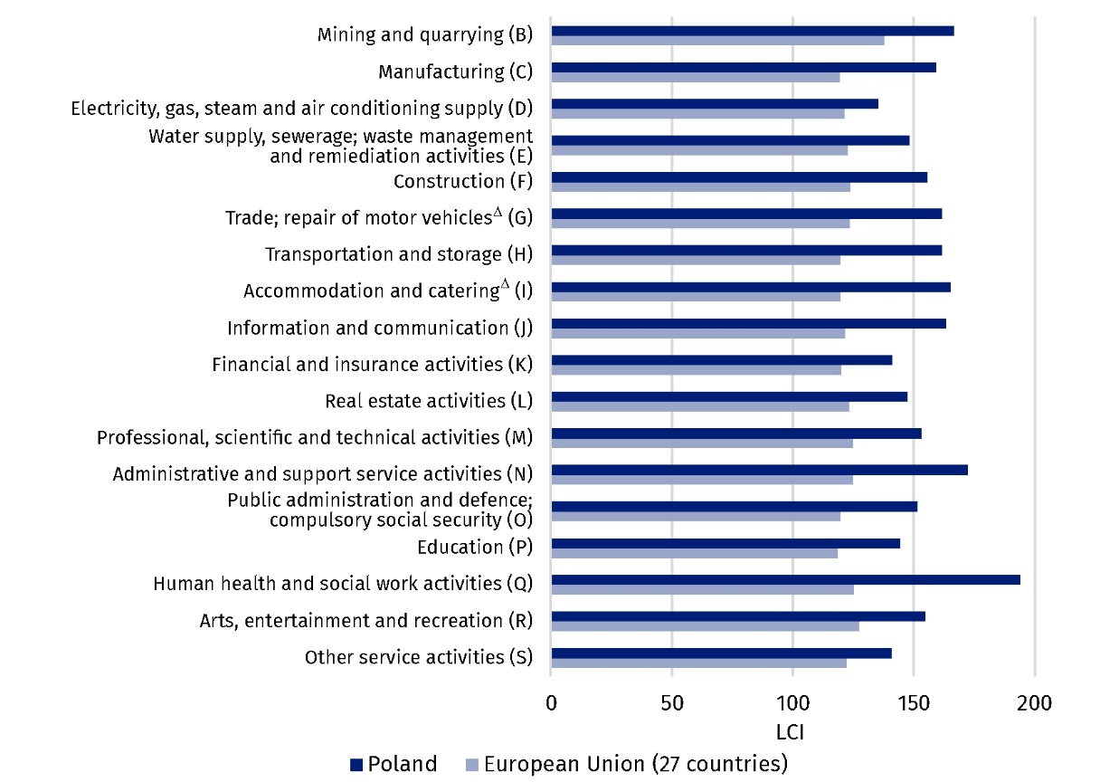Source of data: Eurostat
In the fourth quarter of 2022, the highest labour cost index in the EU was recorded in the Mining and Quarrying section, whereas in Poland – in the Human health and social work activities section. The lowest values of the index in the EU were observed in Education, and in Poland in Electricity, gas, steam and air conditioning supply. The largest difference in the value of the labour cost index between Poland and the European Union occurred in the Human health and social work activities section – in Poland amounted to 194.0, and in the EU 125.1.
In this news release abbreviated names of NACE, Rev. 2 sections were used. Abbreviations are marked with a ‘Δ’ symbol. Full names are available on the Eurostat website at: https://ec.europa.eu/eurostat/data/classifications
In the case of quoting Statistics Poland data, please provide information: "Source of data: Statistics Poland", and in the case of publishing calculations made on data published by Statistics Poland, please provide information: "Own elaboration based on Statistics Poland data.".

Prepared by:  Statistical Office in Bydgoszcz  Director Wiesława Gierańczyk, Ph.D.  Phone: (+48 52) 366 93 90 | Issued by:  The Spokesperson for the President  of Statistics Poland  Karolina Banaszek  Phone: (+48) 695 255 011
Press Office  Phone: (+48 22) 608 38 04  e-mail: obslugaprasowa@stat.gov.pl |   stat.gov.pl/en/

@GUS_STAT

@GlownyUrzadStatystyczny

gus_stat

glownyurzadstatystycznygus

glownyurzadstatystyczny
Data available in databases
Eurostat Database – Labour market
Terms used in official statistics
Labour cost index
Time worked
Labour costs

