The situation of households in 2023 on the basis of results of the Household Budget Survey
In 2023, the income situation of households improved. Average monthly income increased both in nominal and in real terms, and average monthly expenditure, despite nominal growth, decreased in real terms
In 2023 the financial situation of households improved. Households achieved in nominal terms both higher income and expenditure. The level of average monthly available income per capita in 2023 rounded to 1 PLN, amounted to PLN 2678 and was higher by 13.7% in nominal terms, and by 2.1% in real terms than the income in 2022. The average monthly expenditure per capita in households in 2023 reached the value of PLN 1636 and was higher by 9.4% in nominal terms, and lower by 1.8% in real terms than expenditure in 2022. Expenditure on consumer goods and services amounted to PLN 1580 and was higher by 9.8% in nominal terms, and lower by 1.5% in real terms in comparison with 2022. The share of expenditure in available income decreased from 63.5% in 2022 to 61.1% in 2023, and reached the lowest in the period since 2010 level.
2.1%
The increase of the average monthly available income per capita in households in 2023 – in real terms

Income and expenditure
Households of self-employed outside farming had the highest average monthly available income per capita – PLN 3313, as well as average monthly expenditure per capita – PLN 1862
In 2023, there was still a relatively large diversity in average monthly income and expenditure between various socio-economic groups of households. Similarly to the previous years, the highest average monthly available income per capita in households (rounded to 1 PLN – PLN 3313) and average monthly expenditure per capita (rounded to 1 PLN – PLN 1862) were recorded in households of self-employed outside farming. In this group of households – in comparison with the average for the total of households in Poland – both income and expenditure were higher by 23.7% and 13.8% respectively (in 2022, by 16.6% and 13.3% respectively).
Similarly to the previous years, households of pensioners had the lowest average monthly available income per capita in 2023. Their average monthly available income per capita amounted to PLN 2162, and was by 19.3% lower than average for households in total (in 2022 lower by 22.7%). The lowest average monthly expenditure per capita was noted in the households of farmers (PLN 1245) and it was by 23.9% lower than average for households in total (in 2022 – lower by 21.1%).

The highest share of expenditure in available income was observed in households of pensioners and the lowest in households of farmers

As in previous years, the highest share of expenditure in income (74.8%) and the lowest amount of average monthly excess of available income per capita over expenditure per capita
(PLN 545) was recorded in the households of pensioners. The lowest share of expenditure in income (50.9%) similarly to the previous year had the households of farmers, while the highest average excess of income over expenditure (PLN 1451) was noted in the households of self-employed.
In comparison with the previous year the share of expenditure in income for total households decreased by 2.4 percentage points to 61.1%, which indicates a higher possibility of accumulating savings in comparison with the previous year. The share of average monthly expenditure in average monthly income decreased in all socio-economic groups, except the households of farmers, where it increased by slightly over 1 percentage point.
The difference between average monthly available income indicator among socio-economic groups increased to 43.0 percentage points (in 2022 – 39.3 percentage points), while the difference between average monthly expenditure indicator in these groups increased to 37.7 percentage points (in 2022 – 34.4 percentage points).

In 2023, there was a growth in average monthly available income per capita in real terms in total – by 2.1%. Growth in real terms occurred in almost all socio-economic groups of households, among which the highest was recorded in the households of self-employed (by 8.4%). Decline in average monthly available income per capita in real terms was noted only in the households of farmers (by 5.9%).
Similarly to 2022, the highest share of income from the main source of income occurred in the households of retirees (81.6% against 81.5% in 2022) and the lowest in the households of farmers (66.3% against 67.6% in 2022).
In the structure of the households’ total income, similarly to the previous years, income from hired work (55.7% against 56.1% in 2022) as well as income from social security benefits (24.4% against 23.6 in 2022) dominated.
In 2023, in comparison with 2022, differences in the structure of the average monthly available income per capita in households ranged from -0.6 percentage points in the case of income from other social benefits to +0.8 percentage points for income from social security benefits.

The diversity of income per capita in households, measured by the Gini coefficient, after a period of decline in 2014-2017 and temporary stabilisation, increased in 2020 and 2021, and in 2022-2023 remained at the level of 0.314, almost equal to the value from 2020. Indices of the Gini coefficient for urban areas was very similar to the average noted in the country, although at a lower level of its value. In the case of rural areas, after 3 years of the upward trend, the Gini coefficient decreased in 2023 to the level of 0.311, which also constituted value almost equal to the value from 2020.

Recorded in the years 2014-2017 significant decline in disparity in income per capita in households, measured by the Gini coefficient, in 2018 and 2019 was stopped. In 2020 and 2021, it increased, and in 2022-2023 remained at the level equal to the level from 2020
The percentage of households with income below PLN 2000 per capita decreased to 29.3% (by 9.2 percentage points) and the percentage of households with income above PLN 6000 per capita increased to 5.5% (by 1.6 percentage points)
In 2023, 29.3% of households had an average monthly available income per capita below PLN 2000 (38.5% in 2022), 51.3% of households had an income between PLN 2000 and PLN 4000 per capita (48.7% in 2022), 13.9% of households had an income from PLN 4000 to PLN 6000 per capita (8.9% in 2022), and PLN 6000 or more per capita had 5.5% of households (3.9% in 2022). In 2023, the percentage of households with an average monthly income of at least PLN 2000 per capita amounted to 70.7% (in 2022 – 61.5%).
In 2023, in comparison with the previous year, in real terms the average monthly expenditure per capita decreased by 1.8%. There was a real decrease in average monthly expenditure per capita in comparison with 2022 in almost all socio-economic groups of households, and the biggest in the group of farmers (decrease by 3.9%), pensioners (by 3.7%) and employees (by 2.6%). Average monthly expenditure per capita in households of retirees in real terms did not change.
In real terms – the average monthly expenditure per capita in households in 2023 decreased by 1.8% in comparison with the previous year

Expenditure on food and non-alcoholic beverages, similarly to the previous years, had the highest share in the structure of expenditure for households in total – 27.2% (slightly higher in comparison with the previous year – by 0.4 percentage points). In individual socio-economic groups it ranged from 23.5% in households of self-employed outside farming to 31.9% in households of farmers.
Another important item in households expenditure was expenditure on housing, water, electricity, gas and other fuels. Its share in total expenditure was on average 19.9% and in 2023 increased by 0.4 percentage points in comparison with the previous year. Among the socio-economic groups, the lowest share of expenditure on housing, water, electricity, gas and other fuels was recorded in the households of farmers (16.9%) and the highest in the households of pensioners (24.6%).

In the case of the main groups of consumer goods and services, between 2022 and 2023, changes in the share in expenditure structure for households in total ranged from -0.7 percentage points (transport) to +0.5 percentage points (restaurants and hotels).

The average monthly available income per capita in the group of the 20% of persons with the highest income (5th quintile group) amounted to PLN 5269, and it was 6.4 times higher (in 2022 – 6.6 times higher and amounted to PLN 4681) than the respective income of the 20% of persons with the lowest income (1st quintile group).
In the households of 20% of persons in the most favourable financial situation was accumulated 39.3% of income of entire surveyed population of households, while in the households of 20% of the persons in the worst situation
– 6.2%
In the households of 20% of persons in the most favourable income situation, there was accumulated 39.3% of income of entire surveyed population of households (in 2022 – 39.7%), while in the households of 20% of persons in the worst income situation – 6.2% (in 2022
– 6.0%).

The average monthly expenditure per capita in the 5th quintile group were 2.1 times higher than in the 1st quintile group (in 2022 – also 2.1 times higher). The share of expenditure in available income in the highest quintile group amounted to 48.7% (in 2022 – 50.4%), and in the lowest – 146.2% (in 2022 – 157.4%), which means that the poorest households to a significant extent were forced to use their savings, or loans, or credits.

The average monthly available income per capita in urban households was by 26.6% higher than in rural households
The average monthly expenditure per capita in urban households was by 29.5% higher than in rural households

The place of residence is another factor that substantially diversified dynamics and structure of income and expenditure of households.
The average monthly available income per capita in urban households was by 26.6% higher than in rural households (in 2022 by 24.9%), which resulted from the amount of income obtained by households, but were also connected with the larger number of persons living in rural households. Similar situation was observed in the case of expenditure of households. Average monthly expenditure per capita in urban households was by 29.5% higher than in rural households (in 2022 by 27.6%).
In territorial terms average monthly available income per capita higher than the national average by at least 1% appeared in voivodships: Mazowieckie, Śląskie, Zachodniopomorskie, Małopolskie, Lubuskie and Dolnośląskie. As in the previous year, definitely the highest average monthly income per capita was in households in Mazowieckie Voivodship – PLN 3209 (in 2022 – PLN 2807). The income in Mazowieckie Voivodship was higher than the average monthly income per capita for the country by 19.8% (higher than national average by 34.8% in Warsaw Capital Region and lower by 0.7% in the remaining part of Mazowieckie Voivodship). The lowest average monthly available income per capita obtained households in Podkarpackie Voivodship (PLN 2281 in comparison with PLN 1930 in 2022) – by 14.8% below the national average. The next voivodships with the lowest level of average monthly income per capita were voivodships: Pomorskie (lower than national average by 14.4%), Świętokrzyskie (lower by 9.7%), Warmińsko-Mazurskie (lower by 9.3%) and Lubuskie (lower by 8.1%).
The difference between the highest and the lowest average monthly income per capita in voivodships in relation to the national average compared with the previous year decreased by 2.6 percentage points and amounted to 34.6 percentage points (for 15 voivodships excluding Opolskie Voivodship, for which in the 2023 survey there were received too few answers regarding income to provide the value of an average monthly available income per capita in households and the income index for this voivodship).

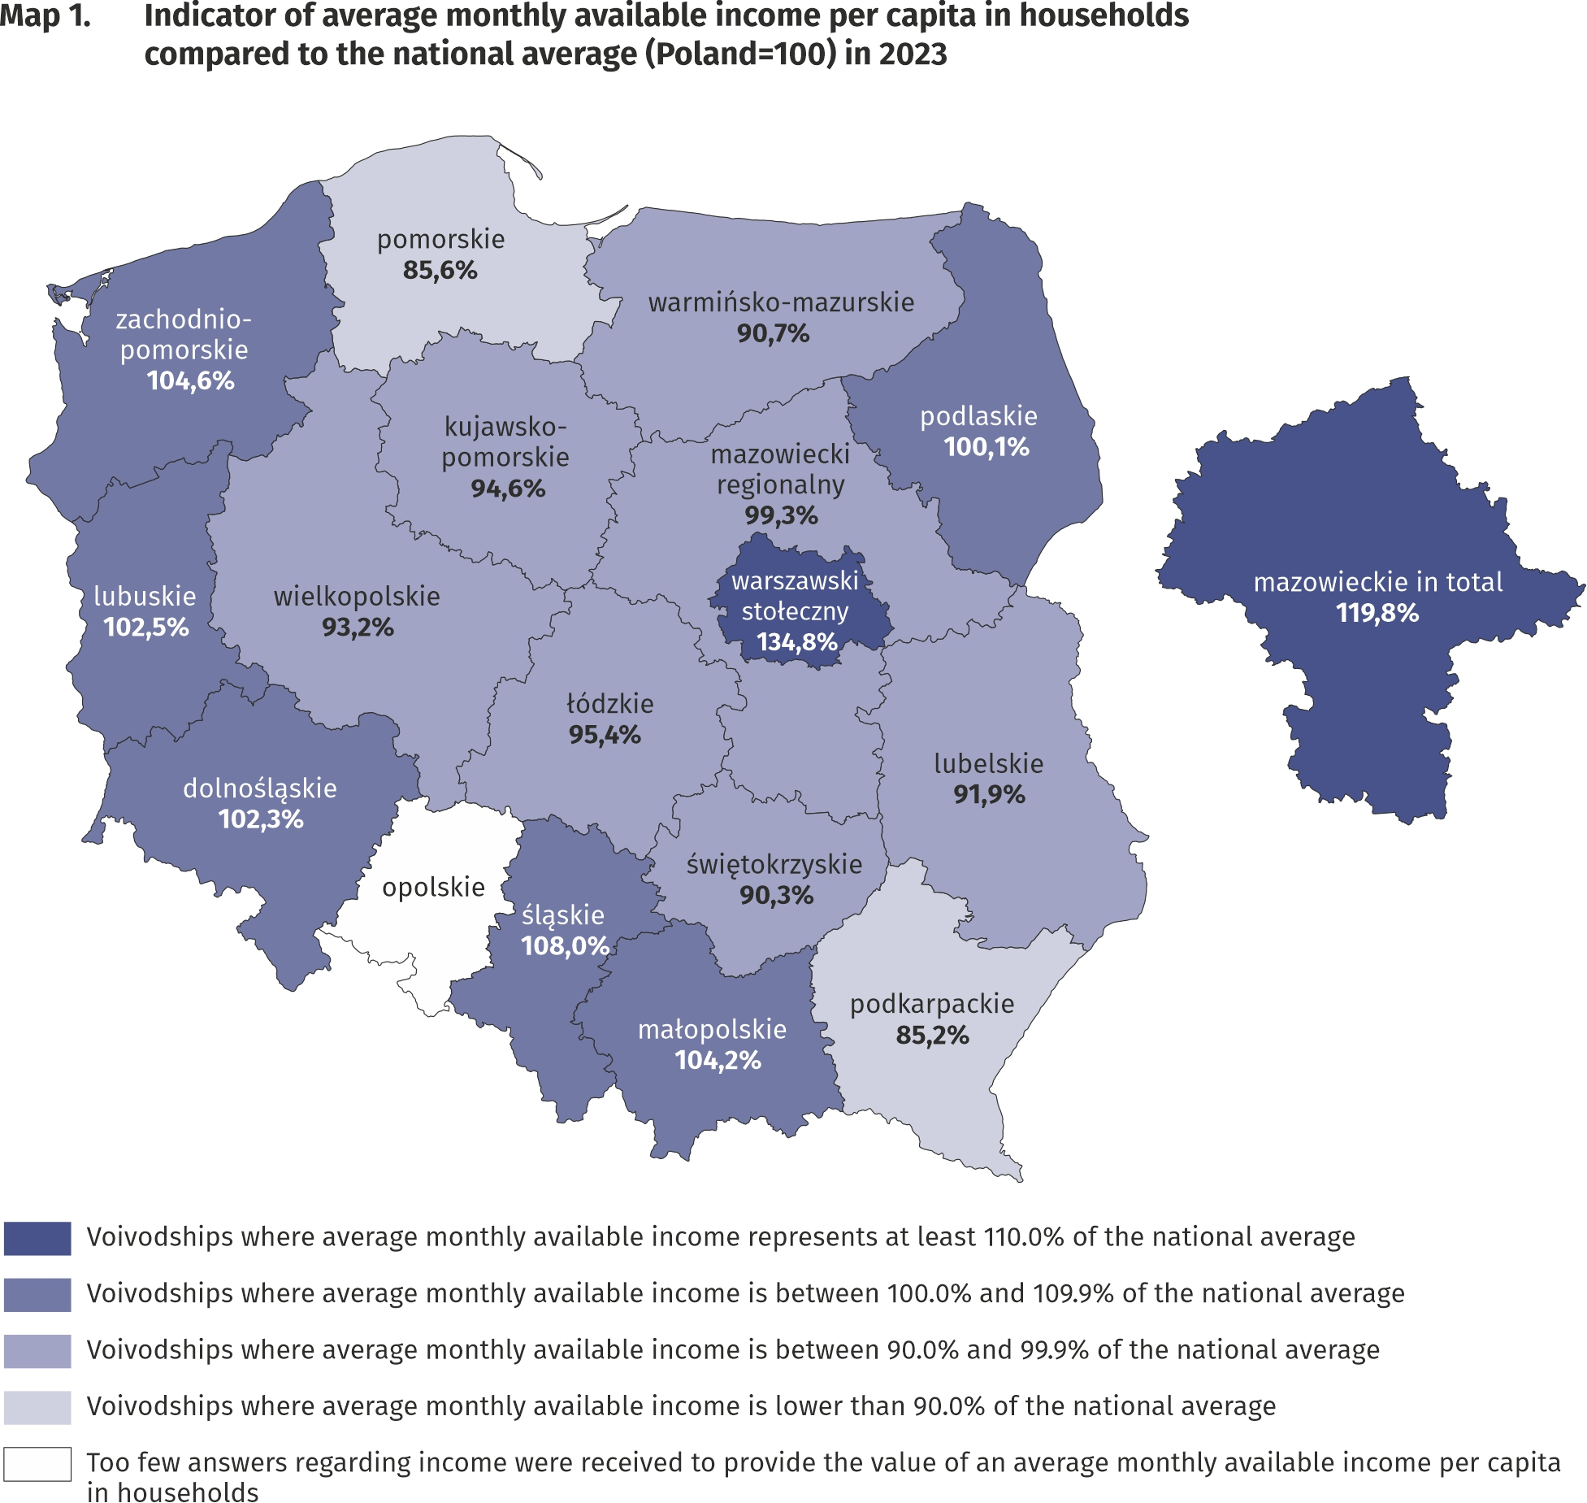
The highest average monthly available income per capita had households in
Mazowieckie Voivodship – PLN 3209 and the lowest
– households living in
Podkarpackie Voivodship –PLN 2281

In the case of expenditure, average monthly values above average for Poland in 2023 were recorded in voivodships: Mazowieckie, Dolnośląskie, Pomorskie, Łódzkie, Śląskie and Opolskie. The highest average monthly expenditure per capita was noted in Dolnośląskie and Mazowieckie Voivodships – PLN 1849 each (in 2022 – PLN 1654 and PLN 1682 respectively), and they were higher than the national average by 13.0% (higher than the average for Poland by 27.5% in Warsaw Capital Region and lower by 6.8% in the remaining part of Mazowieckie Voivodship). Similarly, in Dolnośląskie Voivodship, average monthly expenditure per capita amounted to PLN 1849 and were 13.0% higher than the national average. The lowest average monthly expenditure per capita occurred in Podkarpackie Voivodship (PLN 1320 in comparison with PLN 1184 in 2022) and with respect to the average for the whole country was lower by 19.3%, subsequently in Podlaskie Voivodship (lower by 19.1%), Warmińsko-Mazurskie (lower by 18.1%), Małopolskie Voivodship (lower by 12.3%) as well as Świętokrzyskie Voivodship (lower by 10.9%).
The difference between the highest and the lowest average monthly expenditure per capita in voivodships decreased by 1.0 percentage points in comparison with 2022 year and amounted to 32.3 percentage points.

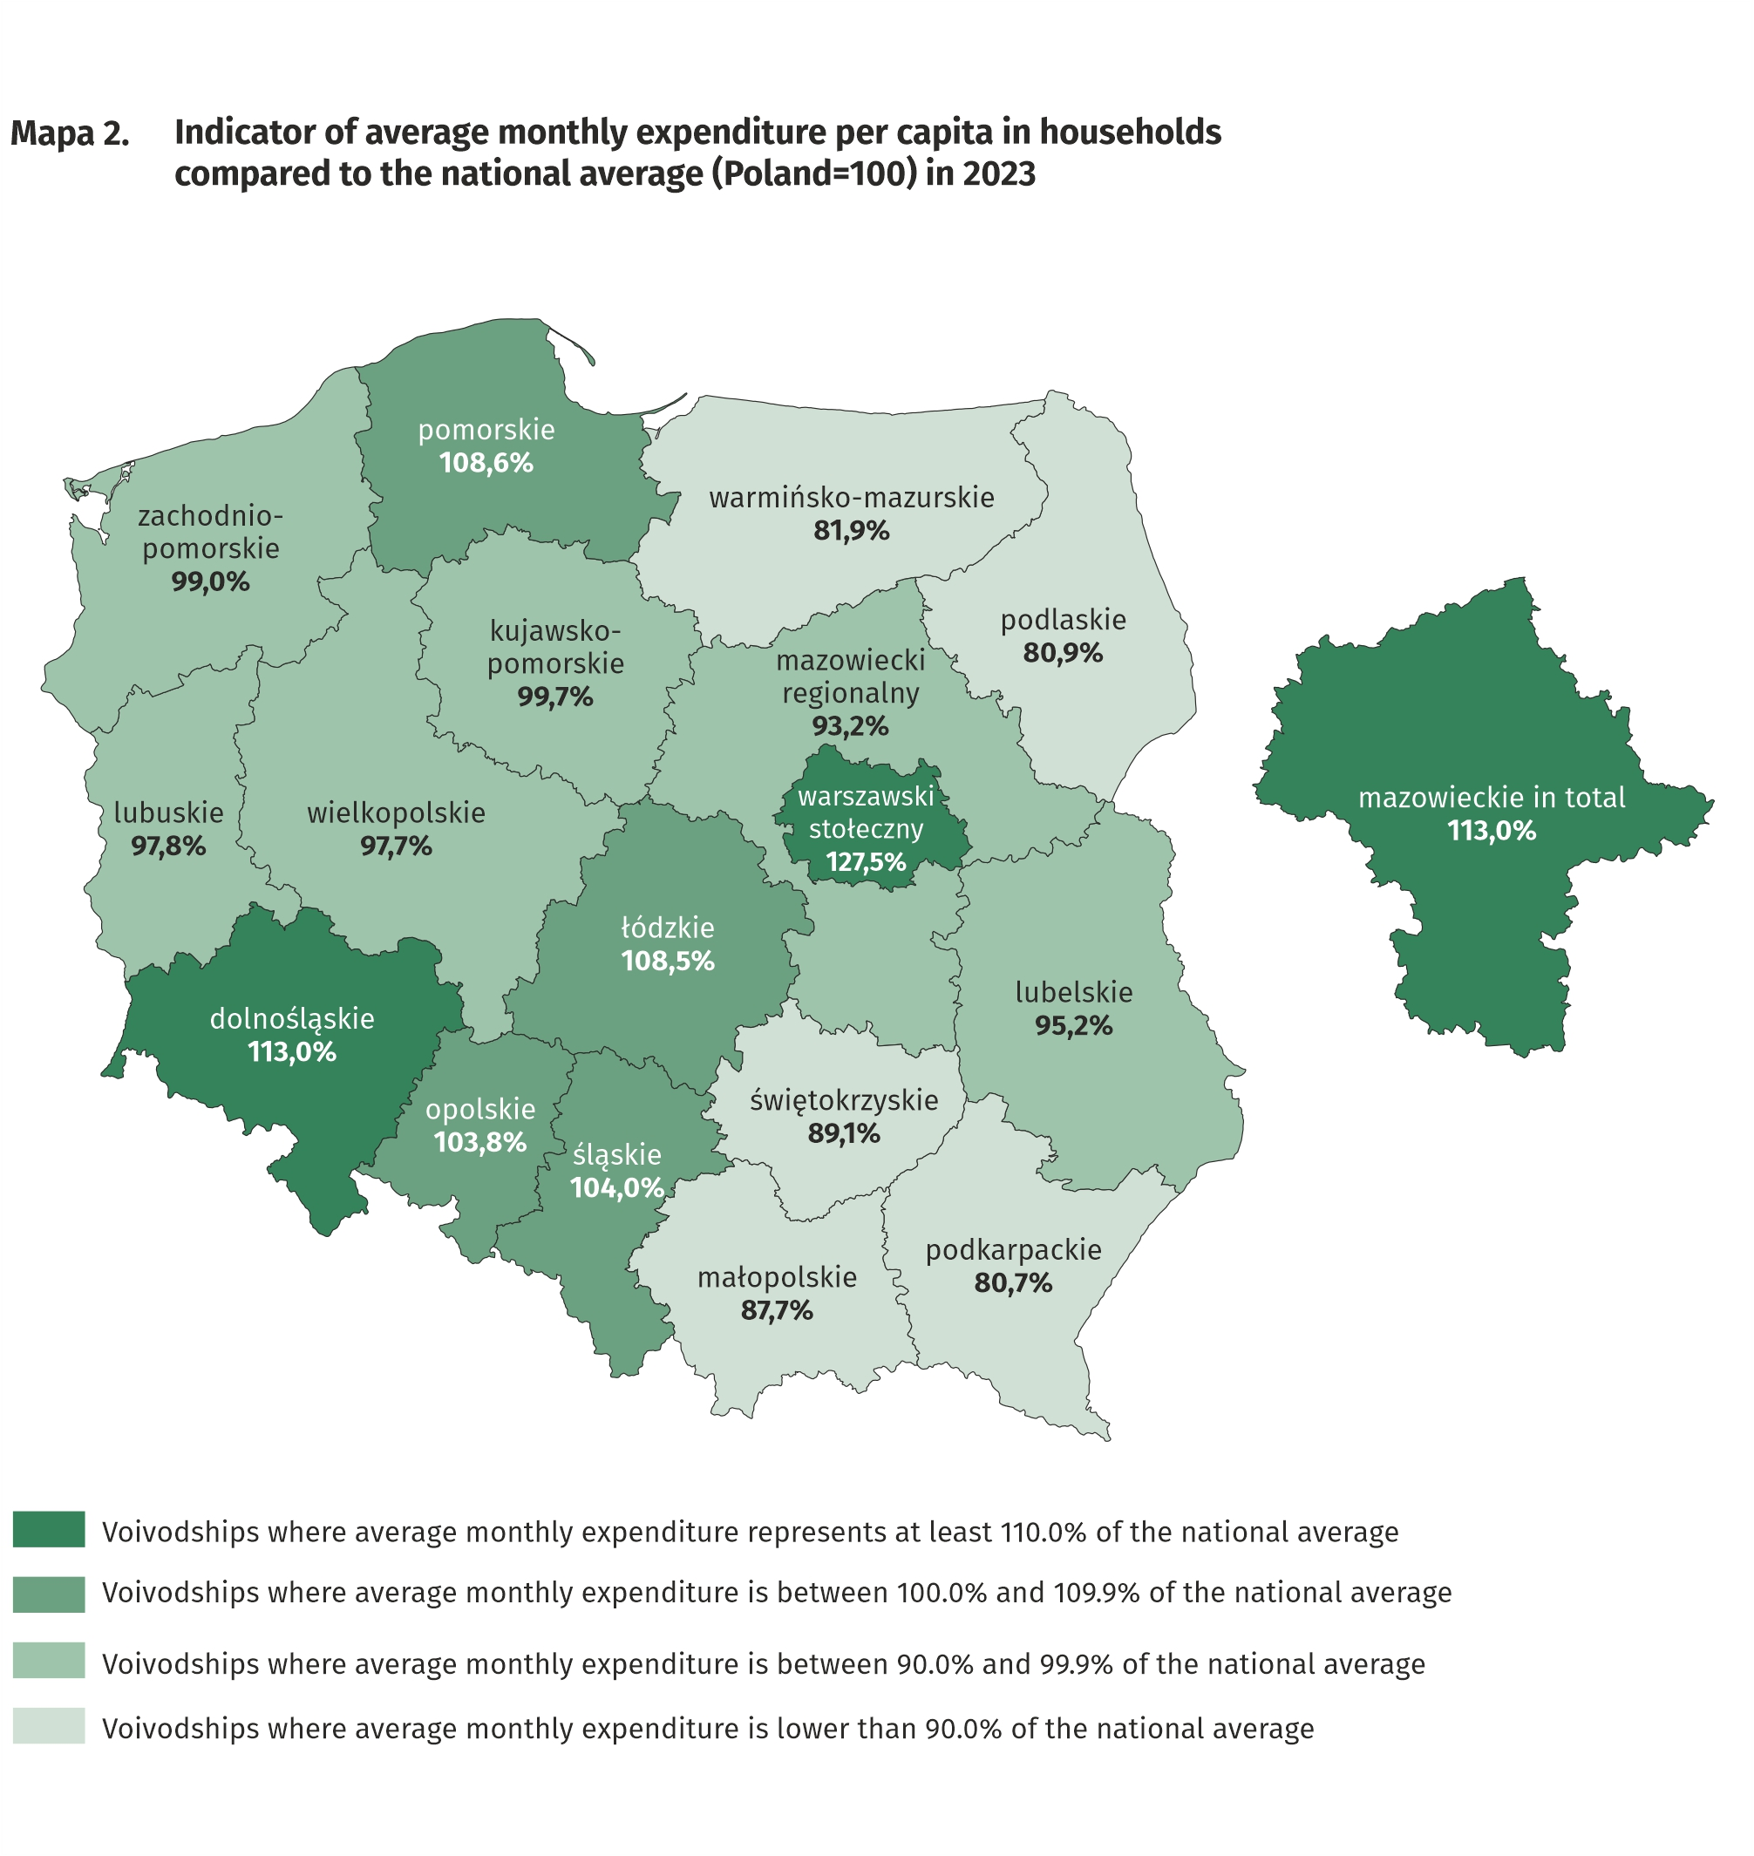
The highest average monthly expenditure per capita in households occurred in voivodships: Dolnośląskie and Mazowieckie – PLN 1849 each and the lowest – in Podkarpackie Voivodship – PLN 1320

Quantitative food consumption
In 2023, there was a decrease in consumption of the most basic foodstuffs, and particularly sugar, margarine and vegetable fats as well as pasta and pasta products
In 2023, there was a decrease in consumption of the majority of basic foodstuffs. The highest decline was recorded in: sugar (by 12.5%), margarine and vegetable fats (by 12.0%) as well as pasta and pasta products (by 9.3%). The highest increase was noted in the case of cheese and curd (by 5.2%), apples (by 4.7%) and yogurt (by 3.4%). The decrease in the level of food consumption might be influenced by a 15.9% increase in expenditure on gastronomy in comparison to 2022 and an increase in the prices of food and non-alcoholic beverages.
The level of consumption of foodstuffs greatly depends on household income. As the wealth of households increases, so does the level of consumption of certain foodstuffs, such as bread and cereals, meat, vegetables, fruit, cheese and curd, sugar as well as mineral and spring waters.

The level of food consumption is also affected by dietary habits, prices of foodstuffs and a place of residence. Households in rural areas compared with households in urban areas are characterised by a slightly different model of nutrition. In the rural areas there was, among others, a higher consumption of bread and cereals, meat, potatoes and sugar, while in urban areas – vegetables (except potatoes), fruit, cheese and curd as well as mineral and spring waters.
Negative phenomenon, both in urban and rural areas, is a decrease in the value of monthly consumption per capita of vegetables (by 0.5 and 0.6 kg respectively).

The equipment of households with durable goods
In 2023, there was an increase in the number of households equipped with durable goods, and the highest in the case of game console, equipment for reception, recording and reproduction of sound as well as motorcycle, scooter, motorbike
In 2023, an increase in the number of households equipped with durable goods was noted. The highest growth occurred in the case of a game console (by 26.8%), equipment for reception, recording and reproduction of sound (by 13.9%) as well as motorcycle, scooter, motorbike (by 13.3%), however, the decrease occurred in the case of bicycle (by 0.9%). In the case of such goods as: access to the Internet, smartphone, TV set, dishwasher, passenger car differences in the degree of the households equipment between 2022 and 2023 were less significant and ranged from -0.6 percentage points to +5.8 percentage points.
The level of household equipment with durable goods largely depends on their financial situation.
The richest households (5th quintile group) were better equipped with durable goods than the poorest households (1st quintile group). It should be emphasised, however, that the differences in the degree of equipment between 5th and 1st quintile groups decreased in comparison with 2022, the most in the case of passenger car – by 2.6 percentage points with a decline in the percentage of households with car in the 5th quintile group. However, there was an increase in the difference between these extreme quintile groups in the degree of equipment with a dishwasher compared with the previous year – by 2.4 percentage points.

In terms of equipping with new generation goods, such as access to the Internet and smartphone, there was a slight difference between households in urban and rural areas. In the case of equipment with a smartphone, the difference was 0.4 percentage points in favour of urban areas, while the level of equipping with the access to the Internet (e.g. on a computer, smartphone) was at the same level. A significantly higher percentage of rural than urban households owned a bicycle (by 26.6 percentage points), a passenger car (by 18.4 percentage points) or a motorcycle, scooter, motorbike (by 7.3 percentage points). In comparison with 2022, there was not a significant change of the difference in the level of equipment with new generation devices between households in urban and rural areas.

In rural areas there was a higher percentage of households owning dishwasher, bicycle, passenger car, motorcycle, scooters, motorbikes as well as TV set

Dwelling conditions
In 2023, the dwelling conditions of households improved slightly. The average household occupied a dwelling with a floor area of 88.2 m², which consisted of 3 rooms. The systematic increase in the average size of a dwelling has continued since 2013

The average household in 2023 occupied a dwelling with a floor area of 88.2 m² (in 2022 – 86.6 m²), which consisted of 3 rooms. There was an average of 30.9 m² of usable floor area and 1 room per capita in the household (in 2022 – 30.3 m² and 1 room).
The largest average usable floor area of dwellings was held by households of farmers
– 144.1 m², while the smallest by households of pensioners – 71.6 m². In comparison with 2022, the highest increase in the average floor area of the dwellings occupied by households occurred in the households of farmers (by 4.5 m²), while the lowest increase – in households of employees (by 1.4 m²).
The largest average usable floor area per capita was in the households of pensioners (41.8 m²) and retirees (39.0 m²), which is related to a smaller number of persons in the household, while the smallest usable floor area per capita – in the households of employees (27.5 m²).
The area of dwellings occupied by households was also differentiated according to the level of their income. In the case of the households with the highest income (5th quintile group) average occupied area was smaller (83.9 m²) than households with the lowest income (1st quintile group) – 90.1 m². However, members of households with the highest income (5th quintile group) had much greater floor area per capita (40.0 m²) than households with the lowest income (24.7 m²).
The equipment of dwellings with technical and sanitary installations is systematically improving. Dwellings equipped with running water accounted for 99.9% of all households, with sewage system and a flushing toilet – 99.2% each, and with a bathroom – 99.0%.
As in the previous years, the best equipped with technical and sanitary installations (except gas and central heating) were the dwellings of self-employed outside farming, and the worst – households of pensioners.
Households in urban areas were slightly better equipped with sanitary and technical installations than households in rural areas, except equipping with gas, which is related to the refusal to equip new multi-family buildings with gas installations. Among households in rural areas, changes in comparison with 2022 took place in the case of equipment with gas from a cylinder – decrease by 2.6 percentage points.
Households in urban areas were slightly better equipped with sanitary and technical installations (except gas) than households in rural areas

There is clear relationship between household’s income and the equipment of dwellings in sanitary and technical installations, except gas, which was used by the richest households the least (5th quintile group). The most significant difference in this area between 1st and 5th quintile group in favour of the richest households concerned the equipment with central heating (by 5.3 percentage points), bathroom (by 2.3 percentage points) and flushing toilet (by 1.9 percentage points). These differences remain on similar to 2022 level.

A subjective evaluation of the financial situation of households
The subjective evaluation of the financial situation of households improved in all socio-economic groups; good or rather good assessments prevailed over bad or rather bad
The subjective evaluation of the financial situation of households in 2023 improved in all socio-economic groups, and in all these groups good or rather good assessments prevailed over bad or rather bad. In 2023, there was an increase in the percentage of households assessing their financial situation as good or rather good (54.0% of households in total compared with 50.6% in 2022) and the decrease in the percentage of households perceiving it as bad or rather bad (4.9% compared with 5.9% in 2022). Households of self-employed outside farming, similarly to the previous years, assessed their financial situation the most favourably (76.0% positive assessments compared with 71.2% in 2022), whereas households of pensioners assessed their situation the worst (23.9% positive assessments compared with 20.9% in 2022).

The subjective evaluation of the financial situation of households depends to a large extent on the place of residence of a household. Households in rural areas, similarly to the previous years, assessed their financial situation worse than urban residents, especially those from cities with a population of 500 thousand or more. Among households in cities with population 500 thousand or more the percentage of subjective evaluations good or rather good increased from 61.6% in 2022 to 65.1% in 2023. In households in rural areas, the corresponding percentage was at a much lower level, but also increased from 46.4% in 2022 to 51.4% in 2023.

Support granted by households to the inhabitants of Ukraine (in Poland and Ukraine)
In 2022 and 2023, households provided aid to inhabitants of covered by the war Ukraine (in Poland and Ukraine), although the scale of this assistance was systematically decreasing from 69.3% of households in total in the first quarter of 2022 to 9.3% in the fourth quarter of 2023
In 2023 households in Poland continued, although in the smaller scale, providing aid to inhabitants of Ukraine covered by the war, resulting from the Russian invasion. In individual quarters of 2022 and 2023, the scale of assistance provided by households to residents of Ukraine decreased from 69.3% in the first quarter of 2022 to 9.3% in the fourth quarter of 2023.

Among helping households, both in 2022 and 2023, the dominant forms of support were in-kind donations and financial support (directly or through organizations). It is also worth noting that households provided assistance to refugees from Ukraine in Poland in finding a job, taking care of everyday matters or caring for relatives.

The highest share of households granting support to Ukrainian inhabitants in all quarters of 2023 was among households of self-employed (from 26.3% in the first quarter to 11.9% in the fourth quarter) as well as in the households of employees (from 22.5% in the first quarter to 10.2% in the fourth quarter).

In the following quarters of 2023, among the households of self-employed was recorded the highest percentage of those providing support to residents of Ukraine (in Poland and Ukraine)

In the following quarters of 2023, households from 5th quintile group (covering 20% of the wealthiest persons) were the most engaged in the support to the inhabitants of Ukraine. In this quintile group the percentage of helping households ranged from 28.3% in the first quarter (in the same period of the previous year – 75.4%) to 12.3% in the fourth quarter (in the same period of the previous year – 32.5%).

Households declaring support to the inhabitants of Ukraine were numerous in all the classes of locality. In all quarters the highest percentage of households that provided assistance was in the cities with 500 thousand or more residents – from 31.7% in the first quarter (in the same period of the previous year – 73.6%) to 19.0% in the fourth quarter (in the same period of the previous year – 36.5%).

In all quarters of 2023, the highest percentage of households helping residents of Ukraine was in the cities with 500 thousand or more residents

It is worth of emphasizing, that in 2023 support granted to the inhabitants of Ukraine escaping from war to Poland or staying on the territory of covered by war Ukraine, despite the decline in the intensity of this assistance in the following quarters, was continued.

In case of quoting Statistics Poland data, please provide information: “Source of data: Statistics Poland”, and in case of publishing calculations made on data published by Statistics Poland, please include the following disclaimer: “Own study based on figures from Statistics Poland”.

Prepared by:  Social Surveys and Labour Market Department  Director  Piotr Łysoń PhD  Office: tel. (+ 48 22) 449 40 27,  (+ 48 22) 608 31 22 | Issued by:  Press Office  Mobile +48 695 255 032  Phone +48 22 608 38 04, +48 22 449 41 45,  +48 22 608 30 09  e-mail: obslugaprasowa@stat.gov.pl

stat.gov.pl/en/

@StatPoland

@GlownyUrzadStatystyczny

gus_stat

glownyurzadstatystycznygus

glownyurzadstatystyczny
Related information
Household Budget Survey in 2022
Support granted by households to the inhabitants of Ukraine in the first half of 2022 on the basis of results of the Household Budget Survey

Data available in databases
LOCAL DATA BANK private households
HBS - material conditions of population by socio-economic groups and household size
HBS - material conditions of population by class of locality
HBS - material conditions of population by voivodships

Terms used in official statistics
Household's budget
Disposable income
Household's available income
Private household
Net household's receipts
Net household's outgoings
Quantitative consumption of foodstuffs in households per person
Subjective evaluation of material situation
Housing conditions
Expenditures of a household
Household's equipment

Due to the introduction of a new classification of individual consumption by purpose in 2013, based on harmonized COICOP classification for all surveys of the European Statistical System, the results for 2010–2023 are presented in comparable conditions – each “expenditure” item from 2010–2012 was supplemented by the “life-insurance contributions” item.
The average monthly income indicator is equal to the quotient of the average monthly income per capita in the surveyed group by the average monthly income per capita for the whole Poland.
The average monthly expenditure indicator is equal to the quotient of the average monthly expenditure per capita in the surveyed group by the average monthly expenditure per capita for the whole Poland.
In 2023 the average number of persons in urban households was 2.56, while in rural households – 3.45.
The category of “new generation goods” includes: access to the Internet, smartphone, plasma or LCD TV set, dishwasher and passenger car.
This category includes access to the Internet, regardless of the type of Internet connection and the type of device (e.g. desktop computer, laptop, tablet, TV set, smartphone).
The average number of persons in 1st quintile group of households was 3.65, and in 5th quintile group – 2.10.
Concerns the provision of assistance due to warfare - regardless of its form and scope (covers both support provided in Poland and directed to persons remaining in Ukraine) at least once in the period from 24th February 2022 to the end of the first quarter or in the quarter, in which the household participated in the survey.

