Retail sales index – June 2024
In June 2024 retail sales at constant prices were by 4.4% higher than the year before (against a decrease of 4.7% in June 2023). Compared with May 2024, an increase by 0.3% in retail sales was recorded. In the period of January-June 2024 sales increased y/y by 4.9% (against a decrease by 5.7% in corresponding period of 2023).
4.4%
An increase compared with
the corresponding month of the previous year

Retail sales of goods by type of enterprise activity
In June 2024, an increase in retail sales y/y was recorded in most groups
In June 2024, a significant increase in retail sales (at constant prices) compared with the corresponding period of 2023 was recorded by entities from the following groups: “motor vehicles, motorcycles, parts” (by 24.3%), “others” (by 15.9%), “solid, liquid and gaseous fuels” (by 11.0%). Enterprises classified in the group with the largest share in retail sales “total” - “food, beverages and tobacco products” noted a drop by 4.0%.
In June 2024 compared with June 2023, a rise in retail sales value via Internet at current prices was recorded (by 11.8%). The share of sales via Internet in “total” sales increased in June 2024 compared with corresponding period of previous year from 7.7% to 8.2%. Among the presented groups with a significant share of sales via Internet an increase in share was reported by enterprises from the groups: “textiles, clothing, footwear” (from 16.9% a year ago to 21.6%), “furniture, radio, TV and household appliances” (from 14.4% to 17.2% respectively) and “newspapers, books, other sale in specialized stores” (from 21.2% to 21.4%).
Chart 1. Retail sales of goods (constant prices) – corresponding period of previous year=100
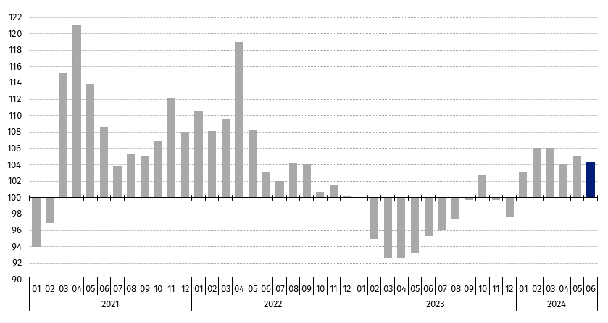

Table 1. Index numbers of retail sales (constant prices)
Specification
Specification | 06 2024 |  | 01-06 2024
Specification | 05 2024=100 | 06 2023=100 | 01-06 2023=100
TOTAL | 100.3 | 104.4 | 104.9
of which:
Motor vehicles, motorcycles, parts | 103.4 | 124.3 | 125.0
Solid, liquid and gaseous fuels | 101.5 | 111.0 | 112.3
Food, beverages and tobacco products | 98.9 | 96.0 | 99.2
Other retail sale in non-specialized stores | . | . | .
Pharmaceuticals, cosmetics, orthopaedic equipment | 97.1 | 105.4 | 107.0
Textiles, clothing, footwear | 98.5 | 80.7 | 85.3
Furniture, radio, TV and household appliances | 98.6 | 93.3 | 91.6
Newspapers, books, other sale in specialized stores | 96.8 | 102.1 | 101.3
Others | 93.9 | 115.9 | 122.9
(.) Data not available, classified data (statistical confidentiality) or providing data impossible or purposeless

Table 2. Index numbers and structure of retail sales (current prices)
Specification
Specification | 06 2024 |  | 01–06 2024
Specification | 05 2024=100 | 06 2023=100 | 01–06 2023=100 | Structure in %
TOTAL | 100.0 | 104.7 | 105.3 | 100.0
of which:
Motor vehicles, motorcycles, parts | 102.6 | 119.1 | 121.4 | 8.3
Solid, liquid and gaseous fuels | 99.5 | 108.4 | 105.1 | 13.9
Food, beverages and tobacco products | 99.5 | 98.6 | 101.9 | 25.4
Other retail sale in non-specialized stores | . | . | . | .
Pharmaceuticals, cosmetics, orthopaedic equipment | 97.6 | 106.0 | 109.7 | 7.4
Textiles, clothing, footwear | 96.9 | 79.9 | 86.0 | 5.6
Furniture, radio, TV and household appliances | 98.6 | 94.3 | 93.6 | 7.0
Newspapers, books, other sale in specialized stores | 96.9 | 103.3 | 102.6 | 3.9
Others | 93.9 | 117.4 | 125.6 | 10.3
(.) Data not available, classified data (statistical confidentiality) or providing data impossible or purposeless

Chart 2. Retail sales of goods in June 2024 by type of enterprise activity (constant prices) – corresponding period of previous year=100
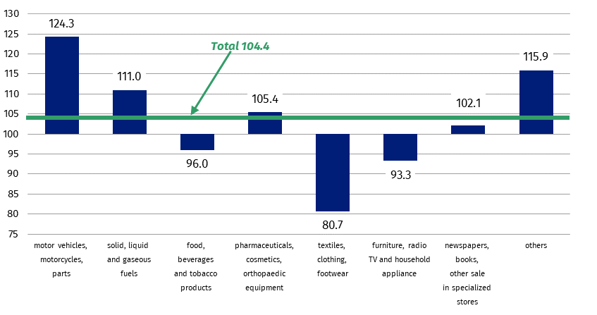

Retail sales seasonally adjusted
In June 2024, an increase of 1.5% in retail sales seasonally adjusted was recorded in comparison with May 2024
After eliminating the seasonal factors, retail sales at constant prices in June 2024 were by 1.5% higher compared with May 2024.
Chart 3. Retail sales – seasonally adjusted and unadjusted data (constant prices) – monthly average 2021=100
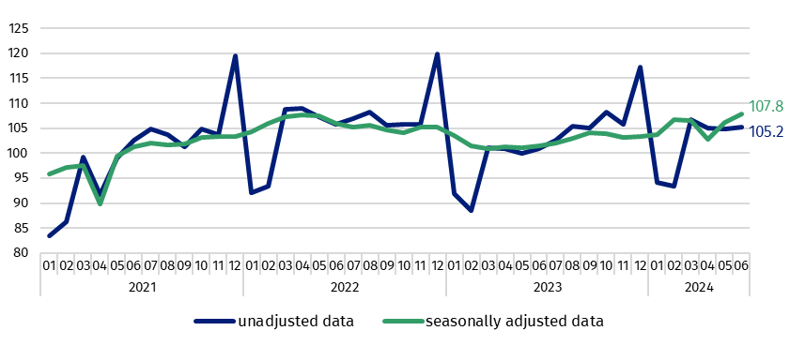

In Knowledge Databases (DBW) simultaneously with the data on retail sales, the data for the volume of sales by KAU (Kind-of-activity unit), which is prepared for the needs of European statistics, is presented additionally. The volume of sales (constant prices 2021=100) includes divisions and groups of Section G - "Wholesale and retail trade; repair of motor vehicles and motorcycles”. The data is disseminated on the website of the Statistics Poland in the resources Knowledge Databases/Database/Economy/Short-Term Statistics - data by Kind-of-activity unit.
When quoting Statistics Poland data, please provide the information: “Source of data: Statistics Poland”, and when publishing calculations made on data published by Statistics Poland, please include the following disclaimer: “Own study based on figures from Statistics Poland”.

Prepared by:  Trade and Services Department  Director Ewa Adach-Stankiewicz  Phone: (+48 22) 608 31 24 | Issued by:  Press Office  Mobile: (+48) 695 255 032  Phone: (+48 22) 608 38 04, (+48 22) 449 41 45,  (+48 22) 608 30 09  e-mail: obslugaprasowa@stat.gov.pl

www.stat.gov.pl/en/

@StatPoland

@GlownyUrzadStatystyczny

gus_stat

glownyurzadstatystycznygus

glownyurzadstatystyczny
Related information
Internal market in 2022
Data available in databases
Knowledge Database - Internal market
Macroeconomic Data Bank
Local Data Bank
Terms used in official statistics
Retail sales of goods

Data concerns trade and non-trade enterprises employing more than 9 persons. Groups of enterprises were created on the basis of the Polish Classification of Activities (PKD 2007) and a given enterprise is included to a specific category by predominating kind of activity and according to its present organizational status in mentioned period. The recorded changes of rise or fall of the dynamics of retail sales in particular groups of enterprises activity may result from a change in the predominating kind of activity and organisational changes (e.g. a merger of enterprises). This does not have impact on the dynamics of the total retail sales.
Corrections made by reporting entities were included in cumulative data.
The volume of sales is defined as turnover in trade deflated by price index i.e. turnover at constant prices on the basis of the base year; from 2024 the valid base year is 2021

