Producer price indices for business services in the first quarter of 2024

In the first quarter of 2024, the producer prices for business services increased compared to the previous quarter by 2.4%. Compared to the first quarter of 2023 they increased by 5.5%.
102.4
Increase in producer prices for business services compared to the fourth quarter of 2023

Table 1. Producer price indices for business services in the first quarter of 2024
SPECIFICATION | 1 quarter  2024
SPECIFICATION | 4 quarter 2023=100 | 1 quater 2023=100
TOTAL | 102.4 | 105.5
Publishing activities | 102.4 | 107.1
Motion picture, video and television programme production, sound recording and music publishing activities | 101.9 | 104.7
Programming and broadcasting activities | 98.1 | 105.3
Computer programming, consultancy and related activities | 100.9 | 101.6
Information service activities | 102.5 | 105.2
Real estate activities | 103.8 | 108.0
Legal and accounting activities | 101.7 | 104.3
Management consultancy activities | 101.0 | 100.2
Architectural and engineering activities; technical testing and analysis | 101.3 | 106.2
Advertising and market research | 103.6 | 107.7
Other professional, scientific and technical activities | 101.7 | 109.2
Rental and leasing activities | 99.6 | 101.7

SPECIFICATION | 1 quarter 2024
SPECIFICATION | 4 quarter 2023=100 | 1 quarter 2023=100
Employment activities | 104.2 | 108.6
Travel agency, tour operator reservation service and related activities | 102.9 | 108.5
Security and investigation activities | 110.4 | 115.1
Services to buildings and landscape activities | 105.7 | 108.9
Office administrative, office support and other business support activities | 102.3 | 105.9

In the 1st quarter of 2024, the highest increase of prices compared to the previous quarter, was recorded in security and investigation activities
In the first quarter of 2024 the highest increase of prices compared to the previous quarter, was recorded in security and investigation activities, that is, by 10.4%. Subsequently, there was noticed the rise of service prices in services to buildings and landscape activities (by 5.7% ) and employment activities (by 4.2%). Whereas, price growths over 3% were recorded in real estate activities (by 3.8%) and advertising and market research services (by 3.6%). The lowest growths in prices were noticed in computer programming, consultancy and related activities (by 0.9%) and in management consultancy activities (by 1.0%).
Price decrease compared to the previous quarter was recorded in the case of programming and broadcasting activities (by 1.9%) and rental and leasing activities (by 0.4%).
Compared to the first quarter of 2023, the highest increase of prices occurred also in security and investigation activities (by 15.1%). High price increases were recorded also in other professional, scientific and technical activities (by 9.2%), services to buildings and landscape activities (by 8.9%), employment activities (by 8.6%), travel agency, tour operator reservation service and related activities (by 8.5%), as well as in real estate activities (by 8.0%).
Whereas, the lowest increase of prices compared to the first quarter of previous year was recorded in the case of management consultancy activities (by 0.2%), computer programming, consultancy and related activities (by 1.6%) and rental and leasing activities (by 1.7%).

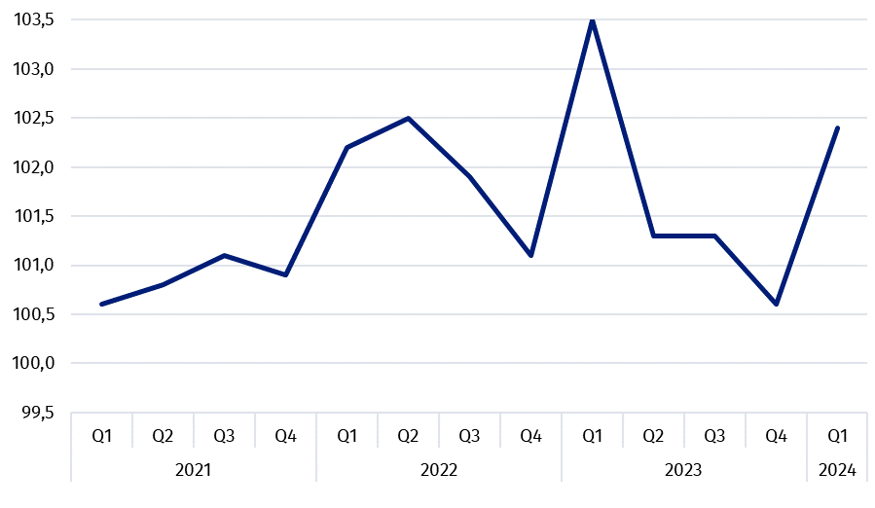
Chart 1. Producer price changes of business services in 2021-2024 (the previous quarter = 100)

Chart 2. Producer price changes of business services in 2021-2024 (corresponding period of the previous year = 100)

In case of quoting Statistics Poland data, please provide information: “Source of data: Statistics Poland”, and in case of publishing calculations made on data published by Statistics Poland, please include the following disclaimer: “Own study based on figures from Statistics Poland”.

Prepared by:  Trade and Services Department  Director Ewa Adach-Stankiewicz  Phone: (+48 22) 608 31 24 | Issued by:  Press Office  Mobile +48 695 255 032  Phone +48 22 608 38 04, +48 22 449 41 45,  +48 22 608 30 09  e-mail: obslugaprasowa@stat.gov.pl

www.stat.gov.pl/en/

@StatPoland

@GlownyUrzadStatystyczny

gus_stat

glownyurzadstatystycznygus

glownyurzadstatystyczny
Related information
News releases

Prices in the national economy

Data available in databases
Knowledge Databases
Prices indices (Topics: Prices, Trade)

Terms used inn official statistics
Producer price indices for business services

