Index numbers of sold production of industry in December 2023^{a)}
In December 2023, sold production of industry was by 3.9% lower than in December 2022, when an increase was recorded by 1.0% as compared to the corresponding period of 2021, whereas in comparison with November 2023, it decreased by 9.8%. In the period January-December of 2023, sold production of industry was by 1.5% lower than in the corresponding period of 2022, which saw an increase by 10.2% as compared to the corresponding period of 2021.
3.9%
Decrease in sold production of industry as compared to December 2022

After seasonal adjustment, a decrease in sold industrial production in December 2023 amounted to 0.5% per year

After eliminating the seasonal factors, in December 2023 sold production of industry reached the level lower by 0.5% than in the corresponding month of 2022 and by 2.9% higher as compared to November 2023.
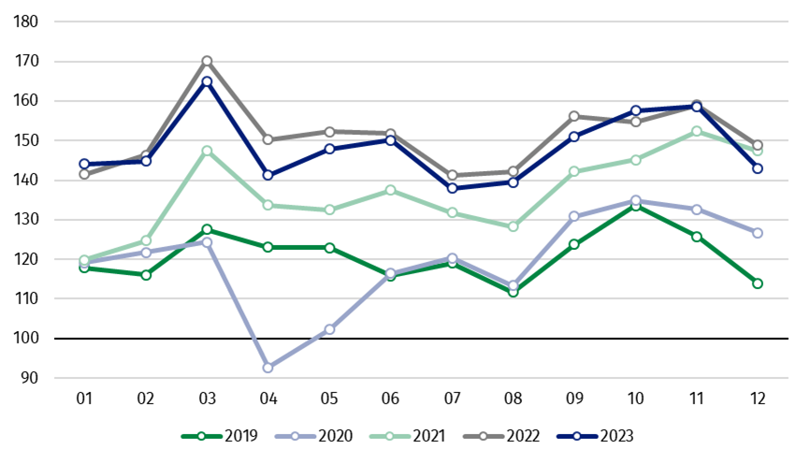
Chart 1. Sold production of industry (average monthly level in 2015=100)

In December 2023, among the main industrial groupings there was a decrease per year in the production of durable consumer goods – by 16.2%, intermediate goods – by 11.3% and lower in production of non-durable consumer goods – by 3.3%. An increase was observed in the production of capital goods – by 3.7% and energy – by 2.2%.

^{a)} Reported data; comprise enterprises with 10 or more persons employed.

Table 1. Index numbers of sold production of industry ^{a)} (constant prices)
SPECIFICATION | 2023
SPECIFICATION | 11 | 12 | 11 | 12 | 01-12 | 11 | 12
SPECIFICATION | previous month =100 |  | previous year =100 |  |  | monthly average  of 2015 =100
INDUSTRY | 100.6* | 90.2 | 99.7* | 96.1 | 98.5 | 158.6* | 143.0
Mining and quarrying | 96.2* | 85.7 | 101.8* | 96.5 | 95.0 | 96.9* | 83.1
Manufacturing | 99.6* | 88.1 | 98.5* | 94.4 | 98.8 | 160.7* | 141.7
Electricity, gas, steam and air conditioning supply | 114.6* | 109.5 | 111.2* | 111.4 | 95.0 | 165.3* | 181.0
Water supply; sewerage waste management and remediation activities | 98.7* | 102.0 | 104.7* | 101.6 | 99.9 | 156.8* | 159.9
^{a)} Data including final information on production and prices in November and reported data in December.
* Data revised.
Share of production value of industry divisions, which saw a decrease in comparison to December 2022, stood at 68.7%

According to the preliminary data, in December 2023 as compared to December 2022, a decrease in sold production (in constant prices) was reported in 23 (out of 34) industry divisions, among others, in manufacture of electrical equipment – by 23.8%, manufacture of chemicals and chemical products – by 15.3%, manufacture of products of wood, cork, straw and wicker – by 13.7%, manufacture of rubber and plastic products – by 13.3%, manufacture of other non-metallic mineral products – by 11.8%, in repair and installation of machinery and equipment – by 9.0%, in manufacture of furniture – by 8.8%, in mining of coal and lignite – by 7.1%.
An increase in sold production of industry, as compared to December 2022, was recorded in 11 divisions, among others, in manufacture of other transport equipment – by 47.8%, in printing and reproduction of recorded media – by 7.5%,

Chart 2. Index numbers of sold production of industry by selected NACE divisions (constant
prices; previous year =100)
As compared to November 2023, a decrease in sold production (in constant prices) in December 2023 was recorded in 25 (out of 34) industry divisions, among others, in manufacture of rubber and plastic products – by 24.3%, manufacture of products of wood, cork, straw and wicker – by 23.0%, manufacture of other non-metallic mineral products – by 21.9%, manufacture of computer, electronic and optical products – by 21.1%, manufacture of motor vehicles, trailers and semi-trailers – by 19.9%, manufacture of chemicals and chemical products – by 18.3%, manufacture of furniture – by 16.2%, manufacture of basic metals – by 15.8%.
An increase in sold production of industry, as compared to November 2023, was recorded in 9 divisions, among others, in manufacture of other transport equipment – by 21.2%, in repair and installation of machinery and equipment – by 19.4%, in electricity, gas, steam and air conditioning supply – by 9.5%, in manufacture of machinery and equipment – by 8.6%.

Chart 3. Index numbers of sold production of industry by selected NACE divisions (constant
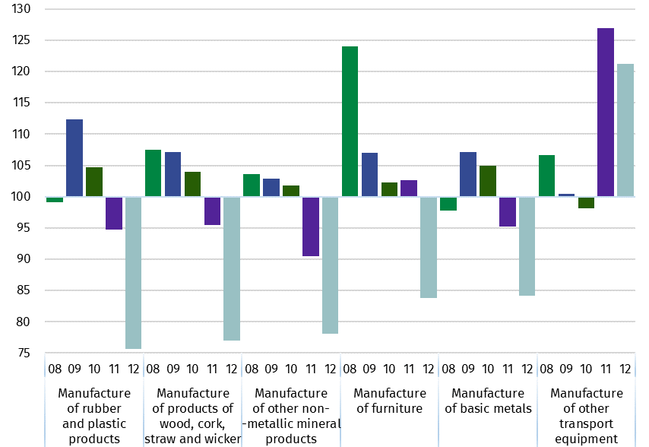
prices; previous month =100)

In case of quoting Statistics Poland data, please provide information: “Source of data: Statistics Poland”, and in case of publishing calculations made on data published by Statistics Poland, please include the following disclaimer: “Own study based on figures from Statistics Poland”.
Prepared by:  Enterprises Department  Director Katarzyna Walkowska  Phone: (+48 22) 608 31 25 | Issued by:  The Spokesperson for the President  of Statistics Poland  Karolina Banaszek  Phone: (+48) 695 255 011
Press Office  Phone: (+48 22) 608 38 04  e-mail: obslugaprasowa@stat.gov.pl |   stat.gov.pl

@GUS_STAT

@GlownyUrzadStatystyczny

gus_stat

glownyurzadstatystycznygus

glownyurzadstatystyczny

Related information
Statistical Bulletin
Socio-economic situation of the country

Data available in databases
Knowledge Database - Industrial Production
Macroeconomic Data Bank
Macroeconomic indicators
Local Data Bank

Terms used in official statistics
Sold production of industry
Seasonally un-adjustedindex of sold production of industry
Seasonally adjustedindex of sold production of industry
Production of capital goods
Production of non-durable consumer goods
Production of durable consumer goods
Production of intermediate goods
Production of goods related to energy

