Index numbers of sold production of industry in February 2024^{a)}
In February 2024, sold production of industry was by 3.3% higher than in February 2023, when a decrease was recorded by 1.6% as compared to the corresponding period of the previous year, whereas in comparison with January 2024, it increased by 0.7%. In the period January-February of 2024, sold production of industry was by 2.8% higher than in the corresponding period of 2023.
3.3%
Increase in sold production of industry as compared to February 2023

After seasonal adjustment, an increase in sold industrial production in February 2024 amounted to 1.1% per year

After eliminating the seasonal factors, in February 2024 sold production of industry reached the level higher by 1.1% than in the corresponding month of 2023 and by 0.1% lower as compared to January 2024.
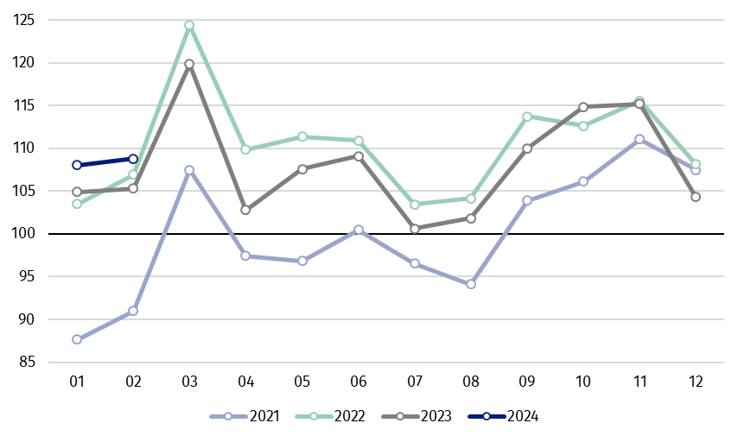
Chart 1. Sold production of industry (average monthly level in 2021=100)

In February 2024, among the main industrial groupings there was an increase per year in the production of capital goods – by 11.5%, non-durable consumer goods – by 3.8% and intermediate goods – by 1.0%. A decrease was observed in the production of energy – by 1.8% and slight in durable consumer goods – by 0.1%.

^{a)} Reported data; comprise enterprises with 10 or more persons employed.

Table 1. Index numbers of sold production of industry ^{a)} (constant prices)
SPECIFICATION | 2024
SPECIFICATION | 01 | 02 | 01 | 02 | 01-02 | 01 | 02
SPECIFICATION | previous month =100 |  | previous year =100 |  |  | monthly average  of 2021 =100
INDUSTRY | 103.6* | 100.7 | 102.9* | 103.3 | 102.8 | 108.0* | 108.8
Mining and quarrying | 106.2* | 105.3 | 95.8* | 98.0 | 96.6 | 104.4* | 110.0
Manufacturing | 104.0* | 101.5 | 102.6* | 103.8 | 102.9 | 104.8* | 106.8
Electricity, gas, steam and air conditioning supply | 102.1* | 87.1 | 109.5* | 95.7 | 101.9 | 150.9* | 127.7
Water supply; sewerage waste management and remediation activities | 92.6* | 102.5 | 109.7* | 110.3 | 109.2 | 102.6* | 105.2

^{a)} Data including final information on production and prices in January and reported data in February.
* Data revised.
Share of production value of industry divisions, which saw an increase in comparison to February 2023, stood at 73.4%

According to the preliminary data, in February 2024 as compared to February 2023, an increase in sold production (in constant prices) was reported in 24 (out of 34) industry divisions, among others in repair and installation of machinery and equipment – by 48.5%, in manufacture of other transport equipment – by 17.8%, manufacture of motor vehicles, trailers and semi-trailers – by 13.9%, manufacture of chemicals and chemical products – by 10.3%, manufacture of paper and paper products – by 10.1%, manufacture of other non-metallic mineral products – by 6.9%, manufacture of food products – by 5.5%.
A decrease in sold production of industry, as compared to February 2023, was recorded in 10 divisions, among others in manufacture of electrical equipment – by 23.9%, in mining of coal and lignite – by 18.5%, in electricity, gas, steam and air conditioning supply – by 4.3%.

Chart 2. Index numbers of sold production of industry by selected NACE divisions (constant
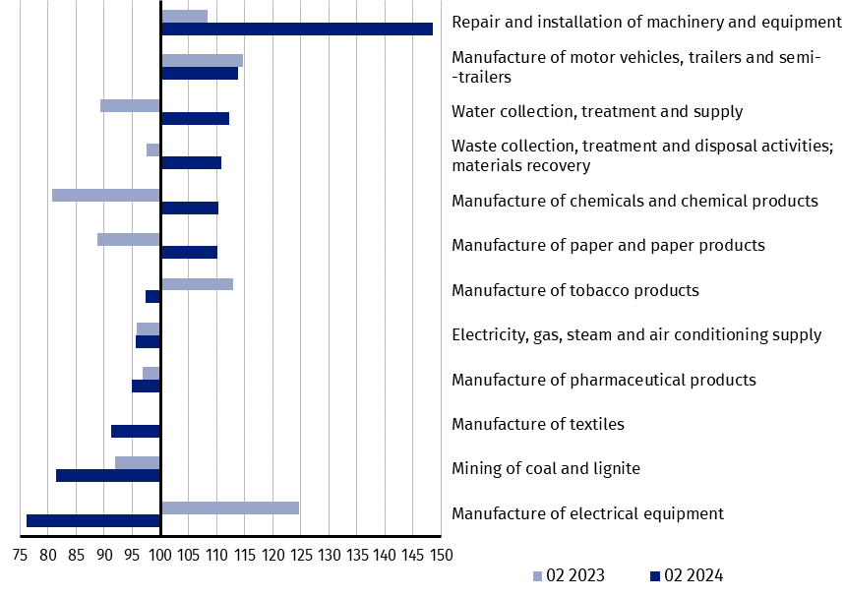
prices; previous year =100)
As compared to January 2024, an increase in sold production (in constant prices) in February 2024 was recorded in 24 (out of 34) industry divisions, among others in repair and installation of machinery and equipment – by 40.8%, in manufacture of machinery and equipment – by 15.4%, manufacture of other non-metallic mineral products – by 14.5%, manufacture of other transport equipment – by 11.8%, manufacture of chemicals and chemical products – by 3.9%, manufacture of rubber and plastic products – by 3.4%.
A decrease in sold production of industry, as compared to January 2024, was recorded in 10 divisions, among others in mining of coal and lignite – by 14.4%, in electricity, gas, steam and air conditioning supply – by 12.9%, in manufacture of paper and paper products – by 5.9%, manufacture of food products – by 2.1%.

Chart 3. Index numbers of sold production of industry by selected NACE divisions (constant
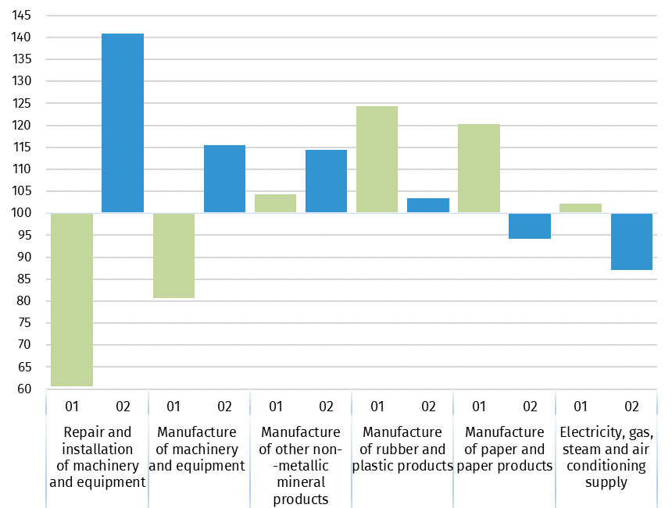
prices; previous month =100)

In case of quoting Statistics Poland data, please provide information: “Source of data: Statistics Poland”, and in case of publishing calculations made on data published by Statistics Poland, please include the following disclaimer: “Own study based on figures from Statistics Poland”.
Prepared by:  Enterprises Department  Director Katarzyna Walkowska  Phone: (+48 22) 608 31 25 | Issued by:  The Spokesperson for the President  of Statistics Poland  Karolina Banaszek  Phone: (+48) 695 255 011
Press Office  Phone: (+48 22) 608 38 04  e-mail: obslugaprasowa@stat.gov.pl |   stat.gov.pl

@GUS_STAT

@GlownyUrzadStatystyczny

gus_stat

glownyurzadstatystycznygus

glownyurzadstatystyczny

Related information
Statistical Bulletin
Socio-economic situation of the country

Data available in databases
Knowledge Database - Industrial Production
Macroeconomic Data Bank
Macroeconomic indicators
Local Data Bank

Terms used in official statistics
Sold production of industry
Seasonally un-adjustedindex of sold production of industry
Seasonally adjustedindex of sold production of industry
Production of capital goods
Production of non-durable consumer goods
Production of durable consumer goods
Production of intermediate goods
Production of goods related to energy

