Index numbers of sold production of industry in March 2024^{a)}
In March 2024, sold production of industry was by 6.0% lower than in March 2023, when a decrease was recorded by 3.7% as compared to the corresponding period of the previous year, whereas in comparison with February 2024, it increased by 3.6%. In the period January-March of 2024, sold production of industry was by 0.7% lower than in the corresponding period of 2023, which saw a decrease by 1.1% as compared to the corresponding period of 2022.
6.0%
Decrease in sold production of industry as compared to March 2023

After seasonal adjustment, a decrease in sold industrial production in March 2024 amounted to 3.9% per year

After eliminating the seasonal factors, in March 2024 sold production of industry reached the level lower by 3.9% than in the corresponding month of 2023 and by 5.5% lower as compared to February 2024.
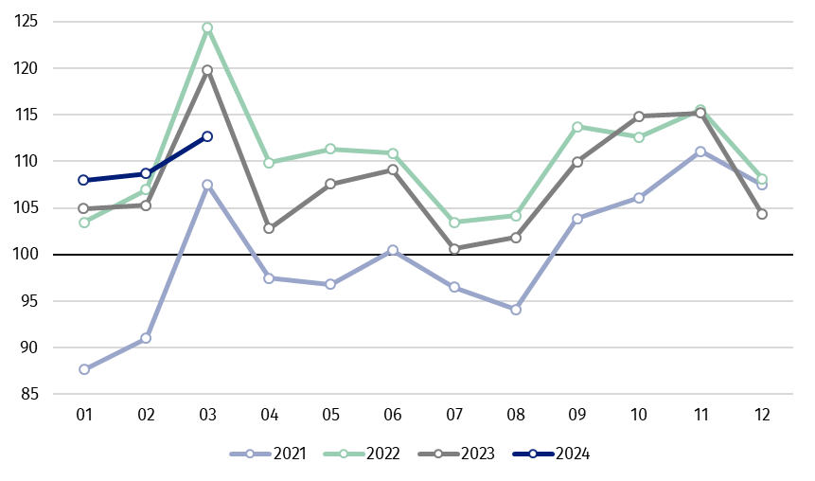
Chart 1. Sold production of industry (average monthly level in 2021=100)

In March 2024, in all main industrial groupings there was a decrease per year, in the production of intermediate goods – by 8.9%, durable consumer goods – by 7.1%, capital goods – by 6.3%, non-durable consumer goods – by 3.6% and the production of energy – by 2.4%.

^{a)} Reported data; comprise enterprises with 10 or more persons employed.

Table 1. Index numbers of sold production of industry ^{a)} (constant prices)
SPECIFICATION | 2024
SPECIFICATION | 02 | 03 | 02 | 03 | 01-03 | 02 | 03
SPECIFICATION | previous month =100 |  | previous year =100 |  |  | monthly average  of 2021 =100
INDUSTRY | 100.7 | 103.6 | 103.3 | 94.0 | 99.3 | 108.7* | 112.7
Mining and quarrying | 105.0* | 96.0 | 97.7* | 86.9 | 92.6 | 109.6* | 105.3
Manufacturing | 101.4* | 104.0 | 103.8 | 93.7 | 99.2 | 106.8 | 111.6
Electricity, gas, steam and air conditioning supply | 87.1 | 101.0 | 95.8* | 100.1 | 102.4 | 127.7 | 132.5
Water supply; sewerage waste management and remediation activities | 102.1* | 105.5 | 109.8* | 106.2 | 108.1 | 104.7* | 110.5

^{a)} Data including final information on production and prices in February and reported data in March.
* Data revised.
Share of production value of industry divisions, which saw a decrease in comparison to March 2023, stood at 83.5%

According to the preliminary data, in March 2024 as compared to March 2023, a decrease in sold production (in constant prices) was reported in 26 (out of 34) industry divisions, among others in manufacture of electrical equipment – by 29.1%, in mining of coal and lignite – by 25.9%, in manufacture of beverages – by 13.8%, manufacture of basic metals – by 12.5%, manufacture of metal products – by 10.3%, in repair and installation of machinery and equipment – by 9.6%, in manufacture of machinery and equipment – by 9.3%, manufacture of furniture – by 8.1%.
An increase in sold production of industry, as compared to March 2023, was recorded in 8 divisions, among others in waste collection, treatment and disposal activities; materials recovery – by 7.5%, in manufacture of chemicals and chemical products – by 4.5%, manufacture of other transport equipment – by 2.1%.

Chart 2. Index numbers of sold production of industry by selected NACE divisions (constant
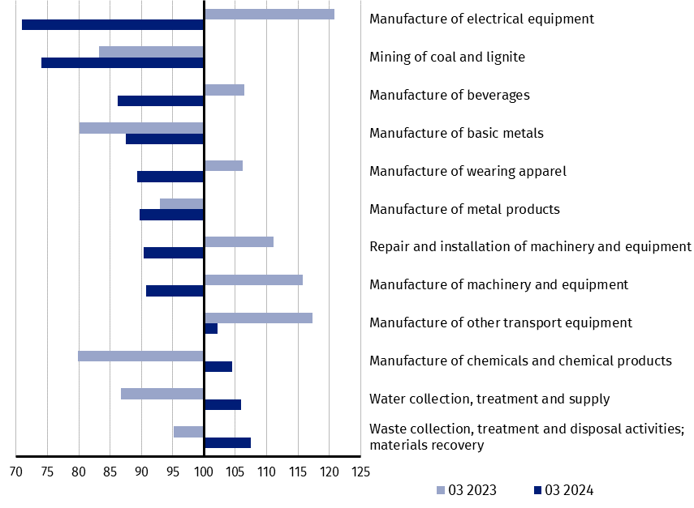
prices; previous year =100)
As compared to February 2024, an increase in sold production (in constant prices) in March 2024 was recorded in 27 (out of 34) industry divisions, among others in manufacture of beverages – by 28.0%, manufacture of other transport equipment – by 21.2%, manufacture of other non-metallic mineral products – by 10.6%, manufacture of computer, electronic and optical products – by 9.5%, manufacture of food products – by 8.7%, manufacture of machinery and equipment – by 7.3%, in waste collection, treatment and disposal activities; materials recovery – by 6.8%.
A decrease in sold production of industry, as compared to February 2024, was recorded in 7 divisions, among others in repair and installation of machinery and equipment – by 19.8%,
in mining of coal and lignite – by 3.7%, in manufacture of motor vehicles, trailers and semi- -trailers – by 1.8%, manufacture of furniture – by 1.3%.

Chart 3. Index numbers of sold production of industry by selected NACE divisions (constant
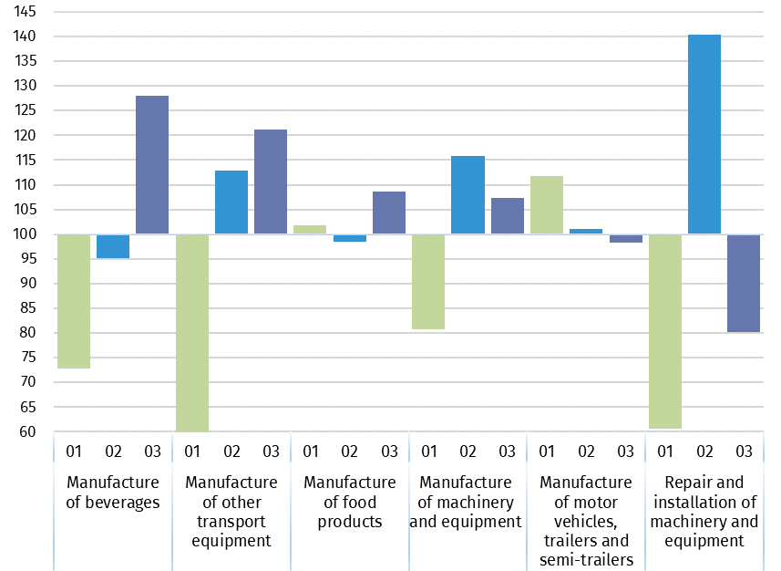
prices; previous month =100)

In case of quoting Statistics Poland data, please provide information: “Source of data: Statistics Poland”, and in case of publishing calculations made on data published by Statistics Poland, please include the following disclaimer: “Own study based on figures from Statistics Poland”.
Prepared by:  Enterprises Department  Director Katarzyna Walkowska  Phone: (+48 22) 608 31 25 | Issued by:  The Spokesperson for the President  of Statistics Poland  Karolina Banaszek  Phone: (+48) 695 255 011
Press Office  Phone: (+48 22) 608 38 04  e-mail: obslugaprasowa@stat.gov.pl |   stat.gov.pl

@GUS_STAT

@GlownyUrzadStatystyczny

gus_stat

glownyurzadstatystycznygus

glownyurzadstatystyczny

Related information
Statistical Bulletin
Socio-economic situation of the country

Data available in databases
Knowledge Database - Industrial Production
Macroeconomic Data Bank
Macroeconomic indicators
Local Data Bank

Terms used in official statistics
Sold production of industry
Seasonally un-adjustedindex of sold production of industry
Seasonally adjustedindex of sold production of industry
Production of capital goods
Production of non-durable consumer goods
Production of durable consumer goods
Production of intermediate goods
Production of goods related to energy

