Index numbers of sold production of industry in May 2024^{a)}
In May 2024, sold production of industry was by 1.7% lower than in May 2023, when a decrease was recorded by 3.4% as compared to the corresponding period of the previous year, whereas in comparison with April 2024, it decreased by 4.6%. In the period January-May of 2024, sold production of industry was by 0.3% higher than in the corresponding period of 2023, which saw a decrease by 2.2% as compared to the corresponding period of 2022.
1.7%
Decrease in sold production of industry as compared to May 2023

After seasonal adjustment, an increase in sold industrial production in May 2024 amounted to 0.7% per year

After eliminating the seasonal factors, in May 2024 sold production of industry reached the level higher by 0.7% than in the corresponding month of 2023 and by 2.1% lower as compared to April 2024.
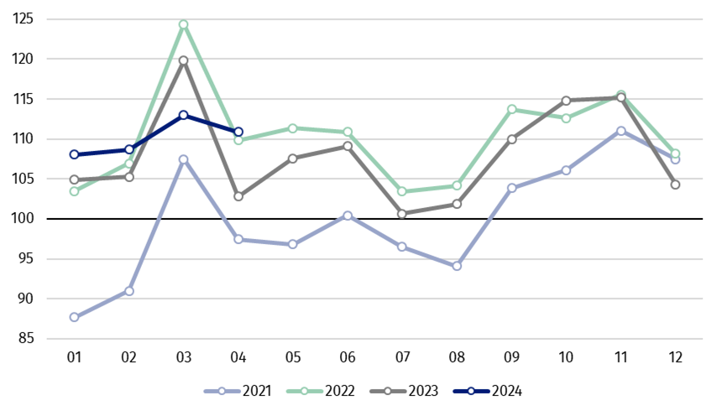
Chart 1. Sold production of industry (average monthly level in 2021=100)

In May 2024, among the main industrial groupings there was a decrease per year, in the production of intermediate goods – by 4.9%, capital goods – by 2.7%, and slight in the production of non-durable consumer goods – by 0.5% and durable consumer goods – by 0.3%. An increase was observed in the production of energy – by 6.4%.

^{a)} Reported data; comprise enterprises with 10 or more persons employed.

Table 1. Index numbers of sold production of industry ^{a)} (constant prices)
SPECIFICATION | 2024
SPECIFICATION | 04 | 05 | 04 | 05 | 01-05 | 04 | 05
SPECIFICATION | previous month =100 |  | previous year =100 |  |  | monthly average  of 2021 =100
INDUSTRY | 97.7* | 95.4 | 107.8* | 98.3 | 100.3 | 110.8* | 105.8
Mining and quarrying | 103.5* | 92.9 | 106.1* | 97.7 | 95.2 | 109.0* | 101.3
Manufacturing | 98.0 | 95.7 | 108.1* | 98.1 | 100.2 | 111.3* | 107.3
Electricity, gas, steam and air conditioning supply | 86.9* | 88.6 | 100.5* | 97.7 | 101.0 | 101.5* | 87.3
Water supply; sewerage waste management and remediation activities | 103.7* | 99.2 | 112.7* | 106.0 | 108.9 | 114.7* | 113.7

^{a)} Data including final information on production and prices in April and reported data in May.
* Data revised.
Share of production value of industry divisions, which saw a decrease in comparison to May 2023, stood at 45.7%

According to the preliminary data, in May 2024 as compared to May 2023, a decrease in sold production (in constant prices) was reported in 19 (out of 34) industry divisions, among others in manufacture of electrical equipment – by 29.7%, in mining of coal and lignite – by 13.4%, in manufacture of machinery and equipment – by 8.2%, manufacture of metal products – by 8.0%, manufacture of basic metals – by 6.9%, manufacture of beverages – by 6.3%, manufacture of furniture – by 5.0%, in repair and installation of machinery and equipment – by 3.7%.
An increase in sold production of industry, as compared to May 2023, was recorded in 14 divisions, among others in manufacture of chemicals and chemical products – by 7.1%, in waste collection, treatment and disposal activities; materials recovery – by 6.0%, in manufacture of computer, electronic and optical products – by 5.5%, manufacture of other transport equipment – by 4.9%, manufacture of products of wood, cork, straw and wicker – by 3.3%, manufacture of food products – by 2.2%.

Chart 2. Index numbers of sold production of industry by selected NACE divisions (constant
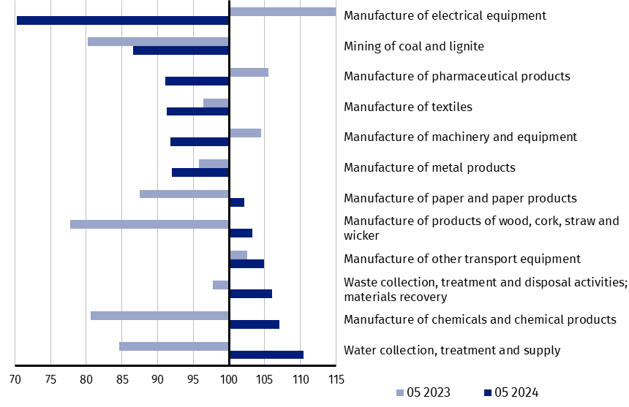
prices; previous year =100)
As compared to April 2024, a decrease in sold production (in constant prices) in May 2024 was recorded in 27 (out of 34) industry divisions, among others in manufacture of furniture – by 13.3%, in electricity, gas, steam and air conditioning supply – by 11.4%, in mining of coal and lignite – by 9.9%, in manufacture of metal products – by 8.8%, manufacture of machinery and equipment – by 8.1%, manufacture of chemicals and chemical products – by 7.4%, manufacture of paper and paper products – by 7.2%, manufacture of products of wood, cork, straw and wicker – by 6.7%, manufacture of rubber and plastic products – by 6.0%.
An increase in sold production of industry, as compared to April 2024, was recorded in 7 divisions, among others in repair and installation of machinery and equipment – by 5.1%, in manufacture of beverages – by 4.6%, manufacture of other transport equipment – by 4.3%.

Chart 3. Index numbers of sold production of industry by selected NACE divisions (constant
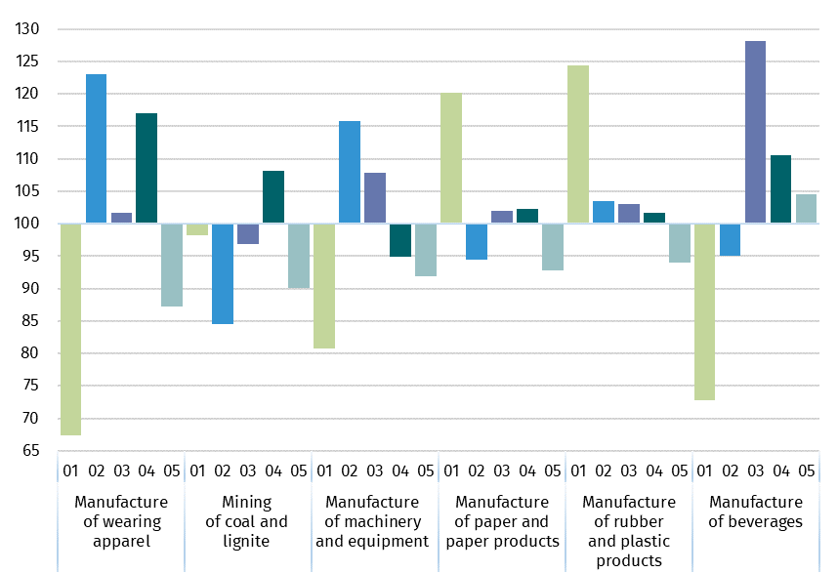
prices; previous month =100)

In case of quoting Statistics Poland data, please provide information: “Source of data: Statistics Poland”, and in case of publishing calculations made on data published by Statistics Poland, please include the following disclaimer: “Own study based on figures from Statistics Poland”.
Prepared by:  Enterprises Department  Director Katarzyna Walkowska  Phone: (+48 22) 608 31 25 | Issued by:  Press Office  Mobile +48 695 255 032  Phone +48 22 608 38 04, +48 22 449 41 45,  +48 22 608 30 09  e-mail: obslugaprasowa@stat.gov.pl

stat.gov.pl

@GUS_STAT

@GlownyUrzadStatystyczny

gus_stat

glownyurzadstatystycznygus

glownyurzadstatystyczny

Related information
Statistical Bulletin
Socio-economic situation of the country

Data available in databases
Knowledge Database - Industrial Production
Macroeconomic Data Bank
Macroeconomic indicators
Local Data Bank

Terms used in official statistics
Sold production of industry
Seasonally un-adjustedindex of sold production of industry
Seasonally adjustedindex of sold production of industry
Production of capital goods
Production of non-durable consumer goods
Production of durable consumer goods
Production of intermediate goods
Production of goods related to energy

