Index numbers of sold production of industry in August 2024^{a)}
In August 2024, sold production of industry was by 1.5% lower than in August 2023, when a decrease was recorded by 2.2% as compared to the corresponding period of the previous year, whereas in comparison with July 2024, it decreased by 5.2%. In the period January-August of 2024, sold production of industry was by 0.4% higher than in the corresponding period of 2023, which saw a decrease by 2.3% as compared to the corresponding period of 2022.
1.5%
Decrease in sold production of industry as compared to August 2023

After seasonal adjustment, an increase in sold industrial production in August 2024 amounted to 0.6% per year

After eliminating the seasonal factors, in August 2024 sold production of industry reached the level higher by 0.6% than in the corresponding month of 2023 and by 0.8% lower as compared to July 2024.
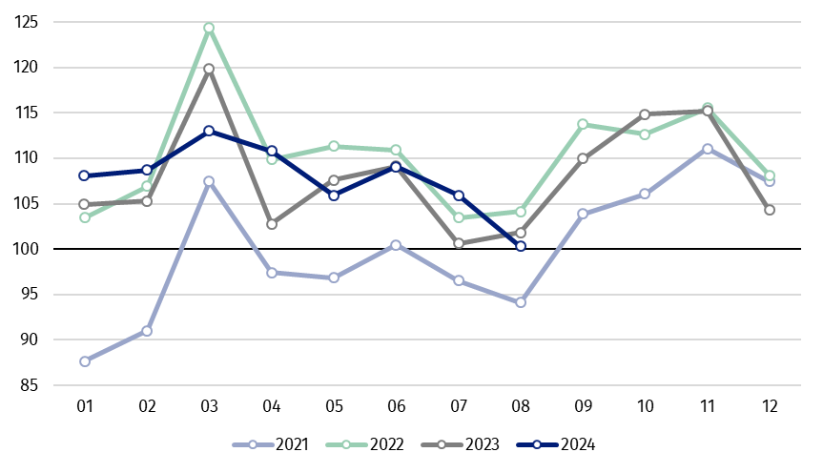
Chart 1. Sold production of industry (average monthly level in 2021=100)

In August 2024, among the main industrial groupings there was a decrease per year in the production of capital goods – by 4.2%, intermediate goods – by 3.8% and smaller in the production of durable consumer goods – by 0.3%. An increase was observed in the production of non-durable consumer goods – by 2.3% and slightly in the production of energy – by 0.2%.

^{a)} Reported data; comprise enterprises with 10 or more persons employed.

Table 1. Index numbers of sold production of industry ^{a)} (constant prices)
SPECIFICATION | 2024
SPECIFICATION | 07 | 08 | 07 | 08 | 01-08 | 07 | 08
SPECIFICATION | previous month =100 |  | previous year =100 |  |  | monthly average  of 2021 =100
INDUSTRY | 97.0* | 94.8 | 105.2* | 98.5 | 100.4 | 105.9* | 100.3
Mining and quarrying | 100.4* | 91.8 | 102.5* | 92.2 | 95.7 | 107.7* | 98.9
Manufacturing | 96.6* | 94.6 | 105.4* | 98.3 | 100.2 | 107.4* | 101.2
Electricity, gas, steam and air conditioning supply | 101.2* | 99.4 | 100.5* | 100.2 | 101.9 | 83.6* | 86.4
Water supply; sewerage waste management and remediation activities | 102.3* | 98.3 | 110.6* | 108.1 | 108.5 | 116.7* | 114.7

^{a)} Data including final information on production and prices in July and reported data in August.
* Data revised.
Share of production value of industry divisions, which saw a decrease in comparison to August 2023, stood at 42.4%

According to the preliminary data, in August 2024 as compared to August 2023, a decrease in sold production (in constant prices) was reported in 16 (out of 34) industry divisions, among others in manufacture of electrical equipment – by 21.4%, in repair and installation of machinery and equipment – by 13.8%, in manufacture of machinery and equipment – by 9.8%, in mining of coal and lignite – by 9.4%, in manufacture of chemicals and chemical products – by 6.2%, manufacture of metal products – by 6.0%.
An increase in sold production of industry, as compared to August 2023, was recorded in 17 divisions, among others in manufacture of computer, electronic and optical products – by 13.7%, in waste collection, treatment and disposal activities; materials recovery – by 9.4%, in manufacture of paper and paper products – by 4.1%, manufacture of food products – by 3.9%.

Chart 2. Index numbers of sold production of industry by selected NACE divisions (constant
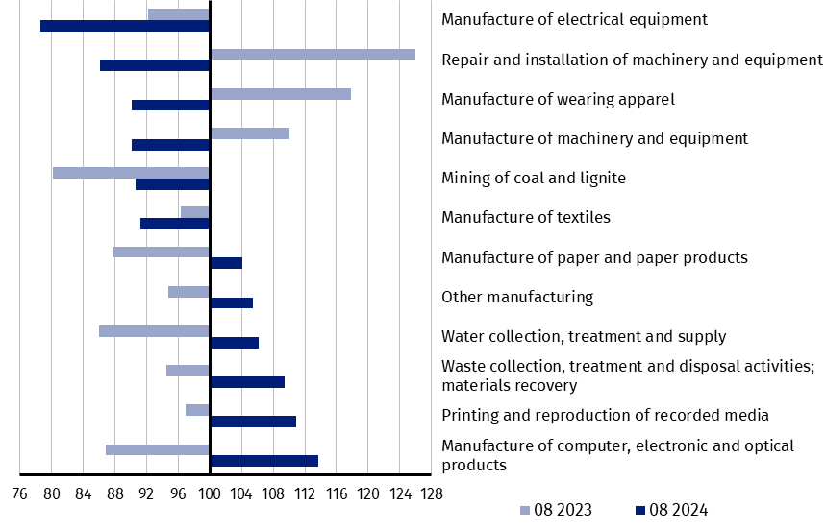
prices; previous year =100)
As compared to July 2024, a decrease in sold production (in constant prices) in August 2024 was recorded in 27 (out of 34) industry divisions, among others in manufacture of machinery and equipment – by 11.9%, manufacture of products of wood, cork, straw and wicker – by 10.8%, manufacture of basic metals – by 10.6%, manufacture of other transport equipment – by 9.0%, manufacture of rubber and plastic products and manufacture of motor vehicles, trailers and semi-trailers – by 7.9% each, manufacture of other non-metallic mineral products – by 6.9%, manufacture of chemicals and chemical products – by 6.8%.
An increase in sold production of industry, as compared to July 2024, was recorded in 7 divisions, among others in manufacture of furniture – by 4.2%, in printing and reproduction of recorded media – by 3.4%.

Chart 3. Index numbers of sold production of industry by selected NACE divisions (constant
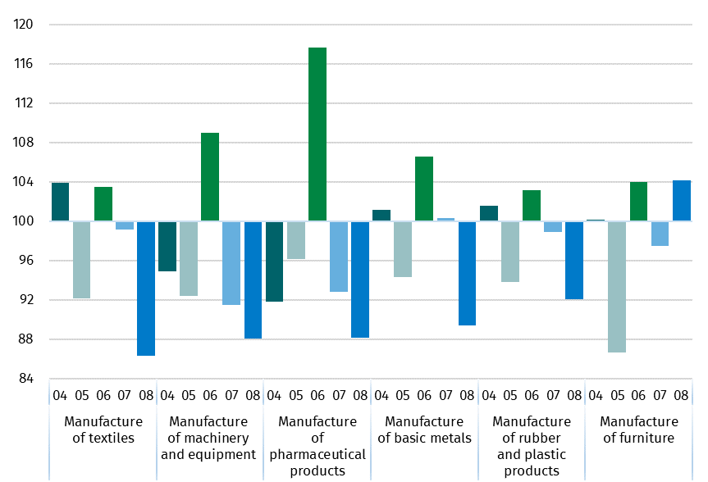
prices; previous month =100)

In case of quoting Statistics Poland data, please provide information: “Source of data: Statistics Poland”, and in case of publishing calculations made on data published by Statistics Poland, please include the following disclaimer: “Own study based on figures from Statistics Poland”.
Prepared by:  Enterprises Department  Director Katarzyna Walkowska  Phone: (+48 22) 608 31 25 | Issued by:  Press Office  Mobile +48 695 255 032  Phone +48 22 608 38 04, +48 22 449 41 45,  +48 22 608 30 09  e-mail: obslugaprasowa@stat.gov.pl

stat.gov.pl

@GUS_STAT

@GlownyUrzadStatystyczny

gus_stat

glownyurzadstatystycznygus

glownyurzadstatystyczny

Related information
Statistical Bulletin
Socio-economic situation of the country

Data available in databases
Knowledge Database - Industrial Production
Macroeconomic Data Bank
Macroeconomic indicators
Local Data Bank

Terms used in official statistics
Sold production of industry
Seasonally un-adjustedindex of sold production of industry
Seasonally adjustedindex of sold production of industry
Production of capital goods
Production of non-durable consumer goods
Production of durable consumer goods
Production of intermediate goods
Production of goods related to energy

