Index numbers of sold production of industry in September 2024^{a)}
In September 2024, sold production of industry was by 0.3% lower than in September 2023, when a decrease was recorded by 3.3% as compared to the corresponding period of the previous year, whereas in comparison with August 2024, it increased by 9.0%. In the period January-September of 2024, sold production of industry was by 0.2% higher than in the corresponding period of 2023, which saw a decrease by 2.3% as compared to the corresponding period of 2022.
0.3%
Decrease in sold production of industry as compared to September 2023

After seasonal adjustment, an increase in sold industrial production in September 2024 amounted to 0.4% per year

After eliminating the seasonal factors, in September 2024 sold production of industry reached the level higher by 0.4% than in the corresponding month of 2023 and by 0.2% lower as compared to August 2024.
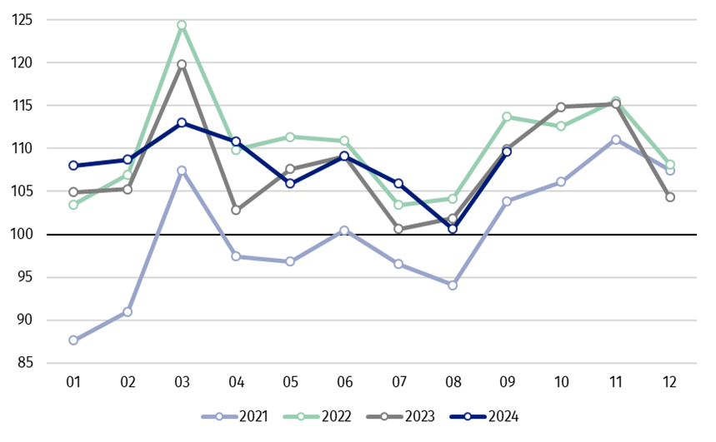
Chart 1. Sold production of industry (average monthly level in 2021=100)

In September 2024, among the main industrial groupings there was a decrease per year in the production of intermediate goods – by 2.6% and capital goods – by 1.2%. An increase was observed in the production of non-durable consumer goods – by 2.7%, durable consumer goods – by 2.3% and slightly in the production of energy – by 0.1%.

^{a)} Reported data; comprise enterprises with 10 or more persons employed.

Table 1. Index numbers of sold production of industry ^{a)} (constant prices)
SPECIFICATION | 2024
SPECIFICATION | 08 | 09 | 08 | 09 | 01-09 | 08 | 09
SPECIFICATION | previous month =100 |  | previous year =100 |  |  | monthly average  of 2021 =100
INDUSTRY | 95.1* | 109.0 | 98.8* | 99.7 | 100.2 | 100.6* | 109.6
Mining and quarrying | 92.5* | 107.8 | 92.8* | 92.7 | 95.7 | 99.6* | 107.4
Manufacturing | 94.8* | 109.7 | 98.6* | 99.7 | 100.1 | 101.5* | 111.5
Electricity, gas, steam and air conditioning supply | 100.4* | 101.2 | 101.3* | 101.6 | 101.2 | 87.3* | 87.8
Water supply; sewerage waste management and remediation activities | 98.2* | 100.0 | 108.0* | 106.9 | 108.2 | 114.6* | 114.6

^{a)} Data including final information on production and prices in August and reported data in September.
* Data revised.
Share of production value of industry divisions, which saw a decrease in comparison to September 2023, stood at 48.5%

According to the preliminary data, in September 2024 as compared to September 2023, a decrease in sold production (in constant prices) was reported in 17 (out of 34) industry divisions, among others in mining of coal and lignite – by 21.0%, in repair and installation of machinery and equipment – by 17.6%, in manufacture of electrical equipment – by 15.7%, manufacture of chemicals and chemical products – by 5.7%, manufacture of beverages – by 4.4%, manufacture of machinery and equipment – by 2.9%, manufacture of basic metals – by 2.1%, manufacture of motor vehicles, trailers and semi-trailers – by 2.0%.
An increase in sold production of industry, as compared to September 2023, was recorded in 17 divisions, among others in manufacture of other transport equipment – by 18.7%, in waste collection, treatment and disposal activities; materials recovery – by 7.6%, in manufacture of paper and paper products – by 7.4%, manufacture of computer, electronic and optical products – by 6.7%, manufacture of food products – by 5.0%, manufacture of products of wood, cork, straw and wicker – by 4.2%.

Chart 2. Index numbers of sold production of industry by selected NACE divisions (constant
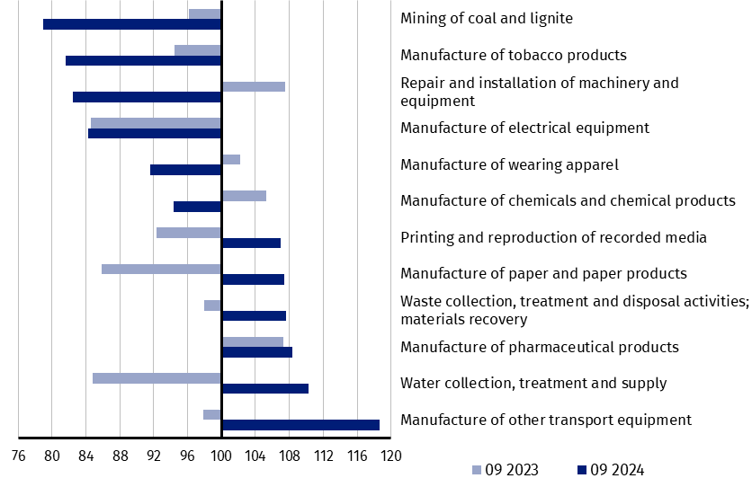
prices; previous year =100)
As compared to August 2024, an increase in sold production (in constant prices) in September 2024 was recorded in 24 (out of 34) industry divisions, among others in manufacture of motor vehicles, trailers and semi-trailers – by 29.3%, manufacture of computer, electronic and optical products – by 21.8%, manufacture of machinery and equipment – by 19.5%, manufacture of electrical equipment – by 19.3%, manufacture of other transport equipment – by 17.1%, manufacture of products of wood, cork, straw and wicker – by 11.7%, manufacture of metal products – by 11.0%, manufacture of rubber and plastic products – by 9.9%.
A decrease in sold production of industry, as compared to August 2024, was recorded in 10 divisions, among others in manufacture of beverages – by 9.6%, in mining of coal and lignite – by 5.4%.

Chart 3. Index numbers of sold production of industry by selected NACE divisions (constant
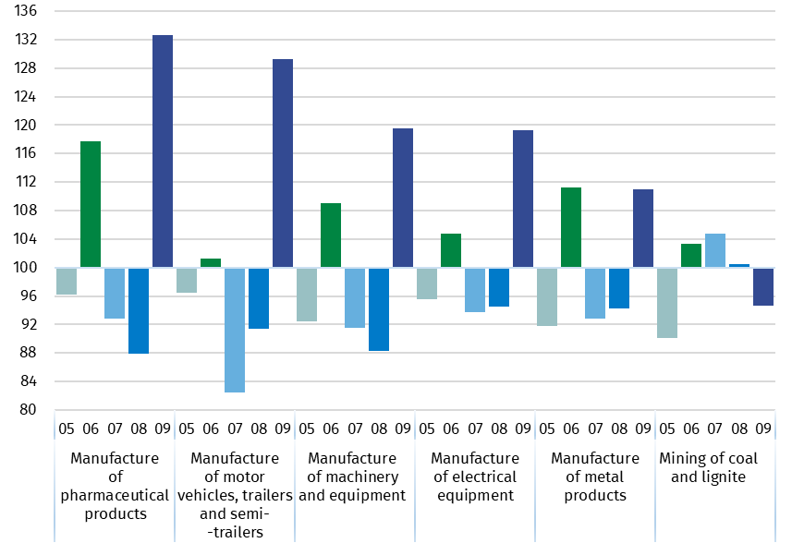
prices; previous month =100)

In case of quoting Statistics Poland data, please provide information: “Source of data: Statistics Poland”, and in case of publishing calculations made on data published by Statistics Poland, please include the following disclaimer: “Own study based on figures from Statistics Poland”.
Prepared by:  Enterprises Department  Director Katarzyna Walkowska  Phone: (+48 22) 608 31 25 | Issued by:  Press Office  Mobile +48 695 255 032  Phone +48 22 608 38 04, +48 22 449 41 45,  +48 22 608 30 09  e-mail: obslugaprasowa@stat.gov.pl

stat.gov.pl

@GUS_STAT

@GlownyUrzadStatystyczny

gus_stat

glownyurzadstatystycznygus

glownyurzadstatystyczny

Related information
Statistical Bulletin
Socio-economic situation of the country

Data available in databases
Knowledge Database - Industrial Production
Macroeconomic Data Bank
Macroeconomic indicators
Local Data Bank

Terms used in official statistics
Sold production of industry
Seasonally un-adjustedindex of sold production of industry
Seasonally adjustedindex of sold production of industry
Production of capital goods
Production of non-durable consumer goods
Production of durable consumer goods
Production of intermediate goods
Production of goods related to energy

