General government deficit and debt in 2023
1 5,1%
General government deficit in 2023 in relation to GDP

According to the EDP notification, in 2023 the general government deficit was equal 173 832 mln zl (5,1% of GDP), while the general government debt amounted to 1 691 148 mln zl (49,6% of GDP).

Statistics Poland presents the general government deficit and debt data for years 2020-2023 developed as part of April EDP notification.
The data have been developed in accordance with the methodology of the European System of National and Regional Accounts in the European Union introduced by the Regulation (EU) No. 549/2013 of the European Parliament and of the Council of 21 May 2013 (ESA2010) with amendments and the guidelines contained in the Manual on Government Deficit and Debt, Implementation of ESA2010 (MGDD, 2022 edition).

Table 1. General government deficit and debt in years 2020-2023 (mln zl)
Specification | 2020 | 2021 | 2022 | 2023
Gross domestic product (GDP) | 2 337 672 | 2 631 302 | 3 074 798* | 3 410 137
General government deficit/surplus | -162 106* | -48 242* | -105 890* | -173 832
% GDP | -6,9% | -1,8% | -3,4%* | -5,1%
Central government deficit/surplus | -183 665* | -48 971* | -91 443* | -135 585
% GDP | -7,9% | -1,9% | -3,0% | -4,0%
Local government deficit/surplus | 4 131* | 14 836* | -13 296* | -24 173
% GDP | 0,2% | 0,6% | -0,4% | -0,7%
Social security funds deficit/surplus | 17 428 | -14 107 | -1 151 | -14 074
% GDP | 0,7% | -0,5% | 0,0% | -0,4
General government debt | 1 337 039* | 1 410 961* | 1 512 773* | 1 691 148
% GDP | 57,2% | 53,6% | 49,2%* | 49,6%

Chart 1. General government deficit in % of GDP

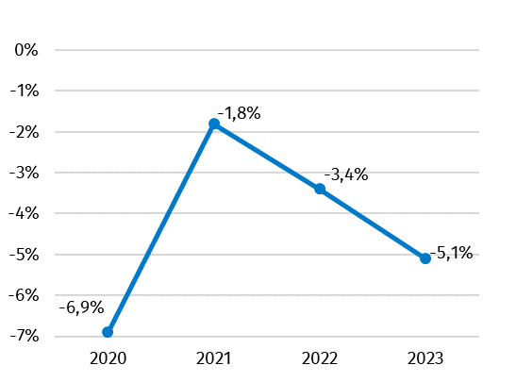

Chart 2. General government debt in % of GDP

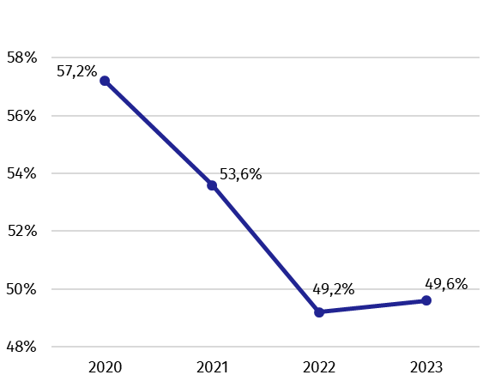

Data for years 2020-2022 have been revised in relation to the previously published (October 2023) mainly due to updated data sources and changes in the scope of general government sector.
In table 2 presents data on revenues and expenditures of the general government sector divided into ESA2010 transactions, consistent with data developed as part of EDP notification.
Table 2. Total revenues and expenditures of the general government sector according to ESA2010 in years 2020-2023 (mln zl)
Specification | 2020 | 2021 | 2022 | 2023
Total revenues | 965 759* | 1 111 945* | 1 235 275* | 1 420 301
% GDP | 41,3 | 42,3 | 40,2 | 41,6
Total expenditures | 1 127 866 | 1 160 188 | 1 341 164* | 1 594 133
% GDP | 48,2 | 44,1 | 43,6* | 46,7

Chart 3. Total revenues and expenditures of the general government sector in % of GDP
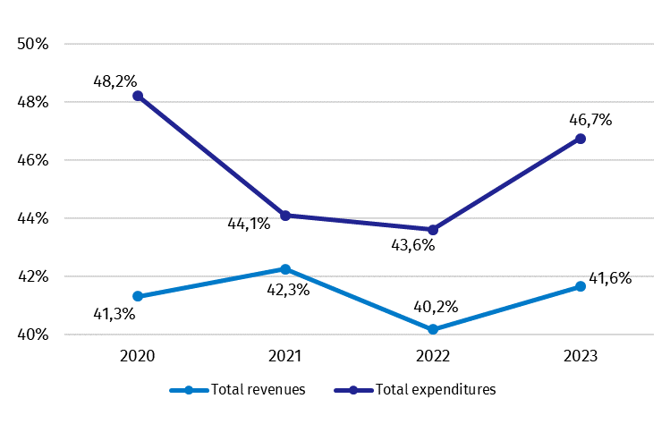

Similarly, as in case of deficit and debt, data on the general government revenues and expenditures for years 2020-2022 have been revised in relation to the previously published (October 2023).
The revision of the general government revenues caused their decrease (without change in relation to GDP) in years 2020-2001, respectively of 272 mln zl and 47 mln zl, and in 2022 growth of 1 547 mln zl zl (without change in relation to GDP). The changes mainly concerns transactions other current transfers (in years 2020-2021) and capital transfers (in 2022 year). The revision of expenditures in 2022 year causing their decrease of 5 397 mln zl (0,3 percentage point in relation to GDP), mainly concerns transactions other current transfers, capital transfers and gross capital formation.
Detailed data on revenues and expenditures of the general government sector divided into ESA2010 transactions are presented in Annex 1.
Information on the general government deficit and debt of all EU Member States will be available on 22 April 2024 at 11 a.m. on the Eurostat website:
http://epp.eurostat.ec.europa.eu/portal/page/portal/eurostat/home.
Inventory of the methods, procedures and sources used for the compilation of deficit and debt data and the underlying government sector accounts according to ESA2010 prepared according to the European Commission’s guidelines in English version is available on Eurostat website:

http://ec.europa.eu/eurostat/web/government-finance-statistics/excessive-deficit-procedure/edp-inventories.

In case of quoting Statistics Poland data, please provide information: “Source of data: Statistics Poland”, and in case of publishing calculations made on data published by Statistics Poland, please include the following disclaimer: “Own study based on figures from Statistics Poland”.

Prepared by:  National Accounts Department  Director Anita Perzyna  Phone: (+48 22) 608 31 17 | Issued by:  The Spokesperson for the President  of Statistics Poland  Karolina Banaszek  Phone: (+48) 695 255 011
Press Office  Phone: (+48 22) 608 38 04  e-mail: obslugaprasowa@stat.gov.pl |   stat.gov.pl/en/

@StatPoland

@GlownyUrzadStatystyczny

gus_stat

glownyurzadstatystycznygus

glownyurzadstatystyczny
Related studies
General government deficit and debt in 2022

Subject available in databases
Knowledge Databases – National Accounts

Important concepts available in the dictionary
Gross domestic product

* Data have been revised in relation to the previously published on 23.10.2023. The manual is available on the website: https://ec.europa.eu/eurostat/documents/3859598/16029761/KS-GQ-23-002-EN-N.pdf/77a75b07-61c3-7d34-5243-70d09bc00e44?version=3.0&t=1677163672121

