General government deficit and debt in 2023
1 5,3%
General government deficit in 2023 in relation to GDP

According to the EDP notification, in 2023 the general government deficit was equal 179 935 mln zl (5,3% of GDP), while the general government debt amounted to 1 691 216 mln zl (49,7% of GDP).

Statistics Poland presents the general government deficit and debt data for years 2020-2023 developed as part of September EDP notification.
The data have been developed in accordance with the methodology of the European System of National and Regional Accounts in the European Union introduced by the Regulation (EU) No. 549/2013 of the European Parliament and of the Council of 21 May 2013 (ESA2010) with amendments and the guidelines contained in the Manual on Government Deficit and Debt, Implementation of ESA2010 (MGDD, 2022 edition).

Table 1. General government deficit and debt in years 2020-2023 (mln zl)
Specification | 2020 | 2021 | 2022 | 2023
Gross domestic product (GDP) | 2 362 909* | 2 661 518* | 3 100 850* | 3 410 610*
General government deficit/surplus | -161 932* | -46 458* | -106 498* | -179 935*
% GDP | -6,9% | -1,7%* | -3,4% | -5,3%*
Central government deficit/surplus | -183 491* | -47 187* | -92 051* | -138 625*
% GDP | -7,8%* | -1,8%* | -3,0% | -4,1%*
Local government deficit/surplus | 4 131 | 14 836 | -13 296 | -24 836*
% GDP | 0,2% | 0,6% | -0,4% | -0,7%
Social security funds deficit/surplus | 17 428 | -14 107 | -1 151 | -16 474*
% GDP | 0,7% | -0,5% | 0,0% | -0,5%*
General government debt | 1 337 044* | 1 410 966* | 1 512 778* | 1 691 216*
% GDP | 56,6%* | 53,0%* | 48,8%* | 49,7%*

Chart 1. General government deficit in % of GDP

Chart 2. General government debt in % of GDP

Data for years 2020-2023 have been revised in relation to the previously published (April 2023) mainly due to updated data sources and the benchmarking revision of national accounts.
In table 2 presents data on revenues and expenditures of the general government sector divided into ESA2010 transactions, consistent with data developed as part of EDP notification.
Table 2. Total revenues and expenditures of the general government sector according to ESA2010 in years 2020-2023 (mln zl)
Specification | 2020 | 2021 | 2022 | 2023
Total revenues | 966 002* | 1 113 129* | 1 234 644* | 1 420 504*
% GDP | 40,9* | 41,8* | 39,8* | 41,8*
Total expenditures | 1 127 935* | 1 159 588* | 1 341 141* | 1 600 439*
% GDP | 47,7* | 43,6* | 43,3* | 47,0*
Chart 3. Total revenues and expenditures of the general government sector in % of GDP
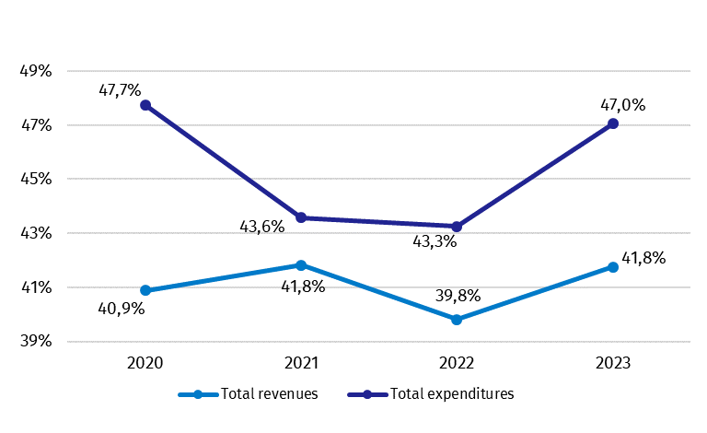

Similarly, as in case of deficit and debt, data on the general government revenues and expenditures for years 2020-2023 have been revised in relation to the previously published (April 2023). The revision of general government revenues resulted in an increase in 2020-2021 of 243 mln zl and 1 184 mln zl, respectively, and a decrease of 0,4 percentage points and 0,5 percentage points respectively in relation to GDP due to the increase of gross domestic product in these years. In 2023 the increase of revenues of 203 mln zl also resulted in an increase of revenue in relation to GDP by 0,2 percentage points. In 2022 there was a decrease of revenue of 631 mln zl (0,4 percentage points in relation to GDP). The changes mainly concerned transactions: other current transfers (in 2020-2021) and taxes on production and imports (in 2021-2022). The largest changes in 2023 mainly concerned transactions: output and output for own final use, payments for non-market output, other current transfers and capital transfers.
The increase in expenditure in 2020 of 70 mln zl resulted into a decrease in its relation to GDP by 0,5 percentage points due to the increase of gross domestic product. In 2023 there was also an increase in expenditure of 6 306 mln zl (0,3 percentage points in relation to GDP). In 2021-2022 a decrease in expenditure was recorded of 601 mln zl (0,5 percentage points in relation to GDP) and 23 mln zl (0,4 percentage points in relation to GDP), respectively. The changes mainly concerned the transactions subsidies and capital transfers (2020-2022) and intermediate consumption, compensation of employees, other current transfers and gross capital formation.
Detailed data on revenues and expenditures of the general government sector divided into ESA2010 transactions are presented in Annex 1.
Information on the general government deficit and debt of all EU Member States will be available on 22 October 2024 at 11 a.m. on the Eurostat website:
http://epp.eurostat.ec.europa.eu/portal/page/portal/eurostat/home.
Inventory of the methods, procedures and sources used for the compilation of deficit and debt data and the underlying government sector accounts according to ESA2010 prepared according to the European Commission’s guidelines in English version is available on Eurostat website:

http://ec.europa.eu/eurostat/web/government-finance-statistics/excessive-deficit-procedure/edp-inventories.

In case of quoting Statistics Poland data, please provide information: “Source of data: Statistics Poland”, and in case of publishing calculations made on data published by Statistics Poland, please include the following disclaimer: “Own study based on figures from Statistics Poland”.

Prepared by:  National Accounts Department  Director Anita Perzyna  Phone: (+48 22) 608 31 17 | Issued by:  Press Office  Mobile +48 695 255 032  Phone +48 22 608 38 04, +48 22 449 41 45,  +48 22 608 30 09  e-mail: obslugaprasowa@stat.gov.pl

stat.gov.pl/en/

@StatPoland

@GlownyUrzadStatystyczny

gus_stat

glownyurzadstatystycznygus

glownyurzadstatystyczny
Related studies
General government deficit and debt in 2023

Subject available in databases
Knowledge Databases – National Accounts

Important concepts available in the dictionary
Gross domestic product

* Data have been revised in relation to the previously published on 22.04.2023. The manual is available on the website: https://ec.europa.eu/eurostat/documents/3859598/16029761/KS-GQ-23-002-EN-N.pdf/77a75b07-61c3-7d34-5243-70d09bc00e44?version=3.0&t=1677163672121
More information on the revision can be found in the document Informacja Głównego Urzędu Statystycznego na temat rewizji rachunków narodowych w latach 1995–2022. Wpływ zmian na główne agregaty makroekonomiczne (in Polish only), available on website: https://stat.gov.pl/obszary-tematyczne/rachunki-narodowe/roczne-rachunki-narodowe/informacja-glownego-urzedu-statystycznego-na-temat-rewizji-rachunkow-narodowych-w-latach-1995-2022,17,2.html

