Spring assessment of the condition of agricultural and horticultural crops in 2024
29.05.2024
Winter and spring losses in winter cereal sown areas were small, amounting to about 0.9% for: winter cereal mixtures, about 0.3% for winter barley and about 0.1% for rye. In winter wheat and winter triticale plantations, winter losses were less than 0.1%.The current year's sown area of basic cereals with cereal mixtures is preliminary estimated to be smaller than last year's (after taking into account the area plowed up due to winter damage) at about 5.7 million hectares (a reduction of about 1.6%). According to preliminary estimates, the area under rape and turnip rape is expected to decrease by about 1.9%.
1.6 %
decrease in the sown area of basic cereals with cereal mixtures compared to the 2023 sown area
Spring vegetation of plants in 2024 started very early. In the second half of February, the start of vegetation of winter cereals, winter rape and vegetation on permanent grassland was observed throughout Poland. Agro-meteorological conditions during spring varied. The rainfall recorded in the first quarter of 2024, which exceeded the multi-year norm, contributed to good and in some places even excess moisture in the topsoil. In many areas of the country, excessive soil moisture made spring field work difficult or impossible and caused delays in the start of spring cereal and vegetable sowing. Warm and sunny weather in late March and early April accelerated the pace of plant growth and development. However, frosts occurring in the second half of April (in places even below -9°C) caused damage to some agricultural crops, as well as blossoming of fruit trees and bushes and berry plantations. Weather conditions in early May were favorable for plant growth and development. As a result of the cooling and ground frosts occurring in the second decade of May, the rate of plant growth and development slowed down. The shortage of precipitation recorded from the second half of April and in the first and second decades of May, which was significant in places, contributed to a decrease in soil water reserves. Drying of the topsoil occurred in most parts of the country, and the water needs of plants were not fully met.
In the second half of February, the start of vegetation of winter crops and permanent grassland was observed throughout the country
The good condition of fruit trees and bushes as well as plants on berry plantations at the beginning of the growing season deteriorated after a wave of frosts occurring at the end of April and the first half of May. As a consequence, significant damage was noted to both flower buds and already set fruit. In some areas of the country, plants were also damaged as a result of intense storms with hail that occurred in the second half of May.
Preliminary estimates of the area of certain crops for harvest in 2024
The area of winter basic cereals with cereal mixtures was estimated at about 4.5 million hectares
The area of winter basic cereals with cereal mixtures was estimated at about 4.5 million hectares, about 0.8% less than the sown area in the previous growing season, including:
- winter wheat over 2.3 million hectares,
- rye about 0.7 million hectares,
- winter barley about 0.3 million hectares,
- winter triticale more than 1.1 million hectares.
It is preliminary estimated that spring basic cereals with cereal mixtures were sown on about 1.2 million hectares, about 4,4% less than the sown area last year, of which:
The area of spring basic cereals with cereal mixtures was estimated at about 1.2 million hectares
- spring wheat about 0.2 million ha,
- spring barley about 0.3 million ha,
- oats about 0.5 million ha,
- spring triticale about 0.1 million ha,
- spring cereal mixtures about 0.2 million ha.
The area under potatoes is expected to be about 0.2 million hectares. The area under sugar beets is also estimated at about 0.2 million hectares.
The course of agrometeorological conditions from autumn 2023 to spring 2024
The course of weather conditions during the winter was generally favorable for overwintering plants
The high air and soil temperatures that persisted until the end of the second decade of November supported vegetation and created good conditions for the emergence, growth and development of late sown winter crops. It also enabled autumn field work and harvesting of root and fodder crops. Winter crops sown at optimum agrotechnical dates in November were tillering. The significant cooling and snowfall occurring in the third decade of the month contributed to the slowdown of plant life processes. In significant drops in air temperature near the ground level recorded mainly in the first half of December, sometimes reaching even - 15°C and below, despite the lack of snow cover or its low height, did not cause excessive cooling of the soil at the depth of the tillering node, but did inhibit the life processes of plants. In the second half of the month, as a result of warming (in places the air temperature rose up to 13°C), melting snow combined with rainfall resulted in ponding of water in the fields in some places. As a result of diurnal fluctuations in air temperature, there were repeated processes of freezing and thawing of the topsoil, which could cause weakening of the root system of plants.
The high air temperature persisting in early January caused disturbances in the winter dormancy of plants. The drops in air temperature recorded at the end of the first and second decade of the month (in places as low as minus 20°C and below) were short-lived and did not cause excessive cooling of the soil at the depth of the tillering node. At the end of the month, melting snow and rainfall caused ponding water in the fields in some places.
Exceptionally high air temperatures recorded in February, significantly exceeding the long-term norm, disturbed the winter dormancy of plants. In the second half of February, the start of the vegetation of winter plants and permanent grasslands was observed throughout the country. The rainfall that occurred during the month contributed to excessive moisture of the top layer of soil.
The weather in March was favorable for the growth and development of crops. The generally favorable agro-meteorological conditions recorded during the month enabled spring field work to be carried out. Locally, in the first decade (in evenly moist fields), and in a large area of the country in the second decade of the month, sowing of oats, spring wheat and spring barley began. Moistening the top layer of soil at the beginning of the growing season fully met the water needs of the plants.
Agrometeorological conditions in April varied. Warm days recorded in the first decade of the month were conducive to plant growth and development, as well as common field work. However, frosts in the second half of April (in places even below -9°C) caused damage to some agricultural crops, as well as flowering fruit trees and bushes and berry plantations. By the end of the month, the topsoil was observed to dry out in many areas of the country.
The warm and sunny weather at the beginning of May was conducive to widespread field work and plant growth and development. As a result of the cooling occurring in the second decade of May, the rate of plant growth and development slowed down. The marked shortage of precipitation during the month, significant in places, contributed to a decrease in soil water reserves. In many areas of the country there was a drying of the topsoil, and the water needs of plants were not fully met.
Table 1. Air temperature and precipitation from autumn 2023 to spring 2024
Specification | National average air temperature |  | National average rainfall totals
Specification | ºC | deviation from the norm ^{a)} | mm | % norm ^{a)}
AUTUMN ^{b)} 2023
September | 17.7 | 3.9 | 22.4 | 39.0
October | 10.9 | 2.1 | 75.5 | 162.0
November | 4.2 | 0.1 | 70.4 | 177.0
WINTER ^{b)} 2023/2024
December | 2.0 | 1.8 | 59.7 | 153.0
January | -0.3 | 0.9 | 50.8 | 139.0
February | 5.7 | 5.8 | 65.2 | 206.0
SPRING ^{b)} 2024
March | 6.7 | 3.6 | 28.4 | 75.1
April | 10.5 | 1.9 | 37.8 | 104.0
a) From 2021 IMiGW adopts as the average norm from years 1991-2020.
b) Monthly averages /Statistics Poland calculations based on IMiGW data/.

Assessment of the condition of agricultural crops

Winter crops
An assessment carried out in the first decade of May 2024 by Statistics Poland field appraisers shows that the state of winter cereal sowings is better than last year. It was assessed at 3.9 - 4.0 qualification degrees, while the condition of winter rape and turnip rape was assessed lower by 0.1 qualification degrees than last year's assessment.

Table 2. Spring assessment of winter crops
Years | Wheat | Rye | Barley | Triticale | Rape and turnip rape
Years | in qualifying grades ^{a)}
2006-2010^{b)} | 3.7 | 3.5 | 3.5 | 3.6 | 3.6
2011-2015^{b)} | 3.7 | 3.5 | 3.5 | 3.6 | 3.5
2016-2020^{b)} | 3.7 | 3.6 | 3.6 | 3.6 | 3.5
2020 | 3.6 | 3.5 | 3.6 | 3.6 | 3.6
2021 | 3.7 | 3.7 | 3.7 | 3.7 | 3.7
2022 | 3.8 | 3.8 | 3.8 | 3.8 | 3.8
2023 | 3.9 | 3.9 | 3.9 | 3.9 | 3.9
2024 | 4.0 | 3.9 | 3.9 | 4.0 | 3.8
a) A grade of „5” indicates very good condition, „4”– good, „3”– sufficient, „2” – poor, „1”– bad, disaster.
b) Annual average.

Spring crops
Spring cereals were sown in most voivodeships on time or with a slight delay. Rainfall caused delays in the start of spring cereal sowing in regions. Warm and sunny weather in late March and early April favored plant emergence and development. Significant soil dryness in late April and the first half of May inhibited the growth and development of spring crops.
The condition of spring cereals was assessed at 3.7 qualifying grades, i.e. higher than last year's assessment, and the condition of spring rape and turnip rape was assessed at 3.6 qualifying grades, i.e. at the level of last year's assessment.
Table 3. Spring condition assessment for spring crops
Years | Wheat | Barley | Oats | Triticale | Cereals mixtures | Rape and turnip rape
Years | in qualifying grades ^{a)}
2006-2010^{b)} | 3.4 | 3.4 | 3.4 | 3.4 | 3.4 | 3.3
2011-2015 ^{b)} | 3.5 | 3.5 | 3.5 | 3.5 | 3.5 | 3.4
2016-2020 ^{b)} | 3.4 | 3.5 | 3.5 | 3.4 | 3.4 | 3.4
2020 | 3.2 | 3.2 | 3.2 | 3.1 | 3.1 | 3.2
2021 | 3.4 | 3.4 | 3.5 | 3.4 | 3.4 | 3.5
2022 | 3.5 | 3.5 | 3.5 | 3.5 | 3.5 | 3.5
2023 | 3.7 | 3.6 | 3.7 | 3.6 | 3.6 | 3.6
2024 | 3.7 | 3.7 | 3.7 | 3.7 | 3.7 | 3.6
a) A grade of „5” indicates very good condition, „4”– good, „3”– sufficient, „2” – poor, „1”– bad, disaster.
b) Annual average.
Permanent grassland and clover plantations
The winter did not cause damage to permanent grasslands and their post-winter condition was generally good, currently rated higher than last year. Vegetation conditions of meadow-pasture vegetation in spring were generally favorable. Locally, rassland haying began in the first decade of May (earlier than usual).
In the voivodeship cross-section, assessments of the condition of permanent meadows ranged from 4.5 degrees in the Lubelskie Voivodeship to 3.0 degrees in the Opolskie Voivodeship. In the voivodeship cross-section, assessments of the condition of pastures ranged from 4.5 degrees in the Lubelskie Voivodeship to 2.9 degrees in the Opolskie Voivodeship. Assessments of the condition of red clover in pure sowing and in mixtures with grasses ranged from 4.5 degrees in the Lubuskie and Lubelskie Voivodeships to 3.1 degrees in the Opolskie Voivodeship.
Table 4. Condition assessment of permanent grassland and red clover
Years | Meadows | Pastures | Clover ^{a)}
Years | in qualifying grades ^{b)}
2006 – 2010^{c)} | 3.4 | 3.3 | 3.6
2011 – 2015^{c)} | 3.6 | 3.5 | 3.6
2016-2020 ^{c)} | 3.6 | 3.5 | 3.5
2020 | 3.3 | 3.2 | 3.5
2021 | 3.6 | 3.6 | 3.6
2022 | 3.6 | 3.6 | 3.7
2023 | 3.8 | 3.8 | 3.8
2024 | 3.9 | 3.9 | 3.9
a) Red clover in pure sowing and in mixtures with grasses.
b) A grade of „5” indicates very good condition, „4”– good, „3”– sufficient, „2” – poor, „1”– bad, disaster.
c) Annual average.
Assessment of the extent of winter crop losses
This year, total losses in the sown area of winter crops were low, at a higher level than last year, and their condition assessed very early in the spring was generally good.
A total of about 5.1 thousand hectares of winter cereal area sown in autumn 2023 have been qalified for ploughing
It is estimated that by mid-May a total of approximately 5.1 thousand hectares of area sown with winter cereals, i.e. 0.1% of the winter cereal area, had been ploughed and qualified for ploughing, of which:
- winter wheat about 1.7 thousand ha (in 2023 - 0.8 thousand ha),
- rye about 0.9 thousand ha (in 2023 - 0.3 thousand ha),
- winter barley about 1.0 thousand ha (in 2023 - 0.4 thousand ha),
- winter triticale about 1.1 thousand ha (in 2023 - 0.4 thousand ha),
- winter cereal mixtures about 0.4 thousand ha (in 2023 – less than 0.1 thousand ha).
The area of winter rape and turnip rape ploughed and qualified for ploughing amounted to approximately 3.9 thousand ha, i.e. 0.4 % of the area sown in the autumn (in 2023 - approximately 1.3 thousand ha ploughed).
According to the assessment of field appraiser of Statistics Poland, the main reasons for ploughing up winter crop plantations this year were flood losses, damage caused by forest animals and low plant density per 1 m². The highest winter and spring losses in winter cereal crops were recorded in the Podlaskie Voivodship (flood losses), while in rape in the Opolskie (damage caused by forest animals), and Zachodniopomorskie (frost damage) Voivodships.
Losses in stored agricultural and horticultural crops
Approximately 3.6 million tonnes of potatoes were destined for storage during the winter of 2023/2024, i.e. around 64% of the 2023 harvest. Losses in stored potatoes are estimated to similar than in the previous year - at around 11% of the total weight allocated for storage. The highest losses in stored potatoes were reported in the following voivodeships: Podkarpackie Voivodeship - approx. 15.0% as well as in Zachodniopomorskie and Dolnośląskie Voivodeships – at approx. 13.0%, and the lowest in the following voivodeships: Kujawsko-Pomorskie, Łódzkie and Warmińsko-mazurskie Voivodeships – at approx. 8.0%.
Table 5. Losses in stored crops
Years | Potatos | Cabbage | Onion | Carrots | Beetroot | Parsley | Celery | Leeks
Years | as a % of the total quantity of stored crops
2006- 2010^{a)} | 12 | 17 | 13 | 15 | 11 | 16 | 15 | 12
2011- 2015^{a)} | 11 | 17 | 14 | 14 | 12 | 15 | 15 | 12
2016-2020 ^{a)} | 11 | 13 | 12 | 12 | 11 | 13 | 13 | 12
2020 | 11 | 12 | 11 | 12 | 10 | 12 | 11 | 12
2021 | 11 | 11 | 11 | 13 | 10 | 12 | 11 | 10
2022 | 12 | 11 | 11 | 12 | 10 | 11 | 11 | 10
2023 | 11 | 11 | 12 | 13 | 10 | 11 | 11 | 11
2024 | 11 | 10 | 11 | 13 | 11 | 12 | 11 | 12
a) Annual average
In the 2023/24 season, the share of storage cabbage decreased compared to the previous season. An increase was recorded in case of leeks, onions and parsley. The share of stored carrots, beetroots and celeriac was also slightly higher. Losses that occurred during vegetable storage did not differ from the levels observed in previous years. The lowest losses were recorded in the Mazowieckie, Świętokrzyskie and Kujawsko-Pomorskie voivodeships, and the highest in the Wielkopolskie, Dolnośląskie Lubelskie i Zachodniopomorskie voivodeships.
In the current season, the share of apples sent to storage was slightly higher than in the two previous years, while the level of losses remained at a similar level (i.e. 12%). The largest losses in storage facilities were recorded in the Wielkopolskie and Zachodniopomorskie Voivodeships, and the smallest in the Mazowieckie, Podkarpackie and Kujawsko-Pomorskie Voivodeships.
Assessment of overwintering of trees, fruit bushes and berry plantations and the condition of horticultural crops
The course of the winter of 2023/24, as in several previous years, was conducive to maintaining the good condition of fruit plants. Weather conditions at the beginning of the year stimulated trees and shrubs, which resulted in the acceleration of vegetation from 2 to more than 3 weeks compared to the long-term average. As a consequence, fruit plants started blooming exceptionally early. Favorable thermal conditions significantly deteriorated in the second decade of April. The cold air masses flowing in at that time caused significant frost damage to flower buds and already set fruit, especially in regions of the country with a high concentration of fruit crops. An additional factor that will limit the level of this year's fruit harvest were storms with intense hail that hit Poland in the second half of May. As a result of violent weather anomalies, damage to both trees and fruit bushes was reported in many parts of the country.
Strawberries preserved the winter in good condition, and usually started their physiological activity earlier than in previous years. Heavy rainfall at the beginning of the year and the resulting water-logging led to localized planting losses. As a result of the April frosts, earlier varieties and already developed king buds were affected. The phenomenon mainly affected uncovered crops. The use of covers was able to protect plantations from hail in the second half of May, but at the same time promoted the development of fungal diseases.
The weather conditions so far in most parts of the country have not been favorable for growing field vegetables. Due to excessive soil moisture, especially in the north-east and south-east of Poland, there were delays in field work. More favorable conditions occurred in the central and western parts of the country. Sowing of field vegetables in these regions was more advanced compared to last year. Due to sufficient moisture of the top layer of soil, uniform emergence of vegetables sown at the end of March and the beginning of April was observed. The lack of rainfall recorded in the second half of April in many regions of Poland resulted in a slowdown in the growth and development of plants. A significant threat to field vegetable crops in 2024 was frost occurring at the end of April and early May. They posed a great risk of frost losses if plant covers were not used. The increasing shortage of rainfall in the following weeks of May contributed to the weakening of the condition of vegetables, especially on plantations without efficient irrigation systems. Due to local hailstorms, losses were reported in some areas of the country at the end of May.
The level of supply of seed and fertilizers in the first half of 2024 corresponded to the demand of producers. A problematic issue is the gradual withdrawal of some proven and effective plant protection products from the market, which makes it difficult to effectively combat pathogens and pests in horticultural crops.
Agricultural and horticultural crop area forecasting using satellite remote sensing
In the field of work on forecasting the area of agricultural and horticultural crops, activities are carried out aimed at using satellite imagery. The new data acquisition system is the basis of a new methodology for agricultural research.
Within the framework of the "Spring assessment of the condition of agricultural and horticultural crops", an estimation of the sown area of winter crops (without distinguishing between crop species) and winter rape and turnip rape was made using satellite remote sensing methods.
Sentinel-1A optical images (observation period from 15.10.2023 to 10.05.2024) formed the basis for the estimation. The estimation was based on segmentation and cla-sification of the object-oriented T2 coherence matrix and the parameters of the polaryme-tric H/α decomposition using machine learning algorithms (Random Forest). The classification accuracy will be validated against in situ data. A total of 230 satellite scenes of 250 km wide SLC (Single Look Com-plex) radar data were used. A crop database developed using photo-interpretation methods based on Sentinel-2 data was used to teach the system and perform the classification.

Map 1. Estimation of sown area with winter crops
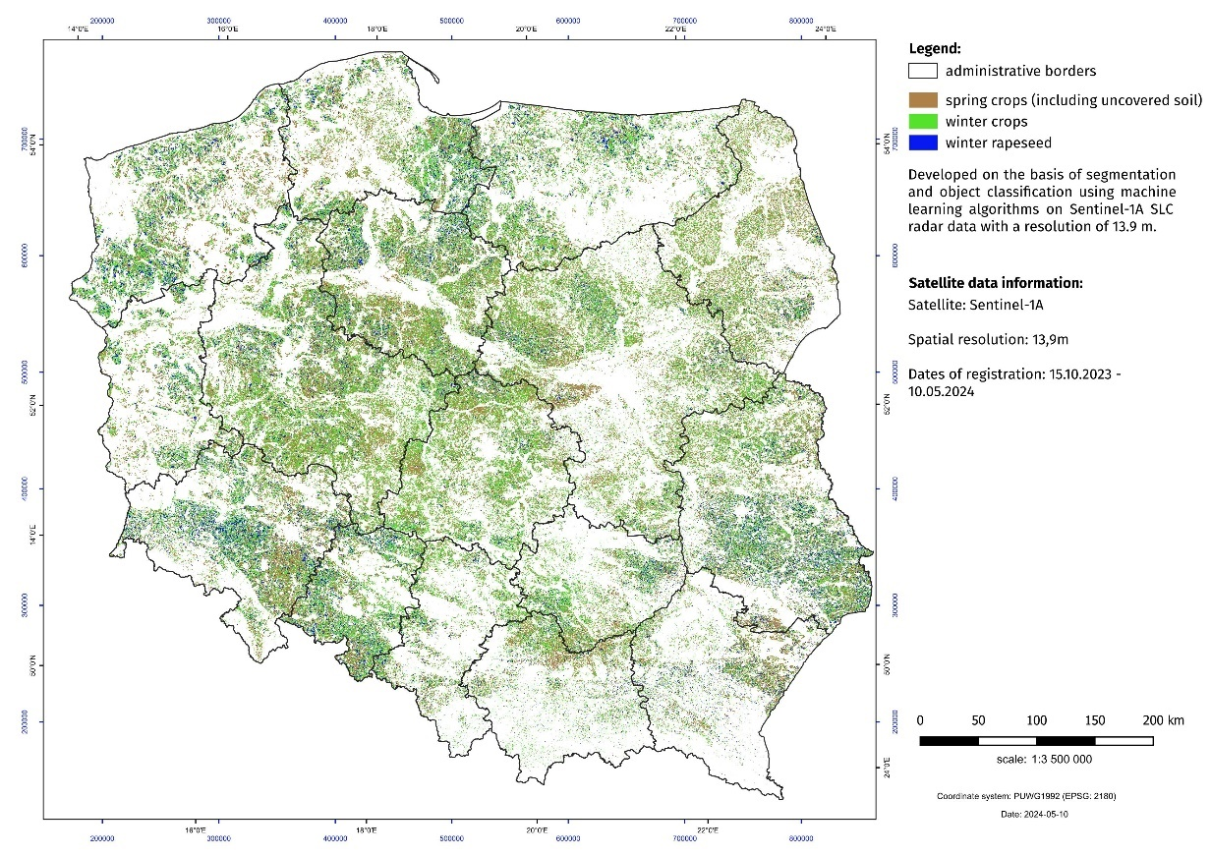

In case of quoting Statistics Poland data, please provide information: “Source of data: Statistics Poland”, and in case of publishing calculations made on data published by Statistics Poland, please include the following disclaimer: “Own study based on figures from Statistics Poland”.
Prepared by:  Agriculture and Environment Department  Director Marta Wojciechowska  Phone: (+48 22) 608 34 62 | Issued by:  Press Office  Mobile +48 695 255 032  Phone +48 22 608 38 04, +48 22 449 41 45,  +48 22 608 30 09  e-mail: obslugaprasowa@stat.gov.pl

www.stat.gov.pl/en/

@StatPoland

@GlownyUrzadStatystyczny

gus_stat

glownyurzadstatystycznygus

glownyurzadstatystyczny
elated information
Production of agricultural and horticultural crops in 2023

Data available in databases
BDL: Sown area

Terms used inn official statistics

BDL: Sown area

The information includes the results of the spring crop condition assessment conducted in the first half of May 2024. The assessment was based on expert opinions of Statistics Poland's field appraisers prepared on the basis of vetting of fields, meadows and orchards. The spring crop condition assessment also includes an estimate of the sown area of major agricultural crops using satellite remote sensing methods and an estimate of winter and spring losses.

