The demand for labour in the fourth quarter of 2023
In Poland, at the end of the fourth quarter of 2023, there were 97.1 thousand job vacancies (12.7% fewer than at the end of the third quarter of 2023).
The largest annual decrease in the number of job vacancies occurred in the Information and communication section. The job vacancy rate decreased by 0.14 percentage points (0.78%) compared with the fourth quarter of 2022.
⇩ 16.1%
Decrease in the number of job vacancies compared with the end of the fourth quarter of 2022
At the end of the fourth quarter of 2023, job vacancies were available in 5.0% of the 610.9 thousand national economy entities. There were 16.7% fewer of them than at the end of the third quarter of 2023 and 6.3% fewer than at the end of the fourth quarter of 2022.
On an annual basis, the number of job vacancies reported to labour offices decreased (by 9.1%)
There were 97.1 thousand job vacancies in Poland at the end of the fourth quarter of 2023. There were 14.1 thousand fewer of them than in the third quarter of 2023 and 18.6 thousand fewer than in the corresponding quarter of 2022. One in five job vacancies was a newly created job (18.1 thousand).
Employees were sought, among others, through labour offices, to which 12.4% of the total number of job vacancies were reported.
The job vacancy rate, which measures the share of job vacancies in the total number of jobs (i.e. occupied and vacant), can be used to assess the labour market situation in terms of reported labour demand. At the end of the fourth quarter of 2023, this rate was 0.78%, down 0.14 percentage points from the fourth quarter of 2022.
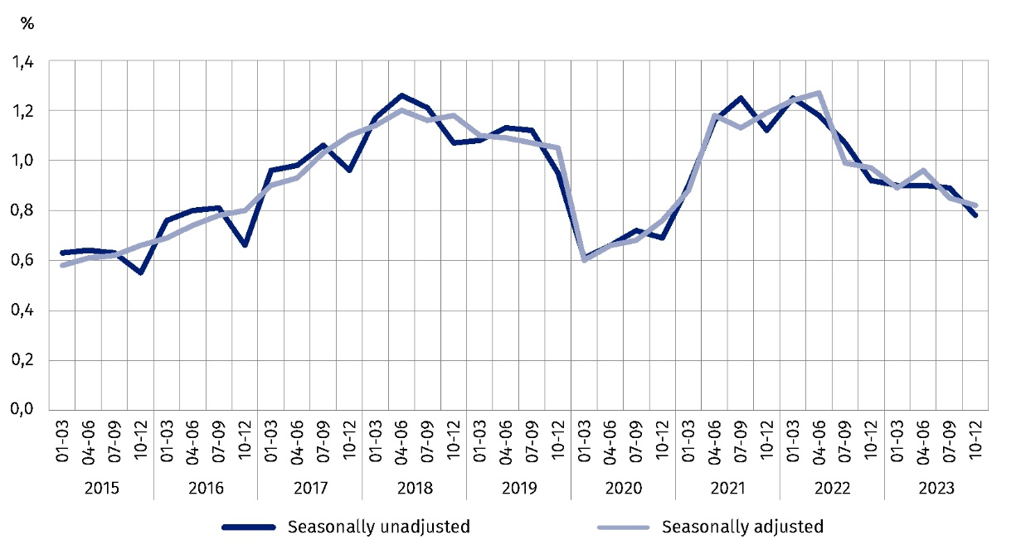
Chart 1. Job vacancy rate
As at the end of the quarter
Across regions (NUTS 2), at the end of the fourth quarter of 2023, the highest job vacancy rate occurred in the Opolskie region (1.09%). A high rate also occurred in the Lubuskie (1.06%) and Zachodniopomorskie (1.04%) regions. The lowest job vacancy rate was recorded in the Świętokrzyskie region (0.47%).
At the end of the fourth quarter of 2023, the highest job vacancy rate was recorded in the Opolskie region and the lowest in the Świętokrzyskie region
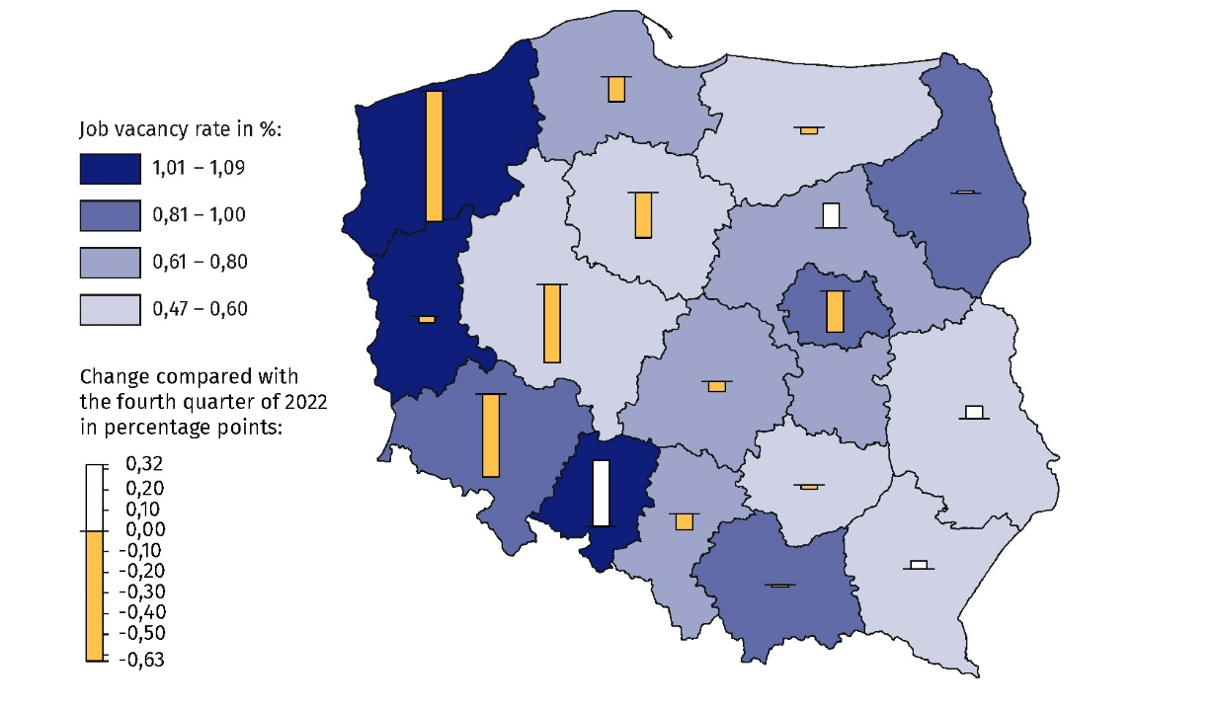
Map 1. Job vacancy rate in regions (NUTS 2) in the fourth quarter of 2023
As at the end of the quarter
The job vacancy rate in the Information and communication section recorded at the end of the fourth quarter of 2023 decreased by 1.0 percentage point year-over-year
Taking into account the kind of activity conducted, the largest number of job vacancies was in national economy entities in the Manufacturing section (20.6% of their total number).
The number of job vacancies in this section was 21.6% lower than at the end of the fourth quarter of 2022. A decrease in the number of job vacancies compared with the fourth quarter of 2022 was also recorded in sections: Information and communication (by 35.0%, i.e. to 6.7 thousand), Administrative and support service activities (by 33.3%, i.e. to 2.6 thousand jobs) and Other service activities (by 28.6%, i.e. to 1.0 thousand jobs). On the other hand,
an increase in the number of job vacancies compared with the fourth quarter of 2022 was recorded in sections: Electricity, gas, steam and air conditioning supply (by 83.3%, i.e. to 1.1 thousand jobs), Agriculture, forestry and fishing (by 25.0%, i.e. to 0.5 thousand jobs)
and Human health and social work activities (by 22.2%, i.e. to 7.7 thousand jobs).
At the end of the fourth quarter of 2023, the highest job vacancy rate was in the Information and communication section (1.82%).
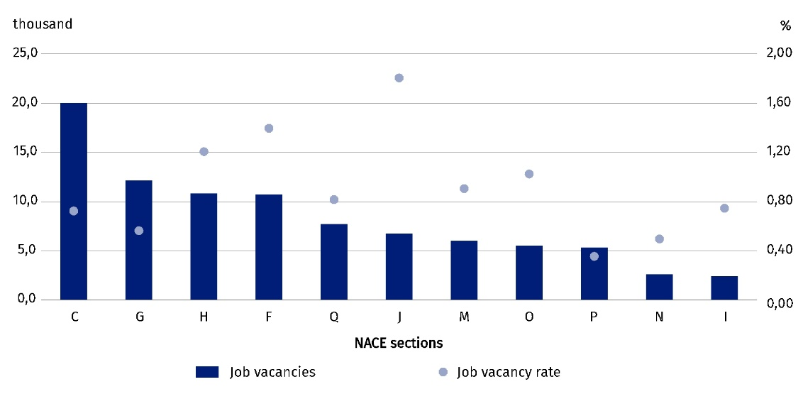
Chart 2 . Job vacancies and the job vacancy rate in selected PKD/NACE sections in the fourth quarter of 2023
As at the end of the quarter
The Labour Demand Survey also allows to determine the demand for employees across major occupational groups. Of the 20.0 thousand job vacancies in national economy entities from the Manufacturing section recorded at the end of the fourth quarter of 2023, the most jobs were available for occupations belonging to the major occupational group of Craft and related trades workers (41.4%). In entities from the Trade; repair of motor vehicles^{Δ} section, job vacancies were most often intended for occupations from the group of Service and sales workers (34.3% of the 12.1 thousand job vacancies in entities from this section). The majority of job vacancies in the Transportation and storage section were in the major occupational group of Plant and machine operators, and assemblers (72.2% of the 10.8 thousand job vacancies in entities from this section).
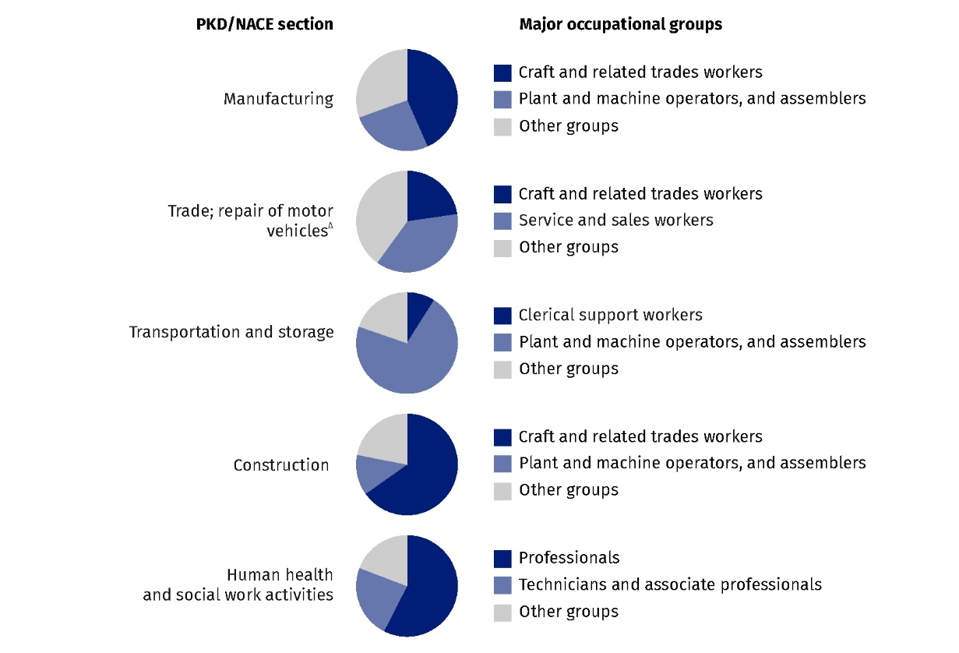
Chart 3. Structure of job vacancies in selected PKD/NACE sections by major occupational group in the fourth quarter of 2023
As at the end of the quarter
In this news release abbreviated names of NACE, Rev. 2 sections were used. Abbreviations are marked with a ‘Δ’ symbol. Full names are available on the Eurostat website at: https://ec.europa.eu/eurostat/web/metadata/classifications .
Relative numbers (rates, percentages) were calculated on the basis of absolute data expressed with greater accuracy than given in the publication.
In the case of quoting Statistics Poland data, please provide information: ‘Source of data: Statistics Poland’, and in the case of publishing calculations made on data published by Statistics Poland, please provide information: ‘Own elaboration based on Statistics Poland data.’
Prepared by:  Statistical Office in Bydgoszcz  Director Wiesława Gierańczyk, Ph.D.  Phone: (+48 52) 366 93 90 | Issued by:  The Spokesperson for the President  of Statistics Poland  Karolina Banaszek  Phone: (+48) 695 255 011
Press Office  Phone: (+48 22) 608 38 04  e-mail: obslugaprasowa@stat.gov.pl |   stat.gov.pl/en/

@StatPoland

@GlownyUrzadStatystyczny

gus_stat

glownyurzadstatystycznygus

glownyurzadstatystyczny
Related information
The demand for labour in 2022 – annual publication
The demand for labour in the third quarter of 2023 – news release
Other publications that contain the results of these surveys: stat.gov.pl → Topics → Labour Market
Methodological report. The demand for labour
Data available in databases
Knowledge Databases → Data → Society → Labor market
Strateg → Statistics by theme → Labour market
Local Data Bank → Labour market
Statistics for the SDGs – global indicators
Terms used in official statistics
Demand for labour
Vacancies

Data concern entities of the national economy and their local units with 1 or more employees, conducting economic activity in the scope of PKD/NACE sections from A (excluding natural persons running individual agricultural holdings) to section S.

