The demand for labour in the third quarter of 2024
In Poland, at the end of the third quarter of 2024, there were 3.1% more job vacancies than at the end of the second quarter of 2024. The job vacancy rate increased by 0.04 percentage points (0.93%) compared with the second quarter of 2024.
2.8%
Increase in the number of job vacancies compared with the end of the third quarter of 2023.
At the end of the third quarter of 2024, 114.3 thousand job vacancies were recorded in Poland. This was 3.4 thousand more than in the second quarter of 2024 and 3.1 thousand more than in the corresponding quarter of 2023.
The survey covers national economy entities and their local units with 1 or more employees
The job vacancy rate can be used to assess the labour market situation in terms of reported labour demand. At the end of the third quarter of 2024, the rate was 0.93%, i.e. 0.04 percentage points higher than in the second quarter of 2024 and 0.04 percentage points higher than in the corresponding quarter of the previous year.
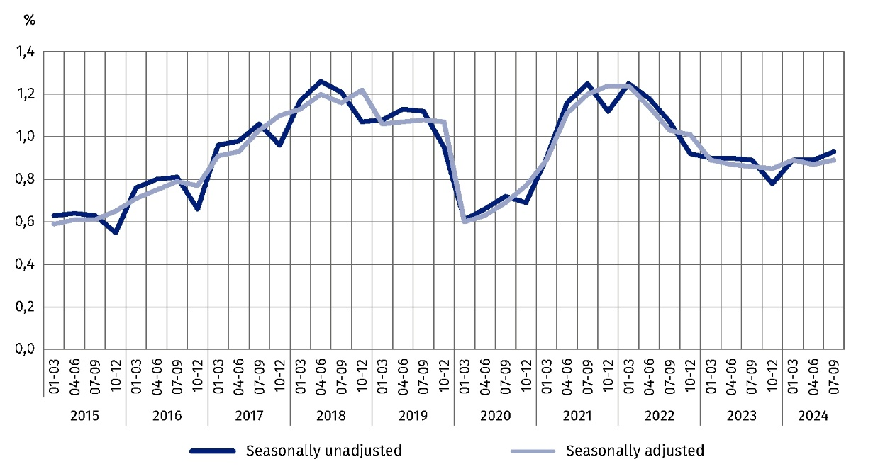
Chart 1. Job vacancy rate
As at the end of the quarter
Across regions (NUTS 2), at the end of the third quarter of 2024, the highest job vacancy rate occurred in the Warszawski stołeczny region (1.23%). In contrast, the lowest job vacancy rate was recorded in the Podlaskie region (0.43%).
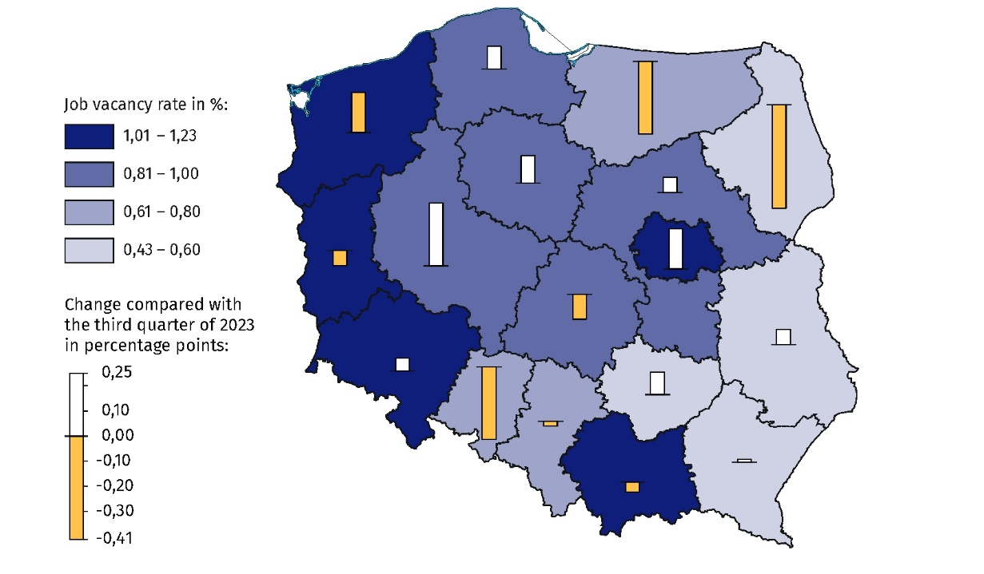
Map 1. Job vacancy rate in regions (NUTS 2) in the third quarter of 2024
As at the end of the quarter
The job vacancy rate measures the share
of job vacancies in the total number of jobs
(i.e. occupied and vacant jobs)
Taking into account the kind of activity conducted, the highest job vacancy rate was recorded in the Construction section (1.80%). The largest increase in the job vacancy rate compared with the third quarter of 2023 was recorded in the Professional, scientific and technical activities section (an increase of 0.49 percentage points to 1.56%). At the end
of the third quarter of 2024, the largest decrease in the job vacancy rate compared with
the corresponding quarter of 2023 was in the Information and communication section
(i.e. by 0.40 percentage points to 1.49%).
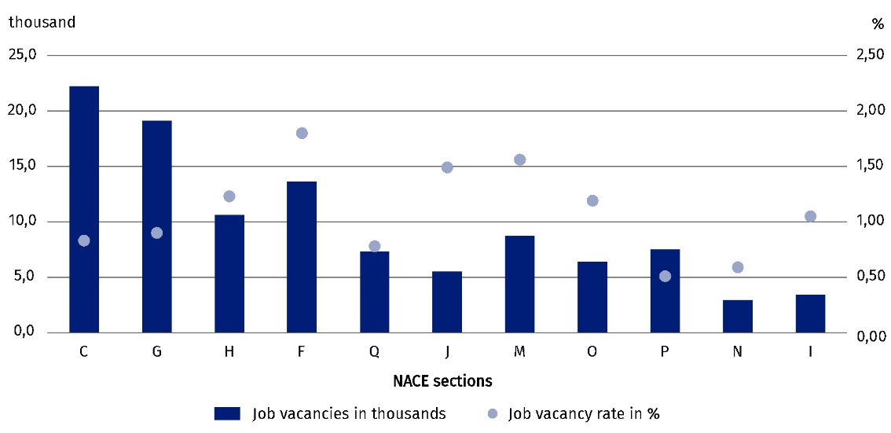
Chart 2. Job vacancies and the job vacancy rate in selected PKD/NACE sections in the third quarter of 2024
As at the end of the quarter
The Labour Demand Survey also allows to determine the demand for employees across major occupational groups. Of the 22.2 thousand job vacancies in national economy entities in the Manufacturing section at the end of the third quarter of 2024, the most job vacancies were available for occupations belonging to the major occupational group of Craft and related trades workers (9.2 thousand). In entities in the Construction section, job vacancies were most often intended for occupations belonging to the major occupational group of Craft and related trades workers (9.5 thousand out of 13.6 thousand job vacancies). The majority of job vacancies in the Trade; repair of motor vehicles^{Δ} section were for occupations belonging to the major occupational group of Service and sales workers (7.3 thousand out of 19.1 thousand job vacancies).
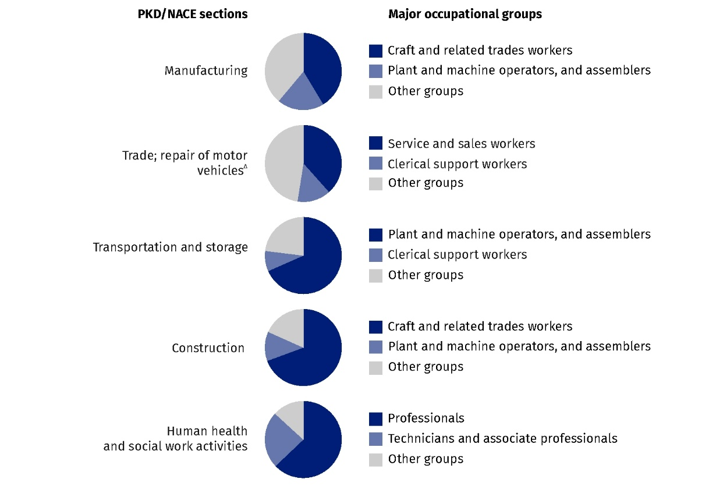
Chart 3. Structure of job vacancies in selected PKD/NACE sections by major occupational group in the third quarter of 2024
As at the end of the quarter
In this news release abbreviated names of NACE, Rev. 2 sections were used. Abbreviations are marked with a ‘Δ’ symbol. Full names are available on the Eurostat website at: https://ec.europa.eu/eurostat/web/metadata/classifications
Relative numbers (rates, percentages) were calculated on the basis of absolute data expressed with greater accuracy than given in the publication.
In the case of quoting Statistics Poland data, please provide information: ‘Source of data: Statistics Poland’, and in the case of publishing calculations made on data published by Statistics Poland, please provide information: ‘Own work based on Statistics Poland data.’
Prepared by:  Statistical Office in Bydgoszcz  Director Wiesława Gierańczyk, Ph.D.  Phone: (+48 52) 366 93 90 | Issued by:  Press Office  Mobile phone: +48 695 255 032  Landline phones: +48 22 608 38 04, +48 22 449 41 45, +48 22 608 30 09  e-mail: obslugaprasowa@stat.gov.pl

stat.gov.pl/en/

@StatPoland

@GlownyUrzadStatystyczny

gus_stat

glownyurzadstatystycznygus

glownyurzadstatystyczny
Related information
The demand for labour in 2023 – annual publication
The demand for labour in the second quarter of 2024 — news release
Other publications that contain the results of these surveys: stat.gov.pl → Topics → Labour Market
Methodological report. The demand for labour
Data available in databases
Knowledge Databases → Search for data → Society → Labour market
Strateg → Statistics by theme → Labour market
Local Data Bank → Labour market
Statistics for the SDGs – global indicators
Terms used in official statistics
Demand for labour
Vacancies

