Labour cost index in the quarters of 2023
In the fourth quarter of 2023, the labour cost index increased by 1.9% compared to the third quarter of the same year, and compared to the fourth quarter of 2022, it increased by 12.8%.
8.7%
Increase in the labour cost index in the fourth quarter of 2023
in relation to the first quarter
of 2023

Labour cost index
The Labour cost index (LCI) is the Laspeyres index of hourly labour costs recorded in the reference quarter in relation to hourly costs in the base year. The base year is revised in
4-year cycle. The basis for determining the index in the current year is 2020. Due to the impact of calendar effects and seasonal fluctuations on employment and time worked, the LCI indicators are subject to the procedure of working days compensation and seasonal adjustments.
The Labour cost index shows the development of labour costs incurred by the employer. Labour costs consist of wages and salaries, social security contributions and taxes paid by the employer, decreased by subsidies received.
Labour cost index is a Euro indicator, one of the European Economic Indicators (PEEI), which describes the current macroeconomic situation of the European Union
$$Labour cost index =\frac{ \frac{labour cost in the current period}{number of hours worked in the current period} }{\frac{labour cost in the base period}{number of hours worked in the base period}} ∙100$$
In 2023, the labour costs increased and the number of hours worked slightly decreased in Poland. In the fourth quarter of 2023, the number of hours worked was 0.4% lower than a year earlier, and labour costs in the same period increased by 13.1%. Between the first and fourth quarter of 2023, the labour cost index increased by 8.7%. The lowest values of LCI were achieved in the first quarter of 2023. In the second and third quarters the values of the index were by 4.7% and 6.7% higher than in the first quarter.

Chart 1. Labour cost index
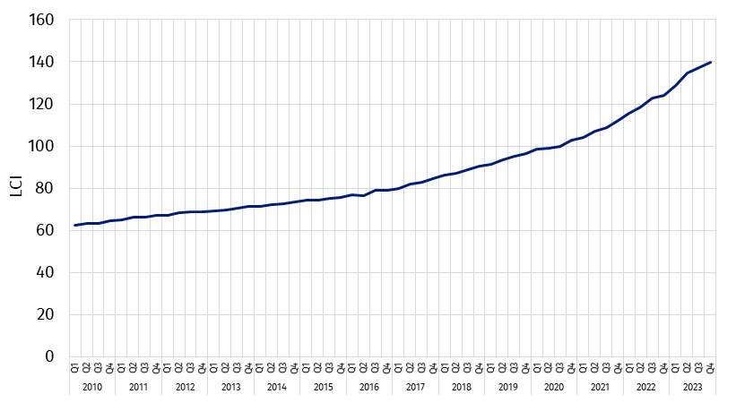
The increase of LCI was recorded in all kinds of activities and ranged from 4.6% in Information and Communication section to 22.6% in Mining and Quarrying section.
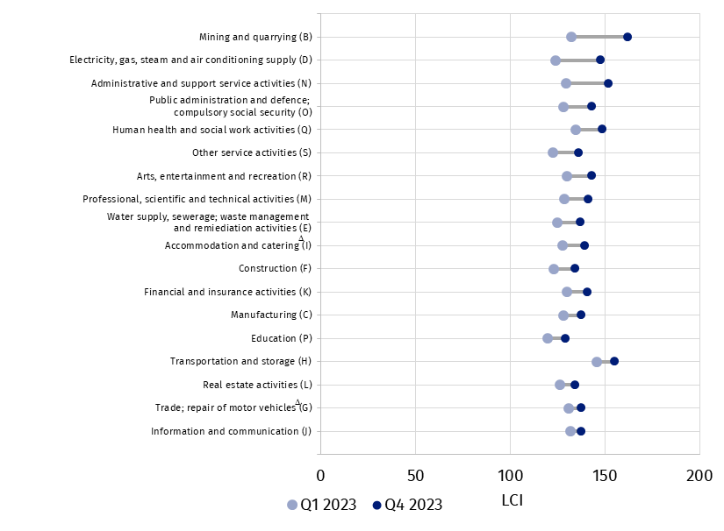
Chart 2. Labour cost index by PKD/NACE ª sections in the first and fourth quarters of 2023
a PKD/NACE sections sorted by the difference in the value of LCI between the fourth and first quarter of 2023

Poland compared to the European Union
In the fourth quarter of 2023 Poland was among the European Union countries with the highest values of the Labour cost index
The methodological arrangements resulting from international implementing regulations, enable the comparison of LCI of the European Union countries and the countries of the European Economic Area.

Table 1. Labour cost index for Poland and groups of European countries in the quarters
of 2023
TERRITORIAL AGGREGATION | Q1 | Q2 | Q3 | Q4
POLAND | 128.6 | 134.7 | 137.2 | 139.8
European Union countries (27 counties) | 109.7 | 110.8 | 112.4 | 113.8
Euro area countries (20 countries) | 108.6 | 109.6 | 111.1 | 112.4
Source of data: Eurostat

Data for 2023 show that in the fourth quarter the labour cost index in Poland was by 22.8% higher than the average for the entire EU. The lowest value of the index was recorded in Italy – 103.4 and the highest in Bulgaria – 148.1.

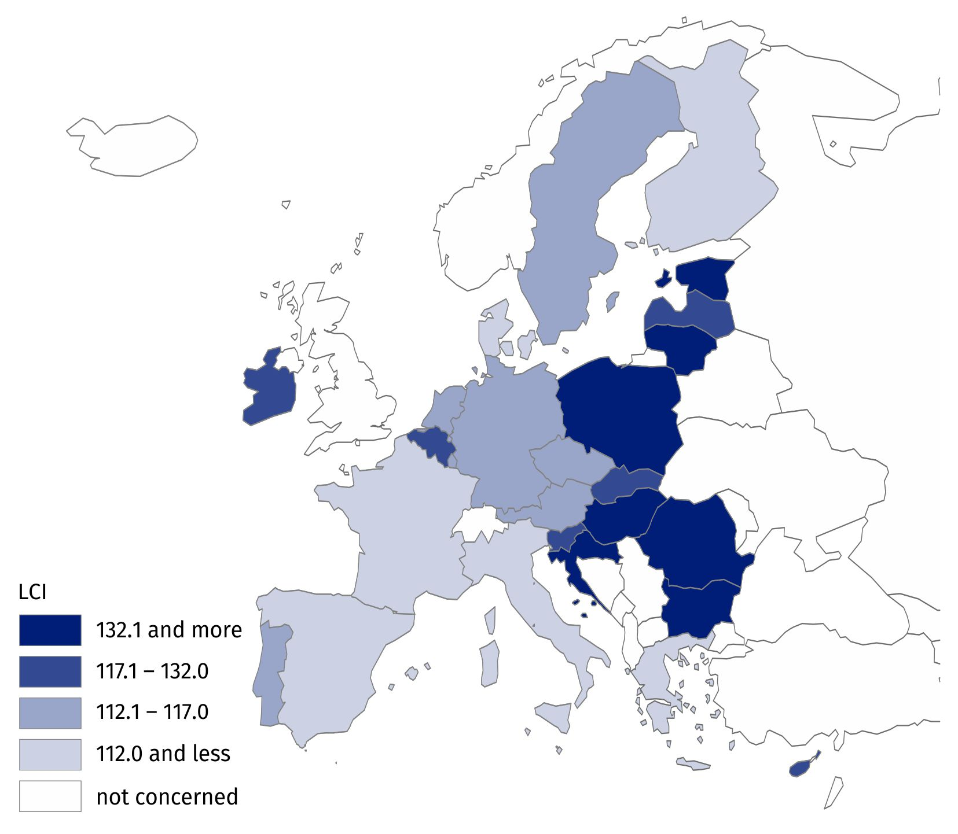
Map 1. Labour cost index for the European countries in the fourth quarter of 2023
Source of data: Eurostat
Taking into account the distribution of the labour cost index by kinds of activity, it can be noted that, compared to the European Union, the values of quarterly LCI in Poland are much higher and more diversified.

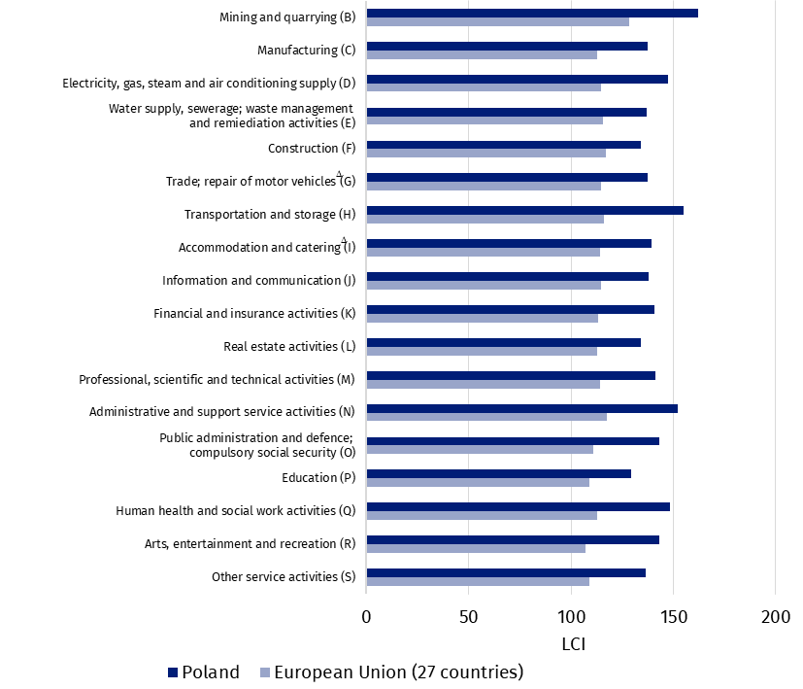
Chart 3. Labour cost index by PKD/NACE sections in the fourth quarter of 2023 for Poland
and the European Union (27 countries)
Source of data: Eurostat
In the fourth quarter of 2023, the highest labour cost index in the EU, as well as in Poland, was recorded in the Mining and Quarrying section. The lowest values of the index in Poland were observed in Education section, and in the EU in Arts, entertainment and recreation section. The largest difference in the value of the labour cost index between Poland and the European Union occurred in the Transportation and storage section – in Poland amounted to 155.0, and in the EU 116.2.
In this news release abbreviated names of NACE, Rev. 2 sections were used. Abbreviations are marked with a ‘Δ’ symbol. Full names are available on the Eurostat website at: https://ec.europa.eu/eurostat/data/classifications
In the case of quoting Statistics Poland data, please provide information: "Source of data: Statistics Poland", and in the case of publishing calculations made on data published by Statistics Poland, please provide information: "Own elaboration based on Statistics Poland data.".

Prepared by:  Statistical Office in Bydgoszcz  Director Wiesława Gierańczyk, Ph.D.  Phone: (+48 52) 366 93 90 | Issued by:  Press Office  Phone: (+48) 695 255 011
Press Office  Phone: (+48 22) 608 38 04  e-mail: obslugaprasowa@stat.gov.pl |   stat.gov.pl/en/

@StatPoland

@GlownyUrzadStatystyczny

gus_stat

glownyurzadstatystycznygus

glownyurzadstatystyczny
Data available in databases
Eurostat Database – Labour market
Terms used in official statistics
Labour cost index
Time worked
Labour costs

