Therapeutic activities of health resort facilities and inpatient rehabilitation facilities in 2023
At the end of 2023, there were operating 257 health resort facilities. 903.8 thousand patients were admitted to health resort facilities during a year, of which 819.2 thousand were inpatients. 73.0 thousand inpatients were treated in 48 inpatient rehabilitation facilities.
10.4%
Increase in the number of inpatients in health resort facilities compared to 2022

Health resort facilities
819.2 thousand inpatients and 84.6 thousand outpatients were treated in health resort facilities

At the end of 2023, there were operating 41 health resort hospitals (of which 3 for children), 188 health resort sanatoriums (of which 2 for children and 1 sanatorium in underground mining excavations), 7 outpatient health resort units and 21 natural healing centres which conduct their treatment in health resort complexes.
At the end of the year there were almost 45.7 thousand health resort beds in health resort hospitals and sanatoriums (the increase by 68 beds compared to 2022). 819.2 thousand inpatients were treated during the year (by 10.4% more in relation to the previous year). Women accounted for 60.3% of the total inpatients being treated, while people aged 65 years and more – 56.1%. Average stay of inpatients was 15.9 days.
The most inpatients were treated in health resort facilities in Zachodniopomorskie Voivodship (222.9 thousand persons) followed by Kujawsko-Pomorskie (169.1 thousand), Dolnośląskie (99.8 thousand) and Małopolskie (93.5 thousand). In total, 71.4% of inpatients were admitted in these mentioned voivodships.
At the national level the share of foreigners in inpatients was 4.9%. The vast majority of foreigners (95.1%) were admitted to health resort facilities in three voivodships: Zachodniopomorskie, Dolnośląskie and Pomorskie.
Table 1. Activities of health resort facilities by type of facility in 2023
Specification | Health resort hospitals | Health resort sanatoriums | Outpatient health resort units | Natural healing centres
Health resort facilities  (as of 31 December) | 41 | 188 | 7 | 21
Beds in thousands  (as of 31 December) | 7.9 | 37.8 | – | –
Inpatients in thousands | 121.4 | 697.8 | – | –
Average stay of inpatients (in days) | 18.6 | 15.4 | – | –
Outpatients in thousands | 6.5 | 28.1 | 15.3 | 34.7
In 2023, 57.3% of inpatients were subsidized by National Health Fund (by 0.4 pp less than in 2022). However, self-pay inpatients were 37.1% of inpatients (by 1.0 pp more than in the previous year).

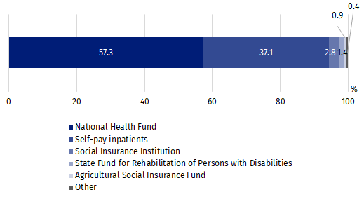
Chart 1. The structure of inpatients treated in health resort facilities by type of financing in 2023
In 2023, 84.6 thousand outpatients were treated in health resort facilities (by 8.5% more than in the previous year). Above 74.2% of patients were admitted to outpatient health resort units and natural healing centres.
Table 2. Activities of health resort facilities by voivodships in 2023
The most inpatients were treated in health resort facilities in Zachodniopomorskie Voivodship (222.9 thousand persons)

Voivodships | Beds (as of 31 December) | Inpatients | Outpatients | Average stay of inpatients (in days)
Voivodships | in thousands |  |  | Average stay of inpatients (in days)
Poland | 45.7 | 819.2 | 84.6 | 15.9
Dolnośląskie | 5.7 | 99.8 | 27.5 | 16.1
Kujawsko-pomorskie | 8.8 | 169.1 | 16.0 | 15.9
Lubelskie | 1.4 | 23.2 | 3.4 | 17.6
Łódzkie | 0.1 | 1.7 | 0.3 | 19.7
Małopolskie | 5.8 | 93.5 | 14.9 | 17.7
Mazowieckie | 0.2 | 2.6 | 0.4 | 20.6
Podkarpackie | 4.2 | 63.6 | 4.0 | 18.9
Podlaskie | 0.5 | 10.0 | 0.6 | 13.9
Pomorskie | 1.3 | 23.5 | 2.3 | 15.3
Śląskie | 2.6 | 39.1 | 0.9 | 18.4
Świętokrzyskie | 3.4 | 64.4 | 6.1 | 15.2
Warmińsko-mazurskie | 0.5 | 5.8 | – | 20.4
Zachodniopomorskie | 11.2 | 222.9 | 8.1 | 13.5
Note: In three voivodships (Lubuskie, Opolskie, Wielkopolskie) the health resort facilities do not occur.
38.0 million medical services were provided in health resort facilities

In 2023, 38.0 million medical services were provided in health resort facilities (by 8.3% more than in 2022). As in the previous year, most medical services belonged to natural healing services (27.1%), among which peat treatments and mineral baths predominated. Kinesiotherapy (18.4%), electrotherapy (11.9%), massage (10.5%) and hydrotherapy (9.5%) were also popular.

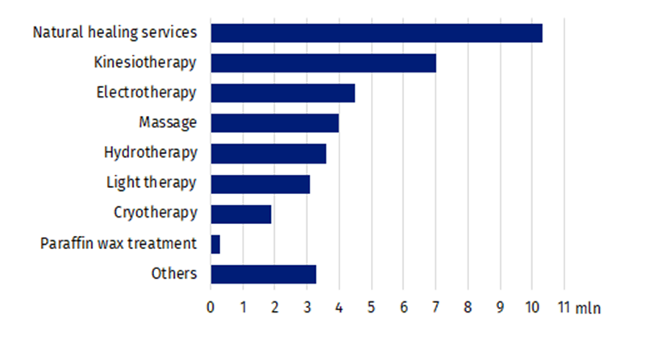
Chart 2. Medical services provided in health resort facilities by type of service in 2023

Inpatient rehabilitation facilities
73.0 thousand patients were treated in inpatient rehabilitation facilities
As the end of 2023, 48 inpatient rehabilitation facilities were operating in which there were 5.2 thousand health resort beds. During the year 73.0 thousand patients were admitted (by 2.1% less than in the previous year), of whom 64.9 thousand inpatients and 8.1 thousand outpatients.
Women accounted for 54.5% of the total inpatients being treated, while people aged 65 years and more – 41.6%. Average stay of inpatients was 13.6 days.

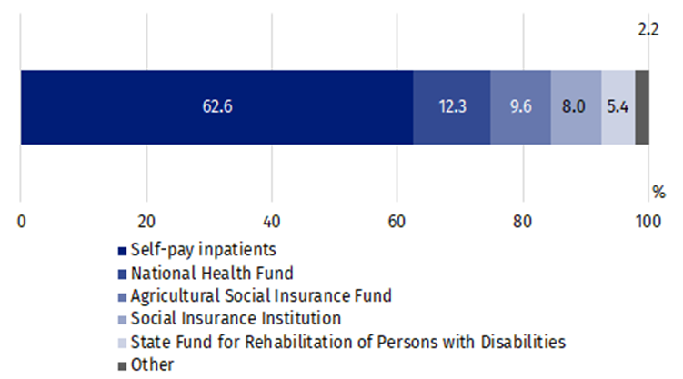
Chart 3. The structure of inpatients treated in inpatient rehabilitation facilities by type of financing in 2023
In inpatient rehabilitation facilities, most inpatients treated belonged to self-pay inpatients – 40.6 thousand persons. Among institutions subsidized inpatients, the National Health Fund subsidized 8.0 thousand persons, the Agricultural Social Insurance Fund – 6.2 thousand and the Social Insurance Institution – 5.2 thousand.
3.2 million medical services were provided in inpatient rehabilitation facilities during 2023 (by 35.9% more than in previous year), most of them belonged to kinesiotherapy (31.4%).
In the case of quoting data from the Statistics Poland, please provide information: "Statistics Poland data source", and in the case of publishing calculations made on data published by the Statistics Poland, please provide information: "Own study based on Statistics Poland data".

Prepared by:  Statistical Office in Kraków  Director Agnieszka Szlubowska  Phone: (+48 12) 420 40 50 | Issued by:  Press Office  Mobile: (+48) 695 255 032  Phone: (+48 22) 608 38 04, (+48 22) 449 41 45,  (+48 22) 608 30 09  e-mail: obslugaprasowa@stat.gov.pl

stat.gov.pl/en/

@StatPoland

@GlownyUrzadStatystyczny

gus_stat

glownyurzadstatystycznygus

glownyurzadstatystyczny
Related information
Health and health care in 2022
Methodological report. Health and health care statistics − Statistics Poland’s reports
Data available in databases
Local Data Bank -> Health care, social welfare and benefits to the family
Knowledge Databases -> Society -> Health and Health care
Terms used inn official statistics
Patient in health resort
Health resort treatment
Inpatient rehabilitation facility
Health resort facility

Medical services provided in natural healing centres operating as a functional unit of the health resort hospital, sanatorium or outpatient health resort unit, are counted together with the main unit.

