Blood donation in 2023
5.2%
Increase in donations of blood and its components compared to 2022

In 2023 blood donors amounted to 640.2 thousand. They donated 1 501.4 thousand blood donations and its components which is 74.2 thousand more donations than in previous year.

Blood Donation Centres
In 2023, there were 23 Blood Donation Centres
In 2023 there were 23 Blood Donation Centres (including 21 Regional Blood Donation Centres and 2 departmental ones – per one under the responsibility of the Ministry of National Defence and the Ministry of Interior and Administration) and 135 Collection sites (including 7 under the responsibility of the Ministry of National Defence). The number of centres as well as collection sites has not changed compared to previous year.
Map 1. Blood Donation Centres and Collection sites in 2023
As of 31 December
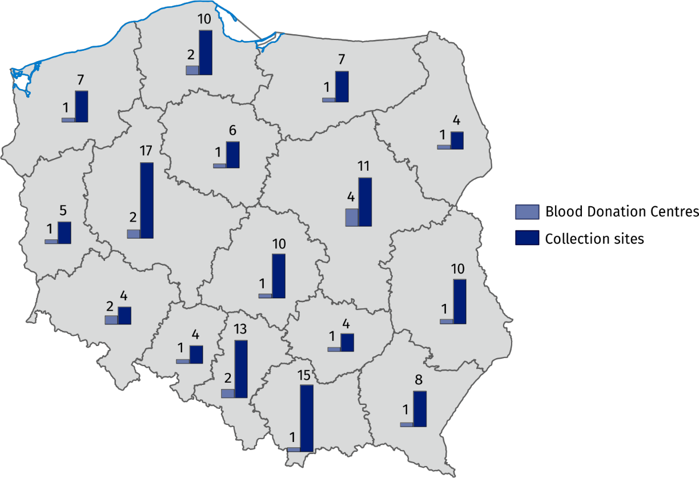

Blood donors
In 2023, there were 1 501.4 thousand blood donations and its components
In 2023, the population of blood donors amounted to 640.2 thousand people (increase by 18.1 thousand people compared to 2022), including 640.0 thousand honorary blood donors. Among the donors, 80.2% were multiple permanent and repeated donors. The majority of blood donors (63.7%) were aged 25 to 44. People aged 18 to 24 accounted for 17.1% of all blood donors and those aged 45 to 64 – 19.1%.
There were 1 501.4 thousand blood donations and its components (increase by 5.2% compared to 2022), of which 1 358.0 thousand were whole blood donations.
Table 1. Blood donors, collected blood and prepared blood components
Specification | 2022 | 2023
Specification | in thousands
Blood donors | 622.1 | 640.2
Collected blood and its components in donations | 1 427.3 | 1 501.4
Collected whole blood in donations | 1 302.9 | 1 358.0
Red blood cell concentrates in unitsª | 1 266.3 | 1 327.5
Fresh frozen plasma in units^{b} | 1 538.7 | 1 650.7
a One unit of red blood cell concentrate equals approximately 250 ml, one litre of red blood cell concentrates equals approximately 4 units.
b One unit of fresh frozen plasma equals approximately 200ml, one litre of plasma equals approximately 5 units.

Chart 1. Blood donors by sex and age in 2023
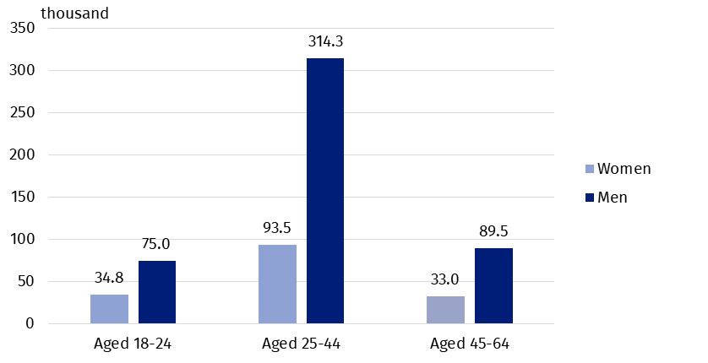
In the year under review, there were 170 blood donors per 10 thousand population (in 2022 – 164).
The maximum number of blood donors per 10 thousand population by localisation of institutions collecting blood (excluding data of the Ministry of National Defence and the Ministry of Inferior and Administration) was recorded in Podlaskie voivodship (almost 265 blood donors per 10 thousand population), while the minimum number - in Mazowieckie voivodship (approximately 131 blood donors per 10 thousand population).
Map 2. Blood donors by voivodships in 2023
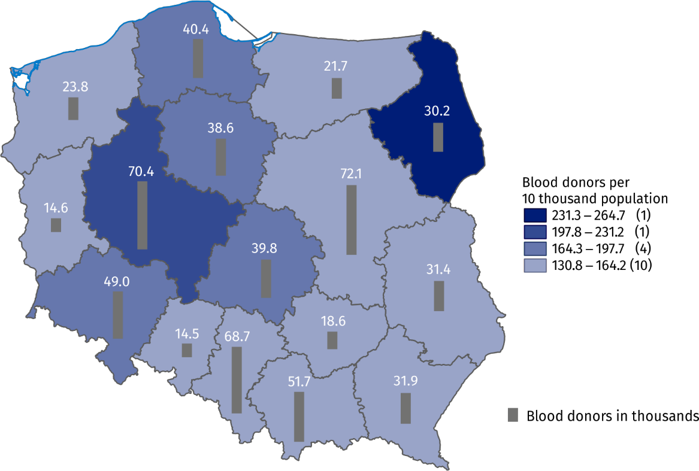Excluding data of the Ministry of National Defence (MON) and the Ministry of Interior and Administration (MSWiA).

Collected whole blood in donations
Most whole blood donation was collected in Śląskie voivodship – 161.1 thousand donations. The inhabitants of three voivodships: Śląskie, Wielkopolskie and Mazowieckie gave a total of 458.4 thousand whole blood donations (33.8% of whole blood collected in Poland). Blood centres subordinated by the Ministry of National Defence and the Ministry of Inferior and Administration collected in total 39.5 thousand whole blood donations (2.9% of whole blood collected in Poland).
The highest increase in the number of whole blood donation was observed in Kujawsko-pomorskie voivodship (increase by 8.8% compared to 2022), and the lowest increase – in Dolnośląskie voivodship (increase by 0.7% compared to previous year). In none of the blood donation centres there was no decrease in the number of collected whole blood donations.
In 2023 there was increase in the number of whole blood donations in all blood donation centres

Chart 2. Whole blood donations by voivodships in 2023
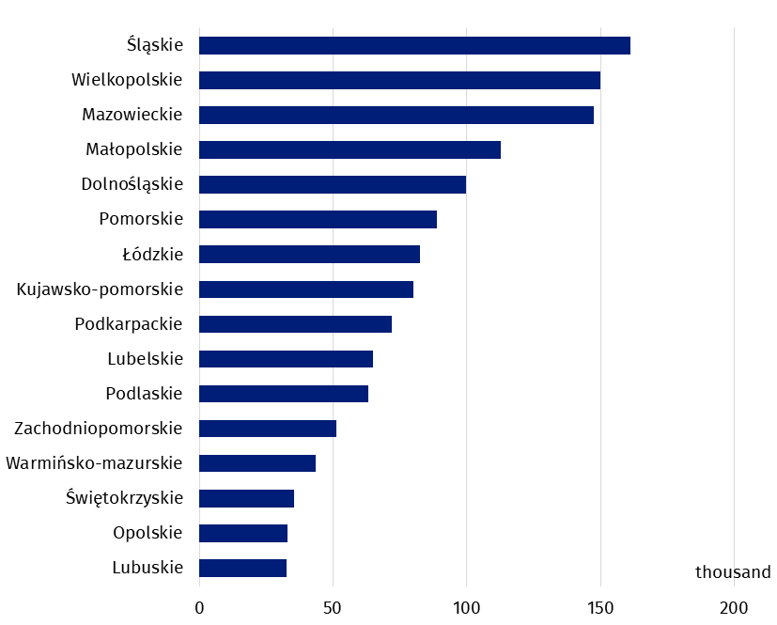
Excluding data of the Ministry of National Defence (MON) and the Ministry of Interior and Administration (MSWiA).
In the case of quoting data from the Statistics Poland, please provide information: "Statistics Poland data source", and in the case of publishing calculations made on data published by the Statistics Poland, please provide information: "Own study based on Statistics Poland data".

Prepared by:  Statistical Office in Kraków  Director Agnieszka Szlubowska  Phone: (+48 12) 420 40 50 | Issued by:  Press Office  Mobile: (+48) 695 255 032  Phone: (+48 22) 608 38 04, (+48 22) 449 41 45,  (+48 22) 608 30 09  e-mail: obslugaprasowa@stat.gov.pl

stat.gov.pl/en/

@StatPoland

@GlownyUrzadStatystyczny

gus_stat

glownyurzadstatystycznygus

glownyurzadstatystyczny
Related information
Health and health care in 2022
Methodological report. Health and health care statistics – Statistics Poland’s reports
Data available in databases
Knowledge Databases -> Society -> Health and Health care
Terms used inn official statistics
The Blood Donation Centres
Donation
Organisational units of public blood service
Blood donor
Blood donation

Multiple permanent donor is a person who regularly donates blood (at least 2 times during 24 months), multiple repeated donor is a person who donates blood in term exceeding 2 years since last donation.
A total of 22 721 blood donors were registered in the blood donation centres subordinated by the Ministry of National Defence and the Ministry of Inferior and Administration, which accounted for 3.5% of all blood donors.

