Accidents at work in 2023 – preliminary data
68,663 persons injured in accidents at work were reported in 2023, by 3.1% more than in 2022.
The number of injured persons per 1,000 employed persons (the incidence rate) increased from 4.66 to 4.90.
Since 2023, the question
"Did the accident occur in connection with the performance of remote work
or telework?" has been included in the Statistical Accident Report (Journal of Laws 2022, item 2750)
The number of persons injured in accidents at work and the incidence rate increased compared to
2022
4.90
Incidence rate in 2023
168 persons were injured in fatal accidents in 2023, while 322 persons sustained injuries
in serious accidents (a 7.8% and 11.8% decrease compared to 2022). The most victims were recorded in accidents at work with other effects – 68,173 persons (3.2% more than in 2022). 240 persons were injured while performing remote work or telework.
The highest incidence rate was recorded for Śląskie (6.56), Opolskie (6.04) and Warmińsko-
-Mazurskie (6.03) Voivodships, the lowest for Mazowieckie (3.36), Małopolskie (3.58) and Podkarpackie (4.55).
Map 1. Persons injured in accidents at work per 1,000 employed persons ª
(excluding private farms in agriculture) in 2023
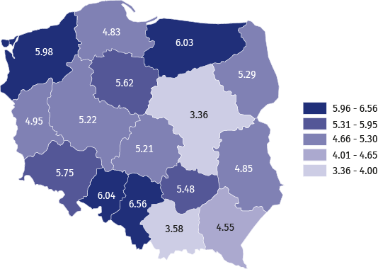
The highest incidence rate was recorded for Śląskie Voivodship, while the lowest for Mazowieckie Voivodship
a The incidence rate was calculated using preliminary data on the number of employees; civilian employees
of budgetary entities conducting activity within the scope of national defence and public safety were not included in the breakdown by voivodships.
In the breakdown by types of economic activity, the highest incidence rate was recorded
in the sections: Mining and quarrying (16.48), Water supply; sewerage, waste management
and remediation activities (13.13) and Manufacturing (7.85), while the lowest in the sections: Information and communication (0.75), Professional. scientific and technical activities (1.18) and Other service activities (1.45).
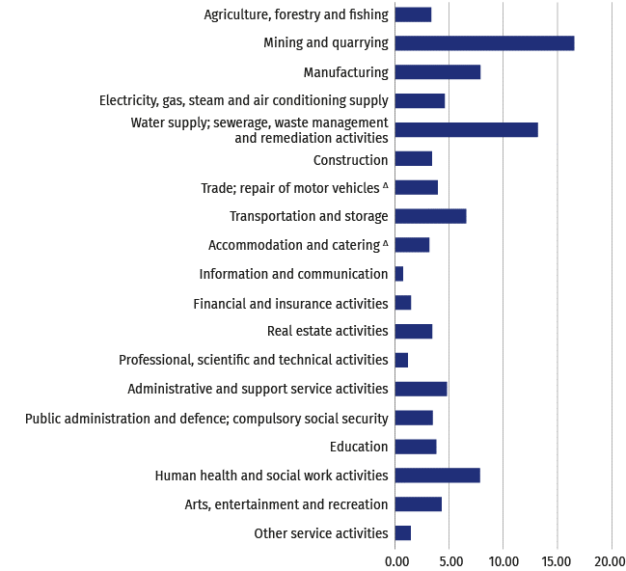
Chart 1. Persons injured in accidents at work per 1,000 employed persons by sections
in 2023 (excluding private farms in agriculture)
The highest incidence rate was recorded in the Mining and quarrying section, while
the lowest in Information and communication

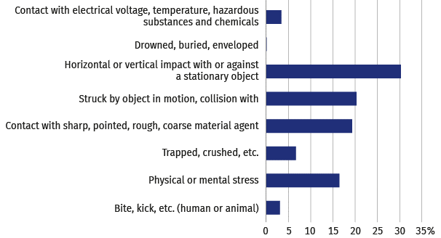
Chart 2. Persons injured in accidents at work by contact-modes of injury in 2023
Horizontal or vertical impact with or against a stationary object was the prevalent group of contact-modes
of injuries (30.4%)

Chart 3. Causes of accidents at work in 2023
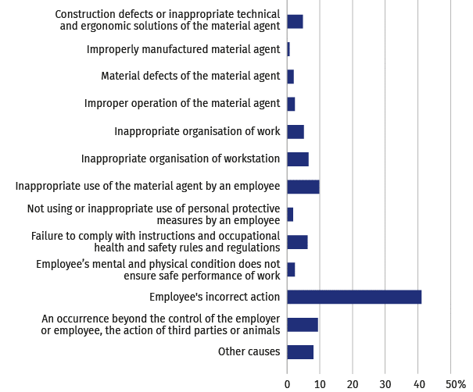
Employee's incorrect action was the cause of 41.1%
of the accidents at work
Chart 4. Persons injured in accidents at work by a specific physical activity performed
by the victim at the time of the accident in 2023
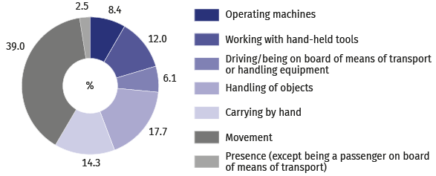
Movement was the most frequent specific physical activity performed
by the victim at the time
of the accident (39.0%)

Chart 5. Persons injured in accidents at work by part of body injure in 2023
78.9% of the persons injured in accidents at work sustained an extremity injury
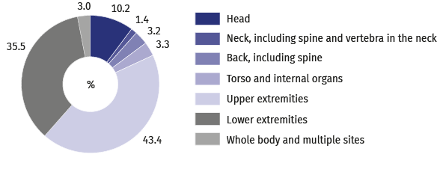
Tables are available on the website in .xlsx format.
When citing data from Statistics Poland, please provide the following information: "Source of data: Statistics Poland". When publishing calculations made on data published by Statistics Poland, provide the following information: "Own study based on the Statistics Poland's data".
METHODOLOGICAL NOTES
The publication includes information on accidents at work of persons employed in the national economy excluding budgetary entities conducting activity within the scope of the national defence and public safety for which information on accidents at work concerns only civilian employees.
Data regarding accidents at work, excluding private farms in agriculture are obtained from the “Z-KW Statistical accident report” and cover all accidents at work, as well as accidents considered equivalent to accidents at work, regardless whether incapacity for work was reported (due to hospitalisation of an injured person, or rejection of
a sick leave, etc.).
Data on accidents at work on private farms in agriculture were compiled on the basis of reports of the Agricultural Social Insurance Fund (ASIF) and are related only to the accidents in respect of which one-off compensations were granted in a given period.
Each accident, regardless whether the victim was injured during a single or multiple casualty incident, is counted as one accident at work.
Incidence rate is the number of persons injured per 1,000 persons employed. The ratio was calculated using
the average number of employed persons expressed as an arithmetic mean for two consecutive dates,
as of 31 December of the previous year and 31 December of the current year.
Information on days lost includes the total number of calendar days of incapacity for work due to work-related accidents, estimated on the basis of sick leaves.
The methodology of the survey on accidents at work is explained in more detail in the annual publication titled "Accidents at work", available on the website of Statistics Poland.
The data presented in this release are preliminary. The final data covering the year 2023 will be available
in a publication coming out in November 2024.

Prepared by:
Statistical Office in Gdańsk
Director Jerzy Auksztol
Office: phone (+48 58) 76 83 130
Press Office
Office: phone (+48 22) 608 34 91, 22 608 38 04
e-mail: obslugaprasowa@stat.gov.pl
Issued by:
Related information
Accidents at work in 2022
Accidents at work in in January-September 2023 – preliminary data
Other studies regarding working conditions
Data available in databases
Local Data Bank -> Labour Market -> Working Conditions
The Spokesperson for the President
of Statistics Poland
Karolina Banaszek
Mobile: (+48) 695 255 011

www.stat.gov.pl/en/

@StatPoland


@GlownyUrzadStatystyczny
gus_stat

glownyurzadstatystycznygus

glownyurzadstatystyczny

