Transport of goods and passengers in 2023

In 2023, compared to the previous year, the number of passengers transported by all modes, except maritime transport, increased. On the other hand, the total volume of goods and the tonne-kilometres performed decreased slightly.
13.1%
Increase in passenger transport compared to 2023

Transport of goods
In 2023, all modes of transport carried less goods than in the previous year.
year
In 2023, in relation to the previous year, the volume of goods and the transport performance decreased in all modes of transport. The exception was road goods transport for hire
or remunaration, where a slight increase in the amount of transported goods was recorded. Tonne-kilometres performed, in relation to the previous year, lowered in most modes
of transport; the increase was only observed in rail and maritime transport.

Table 1. Transport of goods by mode of transport
Specification | 2022 |  | 2023
Specification | in thousand tonnes |  |  | 2022=100 | 2021=100
Total | 2 277 093 | 2 226 309 |  | 97.8 | 98.8
Railway transport ª | 237 587 | 229 935 |  | 96.8 | 96.6
Road transport ^{b} | 1 976 278 | 1 942 800 |  | 98.3 | 99.5
of which hire or reward | 1 182 613 | 1 192 441 |  | 100.8 | 99.1
of which road transport  entities ^{c} | 888 705 | 884 686 |  | 99.5 | 93.1
Pipeline transport | 52 591 | 44 433 |  | 84.5 | 89.1
Maritime transport ^{d} | 8 442 | 7 363 |  | 87.2 | 76.8
Inland waterway transport | 2 076 | 1 689 |  | 81.4 | 48.8
Air transport ^{e} | 119 | 89 |  | 75.1 | 98.6
a Excluding shunting. b Data partially estimated. c Classified according to the Polish Classification of Activities 2007 into the section H „Transport and storage”, excluding division “Postal and Courier Activities”.
d Owned and rented ships e Scheduled and non-scheduled (Polish carriers).

Table 1. Transport of goods by mode of transport (cont.)
Specification | 2022 |  | 2023
Specification | in million  tonne-kilometres |  |  | 2022=100 | 2021=100
Total | 497 832 | 494 563 |  | 99.3 | 100.6
Railway transport ª | 59 306 | 61 085 |  | 103.0 | 112.3
Road transport ^{b} | 406 902 | 400 624 |  | 98.5 | 97.7
of which hire or reward | 352 777 | 349 042 |  | 98.9 | 98.5
of which road transport  entities ^{c} | 308 377 | 305 961 |  | 99.2 | 98.7
Pipeline transport | 19 132 | 12 341 |  | 64.5 | 67.0
Maritime transport ^{d} | 11 602 | 19 681 |  | 169.6 | 260.5
Inland waterway transport | 445 | 408 |  | 91.7 | 82.8
Air transport ^{e} | 445 | 424 |  | 95.3 | 124.5
a Excluding shunting. b Data partially estimated. c Classified according to the Polish Classification of Activities 2007 into the section H „Transport and storage”, excluding division “Postal and Courier Activities”.
d Owned and rented ships e Scheduled and non-scheduled (Polish carriers).
In 2023 self-propelled rolling units dominated the structure by groups of goods transported by sea (60.2%)
In 2023 goods from the group of “metal ores and other mining and quarrying products; peat; uranium and thorium” had the biggest share (23.2%) in transport structure. In maritime transport, the “roll-on roll-off self-propelled units” group of goods constituted the largest part (60.2%).
Graph 1. Structure of goods transport by groups of goods in 2023 and year-over-year
fluctuations ª

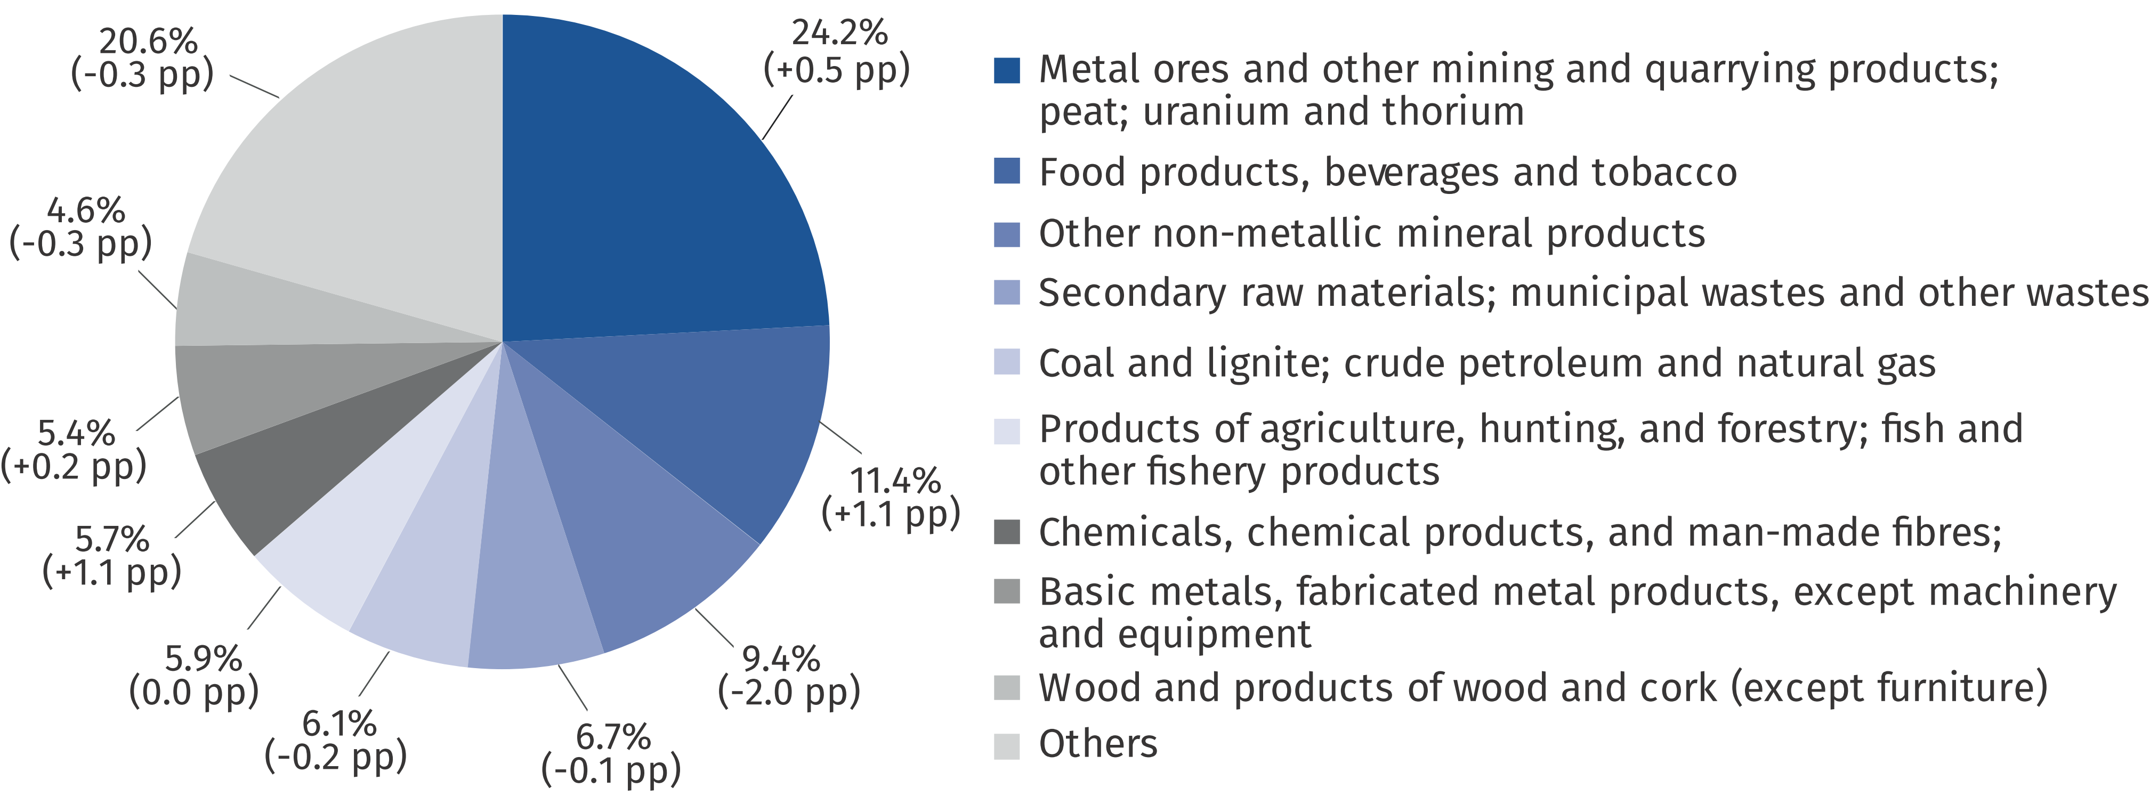

a Applies to railway transport, road transport and inland waterway transport.

Graph 2. Structure of maritime transport of cargo by cargo categories in 2023 and changes compared to the previous year

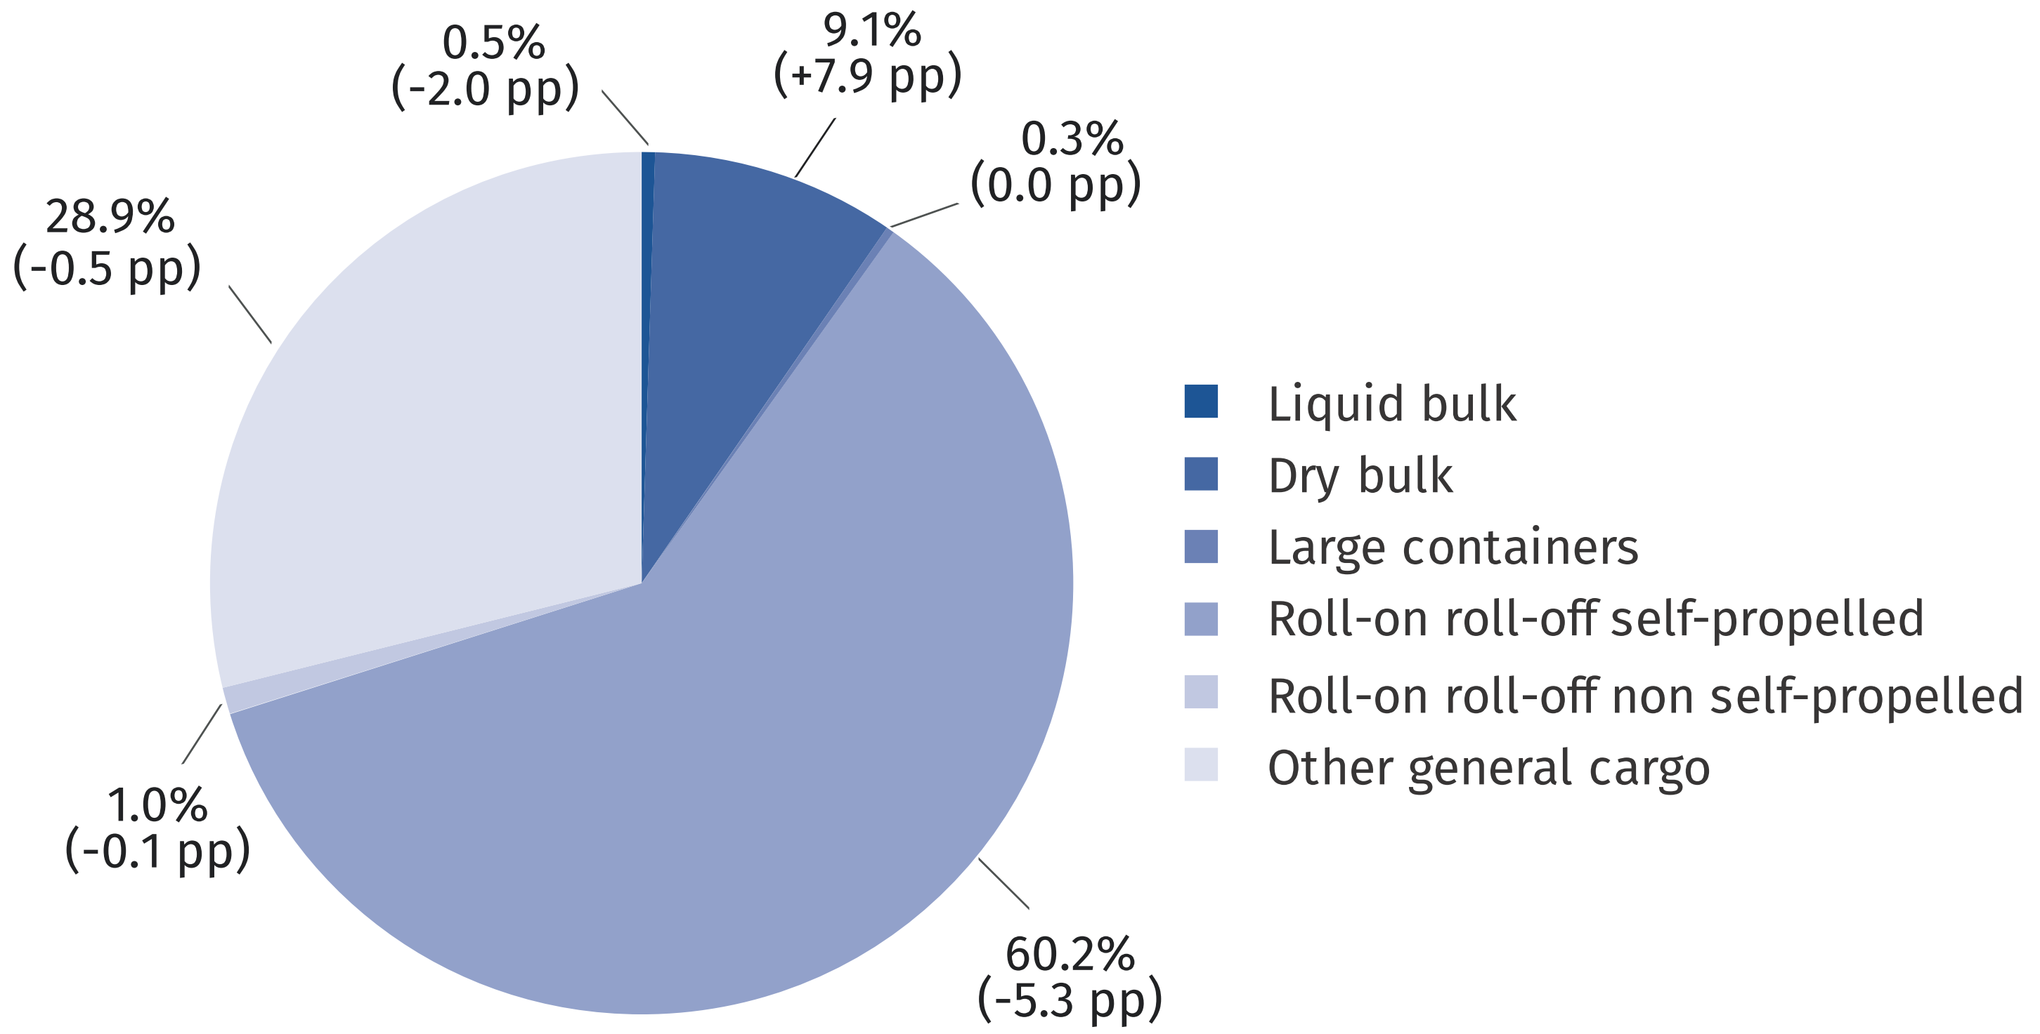

Considering directions of transport, in 2023 most of goods transported by road (81.7%) and rail (65.3%) were carried in national traffic, whereas international conveyance prevailed in other modes of transport.
Table 2. Transport of goods by direction of transport
Specification  a – 2022  b – 2023 |  | Total  in thousand  tonnes | National transport | International transport
 |  | Total  in thousand  tonnes | National transport | export | import | transit | between foreign countries
 |  | Total  in thousand  tonnes | in percent
Railway transport ª | a | 237 587 | 64.3 | 12.4 | 20.3 | 3.0 | .
Railway transport ª | b | 229 935 | 65.3 | 12.8 | 18.6 | 3.3 | .
Road transport ^{b} | a | 1 541 209 | 81.6 | 6.2 | 5.2 | 0.3 | 6.7
Road transport ^{b} | b | 1 524 740 | 81.7 | 6.1 | 5.2 | 0.3 | 6.7
Maritime transport ^{c} | a | 8 459 | 2.5 | 46.9 | 43.2 | 0.2 | 7.3
Maritime transport ^{c} | b | 7 371 | 0.5 | 44.5 | 39.9 | 0.1 | 15.0
Inland waterway transport | a | 2 076 | 32.1 | 9.8 | 2.2 | 0.1 | 55.8
Inland waterway transport | b | 1 689 | 24.5 | 9.6 | 0.5 | 0.1 | 65.3
Air transport ^{d} | a | 119 | 0.2 | 99.8
Air transport ^{d} | b | 89 | 0.3 | 99.7
a Excluding shunting b Data on the basis of results a sample survey. c Owned and rented ships. d Scheduled and non-scheduled (Polish carriers).

Table 2. Transport of goods by direction of transport (cont.)
Specification  a – 2022  b – 2023 |  | Total  in million tonne-  kilometres | National transport | International transport
 |  | Total  in million tonne-  kilometres | National transport | export | import |  | transit |  | between foreign countries
 |  | Total  in million tonne-  kilometres | in percent
Railway transport ª | a | 59 306 | 55.0 | 14.4 |  | 23.3 |  | 7.3 |  | .
Railway transport ª | b | 61 085 | 55.8 | 15.6 |  | 20.9 |  | 7.7 |  | .
Road transport ^{b} | a | 369 932 | 37.9 | 20.9 |  | 18.5 |  | 1.8 |  | 21.0
Road transport ^{b} | b | 362 694 | 37.2 | 20.8 |  | 18.7 |  | 1.8 |  | 21.5
Inland waterway transport | a | 445 | 6.7 | 13.3 |  | 2.6 |  | 0.1 |  | 77.3
Inland waterway transport | b | 408 | 5.4 | 13.3 |  | 0.8 |  | 0.1 |  | 80.4
Air transport ^{d} | a | 445 | 0.0 | 99.9
Air transport ^{d} | b | 424 | 0.0 | 99.9
a Excluding shunting b Data on the basis of results a sample survey. c Owned and rented ships. d Scheduled and non-scheduled (Polish carriers).

Taking into account national traffic by distance classes, one can note that in 2023 the most goods were transported by road for a distance of up to 50 km, by rail for a distance
of 150–299 km and up to 50 km, while by inland waterway for a distance of 50–149 km.
Table 3. National transport of goods by distance classes
Specification  a – 2022  b – 2023 |  | Total  in thousand tonnes | Distance classes
 |  | Total  in thousand tonnes | 49 km  and less | 50-149 | 150-299 | 300-499 | 500 km  and more
 |  | Total  in thousand tonnes | in percent
Railway  transport ^{ab} | a | 151 768 | 28.4 | 19.8 | 28.4 | 12.8 | 10.6
Railway  transport ^{ab} | b | 150 148 | 25.7 | 20.1 | 29.8 | 12.7 | 11.7
Road transport ^{c} | a | 1 257 522 | 46.3 | 26.4 | 24.7 |  | 2.5
Road transport ^{c} | b | 1 245 393 | 47.8 | 25.3 | 24.3 |  | 2.6
Inland waterway transport | a | 668 | 38.4 | 61.2 | 0.1 | 0.1 | 0.2
Inland waterway transport | b | 414 | 37.2 | 59.2 | 0.2 | 3.4 | 0.0
a Excluding shunting. b Excluding official consingments. c Data on the basis of results a sample survey.

Table 3. National transport of goods by distance classes (cont.)
Specification  a – 2022  b – 2023 |  | Total  in million tonne-  kilometres | Distance classes
 |  | Total  in million tonne-  kilometres | 49 km  and less | 50-149 | 150-299 | 300-499 | 500 km  and more
 |  | Total  in million tonne-  kilometres | in percent
Railway  transport ^{ab} | a | 32 590 | 1.5 | 9.3 | 34.2 | 24.5 | 30.5
Railway  transport ^{ab} | b | 34 101 | 1.4 | 9.1 | 35.2 | 23.4 | 30.9
Road transport ^{c} | a | 140 032 | 7.6 | 20.5 | 58.9 |  | 13.0
Road transport ^{c} | b | 134 808 | 8.2 | 20.4 | 57.8 |  | 13.6
Inland waterway transport | a | 29 | 8.0 | 87.5 | 0.5 | 1.0 | 3.0
Inland waterway transport | b | 22 | 9.5 | 69.5 | 0.5 | 20.3 | 0.2
a Excluding shunting. b Excluding official consingments. c Data on the basis of results a sample survey.

Transport of passengers
In 2023, 26.1% more passengers were transported by air than
a year ago
In 2023, there was an increase in passenger transport by all modes, a slight decrease was
noted only in maritime traffic. In total, 13.1% more passengers were conveyed year-over-year. The largest increase was recorded in air transport (by 26.1%), as well as in road transport (by 18.7%), railway transport (by 9.2%) and in inland waterway transport (by 2.5%).
Table 4. Transport of passengers
In 2023, 57.5% of all passengers were carried by railway transport
Specification | 2022 | 2023
Specification | in thousand passengers |  | 2022=100
Total | 572 048 | 646 808 | 113.1
Railway transport | 342 139 | 373 528 | 109.2
Road transport ª | 214 443 | 254 507 | 118.7
Maritime transport ^{bcd} | 1 472 | 1 388 | 94.3
Inland waterway transport | 1 101 | 1 128 | 102.5
Air transport ^{e} | 12 893 | 16 257 | 126.1
a Excluding urban transport and provided by entities employing up to 9 persons. b Owned and rented ships. c Excluding truck drivers on board ferries. d Including coastal shipping. e Scheduled and non-scheduled (Polish carriers).

Table 4. Transport of passengers (cont.)
Specification | 2022 |  | 2023
Specification | in million  passenger-kilometres |  |  | 2022=100
Total |  | 63 393 | 71 145 | 112.2
Railway transport |  | 23 827 | 25 746 | 108.1
Road transport ª |  | 11 623 | 10 551 | 90.8
Maritime transport ^{bcd} |  | 167 | 152 | 91.4
Inland waterway transport |  | 14 | 12 | 90.6
Air transport ^{e} |  | 27 762 | 34 684 | 124.9
a Excluding urban transport and provided by entities employing up to 9 persons. b Owned and rented ships. c Excluding truck drivers on board ferries. d Including coastal shipping. e Scheduled and non-scheduled (Polish carriers).

When quoting data from the Statistics Poland, please include the following information: "Source of data from the Statistics Poland", and in the case of publishing calculations made on the data published by the Statistics Poland, please include the following information: "Own study based on Statistics Poland data".

Prepared by:  Statistical Office in Szczecin  Deputy director Katarzyna Dmitrowicz-Życka  Phone: (+48 91) 459 77 00 | Issued by:  Press Office  Mobile: (+48) 695 255 032  Phone: (+48 22) 608 38 04, (+48 22) 449 41 45,  (+48 22) 608 30 09  e-mail: obslugaprasowa@stat.gov.pl

stat.gov.pl/en/

@StatPoland

@GlownyUrzadStatystyczny

gus_stat

glownyurzadstatystycznygus

glownyurzadstatystyczny
Related information
Transport – activity results in 2022
Data available in databases
SWAID Transport and Communications
Terms used inn official statistics
Transport of goods
Transport of passengers
Tonne-kilometres
Passenger-kilometres

