Distribution of wages and salaries in the national economy in February 2024
PLN 6 427.32
Median monthly gross wage and salary
PLN 8 418.24
Average monthly gross wage and salary
In February 2024, the median monthly gross wage and salary in the national economy in Poland was 23.7% lower than the average monthly gross wage and salary.

Median monthly gross wage and salary in the national economy
The median gross wage and salary in the national economy in February 2024 was PLN 6 427.32. This means that half of employees were paid a wage or salary not higher than this amount, and the other half received a wage or salary not lower. The value of the median wage and salary indicates gender differences – for men it amounted to PLN 6 564.70 and was PLN 291.90 higher than for women. Taking into account the age of employees, it can be noted that the highest median value occurred in the 45-54 age group and amounted to PLN 6 776.00. In terms of entity size, the highest value of the median wage and salary occurred in entities with 1 000 or more employed persons and amounted to PLN 7 569.60.
In February 2024, the median wage and salary of men was higher than the total median wage and salary by 2.1%, and that of women was lower by 2.4%
Deciles of monthly gross wages and salaries in the national economy
In February 2024, among the 10.0% of the highest earning men, the wage and salary was not lower than PLN 14 571.52
In February 2024, 10.0% of the lowest earners received a wage or salary of at most PLN 4 242.00 (the first decile). In contrast, 10.0% of the highest earners received a wage or salary of at least PLN 14 224.51 (the ninth decile). In 8 out of 9 brackets of wages and salaries under analysis, there were differences by sex – only in the first decile was the value of wages and salaries for men and women at the same level. The largest difference in wages and salaries by sex occurred in the ninth decile and amounted to PLN 595.67.
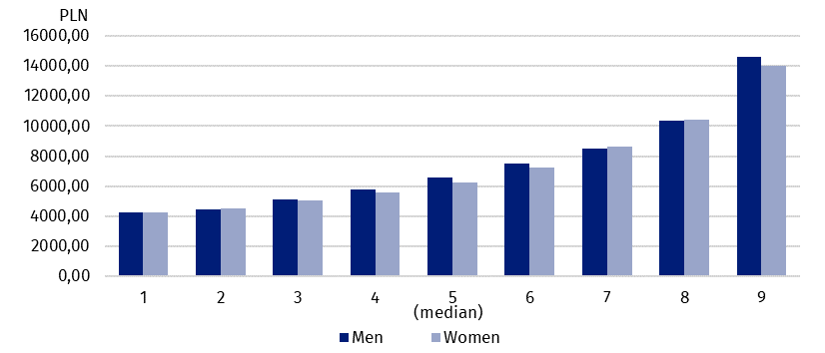
Chart 1. Deciles of monthly wages and salaries in the national economy by sex in February 2024

Average monthly gross wage and salary in the national economy
In February 2024, the average wage and salary of women was PLN 434.81 lower than the average wage and salary of men
The average wage and salary in the national economy in February 2024 was PLN 8 418.24, with the average wage and salary of men amounting to PLN 8 631.43 and accounting for 102.5% of the total average wage and salary. On the other hand, the average wage and salary of women was lower and amounted to PLN 8 196.62. It was equal to 97.4% of the total average wage and salary. When analysing the age of employees, the highest average wage and salary was observed in the 65-or-over age group (PLN 9 235.09), while taking into account entity size – in entities with 1 000 or more employed persons (PLN 10 036.57).

Wages and salaries by territory
Wages and salaries in the national economy in February 2024 were differentiated territorially by place of residence of employees, as well as by place of the entity's seat.
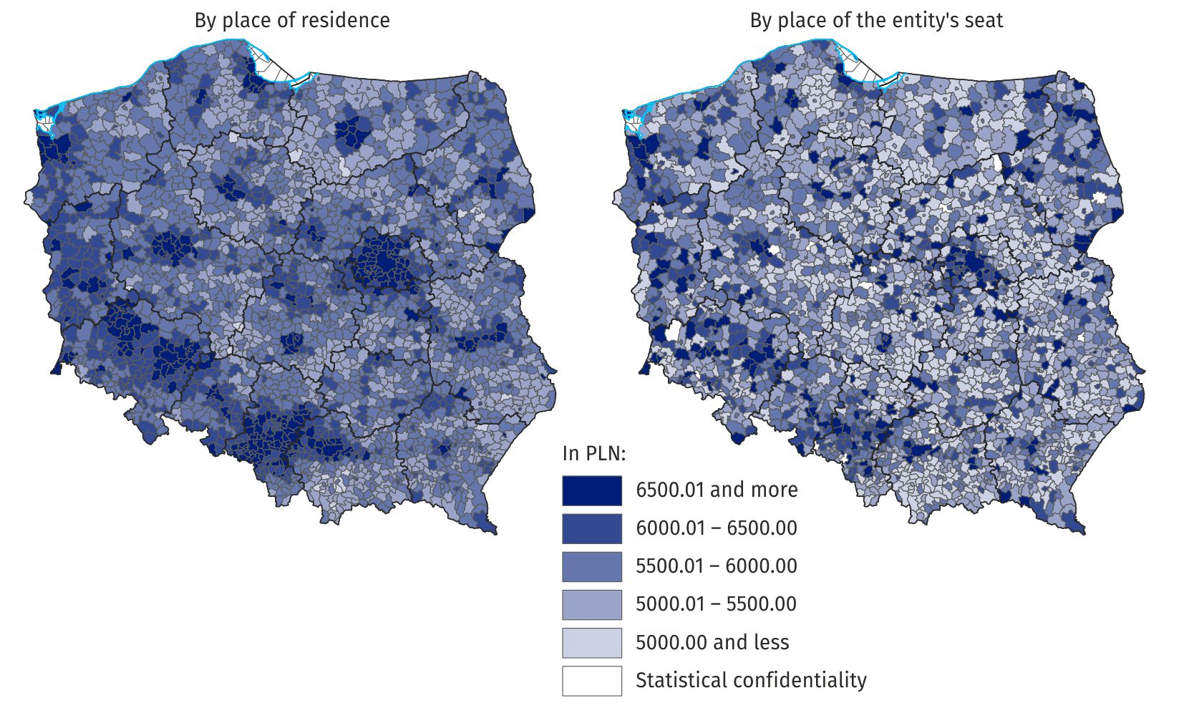
Map 1. Median monthly gross wage and salary in the national economy in February 2024
When analysing the wages and salaries of employees in gminas by place of the entity's seat, it can be observed that the difference between the highest and the lowest value of the median wage and salary was more than PLN 7 000, while in around 28% of gminas the median wage and salary was equal to or lower than PLN 5 000. On the other hand, by place of residence of employees, there was less than 1% of gminas with such a median, and the difference between the highest and the lowest value of the median wage and salary was nearly PLN 4 500.
When analysing gminas by place of the entity's seat, the difference between the highest and lowest median value was more than PLN 7 000 in February 2024

Wages and salaries in PKD/NACE sections
Wages and salaries also varied by kind of activity. In February 2024, the highest median value occurred in the section Mining and quarrying, where it amounted to PLN 15 389.41. In 14 of the 19 PKD/NACE sections analysed, the median wages and salaries of men were higher than the median wages and salaries of women. The section Mining and quarrying stood out, where the median wage and salary of men was 44.5% higher than that of women. In four sections, median wages and salaries of women were higher than median wages and salaries of men. The highest difference occurred in the sections Public administration and defence; compulsory social security and Construction, where women’s median wages and salaries were higher than men’s by 30.7% and 29.7%, respectively. In the remaining two sections, the median wage and salary of women was higher than the median wage and salary of men by no more than 4%.

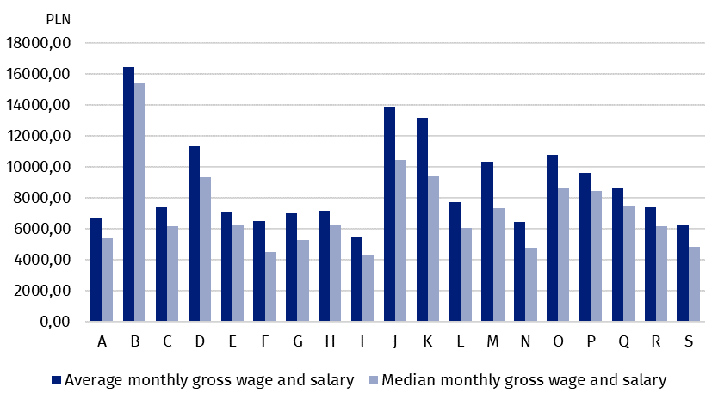
Chart 2. Average monthly gross wage and salary and median monthly gross wage and salary in the national economy in PKD/NACE sections in February 2024
In February 2024, the average monthly gross wage and salary of male employees in the section Mining and quarrying was PLN 16 825.35
The highest average wage and salary occurred in the section Mining and quarrying, where it amounted to more than PLN 16 000. The largest difference between the average wage and salary of men and that of women was in the section Financial and insurance activities, amounting to more than PLN 5 000. In three sections, the average wage and salary of women was higher than that of men – the greatest difference occurred in the section Public administration and defence; compulsory social security, where the average wage and salary of women was higher than that of men by almost PLN 1 700.
***
There is a wider range of data on the distribution of wages and salaries in the publication tables.
***
In this news release abbreviated names of NACE, Rev. 2 sections were used. Abbreviations are marked with a ‘Δ’ symbol. Full names are listed below.
PKD/NACE section symbols:
A – Agriculture, forestry and fishing;
B – Mining and quarrying;
C – Manufacturing;
D – Electricity, gas, steam and air conditioning supply;
E – Water supply; sewerage, waste management and remediation activities;
F – Construction;
G – Wholesale and retail trade; repair of motor vehicles and motorcycles;
H – Transportation and storage;
I – Accommodation and food service activities;
J – Information and communication;
K – Financial and insurance activities;
L – Real estate activities;
M – Professional, scientific and technical activities;
N – Administrative and support service activities;
O – Public administration and defence; compulsory social security;
P – Education;
Q – Human health and social work activities;
R – Arts, entertainment and recreation;
S – Other service activities.

In the case of quoting Statistics Poland data, please provide information: ‘Source of data: Statistics Poland’, and in the case of publishing calculations made on data published by Statistics Poland, please provide information: ‘Own work based on Statistics Poland data.’
Prepared by:  Statistical Office in Bydgoszcz  Director Wiesława Gierańczyk, Ph.D.  Phone: (+48 52) 366 93 90 | Issued by:  Press Office  Mobile phone +48 695 255 032  Landline phones: +48 22 608 38 04, +48 22 449 41 45, +48 22 608 30 09  e-mail: obslugaprasowa@stat.gov.pl

www.stat.gov.pl/en/

@StatPoland

@GlownyUrzadStatystyczny

gus_stat

glownyurzadstatystycznygus

glownyurzadstatystyczny
Related information
Methodological report Distribution of wages and salaries in the national economy

