The situation of households in 2024 on the basis of results of the Household Budget Survey
In 2024, the income situation of households significantly improved. Average monthly income and average monthly expenditure per capita in households increased both in nominal and in real terms
In 2024 the financial situation of households significantly improved in comparison with 2023. This was due, among others, to a higher average monthly salary in the national economy (of which resulting from the increase in the minimum wage), as well as an increase in social and family benefits, with a simultanouse decrease in the growth rate of consumer goods and services prices. Households attained in nominal terms higher income, but they also had higher expenditure. The level of average monthly available income per capita in 2024 amounted to PLN 3167 and was higher by 18.3% in nominal terms, and by 14.1% in real terms than the income in 2023. The average monthly expenditure per capita in households in 2024 reached the value of PLN 1878, and expenditure on consumer goods and services – PLN 1814. In both cases those values were higher on a yearly basis – by 14.8% in nominal terms, and by 10.8% in real terms than expenditure in 2023. The share of expenditure in available income decreased from 61.1% in 2023 to 59.3% in 2024.
14.1%
The increase of the average monthly available income per capita in households in 2024 – in real terms

Income and expenditure
Households of self-employed outside farming had the highest average monthly available income per capita – PLN 3790, as well as average monthly expenditure per capita – PLN 2151
In 2024, there was still a relatively large diversity in average monthly income and expenditure between various socio-economic groups of households. Similarly to the previous years, the highest average monthly available income per capita in households (PLN 3790) and average monthly expenditure per capita (PLN 2151) were recorded in households of self-employed outside farming. In this group of households – in comparison with the average for the total of households in Poland – both income and expenditure were higher by 19.7% and 14.5% respectively (in 2023, by 23.7% and 13.8% respectively).
Similarly to the previous years, in 2024 households of pensioners had the lowest average monthly available income per capita. Their average monthly available income per capita amounted to PLN 2449, and was by 22.7% lower than average for households in total (in 2023 lower by 19.3%). The lowest average monthly expenditure per capita was noted in the households of farmers (PLN 1311) and it was by 30.2% lower than average for households in total (in 2023 – lower by 23.9%).
The highest share of expenditure in available income was observed in households of pensioners and the lowest in households of farmers

As in previous years, in 2024 the highest share of expenditure in income (77.7%) and the lowest amount of average monthly excess of available income per capita over expenditure per capita (PLN 546) was recorded in the households of pensioners. The lowest share of expenditure in income (39.6%) similarly to the previous year had the households of farmers, and in these households the highest average excess of income over expenditure (PLN 1998) was noted.
In 2024 in comparison with 2023 the share of expenditure in income for total households decreased by 1.8 percentage points to 59.3%, which indicates on average a higher possibility of accumulating savings in 2024 than in the previous year. The share of average monthly expenditure in average monthly income decreased the most in the households of farmers (by 11.3 percentage points) and it increased the most in the households of pensioners (by 2.9 percentage points).
The difference between average monthly available income indicator among socio-economic groups slightly decreased to 42.4 percentage points (in 2023 – 43.0 percentage points), while the difference between average monthly expenditure indicator increased to 44.7 percentage points (in 2023 – 37.7 percentage points).

In 2024, there was a growth in average monthly available income per capita in real terms in total – by 14.1%. Growth in real terms occurred in all socio-economic groups of households, among which the highest was recorded in the households of farmers, and the lowest in the households of pensioners.
Recorded in 2024, in comparison with 2023, the increase in the value of the average monthly available income per capita in households is related to a higher than in the previous period increase in average monthly salary (of which the increase in the minimum wage) as well as an increase in social and family benefits.
The highest share of income from the main source of income occurred in the households of employees (81.1 against 82.6% in 2023) and retirees (81.0% against 81.6% in 2023), whereas the lowest – in the households of self-employed (66.6% against 67.2% in 2023) and farmers (69.5% against 66.3% in 2023).
In 2024 in the structure of the households’ total income, similarly to the previous years, income from hired work (54.7% against 55.7% in 2023) as well as income from social security benefits (23.7% against 24.4% in 2023) dominated.

In 2024, in comparison with 2023, differences in the structure of the average monthly available income per capita in households ranged from -1.0 percentage points in the case of income from hired work to +1.2 percentage points for income from other social benefits.
The diversity of income per capita in households, measured by the Gini coefficient, after a period of decline in 2014-2017 and temporary stabilisation, increased in 2020 and 2021, in 2022-2023 remained at the level of 0.314, and in 2024 decreased to the level of 0.300. The dynamics of the Gini coefficient for both urban and rural areas was similar to the average dynamics noted in the country. In the case of rural areas, in 2024 the Gini coefficient decreased to the level of 0.292, which for the first time was the value lower than the Gini coefficient value for urban areas, where it was 0.296.
The percentage of households with income below PLN 2000 per capita decreased to 18.9% (by 10.4 percentage points). The percentage of households with income above PLN 6000 per capita increased to 8.6% (by 3.1 percentage points)
The Gini coefficient in rural areas decreased in 2024 to the level of 0.292, which for the first time was the value lower than the Gini coefficient for urban areas, where it was 0.296
In 2024, significantly lower percentage of households had an average monthly available income per capita below PLN 2000 (18.9% compared to 29.3% in 2023), 52.6% of households had an income between PLN 2000 and PLN 4000 per capita (51.3% in 2023) and 19.9% of households had an income from PLN 4000 to PLN 6000 per capita (13.9% in 2023). More households than in 2023 had income of PLN 6000 or more per capita – 8.6% of them (5.5% in 2023). In 2024, the percentage of households with an average monthly income of at least PLN 2000 per capita amounted to 81.1% (in 2023 – 70.7%).
In 2024, the average monthly expenditure per capita increased in real terms by 10.8% in comparison with 2023. This real increase occurred in all socio-economic groups of households, and the highest in the group of pensioners (increase by 13.4%), employees (by 11.9%) and self-employed (by 10.8%).
In real terms – the average monthly expenditure per capita in households in 2024 increased by 10.8% in comparison with the previous year

Expenditure on food and non-alcoholic beverages, similarly to the previous years, had the highest share in the structure of expenditure for households in total – 25.3% (in 2023 – 27.2). In individual socio-economic groups this share ranged from 21.5% in households of self-employed outside farming to 33.2% in households of farmers.
Another important item in households expenditure was expenditure on housing, water, electricity, gas and other fuels. Its share in total expenditure was on average 18.8% and in 2024 decreased by 1.1 percentage points in comparison with the previous year. Among the socio-economic groups, the lowest share of expenditure on housing, water, electricity, gas and other fuels was recorded in the households of farmers (16.4%) and the highest in the households of pensioners (25.4%).

In 2024, differences in structure in the main groups of consumer goods and services were greater than in 2023. Between 2023 and 2024, changes in the share in expenditure structure for households in total ranged from -1.9 percentage points (food and non-alcoholic beverages) to +1.7 percentage points (transport).

The average monthly available income per capita in the group of the 20% of persons with the highest income (5th quintile group) amounted to PLN 6071, and it was 5.3 times higher (in 2023 – 6.4 times higher and amounted to PLN 5269) than the respective income of the 20% of persons with the lowest income (1st quintile group).
In the households of 20% of persons in the most favourable financial situation was accumulated 38.2% of income of entire surveyed population of households, while in the households of 20% of the persons in the worst situation
– 7.2%
In the households of 20% of persons in the most favourable income situation, there was accumulated 38.2% of income of entire surveyed population of households (in 2023 – 39.3%), while in the households of 20% of persons in the worst income situation – 7.2% (in 2023 – 6.2%).

The average monthly expenditure per capita in the 5th quintile group were 2.3 times higher than in the 1st quintile group (in 2023 – 2.1 times higher). The share of expenditure in available income in the highest quintile group amounted to 49.6% (in 2023 – 48.7%), and in the lowest – 113.2% (in 2023 – 146.2%), which means that the poorest households to some extent were forced to use their savings, or loans, or credits, but on a smaller scale than in 2023.
The average monthly available income per capita in urban households was by 25.0% higher than in rural households
The average monthly expenditure per capita in urban households was by 36.6% higher than in rural households

The place of residence is another factor that substantially diversified dynamics and structure of income and expenditure of households.
The average monthly available income per capita in urban households was by 25.0% higher than in households in rural areas (in 2023 by 26.6%), which resulted from the amount of income obtained by households, but were also connected with the larger number of persons living in rural households. Similar situation was observed in the case of expenditure of households. Average monthly expenditure per capita in households in urban areas was by 36.6% higher than in households in rural areas (in 2023 by 29.5%).
In territorial terms average monthly available income per capita higher than the national average appeared in voivodships: Mazowieckie, Podlaskie, Lubuskie, Małopolskie, Śląskie and Pomorskie. As in the previous year, definitely the highest average monthly income per capita was in households in Mazowieckie Voivodship – PLN 3632 (in 2023 – PLN 3209). The income in Mazowieckie Voivodship was higher than the average monthly income per capita for the country by 14.7% (higher than national average by 32.5% in Warsaw Capital Region and lower by 9.3% in the remaining part of Mazowieckie Voivodship). The lowest average monthly available income per capita obtained households in Opolskie Voivodship (PLN 2538) – by 19.9% below the national average. The next voivodships with the lowest level of average monthly income per capita were voivodships: Podkarpackie (lower by 10.7% than national average), Świętokrzyskie (lower by 9.8%), Warmińsko-Mazurskie (lower by 8.8%), and Lubelskie (lower by 8.3%).
The difference between the highest and the lowest average monthly income per capita in voivodships in relation to the national average amounted to 34.6 percentage points.
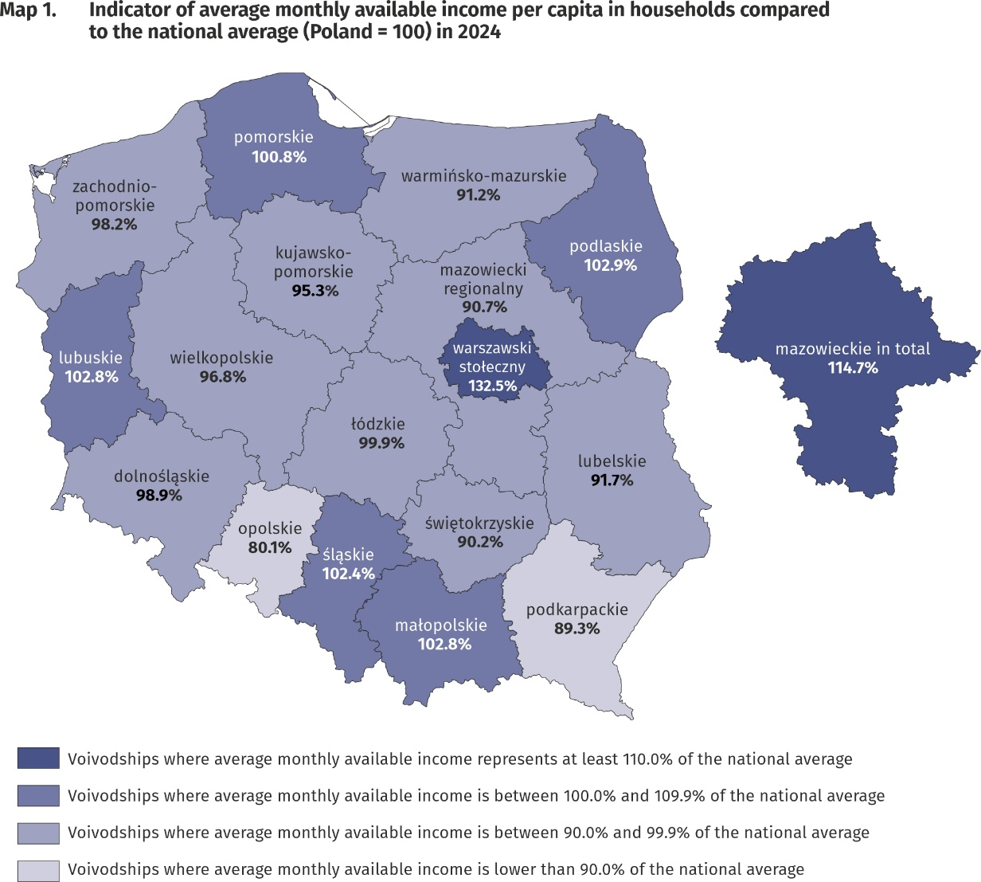
The highest average monthly available income per capita had households in
Mazowieckie Voivodship – PLN 3632 and the lowest
– households living in
Opolskie Voivodship –PLN 2538

In the case of expenditure, average monthly values above average for Poland in 2024 were recorded in voivodships: Mazowieckie, Dolnośląskie, Pomorskie, Śląskie, Kujawsko-Pomorskie, Zachodniopomorskie, Łódzkie, and Opolskie. The highest average monthly expenditure per capita was noted in Mazowieckie Voivodship – PLN 2155 (in 2023 – PLN 1849), and they were higher than the national average by 14.7% (higher than the average for Poland by 34.7% in Warsaw Capital Region and lower by 12.1% in the remaining part of Mazowieckie Voivodship). The lowest average monthly expenditure per capita occurred in Podkarpackie Voivodship (PLN 1549 in comparison with PLN 1320 in 2023) and with respect to the average for the whole country was lower by 17.5%, subsequently in Warmińsko-Mazurskie Voivodship (lower by 17.0%), Świętokrzyskie Voivodship (lower by 15.0%), Podlaskie Voivodship (lower by 12.0%) as well as Małopolskie Voivodship (lower by 11.7%).
The difference between the highest and the lowest average monthly expenditure per capita in voivodships decreased by 0.1 percentage points in comparison with 2023 year and amounted to 32.2 percentage points.
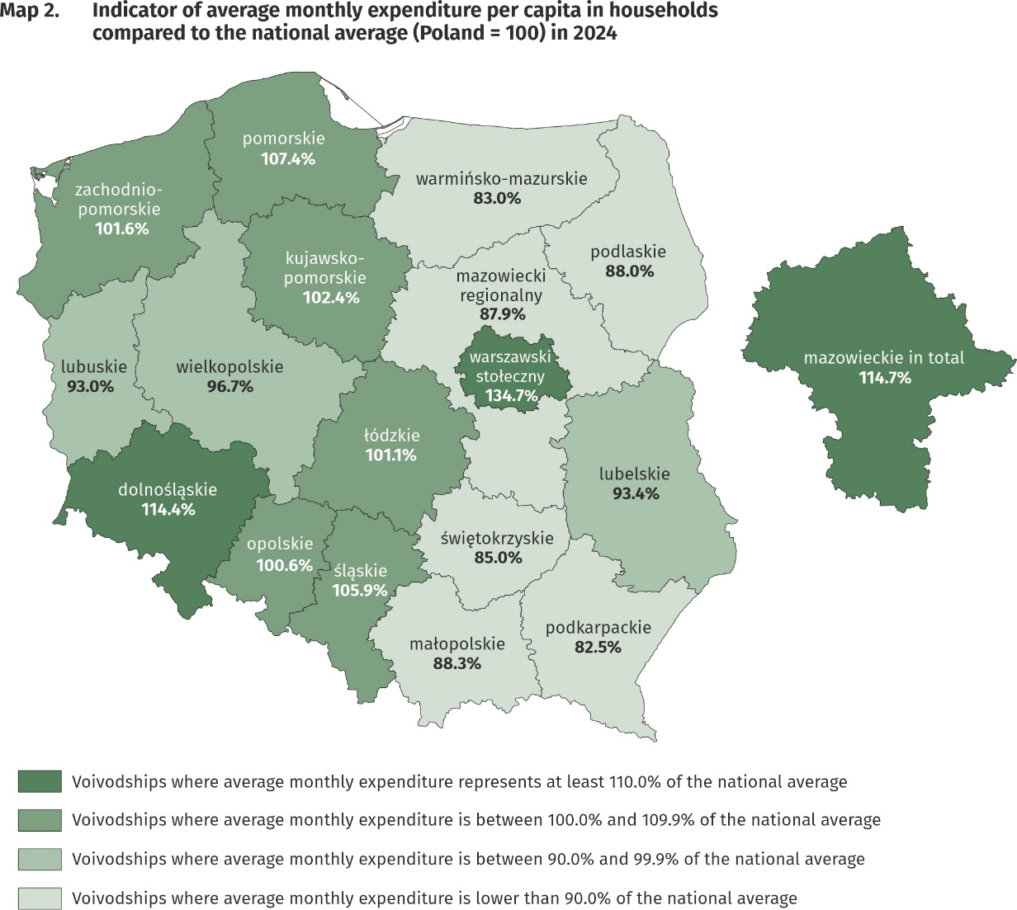
The highest average monthly expenditure per capita in households occurred in Mazowieckie Voivodship – PLN 2155 and the lowest – in Podkarpackie Voivodship – PLN 1549

Quantitative food consumption
In 2024, there was an increase in consumption of the most basic foodstuffs, and particularly sugar, eggs, fruit, animal fats, pasta and pasta products as well as cheese and curd
In 2024, there was an increase in consumption of the majority of basic foodstuffs. The highest growth was recorded in: sugar (by 8.6%), eggs (by 7.5%), fruit (by 5.9%), animal fats (by 5.3%), pasta and pasta products (by 5.1%) as well as cheese and curd (by 5.0%). The highest decrease was noted in the case of margarine and vegetable fats (by 4.5%), fresh milk (by 2.5%) and bread (by 1.5%).
The level of consumption of foodstuffs greatly depends on household income. As the wealth of households increases, so does the level of consumption of certain foodstuffs, such as bread and cereals, meat, vegetables, fruit, cheese and curd, sugar as well as mineral and spring waters.

The level of food consumption is also affected by dietary habits, prices of foodstuffs and a place of residence. Households in rural areas compared with households in urban areas are characterised by a slightly different model of nutrition. In the rural areas there was, among others, a higher consumption of bread and cereals, meat, potatoes, sugar as well as mineral and spring waters, while in urban areas – vegetables (except potatoes), fruit, and cheese and curd.
Positive phenomenon, both in urban and rural areas, is an increase in the value of monthly consumption per capita of fruit (by 0.2 kg each).

The equipment of households with durable goods
In 2024, there was an increase in the number of households equipped with durable goods, and the highest in the case of motorcycle, scooter, motorbike, game console, printer, multifunction printer as well as dishwasher
In 2024, an increase in the number of households equipped with durable goods was noted. The highest growth occurred in the case of motorcycle, scooter, motorbike (by 15.7%), a game console (by 14.9%), printer, multifunction printer (by 6.8%) as well as dishwasher (by 6.0%) whereas the decrease occurred in the case of cable or satellite television (by 0.9%) and automatic washing machine (by 0.5%). In the case of such goods as: equipment for reception, recording and reproduction of sound, mobile phone (of which smartphone), TV set, personal computer, laptop, tablet, access to the Internet, microwave oven, bicycle (excluding children’s), passenger car, the differences in the degree of the households equipment between 2023 and 2024 were less significant and ranged from 0.0 percentage points to +2.9 percentage points.
The level of household equipment with durable goods largely depends on their financial situation.
The richest households (5th quintile group) were better equipped with durable goods than the poorest households (1st quintile group), and the differences in the degree of equipment between 5th and 1st quintile groups increased in comparison with 2023, the most in the case of access to the Internet – by 2.0 percentage points and having a smartphone – by 1.9 percentage points. In the case of TV set the poorest households (1st quintile group) were better equipped than the richest households, and the difference in equipment increased in comparison with 2023 – by 2.1 percentage points.

In terms of equipping with new generation goods, such as access to the Internet and smartphone, there was a slight difference between households in urban and rural areas, and it was 1.2 percentage points in favour urban areas, both in the case of equipping with smartphone and access to the Internet (e.g. on a computer, smartphone). A significantly more rural than urban households owned a bicycle (by 24.4 percentage points), a passenger car (by 16.9 percentage points) as well as a motorcycle, scooter, motorbike (by 7.2 percentage points). In comparison with 2023, there was not a significant change of the difference in the level of equipment with new generation devices between households in urban and rural areas.
In rural areas there were more households owning dishwasher, bicycle, passenger car, motorcycle, scooters, motorbikes as well as TV set
Dwelling conditions
In 2024, the dwelling conditions of households improved slightly. The average household occupied a dwelling with a floor area of 89.2 m², which consisted of 3 rooms. The systematic increase in the average size of a dwelling has continued since 2013

The average household in 2024 occupied a dwelling with a floor area of 89.2 m² (in 2023 – 88.2 m²), which consisted of 3 rooms. There was an average of 31.3 m² of usable floor area and 1 room per capita in the household (in 2023 – 30.9 m² and 1 room).
The largest average usable floor area of dwellings was held by households of farmers
– 142.8 m², while the smallest by households of pensioners – 69.2 m². In comparison with 2023, the increase in the average floor area of the dwellings occupied by households occurred only in the households of employees and retirees (by 1.4 m² and 1.2 m2 respectively), while the highest decrease in households of pensioners (by 2.4 m²) and farmers (by 1.3 m²).
The largest average usable floor area of dwellings per capita was in the households of pensioners (44.0 m²) and retirees (40.0 m²), which is related to a smaller number of persons in the household, while the smallest – in the households of employees (27.8 m²).
The area of dwellings occupied by households was also differentiated according to the level of their income. In the case of the households with the highest income (5th quintile group) average occupied area was smaller (83.2 m²) than households with the lowest income (1st quintile group) – 93.9 m². However, members of households with the highest income had much greater floor area of a dwelling per capita (39.3 m²) than households with the lowest income (26.1 m²).
The equipment of dwellings with technical and sanitary installations is systematically improving. Dwellings equipped with running water accounted for 99.9% of all households, with sewage system and a flushing toilet – 99.3% each, and with a bathroom – 99.2%.
As in the previous years, the best equipped with technical and sanitary installations (except gas and central heating) were the dwellings of self-employed outside farming persons, and the worst – households of pensioners.
Households in urban areas were slightly better equipped with sanitary and technical installations than households in rural areas, except equipping with gas, which is related to the refusal to equip new multi-family buildings with gas installations.
Households in urban areas were slightly better equipped with sanitary and technical installations (except gas) than households in rural areas
There is clear relationship between household’s income and the equipment of dwellings in sanitary and technical installations, except gas, which was used by the richest households the least (5th quintile group). The most significant difference in this area between 1st and 5th quintile group in favour of the richest households concerned the equipment with central heating (by 5.2 percentage points), bathroom (by 2.1 percentage points) and flushing toilet (by 1.8 percentage points). These differences remain on similar to 2023 level.

A subjective evaluation of the financial situation of households
The subjective evaluation of the financial situation of households improved in the majority of socio-economic groups (except farmers); in all groups however good or rather good assessments prevailed over bad or rather bad
The subjective evaluation of the financial situation of households in 2024 improved in the majority of socio-economic groups (except farmers) however in all groups good or rather good assessments prevailed over bad or rather bad. In 2024, there was an increase in the percentage of households assessing their financial situation as good or rather good (57.7% of households in total compared with 54.0% in 2023) and the decrease in the percentage of households perceiving it as bad or rather bad (4.3% compared with 4.9% in 2023). Households of self-employed outside farming, similarly to the previous years, assessed their financial situation the most favourably (76.2% positive assessments compared with 76.0% in 2023), whereas households of pensioners assessed their situation the worst (24.6% positive assessments compared with 23.9% in 2023).

The subjective evaluation of the financial situation of households depends to a large extent on the place of residence of a household. Members of households in rural areas, similarly to the previous years, assessed their financial situation worse than urban residents, especially those from cities with a population of 500 thousand or more. Among households in cities with population 500 thousand or more the percentage of subjective evaluations good or rather good increased from 65.2% in 2023 to 69.8% in 2024. In households in rural areas, the corresponding percentage was at a much lower level, but also increased from 51.4% in 2023 to 52.8% in 2024.

Support granted by households to the inhabitants of Ukraine (in Poland and Ukraine)
In 2024 households in Poland continued, although in the smaller scale, providing aid to inhabitants of Ukraine covered by the war, resulting from the Russian invasion. In individual quarters of 2022–2024, the scale of assistance provided by households to residents of Ukraine decreased from 69.3% in the first quarter of 2022 to 6.0% in the fourth quarter of 2024.
In 2022–2024, households provided aid to inhabitants of Ukraine covered by the war (in Poland and Ukraine), although the scale of this assistance was systematically decreasing from 69.3% of households in total in the first quarter of 2022 to 6.0% in the fourth quarter of 2024
Among households helping persons from Ukraine, the dominant forms of support in 2022–2024 were: in-kind donations and financial support (directly or through organizations). It is also worth noting that households provided assistance to refugees from Ukraine in Poland in finding a job, taking care of everyday matters or caring for relatives.
The highest share of households granting support to Ukrainian inhabitants in all quarters of 2024 was among households of self-employed (from 12.9% in the first quarter to 8.2% in the fourth quarter).
In the following quarters of 2024, among the households of self-employed was recorded the highest percentage of those providing support to residents of Ukraine (in Poland and Ukraine)
In the following quarters of 2024, households from 5th quintile group (covering 20% of the wealthiest persons) were the most engaged in the support to the inhabitants of Ukraine. In this quintile group the percentage of helping households ranged from 11.5% in the first quarter (in the same period of the previous year – 28.3%) to 7.5% in the fourth quarter (in the same period of the previous year – 12.3%).

Households declaring support to the inhabitants of Ukraine were numerous in all the classes of locality. In all quarters the highest percentage of households that provided assistance was in the cities with 500 thousand or more residents – from 13.9% in the first quarter (in the same period of the previous year – 31.7%) to 8.4% in the fourth quarter (in the same period of the previous year – 19.0%).
In all quarters of 2024, the highest percentage of households helping residents of Ukraine was in the cities with 500 thousand or more residents
It is worth of emphasizing, that in 2024 support granted to the inhabitants of Ukraine escaping from war to Poland or staying on the territory of covered by war Ukraine, was continued despite the decline in the intensity of this assistance in the following quarters.

In case of quoting Statistics Poland data, please provide information: “Source of data: Statistics Poland”, and in case of publishing calculations made on data published by Statistics Poland, please include the following disclaimer: “Own study based on figures from Statistics Poland”.

Prepared by:  Social Surveys and Labour Market Department  Director  Agnieszka Zgierska, PhD  Office: tel. (+ 48 22) 608 31 22 | Issued by:  Press Office  Mobile +48 695 255 032  Phone +48 22 608 38 04, +48 22 449 41 45,  +48 22 608 30 09  e-mail: obslugaprasowa@stat.gov.pl

stat.gov.pl/en/

@StatPoland

@GlownyUrzadStatystyczny

gus_stat

glownyurzadstatystycznygus

glownyurzadstatystyczny
Related information
Household Budget Survey in 2023
The situation of households in 2023 on the basis of results of the Household Budget Survey
Support granted by households to the inhabitants of Ukraine in the first half of 2022 on the basis of results of the Household Budget Survey

Data available in databases
LOCAL DATA BANK private households
KNOWLEDGE DATABASES Living conditions of the population

Terms used in official statistics
Household's budget
Disposable income
Household's available income
Private household
Net household's receipts
Net household's outgoings
Quantitative consumption of foodstuffs in households per person
Subjective evaluation of material situation
Housing conditions
Expenditures of a household
Expenditures on consumer goods and services
Household's equipment

Values in the news releases are presented rounded up to 1 PLN.
Due to the introduction of a new classification of individual consumption by purpose in 2013, based on harmonized COICOP classification for all surveys of the European Statistical System, the results for 2011–2024 are presented in comparable conditions – each “expenditure” item from 2011–2012 was supplemented by the “life-insurance contributions” item.
The average monthly income indicator is equal to the quotient of the average monthly income per capita in the surveyed group by the average monthly income per capita for the whole Poland.
The average monthly expenditure indicator is equal to the quotient of the average monthly expenditure per capita in the surveyed group by the average monthly expenditure per capita for the whole Poland.
In 2024 the average number of persons in urban households was 2.56, while in rural households – 3.44.
The category of “new generation goods” includes: access to the Internet, smartphone, plasma or LCD TV set, dishwasher and passenger car.
This category includes access to the Internet, regardless of the type of Internet connection and the type of device (e.g. desktop computer, laptop, tablet, TV set, smartphone).
The average number of persons in 1st quintile group of households was 3.60, and in 5th quintile group – 2.12.
Concerns the provision of assistance due to warfare - regardless of its form and scope (covers both support provided in Poland and directed to persons remaining in Ukraine) at least once in the period from 24th February 2022 to the end of the first quarter or in the quarter, in which the household participated in the survey.

