Distribution of wages and salaries in the national economy in November 2024
PLN 6 842.00
Median monthly gross wage and salary
PLN 8 8376.58
Average monthly gross wage and salary
In November 2024, the median monthly gross wage and salary in the national economy in Poland was 18.3% lower than the average monthly gross wage and salary in that month.

Median monthly gross wage and salary in the national economy
The median gross wage and salary in the national economy in November 2024 was PLN 6 842.00. This means that half of employees were paid a wage or salary not higher than this amount, and the other half received a wage or salary not lower than this amount. The value of the median wage and salary indicated gender differences – for men it amounted to PLN 7 077.60 and was PLN 462.14 higher than for women. Taking into account the age of employees, the highest value of the median wage and salary was recorded in the 35-44 age group and it amounted to PLN 7 119.00. On the other hand, in terms of entity size, the highest value of the median wage and salary was recorded in entities with 1 000 or more employed persons and amounted to PLN 8 132.27.
In November 2024, the median wage and salary of men was by 3.4% higher than the total median wage and salary and that of women - lower by 3.3%
Deciles of monthly gross wages and salaries in the national economy
In November 2024, among the 10.0% of the highest earning men, the wage and salary was at least PLN 14 506.00
In November 2024, as in the previous month, 10.0% of the lowest earners received a wage or salary of at most PLN 4 300.00 (the first decile). In contrast, 10.0% of the highest earners received a wage or salary of at least PLN 13 391.00 (the ninth decile). In 8 out of 9 brackets of wages and salaries under analysis, there were differences by sex of the employees. The largest difference in wages and salaries by sex occurred in the ninth decile and amounted to PLN 2 162.49. Only in the first decile, the value of women's and men's wages and salaries was the same.
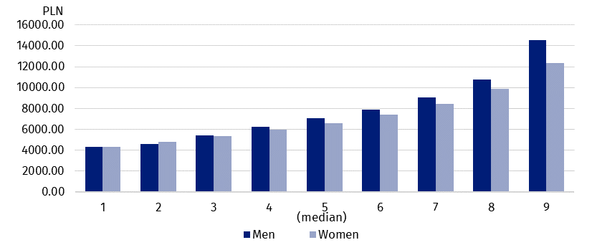
Chart 1. Deciles of monthly gross wages and salaries in the national economy
by sex in November 2024

Average monthly gross wage and salary in the national economy
In November 2024, the average wage and salary of women was PLN 856.91 lower than the average wage and salary of men
The average wage and salary in the national economy in November 2024 was PLN 8 376.58. For men it amounted to PLN 8 797.56 and accounted for 105.0% of the total average wage and salary. On the other hand, the average wage and salary of women amounted to PLN 7 940.65, that is 94.8% of the total average wage and salary. In terms of the age of employees, the highest average wage and salary was recorded in the 45-54 age group (PLN 8 819.15), while taking into account entity size – in units with 1 000 or more employed persons (PLN 9 993.01).

Wages and salaries by territory
Wages and salaries in the national economy in November 2024 were differentiated territorially by place of residence of employees, as well as by place of the entity's seat.
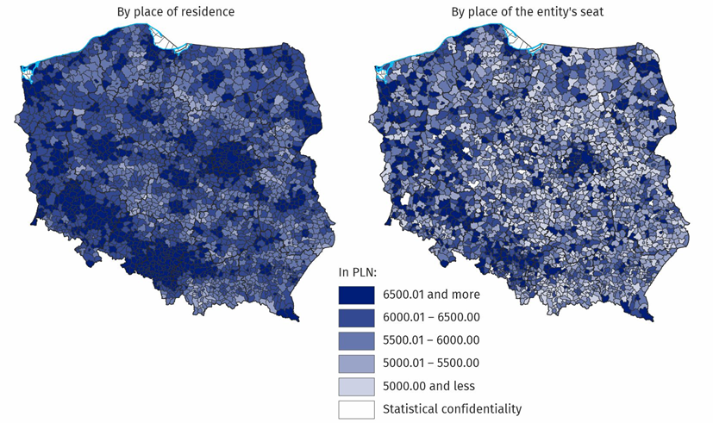
Map 1. Median monthly gross wage and salary in the national economy in November 2024
When analysing gminas by place of the entity's seat, in November 2024, the difference between the highest and lowest median value was PLN 8 104.61
Taking into account wages and salaries of the employees in gminas by place of the entity's seat, the difference between the highest and the lowest value of the median wage and salary was PLN 8 104.61, while in around 16% of gminas the median wage and salary was equal to or lower than PLN 5 000. On the other hand, by place of residence of employees, there were 0.1% of gminas with such a median, and the difference between the highest and the lowest value of the median wage and salary was PLN 4 574.73.

Wages and salaries by PKD 2007/NACE Rev. 2 section
Wages and salaries also varied by kind of activity. In November 2024, the highest median value occurred in the section Mining and quarrying, where it amounted to PLN 13 873.08. In 15 of the 19 PKD 2007/NACE Rev. 2 sections analysed, the median wages and salaries of men were higher than the median wages and salaries of women. The section Mining and quarrying stood out, where the median wage and salary of men was 37.1% higher than in the case of women. In 4 sections, median wages and salaries of women were higher than median wages and salaries of men. The largest difference in favour of women, as was the case in October 2024, occurred in the section Construction – it amounted to 36.1%.

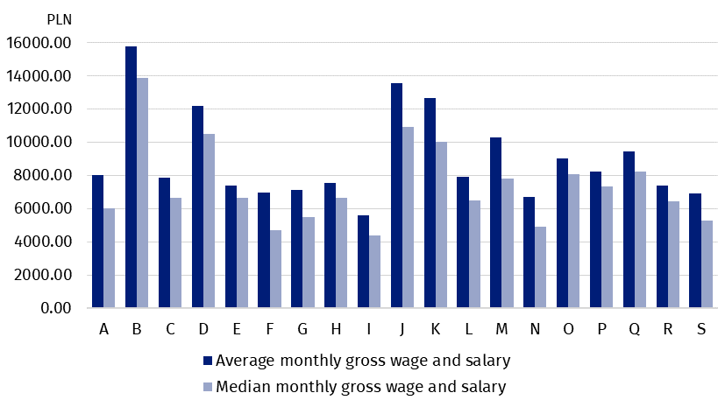
Chart 2. Average monthly gross wage and salary and median monthly gross wage and salary in the national economy by PKD 2007/NACE Rev. 2 section in November 2024
The highest average wage and salary was recorded in the section Mining and quarrying, where it amounted to PLN 15 778.83. As was the case in October 2024, the largest difference between the average wage and salary of men and that of women occurred in the section Financial and insurance activities and it amounted to PLN 4 372.95. In 4 sections, average wages and salaries of women were higher than men's – the largest difference was in the Construction section, where the average wage and salary of women was PLN 966.38 higher than that of men.
In November 2024, the average monthly gross wage and salary of male employees in the section Mining and quarrying was PLN 16 199.16

***
Data source: results of the Survey on the Distribution of Wages and Salaries in the National Economy.
There is a wider range of data on the distribution of wages and salaries in the publication tables.

In this news release abbreviated names of PKD 2007/NACE Rev. 2 sections were used. Abbreviations are marked with a ‘Δ’ symbol.
PKD 2007/NACE Rev. 2 section symbols:
A – Agriculture, forestry and fishing;
B – Mining and quarrying;
C – Manufacturing;
D – Electricity, gas, steam and air conditioning supply;
E – Water supply; sewerage, waste management and remediation activities;
F – Construction;
G – Wholesale and retail trade; repair of motor vehicles and motorcycles;
H – Transportation and storage;
I – Accommodation and food service activities;
J – Information and communication;
K – Financial and insurance activities;
L – Real estate activities;
M – Professional, scientific and technical activities;
N – Administrative and support service activities;
O – Public administration and defence; compulsory social security;
P – Education;
Q – Human health and social work activities;
R – Arts, entertainment and recreation;
S – Other service activities.
The data for the section Other service activities (S) also include employees in the sections Activities of households as employers; undifferentiated goods- and services- producing activities of households for own use (T) and Activities of extraterritorial organisations and bodies (U).
In the case of quoting Statistics Poland data, please provide information: ‘Source of data: Statistics Poland’, and in the case of publishing calculations made on data published by Statistics Poland, please provide information: ‘Own work based on Statistics Poland data.’

Prepared by:  Statistical Office in Bydgoszcz  Director Wiesława Gierańczyk, Ph.D.  Phone: (+48 52) 366 93 90 | Issued by:  Press Office  Mobile phone: +48 695 255 032  Landline phones: +48 22 608 38 04, +48 22 449 41 45, +48 22 608 30 09  e-mail: obslugaprasowa@stat.gov.pl

www.stat.gov.pl/en/

@StatPoland

@GlownyUrzadStatystyczny

gus_stat

glownyurzadstatystycznygus

glownyurzadstatystyczny
Related information
Methodological report Distribution of wages and salaries in the national economy

