Producer price indices for business services in the fourth quarter of 2024

In the fourth quarter of 2024, the producer prices for business services increased compared to the previous quarter by 0.6% and compared to the fourth quarter of 2023 - by 4.7%.
100.6
Increase in producer prices for business services compared to the third quarter of 2024

Table 1. Producer price indices for business services
SPECIFICATION | 4 quarter 2024 |  | 1-4 quarter 2024
SPECIFICATION | 3 quarter 2024=100 | 4 quarter 2023=100 | 1-4 quarter 2023=100
Total | 100.6 | 104.7 | 105.0
Publishing activities | 102.1 | 105.6 | 105.4
Motion picture, video and television programme production, sound recording and music publishing activities | 101.6 | 105.0 | 104.2
Programming and broadcasting activities | 100.4 | 104.8 | 106.2
Computer programming, consultancy and related activities | 100.9 | 103.2 | 102.2
Information service activities | 100.3 | 103.6 | 104.2
Real estate activities | 100.3 | 106.7 | 107.4
Legal and accounting activities | 100.8 | 104.4 | 104.5
Management consultancy activities | 100.4 | 103.3 | 101.8
Architectural and engineering activities; technical testing and analysis | 100.3 | 102.4 | 104.0
Advertising and market research | 101.0 | 106.5 | 107.2

SPECIFICATION | 4 quarter 2024 |  | 1-4 quarter 2024
SPECIFICATION | 3 quarter 2024=100 | 4 quarter 2023=100 | 1-4 quarter 2023=100
Other professional, scientific and technical activities | 101.6 | 105.3 | 106.8
Rental and leasing activities | 100.0 | 99.5 | 100.9
Employment activities | 100.5 | 106.0 | 107.3
Travel agency, tour operator and other reservation service and related activities | 97.1 | 102.2 | 104.9
Security and investigation activities | 100.4 | 112.5 | 113.5
Services to buildings and landscape activities | 100.5 | 108.4 | 108.7
Office administrative, office support and other business support activities | 101.1 | 104.4 | 105.0

In the fourth quarter of 2024, the highest increase of prices compared to the previous quarter was recorded in publishing activities
In the fourth quarter of 2024, the highest increase of prices compared to the previous quarter was recorded in publishing activities (by 2.1%). Subsequently, the service prices in motion picture, video and television programme production, sound recording and music publishing activities and other professional, scientific and technical activities rose the most (by 1.6% each). The lowest growths in prices concerned services in information service activities, real estate activities and architectural and engineering activities; technical testing and analysis (by 0.3% each). However, the prices in rental and leasing activities remained at the level of previous quarter.
Price decrease compared to the previous quarter was recorded in travel agency, tour operator and other reservation service and related activities (by 2.9%).
Compared to the fourth quarter of 2023, the highest increase of prices occurred in security and investigation activities (by 12.5%). Significant price increases were also noticed in services to buildings and landscape activities (by 8.4%), real estate activities (by 6.7%) and advertising and market research (by. 6.5%).
The lowest increase of prices compared to the fourth quarter of 2023 was recorded in the case of travel agency, tour operator and other reservation service and related activities (by 2.2%) and architectural and engineering activities; technical testing and analysis
(by 2.4%).
Whereas, price decerase compared to the fourth quarter of 2023 occurred in rental and leasing activities (by 0.5%).

Chart 1. Producer price changes of business services in 2021-2024 (the previous quarter = 100)
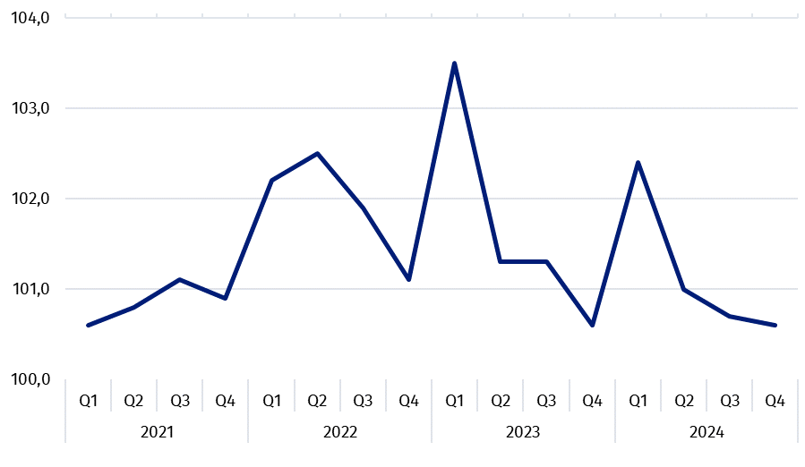

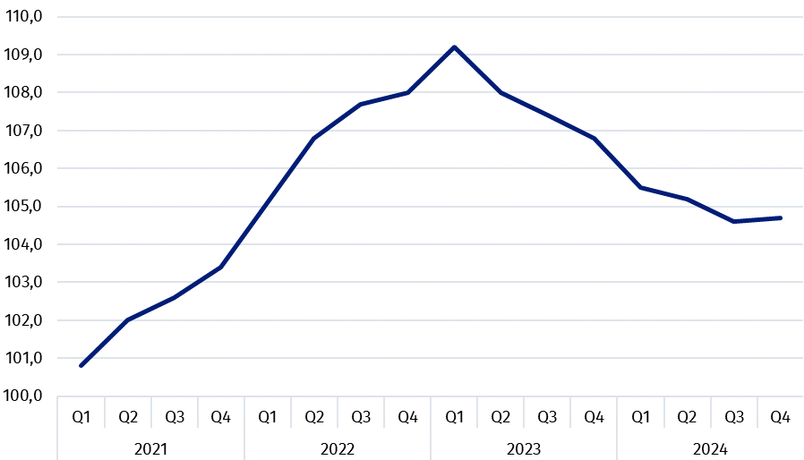
Chart 2. Producer price changes of business services in 2021-2024 (corresponding period of the previous year = 100)

In case of quoting Statistics Poland data, please provide information: “Source of data: Statistics Poland”, and in case of publishing calculations made on data published by Statistics Poland, please include the following disclaimer: “Own study based on figures from Statistics Poland”.

Prepared by:  Trade and Services Department  Director Ewa Adach-Stankiewicz  Phone: (+48 22) 608 31 24 | Issued by:  Press Office  Mobile +48 695 255 032  Phone +48 22 608 38 04, +48 22 449 41 45,  +48 22 608 30 09  e-mail: obslugaprasowa@stat.gov.pl

www.stat.gov.pl/en/

@StatPoland

@GlownyUrzadStatystyczny

gus_stat

glownyurzadstatystycznygus

glownyurzadstatystyczny
Related information
News releases

Prices in the national economy

Data available in databases
Knowledge Databases
Prices indices (Topics: Prices, Trade)

Terms used inn official statistics
Producer price indices for business services

