Stationary social welfare facilities in 2024
As of 31 December 2024 in Poland there were 2 232 stationary social welfare facilities, which had 134.1 thousand places in total. 124.5 thousand residents stayed there, including 61.6 thousand women. In comparison to 2023 the number of facilities increased by 4.4%, the number of places by 1.1% and the number of residents by 2.1%.
4.4%
Increase in the number of stationary social welfare facilities in comparison to 2023

Facilities
Social assistance houses accounted for over 40% of all stationary social welfare facilities
In 2024 there were 2 232 stationary social welfare facilities that is by 4.4% than in 2023. Social assistance houses accounted for 40.5% of all facilities, establishments ensuring 24–hour care for disabled persons, chronic patients or elderly persons within the scope of economic activity or their statutory activity – 30.5% and hostels for homeless persons and night shelters – 19.6%. Family–based assistance houses, community self–help centres (including round–the–clock available places), houses for mothers with children under age and pregnant women and other centres accounted in total for 9.4% of all facilities.

Table 1. Stationary social welfare facilities by type in 2024

As of 31 December
Specification | Centresª |  | Places^{b} |  | Residents^{b}
Specification | in absolute numbers | in percent | in absolute numbers | in percent | in absolute numbers | in percent
Total | 2 232 | 100.0 | 134 050 | 100.0 | 124 462 | 100.0
Social assistance houses | 903 | 40.5 | 84 319 | 63.0 | 82 077 | 66.0
Family-based assistance houses | 40 | 1.8 | 317 | 0.2 | 297 | 0.2
Centres run within the scope of economic or statutory activity^{c} | 680 | 30.5 | 28 025 | 20.9 | 25 185 | 20.3
Community self-help centres^{d} | 25 | 1.1 | 159 | 0.1 | 83 | 0.1
Houses for mothers with children under age and pregnant women | 59 | 2.6 | 1 476 | 1.1 | 892 | 0.7
Night shelters | 107 | 4.8 | 3 228 | 2.4 | 2 411 | 1.9
Hostels for homeless persons | 331 | 14.8 | 15 049 | 11.2 | 12 870 | 10.3
Others | 87 | 3.9 | 1 477 | 1.1 | 647 | 0.5
a Excluding branches. b Including branches. c Establishments ensuring 24-hour care for disabled persons, chronic patients or elderly persons within the scope of economic activity or their statutory activity. d Including round-the-clock places.
Local government was a governing body for 777 stationary social welfare facilities, which accounted for 34.8% of all centres. The rest of facilities were managed among others by natural and legal persons, associations and foundations and by churches and religious unions.

Chart 1. Stationary social welfare facilities by governing bodies in 2024

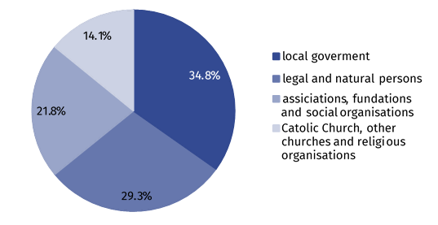
As of 31 December

Places
Stationary social welfare facilities had at their disposal 134.1 thousand places in total (increase by 1.1% in comparison to 2023). The places in social assistance houses accounted for 63.0% of all places in stationary social welfare facilities, 20.9% for establishments ensuring 24–hour care for disabled persons, chronic patients or elderly persons within the scope of economic activity or their statutory activity and 13.6% for hostels for homeless persons and night shelters. Family–based assistance houses, community self–help centres (with round–the–clock available places), houses for mothers with children under age and pregnant women and others accounted in total for 2.5% of all places.
The facilities for which local government was a governing body had at their disposal the biggest number of places – 69.8 thousand. The centres led by physical and legal persons had 26.8 thousand places, the ones led by associations, foundations and social organisations possessed 20.9 thousand places and the units of the Catholic Church, other churches or religious unions provided 16.5 thousand places.

Residents
Nearly 31% of all residents in stationary social welfare facilities stayed in the centres for elderly persons
As of 31 December, in stationary social welfare facilities there were 124.5 thousand residents (increase by 2.1% in comparison to 2023), out of which women accounted for 49.5%. Out of all residents, 66.0% were the residents of social assistance houses. Over 20% residents stayed in establishments ensuring 24–hour care for disabled persons, chronic patients or elderly persons within the scope of economic activity or their statutory activity and 12.2% in hostels for homeless persons and night shelters. The residents staying in houses for mothers, family–based assistance houses, community self–help centres (including round–the–clock available places) and other facilities accounted for 1.5% of all residents.
Likewise in 2023, most residents stayed in the centres for aged persons (30.8% of total number of the residents). Less residents were among others in facilities for chronically mentally ill (19.0%) and in facilities for chronically ill with somatic disorders (17.9%). The smallest share of the residents lived in the centres for people addicted to alcohol (0.1%).

Chart 2. Residents of stationary social welfare facilities by their designation in 2024
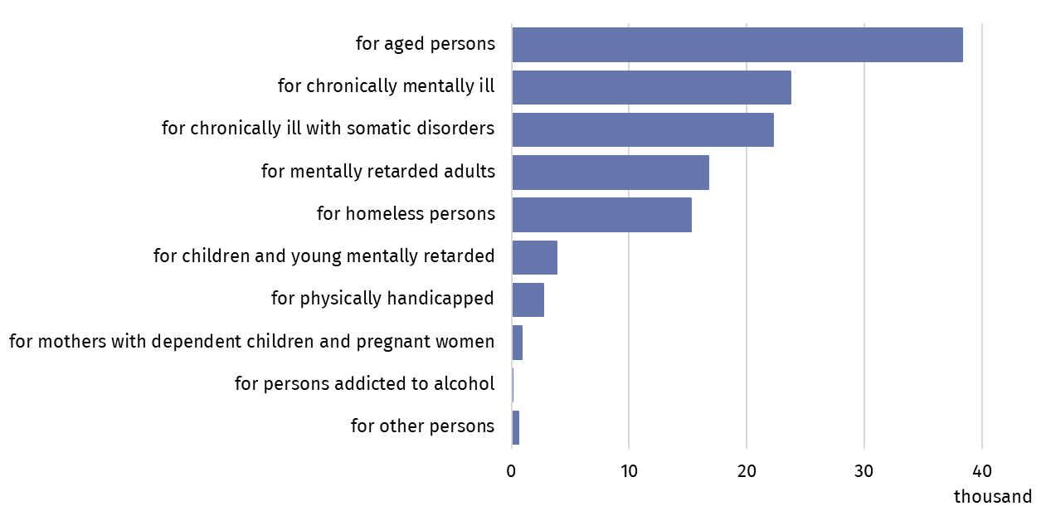
As of 31 December
Most residents in stationary social welfare facilities were the elders over 60 years old (85.5 thousand), while the persons up to age of 18 constituted the smallest group (1.8 thousand).

Chart 3. Residents of stationary social welfare facilities by age groups in 2024

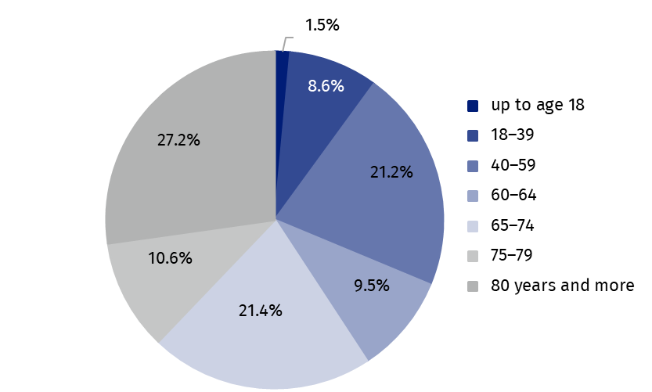
As of 31 December
For 72.0 thousand working persons (regardless the type of employment contract) the stationary social welfare facilities were the principal workplace. The biggest group, nearly 91%, was formed by non-medical personnel. Medical personnel including nurses, physiotherapists and physicians accounted for 6.9%, 2.2% and 0.1% of all the employed respectively.

Table 2. Stationary social welfare facilities by voivodships in 2024
As of 31 December
Specification | Centresª | Places^{b} | Residents^{b}
POLAND | 2 232 | 134 050 | 124 462
Dolnośląskie | 160 | 10 045 | 9 418
Kujawsko-pomorskie | 103 | 6 227 | 5 876
Lubelskie | 91 | 5 902 | 5 525
Lubuskie | 55 | 3 208 | 3 020
Łódzkie | 135 | 8 932 | 8 432
Małopolskie | 177 | 11 761 | 11 182
Mazowieckie | 311 | 18 745 | 17 157
Opolskie | 77 | 4 899 | 4 543
Podkarpackie | 102 | 6 721 | 5 958
Podlaskie | 73 | 3 978 | 3 632
Pomorskie | 168 | 9 175 | 8544
Śląskie | 289 | 16 347 | 15 076
Świętokrzyskie | 98 | 5 642 | 5 185
Warmińsko-mazurskie | 116 | 5 851 | 5 406
Wielkopolskie | 172 | 9 942 | 9 381
Zachodniopomorskie | 105 | 6 675 | 6 127
a Excluding branches. b Including branches.
In the case of quoting data from the Statistics Poland, please provide information: “Statistics Poland data source”, and in the case of publishing calculations made on data published by the Statistics Poland, please provide information: “Own study based on Statistics Poland data”.

Prepared by:  Statistical Office in Kraków  Director Agnieszka Szlubowska  Phone: (+48 12) 420 40 50 | Issued by:  Press Office  Mobile: (+48) 695 255 032  Phone: (+48 22) 608 38 04, (+48 22) 449 41 45,  (+48 22) 608 30 09  e-mail: obslugaprasowa@stat.gov.pl

stat.gov.pl/en/

@StatPoland

@GlownyUrzadStatystyczny

gus_stat

glownyurzadstatystycznygus

glownyurzadstatystyczny
Related information
Social assistance, child and family services in 2023
Data available in databases
Database Local Data Bank – health care, social welfare and benefits to the family
Knowledge Databases - Society - Social assistance and social benefits
Terms used in official statistics
Community self-help centre
Establishment ensuring 24-hour care for disabled persons, chronic patients, or elderly persons within the scope of economic activity or their statutory activity
Family-based assistance house
Hostel for homeless persons
House for mothers with children under age and pregnant women
Night shelter
Social assistance house

