Therapeutic activities of health resort facilities and inpatient rehabilitation facilities in 2024
At the end of 2024, there were operating 263 health resort facilities. 884.2 thousand patients were admitted to health resort facilities during a year, of which 798.9 thousand were inpatients. 86.7 thousand inpatients were treated in 49 inpatient rehabilitation facilities.
2.5%
Decrease in the number of inpatients in health resort facilities compared to 2023
Due to the occurrence of flooding in September 2024 in the southwestern part of the country, there were temporary restrictions on the provision of healthcare services in the disaster-affected areas, which had an impact on the presented data on spa treatment and healing rehabilitation.

Health resort facilities
46.1 thousand beds were in health resort hospitals and sanatoriums
At the end of 2024, there were operating 41 health resort hospitals (of which 3 for children), 194 health resort sanatoriums (of which 2 for children and 1 sanatorium in underground mining excavations), 7 outpatient health resort units and 21 natural healing centres which conduct their treatment in health resort complexes. At the end of the year there were almost 46.1 thousand health resort beds in health resort hospitals and sanatoriums (by 0.4 thousand more in relation to the previous year). 798.9 thousand inpatients were treated during the year (by 2.5% less than in 2023). Women accounted for 60.1% of the total inpatients being treated, while people aged 65 years and more – 58.1%. Average stay of inpatients was 16 days.
The most inpatients were treated in health resort facilities in Zachodniopomorskie Voivodship (210.5 thousand persons). A significant number of inpatients were also recorded in Kujawsko-Pomorskie (166 thousand), Dolnośląskie (95.2 thousand) and Małopolskie (94.3 thousand). In total 70.8% of inpatients were admitted in these four mentioned voivodships.
In Poland 4.3% inpatients treated in health resort facilities were foreigners. The vast majority of foreigners (96.2%) were admitted to health resort facilities in three voivodships: Zachodniopomorskie, Dolnośląskie and Kujawsko-Pomorskie.
Table 1. Activities of health resort facilities by type of facility in 2024
Specification | Health resort hospitals | Health resort sanatoriums | Outpatient health resort units | Natural healing centres
Health resort facilities (as of 31 December) | 41 | 194 | 7 | 21
Beds in thousands (as of 31 December) | 7.6 | 38.5 | – | –
Inpatients in thousands | 111.0 | 687.9 | – | –
Average stay of inpatients (in days) | 18.6 | 15.6 | – | –
Outpatients in thousands | 3.7 | 28.4 | 14.6 | 38.5
In 2024, 458.7 thousand of inpatients were subsidized by National Health Fund (by 2.3% less than in the previous year), while the number of self-pay inpatients amounted to 292.1 thousand (by 3.9% less). The Social Insurance Institution subsidised inpatient treatment for 26.2 persons (by 15.2% more than in 2023).

Chart 1. Inpatients treated in health resort facilities by type of financing in 2024
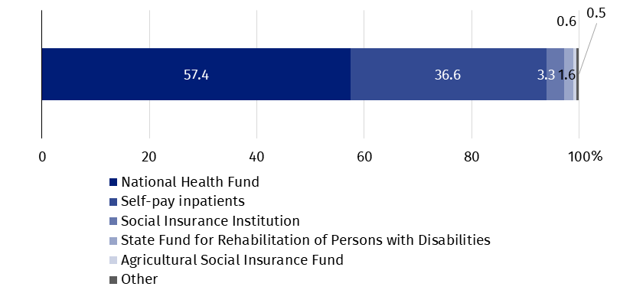
85.3 thousand outpatients were treated in health resort facilities (by 0.9% more than in 2023). Above 78% of patients were admitted to outpatient health resort units and natural healing centres.
Table 2. Activities of health resort facilities by voivodships in 2024
The most inpatients were treated in health resort facilities in Zachodniopomorskie Voivodship (210.5 thousand persons)
Voivodships | Beds (as of 31 December) | Inpatients | Outpatients | Average stay of inpatients (in days)
Voivodships | in thousands |  |  | Average stay of inpatients (in days)
Polska | 46.1 | 798.9 | 85.3 | 16.0
Dolnośląskie | 6.2 | 95.2 | 28.6 | 16.8
Kujawsko-pomorskie | 8.8 | 166.0 | 14.4 | 15.8
Lubelskie | 1.4 | 23.6 | 3.1 | 17.2
Łódzkie | 0.1 | 2.1 | 0.6 | 16.2
Małopolskie | 5.9 | 94.3 | 16.4 | 17.7
Mazowieckie | 0.2 | 2.4 | 0.5 | 20.5
Podkarpackie | 4.1 | 61.6 | 3.8 | 18.9
Podlaskie | 0.4 | 9.9 | 0.8 | 14.2
Pomorskie | 1.3 | 22.9 | 3.0 | 15.7
Śląskie | 2.7 | 36.8 | 1.7 | 18.4
Świętokrzyskie | 3.4 | 67.7 | 5.8 | 15.5
Warmińsko-mazurskie | 0.5 | 5.8 | – | 20.7
Zachodniopomorskie | 11.0 | 210.5 | 6.5 | 13.6
Note: In three voivodships (Lubuskie, Opolskie, Wielkopolskie) the health resort facilities do not occur.
37.5 million medical services were provided in health resort facilities
In 2024, 37.5 million medical services were provided in health resort facilities (by 1.4% less than year ago). As in the previous year, the largest number of natural healing services were performed (9.8 million), including peat treatments and mineral baths. Kinesiotherapy (7.0 million), electrotherapy (4.3 million), massage (4.0 million), other therapeutic treatments and activities (3.7 million), hydrotherapy (3.4 million) and light therapy (3.1 million) were also popular.

Chart 2. Medical services provided in health resort facilities by type of service in 2024

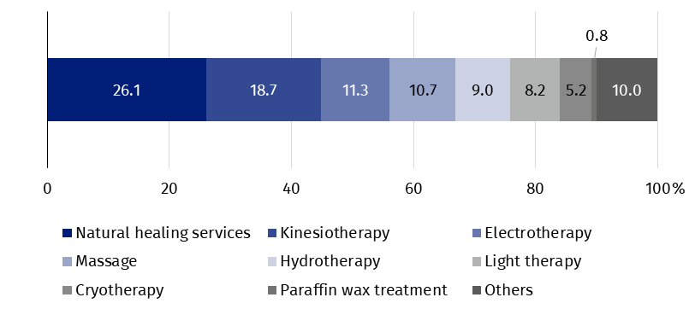

Inpatient rehabilitation facilities
5.4 thousand beds were in inpatient rehabilitation facilities
As the end of 2024, 49 inpatient rehabilitation facilities were operating in which there were 5.4 thousand health resort beds (by 0.2 thousand more than in the previous year). During the year 86.7 thousand patients were admitted (by 18.8% more than in 2023), of whom 78.1 thousand inpatients and 8.6 thousand outpatients.
Women accounted for 57.6% of the total inpatients being treated, while people aged 65 years and more – 48.4%. Average stay of inpatients was 13 days.

Chart 3. Inpatients treated in inpatient rehabilitation facilities by type of financing in 2024

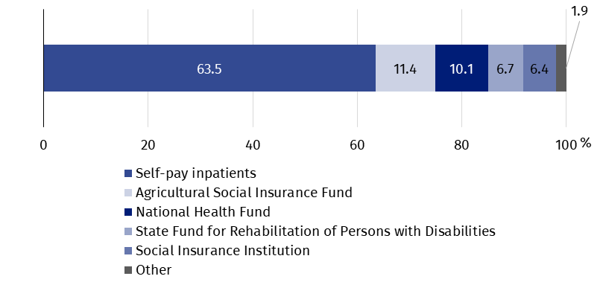
In inpatient rehabilitation facilities, most inpatients treated belonged to self-pay inpatients – 49.6 thousand. Among institutions subsidized inpatients, the Agricultural Social Insurance Fund subsidized 8.9 thousand patients, the National Health Fund – 7.9 thousand, the State Fund for Rehabilitation of Persons with Disabilities – 5.2 thousand and the Social Insurance Institution – 5.0 thousand.
3.7 million medical services were provided in inpatient rehabilitation facilities during a year (by 12.8% more than in 2023), most of them belonged to kinesiotherapy (29.1%).
In the case of quoting data from the Statistics Poland, please provide information: "Statistics Poland data source", and in the case of publishing calculations made on data published by the Statistics Poland, please provide information: "Own study based on Statistics Poland data".

Prepared by:  Statistical Office in Kraków  Director Agnieszka Szlubowska  Phone: (+48 12) 420 40 50 | Issued by:  Press Office  Mobile: (+48) 695 255 032  Phone: (+48 22) 608 38 04, (+48 22) 449 41 45,  (+48 22) 608 30 09  e-mail: obslugaprasowa@stat.gov.pl

stat.gov.pl/en/

@StatPoland

@GlownyUrzadStatystyczny

gus_stat

glownyurzadstatystycznygus

glownyurzadstatystyczny
Related information
Health and health care in 2023
Methodological report. Health and health care statistics − Statistics Poland’s reports
Data available in databases
Local Data Bank -> Health care, social welfare and benefits to the family
Knowledge Databases -> Society -> Health and Health care
Terms used inn official statistics
Patient in health resort
Health resort treatment
Inpatient rehabilitation facility
Health resort facility

Medical services provided in natural healing centres operating as a functional unit of the health resort hospital, sanatorium or outpatient health resort unit, are counted together with the main unit.

