Index of sold production of industry in January 2025^{a)}
In January 2025, sold production of industry was by 1.0% lower than in January 2024, when an increase was recorded by 2.9% as compared to the corresponding period of the previous year, whereas in comparison with December 2024, it increased by 2.3%.
1.0%
Decrease in sold production of industry as compared to January 2024

After seasonal adjustment, an increase in sold industrial production in January 2025 amounted to 0.3% per year

After eliminating the seasonal factors, in January 2025 sold production of industry reached the level higher by 0.3% than in the corresponding month of 2024 and by 0.5% higher as compared to December 2024.
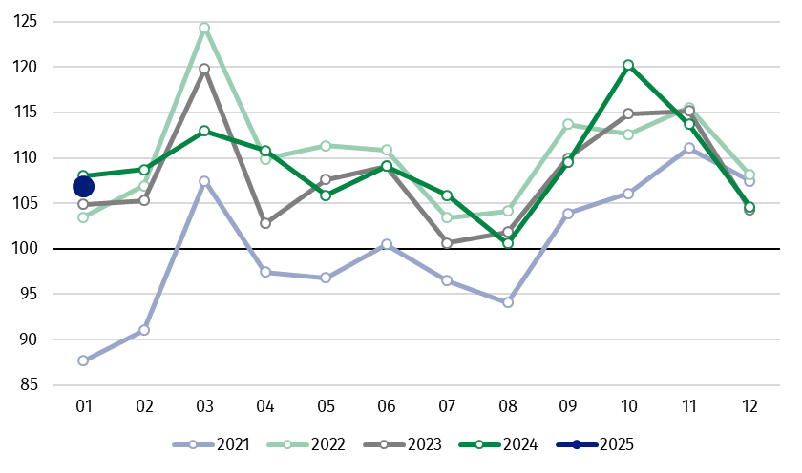
Chart 1. Sold production of industry (monthly average of 2021=100)

In January 2024, among the main industrial groupings there was a decrease per year in the production of energy – by 15.1% and capital goods – by 6.1%. An increase was observed in the production of non-durable consumer goods – by 4.6%, intermediate goods – by 4.0% and durable consumer goods – by 3.3%.

^{a)} Reported data; comprise enterprises with 10 or more persons employed.

Table 1. Index of sold production of industry ^{a)} (constant prices)
SPECIFICATION | 12 2024 | 01 2025 | 12 2024 | 01 2025 | 12 2024 | 01 2025
SPECIFICATION | previous month =100 |  | previous year =100 |  | monthly average  of 2021 =100
INDUSTRY | 92.1* | 102.3 | 100.2 | 99.0 | 104.6* | 106.9
Mining and quarrying | 95.1* | 98.0 | 103.1* | 95.2 | 101.4* | 99.4
Manufacturing | 90.7 | 103.2 | 99.9 | 99.1 | 101.1 | 104.0
Electricity, gas, steam and air conditioning supply | 108.4* | 96.6 | 102.8* | 97.2 | 143.1* | 146.7
Water supply; sewerage waste management and remediation activities | 100.2 | 91.9 | 103.8 | 103.0 | 115.0 | 105.7
^{a)} Data including final information on production and prices in December and reported data in January.
* Data revised.
Share of production value of industry divisions, which saw a decrease in comparison to January 2024, stood at 42.1%

According to the preliminary data, in January 2025 as compared to January 2024, a decrease in sold production (in constant prices) was reported in 14 (out of 34) industry divisions, among others in manufacture of motor vehicles, trailers and semi-trailers – by 15.1%, manufacture of electrical equipment – by 7.7%, in mining of coal and lignite – by 6.0%, in manufacture of beverages – by 3.6%, in electricity, gas, steam and air conditioning supply – by 2.8%.
An increase in sold production of industry, as compared to January 2024, was recorded in 20 divisions, among others in manufacture of basic metals – by 18.9%, in repair and installation of machinery and equipment – by 17.4%, in manufacture of other non-metallic mineral products – by 14.2%, in waste collection, treatment and disposal activities; materials recovery – by 10.0%, in manufacture of other transport equipment – by 7.5%.
Chart 2. Index of sold production of industry by selected NACE divisions (constant
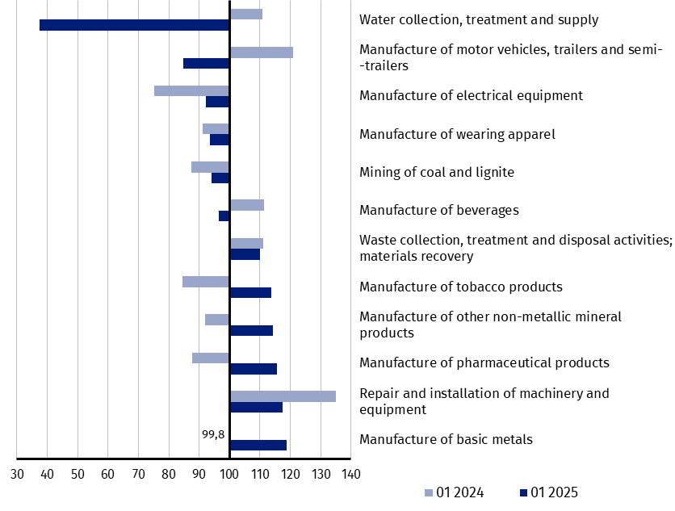
prices; previous year =100)
As compared to December 2024, an increase in sold production (in constant prices) in January 2025 was recorded in 16 (out of 34) industry divisions, among others in manufacture of basic metals – by 50.4%, manufacture of products of wood, cork, straw and wicker – by 30.2%, manufacture of chemicals and chemical products – by 28.0%, manufacture of rubber and plastic products – by 23.5%, manufacture of paper and paper products – by 18.8%, manufacture of furniture – by 15.8%, manufacture of motor vehicles, trailers and semi-trailers – by 11.2%, manufacture of other non-metallic mineral products – by 10.9%, manufacture of metal products – by 8.7%.
A decrease in sold production of industry, as compared to December 2024, was recorded in 18 divisions, among others in manufacture of other transport equipment – by 35.3%, manufacture of beverages – by 29.2%, in repair and installation of machinery and equipment – by 27.3%, in manufacture of machinery and equipment – by 19.2%.

Chart 3. Index of sold production of industry by selected NACE divisions (constant
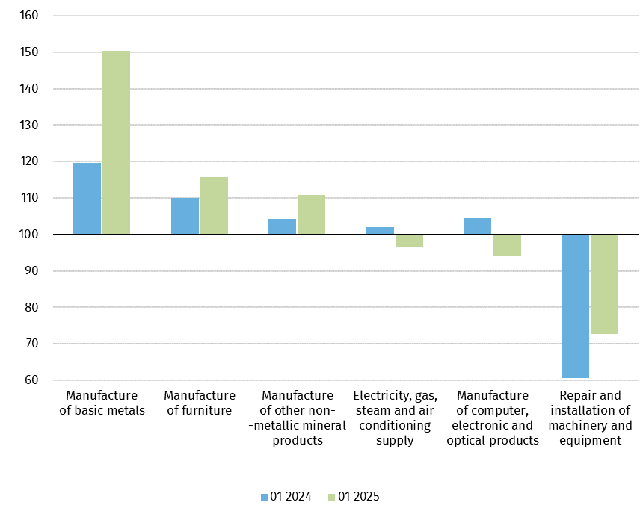
prices; previous month =100)

In case of quoting Statistics Poland data, please provide information: “Source of data: Statistics Poland”, and in case of publishing calculations made on data published by Statistics Poland, please include the following disclaimer: “Own study based on figures from Statistics Poland”.
Prepared by:  Enterprises Department  Director Katarzyna Walkowska  Phone: (+48 22) 608 31 25 | Issued by:  Press Office  Mobile +48 695 255 032  Phone +48 22 608 38 04, +48 22 449 41 45,  +48 22 608 30 09  e-mail: obslugaprasowa@stat.gov.pl

stat.gov.pl

@GUS_STAT

@GlownyUrzadStatystyczny

gus_stat

glownyurzadstatystycznygus

glownyurzadstatystyczny

Related information
Statistical Bulletin
Socio-economic situation of the country

Data available in databases
Knowledge Database - Industrial Production
Macroeconomic Data Bank
Macroeconomic indicators
Local Data Bank

Terms used in official statistics
Sold production of industry
Seasonally un-adjustedindex of sold production of industry
Seasonally adjustedindex of sold production of industry
Production of capital goods
Production of non-durable consumer goods
Production of durable consumer goods
Production of intermediate goods
Production of goods related to energy

