Index of sold production of industry in February 2025¹
In February 2025, sold production of industry was by 2.0% lower than in February 2024 (when an increase was recorded by 3.3%), whereas in comparison with January 2025, it decreased by 0.4%. In the period January-February of 2025, sold production of industry was by 0.9% lower than in the corresponding period of 2024 (which saw an increase by 2.7%).
2.0%
Decrease in sold production of industry as compared to February 2024

After seasonal adjustment, an increase in sold industrial production in February 2025 amounted to 0.1% per year

After eliminating the seasonal factors, in February 2025 sold production of industry reached the level higher by 0.1% than in the corresponding month of 2024 and by 0.2% lower than in January 2025.
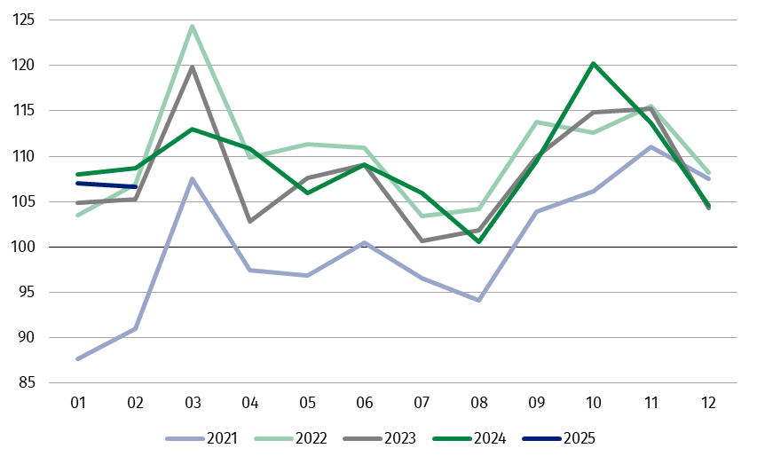
Chart 1. Sold production of industry (monthly average of 2021=100)

In February 2025, in all main industrial groupings there was observed a decrease per year, in the production of energy – by 10.6%, capital goods – by 2.6%, intermediate goods – by 0.8%, non-durable consumer goods – by 0.4% and durable consumer goods – by 0.2%.

1 Preliminary data; comprise enterprises with 10 or more persons employed.

Table 1. Index of sold production of industry ª (constant prices)
SPECIFICATION | 2025
SPECIFICATION | 01 | 02 | 01 | 02 | 01-02 | 01 | 02
SPECIFICATION | previous month =100 |  | previous year =100 |  |  | monthly average  of 2021 =100
INDUSTRY | 102.5* | 99.6 | 99.1* | 98.0 | 99.1 | 107.0* | 106.6
Mining and quarrying | 97.7* | 96.4 | 94.9* | 87.1 | 91.1 | 99.1* | 95.5
Manufacturing | 103.4* | 99.7 | 99.3* | 97.7 | 99.1 | 104.2* | 104.3
Electricity, gas, steam and air conditioning supply | 95.8* | 97.6 | 96.5* | 108.1 | 103.2 | 145.5* | 138.1
Water supply; sewerage waste management and remediation activities | 91.8* | 100.7 | 102.9* | 101.5 | 103.2 | 105.5* | 106.3
a Data including final information on production and prices in January and preliminary data in February.
* Data revised.
Share of production value of industry divisions, which saw a decrease in comparison to February 2024, stood at 47.5%

According to the preliminary data, in February 2025 a decrease in sold production (in constant prices), as compared to February 2024, was reported in 20 (out of 34) industry divisions, among others in repair and installation of machinery and equipment – by 15.1%, in manufacture of electrical equipment – by 7.3%, manufacture of beverages – by 4.9%, manufacture of motor vehicles, trailers and semi-trailers – by 4.8%, manufacture of machinery and equipment – by 3.6%, in mining of coal and lignite – by 2.3%, in manufacture of rubber and plastic products – by 2.2%.
An increase in sold production of industry, as compared to February 2024, was recorded in 14 divisions, among others in manufacture of basic metals – by 15.5%, in manufacture of other transport equipment – by 10.2%, in waste collection, treatment and disposal activities; materials recovery – by 8.7%, in electricity, gas, steam and air conditioning supply – by 8.1%, in manufacture of computer, electronic and optical products – by 6.4%.
Chart 2. Index of sold production of industry by selected NACE divisions (constant
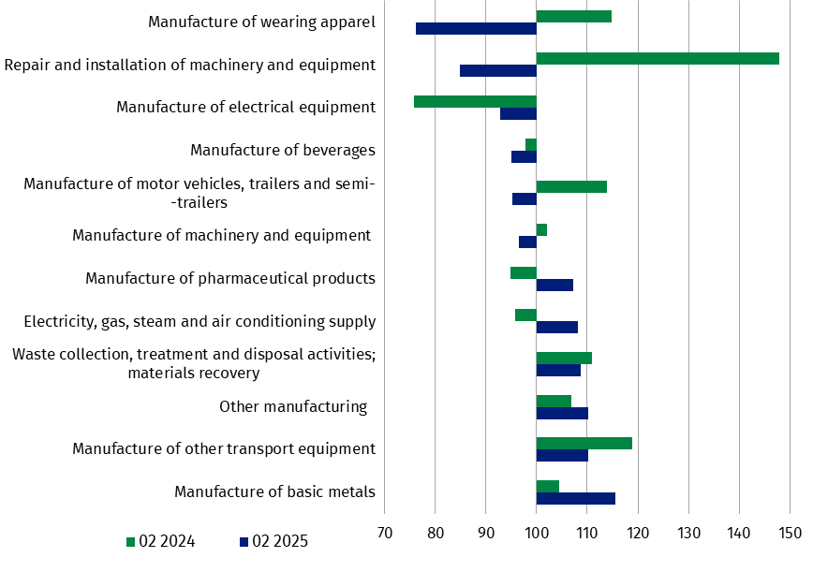
prices; previous year=100)
In February 2025, a decrease in sold production (in constant prices), as compared to January 2025, was recorded in 19 (out of 34) industry divisions, among others in mining of coal and lignite – by 11.6%, in manufacture of paper and paper products – by 8.2%, manufacture of food products – by 6.6%, manufacture of beverages – by 6.3%, manufacture of chemicals and chemical products – by 3.3%, manufacture of furniture – by 3.1%, in electricity, gas, steam and air conditioning supply – by 2.4%.
An increase in sold production of industry, as compared to the previous month, was recorded in 15 divisions, among others in manufacture of other transport equipment – by 17.2%, manufacture of motor vehicles, trailers and semi-trailers – by 12.7%, manufacture of machinery and equipment – by 9.8%.

Chart 3. Index of sold production of industry by selected NACE divisions (constant
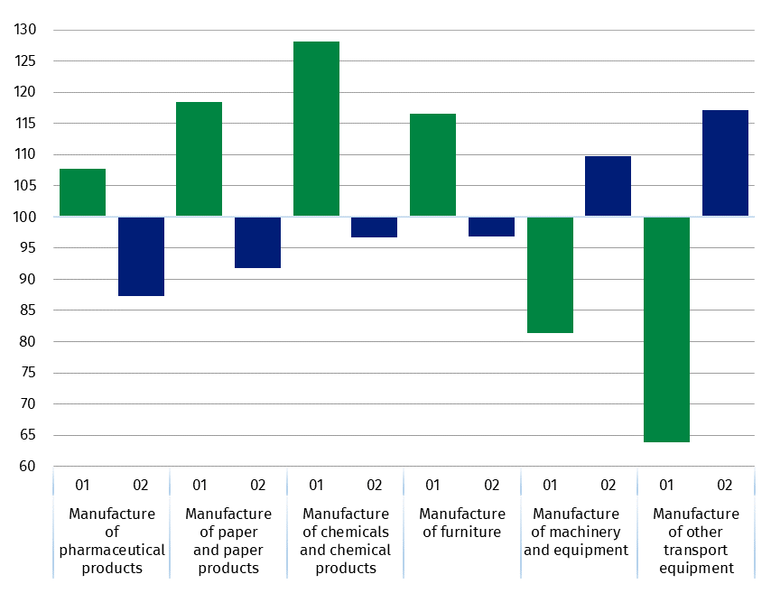
prices; previous month=100)

In case of quoting Statistics Poland data, please provide information: “Source of data: Statistics Poland”, and in case of publishing calculations made on data published by Statistics Poland, please include the following disclaimer: “Own study based on figures from Statistics Poland”.
Prepared by:  Enterprises Department  Director Katarzyna Walkowska  Phone: (+48 22) 608 31 25 | Issued by:  Press Office  Mobile +48 695 255 032  Phone +48 22 608 38 04, +48 22 449 41 45,  +48 22 608 30 09  e-mail: obslugaprasowa@stat.gov.pl

stat.gov.pl

@GUS_STAT

@GlownyUrzadStatystyczny

gus_stat

glownyurzadstatystycznygus

glownyurzadstatystyczny

Related information
Statistical Bulletin
Socio-economic situation of the country

Data available in databases
Knowledge Database - Industry
Macroeconomic Data Bank
Macroeconomic indicators
Local Data Bank

Terms used in official statistics
Sold production of industry
Seasonally un-adjustedindex of sold production of industry
Seasonally adjustedindex of sold production of industry
Production of capital goods
Production of non-durable consumer goods
Production of durable consumer goods
Production of intermediate goods
Production of goods related to energy

