Index of sold production of industry in March 2025¹
In March 2025, sold production of industry was by 2.5% higher than in March 2024 (when a decrease was recorded by 5.6%), whereas in comparison with February 2025, it increased by 8.6%. In the period January-March of 2025, sold production of industry was by 0.9% higher than in the corresponding period of 2024 (which saw a decrease by 0.6%).
2.5%
Increase in sold production of industry as compared to March 2024

After seasonal adjustment, an increase in sold industrial production in March 2025 amounted to 3.8% per year

After eliminating the seasonal factors, in March 2025 sold production of industry reached the level higher by 3.8% than in the corresponding month of 2024 and by 0.7% lower than in February 2025.
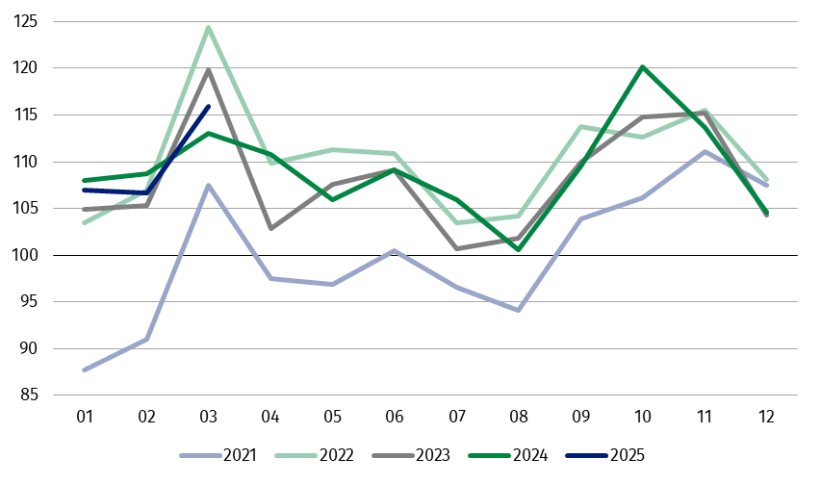
Chart 1. Sold production of industry (monthly average of 2021=100)

In March 2024, among the main industrial groupings there was an increase per year in the production of capital goods – by 10.4%, intermediate goods – by 4.3%, non-durable consumer goods – by 2.6% and durable consumer goods – by 2.5%. A decrease was observed in the production of energy – by 16.9%.

1 Preliminary data; comprise enterprises with 10 or more persons employed.
Table 1. Index of sold production of industry ª (constant prices)
SPECIFICATION | 2025
SPECIFICATION | 02 | 03 | 02 | 03 | 01-03 | 02 | 03
SPECIFICATION | previous month =100 |  | previous year =100 |  |  | monthly average  of 2021 =100
INDUSTRY | 99.7* | 108.6 | 98.1* | 102.5 | 100.9 | 106.7* | 115.9
Mining and quarrying | 96.7* | 103.4 | 87.4* | 94.1 | 92.3 | 95.8* | 99.1
Manufacturing | 100.0* | 109.7 | 97.9* | 103.0 | 101.1 | 104.6* | 115.4
Electricity, gas, steam and air conditioning supply | 96.1* | 93.7 | 106.5* | 98.9 | 100.5 | 136.0* | 130.9
Water supply; sewerage waste management and remediation activities | 100.5* | 106.1 | 101.3* | 101.8 | 103.0 | 106.1* | 112.5
a Data including final information on production and prices in February and preliminary data in March.
* Data revised.
Share of sold production of industry divisions, which saw an increase, in total industry was 72.1%
According to the preliminary data, in March 2025 an increase in sold production (in constant prices), as compared to March 2024, was reported in 19 (out of 34) industry divisions, among others in repair and installation of machinery and equipment – by 23.5%, in manufacture of basic metals – by 21.3%, manufacture of products of wood, cork, straw and wicker – by 13.3%, manufacture of metal products – by 10.8%, manufacture of other non-metallic mineral products – by 10.2%, manufacture of motor vehicles, trailers and semi-trailers – by 9.1%, manufacture of computer, electronic and optical products – by 6.4%, manufacture of machinery and equipment – by 6.0%.
A decrease in sold production of industry, as compared to March 2024, was recorded in 15 divisions, among others in manufacture of tobacco products – by 10.6%, manufacture of electrical equipment – by 6.0%, manufacture of beverages – by 2.0%.
Chart 2. Index of sold production of industry by selected NACE divisions (constant
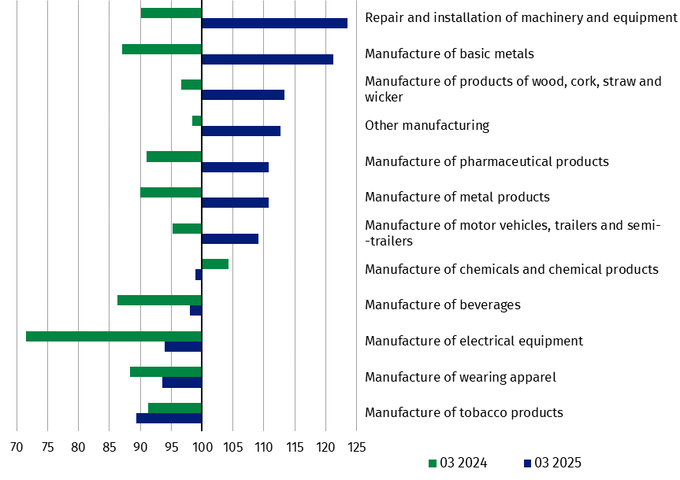
prices; previous year=100)
In March 2025, an increase in sold production (in constant prices), as compared to February 2025, was recorded in 30 (out of 34) industry divisions, among others in manufacture of beverages – by 30.8%, manufacture of other non-metallic mineral products – by 21.0%, manufacture of machinery and equipment – by 18.6%, in repair and installation of machinery and equipment – by 16.5%, in manufacture of products of wood, cork, straw and wicker – by 13.7%, manufacture of metal products – by 12.2%, manufacture of motor vehicles, trailers and semi-trailers – by 11.6%, manufacture of other transport equipment – by 11.1%, manufacture of food products – by 10.7%, manufacture of computer, electronic and optical products – by 9.1%.
A decrease in sold production of industry, as compared to the previous month, was recorded in 4 divisions, among others in electricity, gas, steam and air conditioning supply – by 6.3%, in mining of coal and lignite – by 1.9%.
Chart 3. Index of sold production of industry by selected NACE divisions (constant
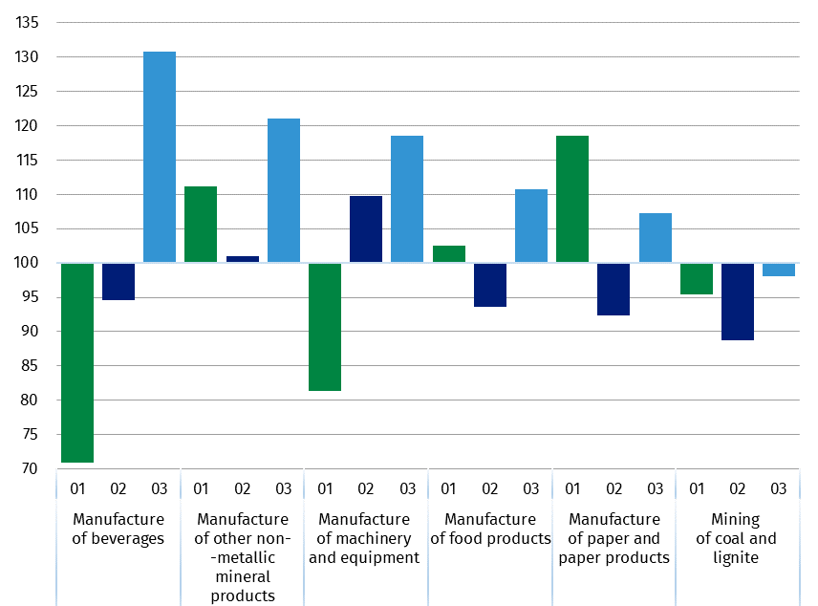
prices; previous month=100)

In case of quoting Statistics Poland data, please provide information: “Source of data: Statistics Poland”, and in case of publishing calculations made on data published by Statistics Poland, please include the following disclaimer: “Own study based on figures from Statistics Poland”.
Prepared by:  Enterprises Department  Director Katarzyna Walkowska  Phone: (+48 22) 608 31 25 | Issued by:  Press Office  Mobile +48 695 255 032  Phone +48 22 608 38 04, +48 22 449 41 45,  +48 22 608 30 09  e-mail: obslugaprasowa@stat.gov.pl

stat.gov.pl

@GUS_STAT

@GlownyUrzadStatystyczny

gus_stat

glownyurzadstatystycznygus

glownyurzadstatystyczny

Related information
Statistical Bulletin
Socio-economic situation of the country

Data available in databases
Knowledge Database - Industry
Macroeconomic Data Bank
Macroeconomic indicators
Local Data Bank

Terms used in official statistics
Sold production of industry
Seasonally un-adjustedindex of sold production of industry
Seasonally adjustedindex of sold production of industry
Production of capital goods
Production of non-durable consumer goods
Production of durable consumer goods
Production of intermediate goods
Production of goods related to energy

