Index of sold production of industry in April 2025¹
In April 2025, sold production of industry was by 1.2% higher than in April 2024 (when an increase was recorded by 7.8%), whereas in comparison with March 2025, it decreased by 3.5%. In the period January-April of 2025, sold production of industry was by 0.8% higher than in the corresponding period of 2024 (which saw an increase also by 0.8%).
The lower y/y growth in sold production than recorded in the previous month was caused by the base effect and the holiday calendar

1.2%
Increase in sold production of industry as compared to April 2024

After eliminating the seasonal factors, in April 2025 sold production of industry reached the level lower by 0.2% than in the corresponding month of 2024 and by 1.0% higher than in March 2025.
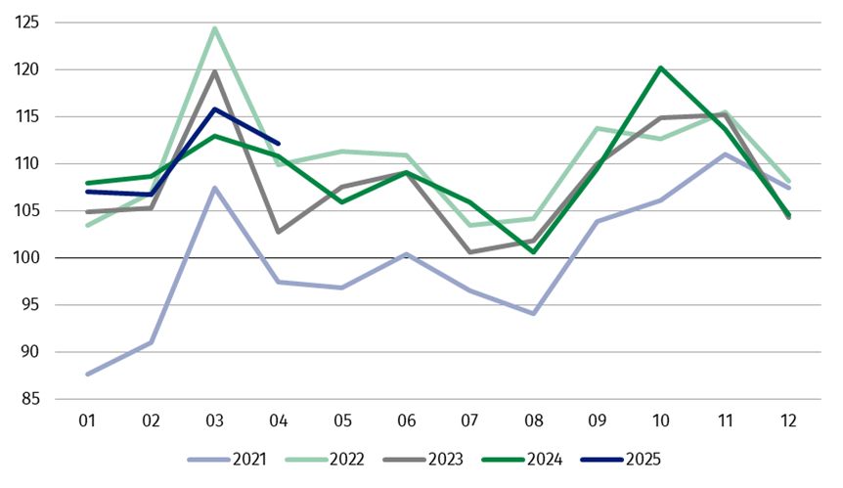
Chart 1. Sold production of industry (monthly average of 2021=100)

In April 2025, among the main industrial groupings there was an increase per year in the production of capital goods – by 7.5% and non-durable consumer goods – by 5.0%. A decrease was observed in the production of energy – by 12.5%, durable consumer goods – by 3.4% and slight in intermediate goods – by 0.3%

1 Preliminary data; comprise enterprises with 10 or more persons employed.
Table 1. Index of sold production of industry ª (constant prices)
SPECIFICATION | 2025
SPECIFICATION | 03 | 04 | 03 | 04 | 01-04 | 03 | 04
SPECIFICATION | previous month =100 |  | previous year =100 |  |  | monthly average  of 2021 =100
INDUSTRY | 108.5* | 96.5 | 102.4* | 101.2 | 100.8 | 115.8* | 112.1
Mining and quarrying | 103.3* | 98.4 | 94.0* | 89.4 | 92.6 | 99.0* | 97.5
Manufacturing | 109.7 | 96.7 | 103.0 | 101.7 | 101.1 | 115.3* | 113.2
Electricity, gas, steam and air conditioning supply | 92.9* | 87.2 | 98.0* | 98.3 | 99.7 | 129.7* | 99.8
Water supply; sewerage waste management and remediation activities | 106.2* | 103.2 | 101.9* | 101.4 | 101.7 | 112.7* | 116.3
a Data including final information on production and prices in March and preliminary data in April.
* Data revised.
Share of sold production of industry divisions, which saw an increase, in total industry was 63.6%
According to the preliminary data, in April 2025 an increase in sold production (in constant prices), as compared to April 2024, was reported in 18 (out of 34) industry divisions, among others in repair and installation of machinery and equipment – by 38.6%, in manufacture of other transport equipment – by 13.5%, manufacture of food products – by 8.9%, in waste collection, treatment and disposal activities; materials recovery – by 7.9%, in manufacture of other non-metallic mineral products – by 4.4%, manufacture of motor vehicles, trailers and semi-trailers – by 3.4%, manufacture of basic metals – by 3.2%, manufacture of machinery and equipment – by 3.1%.
A decrease in sold production of industry, as compared to April 2024, was recorded in 16 divisions, among others in mining of coal and lignite – by 15.5%, in manufacture of chemicals and chemical products – by 8.0%, manufacture of beverages – by 2.6%, manufacture of rubber and plastic products – by 2.1%.
Chart 2. Index of sold production of industry by selected NACE divisions (constant
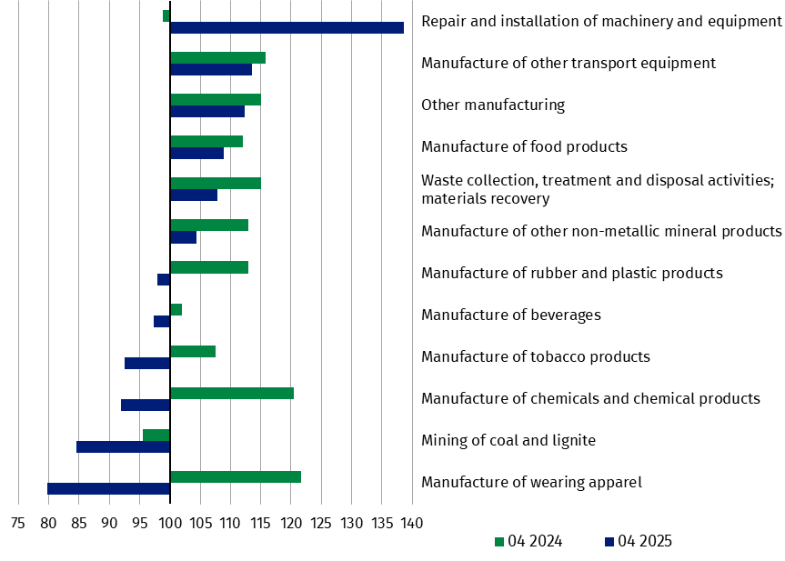
prices; previous year=100)
In April 2025, a decrease in sold production (in constant prices), as compared to March 2025, was recorded in 23 (out of 34) industry divisions, among others in manufacture of basic metals – by 14.0%, in electricity, gas, steam and air conditioning supply – by 12.8%, in manufacture of other transport equipment – by 8.1%, manufacture of machinery and equipment – by 7.8%, manufacture of products of wood, cork, straw and wicker – by 6.6%, manufacture of chemicals and chemical products – by 6.5%, manufacture of computer, electronic and optical products – by 6.4%, manufacture of furniture – by 5.7%, manufacture of metal products – by 5.6%, manufacture of motor vehicles, trailers and semi-trailers – by 5.4%.
An increase in sold production of industry, as compared to the previous month, was recorded in 10 divisions, among others in repair and installation of machinery and equipment – by 14.2%, in manufacture of beverages – by 9.8%, in waste collection, treatment and disposal activities; materials recovery – by 4.8%.
Chart 3. Index of sold production of industry by selected NACE divisions (constant
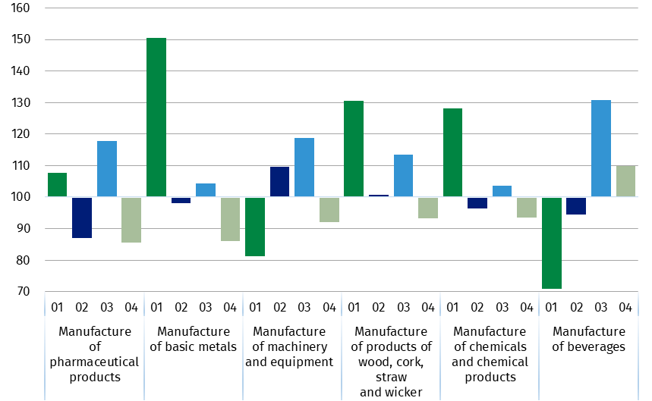
prices; previous month=100)

In Knowledge Databases (DBW) additionally are presented data for industrial production by the kind-of-activity unit (KAU), which are compiled for the needs of European statistics and are also presented in Eurostat database. The production in industry by KAU (constant prices 2021=100) covers the sections: B (Mining and quarrying), C (Manufacturing), D (Electricity, gas, steam and air conditioning supply), excluding group D353 (Steam and air conditioning supply).
The data are disseminated on the website of the Statistics Poland in the Knowledge Databases/Database/Economy/Short-Term Statistics - data by Kind-of-activity unit. The concept of the kind-of-activity unit, according to which the short-term statistics is compiled for the needs of European Union, is presented in the methodological report Short-term statistics by European concept of the Kind-of-activity unit.
In case of quoting Statistics Poland data, please provide information: “Source of data: Statistics Poland”, and in case of publishing calculations made on data published by Statistics Poland, please include the following disclaimer: “Own study based on figures from Statistics Poland”.
Prepared by:  Enterprises Department  Director Katarzyna Walkowska  Phone: (+48 22) 608 31 25 | Issued by:  Press Office  Mobile +48 695 255 032  Phone +48 22 608 38 04, +48 22 449 41 45,  +48 22 608 30 09  e-mail: obslugaprasowa@stat.gov.pl

stat.gov.pl

@GUS_STAT

@GlownyUrzadStatystyczny

gus_stat

glownyurzadstatystycznygus

glownyurzadstatystyczny

Related information
Statistical Bulletin
Socio-economic situation of the country

Data available in databases
Knowledge Database - Industry
Macroeconomic Data Bank
Macroeconomic indicators
Local Data Bank

Terms used in official statistics
Sold production of industry
Seasonally un-adjustedindex of sold production of industry
Seasonally adjustedindex of sold production of industry
Production of capital goods
Production of non-durable consumer goods
Production of durable consumer goods
Production of intermediate goods
Production of goods related to energy

