Spring assessment of the condition of agricultural and horticultural crops in 2025
29.05.2025
Winter and spring losses in winter cereal sown areas were small, amounting to about 0.6% for winter cereal mixtures and about 0.2% for winter barley. In winter wheat, rye and winter triticale plantations, winter losses were less than 0.1%. It is initially estimated that this year the area of ​​basic cereals with cereal mixtures is similar to last year's (after taking into account the area plowed up due to winter damage) at about 5.7 million hectares. According to preliminary estimates, the area under rape and turnip rape is expected to increase by about 0.4%.
0.4%
increase in the total sown area of rape and turnip rape compared to the 2024 sown area

In the first decade of March, the start of vegetation was observed in winter cereals, winter rape and turnip rape, and permanent grasslands. Agrometeorological conditions during the spring period were generally unfavorable for plant growth and development. As a result of frost events recorded in April (locally reaching -8°C or lower), slight damage occurred in some crops, including flowering fruit trees and bushes as well as berry plantations. The deepening precipitation deficit in April and the first half of May, combined with frost, led to a deterioration in soil moisture conditions, thereby hindering plant growth and development. Frost also reduced the effectiveness of spring-applied plant protection products. In most parts of the country, a significant drying of the topsoil layer was recorded, and the water needs of crops were not fully met.
The weather conditions in spring were generally unfavorable for plant growth and development

The condition of fruit trees, bushes, and plants on berry plantations at the beginning of the growing season was generally good. However, frosts recorded in April and May had an adverse effect on the plantations. In many regions of the country, damage to flower buds and fruit set was observed. A significant factor contributing to the weakening of tree condition during the spring period was the increasing lack of rainfall, which led to substantial soil drying.
Preliminary estimates of the area of certain crops for harvest in 2025
The area of winter basic cereals with cereal mixtures was estimated at about 4.4 million hectares
The area of winter basic cereals with cereal mixtures was estimated at about 4.4 million hectares, about 0.1% less than the sown area last year, including:
- winter wheat more than 2.2 million hectares,
- rye about 0.7 million hectares,
- winter barley about 0.4 million hectares,
- winter triticale about 1.1 million hectares.
The area of spring basic cereals with cereal mixtures was estimated at about 1.2 million hectares
It is preliminary estimated that spring basic cereals with cereal mixtures were sown on about 1.2 million hectares, about 0.3% more than the sown area in the previous growing season, of which:
- spring wheat about 0.2 million ha,
- spring barley about 0.3 million ha,
- oats about 0.5 million ha,
- spring triticale about 0.1 million ha,
- spring cereal mixtures about 0.2 million ha.
The area under potatoes is expected to be about 0.2 million hectares. The area under sugar beets is estimated at about 0.3 million hectares.
The course of agrometeorological conditions from autumn 2024 to spring 2025
The air temperature in November supported vegetation and created good conditions for the emergence, growth and development of late sown winter crops. It also enabled autumn field work and harvesting of root and fodder crops. Winter crops sown at optimum agrotechnical dates in November were tillering.
The course of weather conditions during the winter was generally favorable for overwintering plants
The weather conditions in winter generally did not pose a direct threat to plants. The high air temperature in December and January, which was high for this time of year and rose above 10°C at times, caused disruptions in the winter dormancy of winter crops. Periodic daily fluctuations in air temperature, causing thawing and refreezing of the topsoil, could locally weaken the root system of plants. The large drops in air temperature at the ground surface recorded in the second and third decade of February, reaching in places even -20°C and below, were short-lived and did not cause excessive cooling of the soil at the depth of the bushy node. As a result of the daily fluctuations in air temperature recorded at the end of the month, the processes of freezing and thawing of the topsoil layer were repeated, which could locally weaken the root system of plants.
Warm and sunny weather in the first decade of March this year was conducive to the start of vegetation of winter plants and permanent grasslands. Agrometeorological conditions in March allowed for spring field work. Sowing of oats, spring wheat and spring barley began in a large area of ​​the country. However, the persistent lack of rainfall during the month contributed to a decrease in the level of soil moisture.
Cold days and nights during the first half of April delayed the emergence of spring cereals and slowed their growth. As a result of recorded frosts (locally down to -8°C or lower), slight damage occurred in some crops, including flowering fruit trees and bushes as well as berry plantations. The increasing rainfall deficit over the course of the month, combined with the frosts, led to a deterioration in soil moisture conditions, thereby inhibiting plant growth and development. In most parts of the country, significant drying of the topsoil layer was observed, and the water requirements of crops were not fully met.
The cold days and nights recorded in May, together with a rainfall deficit, significant in some areas, had a negative impact on the pace of plant growth and development. The growth of both winter and spring cereals, during their period of highest water demand, occurred under insufficient soil moisture conditions across a large area of Poland. In many regions, the topsoil layer experienced drying. Rainfall in the second half of May improved soil moisture conditions; however, thermal conditions (cold days and nights) continued to slow crop vegetation.

Table 1. Air temperature and precipitation from autumn 2024 to spring 2025
Specification | National average air temperature |  | National average rainfall totals
Specification | ºC | deviation from the norm ^{a)} | mm | % norm ^{a)}
AUTUMN ^{b)} 2024
September | 16.9 | 3.2 | 67.9 | 118.0
October | 10.1 | 1.3 | 33.2 | 71.0
November | 3.8 | -0.2 | 31.8 | 80.1
WINTER ^{b)} 2024/2025
December | 2.5 | 2.3 | 27.5 | 70.6
January | 2.0 | 3.2 | 33.6 | 92.5
February | -0.5 | -0.1 | 13.5 | 42.7
SPRING ^{b)} 2025
March | 6.0 | 2.8 | 25.2 | 66.6
April | 10.5 | 1.9 | 21.9 | 60.1
a) From 2021 IMiGW adopts as the average norm from years 1991-2020.
b) Monthly averages /Statistics Poland calculations based on IMiGW data/.

Assessment of the condition of agricultural crops

Winter crops
Table 2. Spring assessment of winter crops
Years | Wheat | Rye | Barley | Triticale | Rape and turnip rape
Years | in qualifying grades ^{a)}
2006-2010^{b)} | 3.7 | 3.5 | 3.5 | 3.6 | 3.6
2011-2015^{b)} | 3.7 | 3.5 | 3.5 | 3.6 | 3.5
2016-2020^{b)} | 3.7 | 3.6 | 3.6 | 3.6 | 3.5
2021 | 3.7 | 3.7 | 3.7 | 3.7 | 3.7
2022 | 3.8 | 3.8 | 3.8 | 3.8 | 3.8
2023 | 3.9 | 3.9 | 3.9 | 3.9 | 3.9
2024 | 4.0 | 3.9 | 3.9 | 4.0 | 3.8
2025 | 4.0 | 4.1 | 4.0 | 4.1 | 3.8
a) A grade of „5” indicates very good condition, „4”– good, „3”– sufficient, „2” – poor, „1”– bad, disaster.
b) Annual average.
An assessment carried out in the first decade of May 2025 by Statistics Poland field appraisers shows that the state of winter cereal sowings is better than last year. It was assessed at 4.0 - 4.1 qualification degrees, while the condition of winter rape and turnip rape was assessed at 3.8 qualification degrees, i.e. at the level of last year’s assessment.

Spring crops
Spring cereals were sown in most voivodeships on time or with a slight delay. Due to the cold spring with a deepening shortage of rainfall, sowing spring cereals was difficult, and plant emergence was delayed and uneven. Considerable drying of the soil in April and the first half of May inhibited the growth and development of spring crops.
Table 3. Spring condition assessment for spring crops
Years | Wheat | Barley | Oats | Triticale | Cereals mixtures | Rape and turnip rape
Years | in qualifying grades ^{a)}
2006-2010^{b)} | 3.4 | 3.4 | 3.4 | 3.4 | 3.4 | 3.3
2011-2015 ^{b)} | 3.5 | 3.5 | 3.5 | 3.5 | 3.5 | 3.4
2016-2020 ^{b)} | 3.4 | 3.5 | 3.5 | 3.4 | 3.4 | 3.4
2021 | 3.4 | 3.4 | 3.5 | 3.4 | 3.4 | 3.5
2022 | 3.5 | 3.5 | 3.5 | 3.5 | 3.5 | 3.5
2023 | 3.7 | 3.6 | 3.7 | 3.6 | 3.6 | 3.6
2024 | 3.7 | 3.7 | 3.7 | 3.7 | 3.7 | 3.6
2025 | 3.7 | 3.6 | 3.7 | 3.6 | 3.6 | 3.6
a) A grade of „5” indicates very good condition, „4”– good, „3”– sufficient, „2” – poor, „1”– bad, disaster.
b) Annual average.
The condition of spring cereals was assessed at 3.6 – 3.7 qualifying grades, i.e. lower than last year's assessment, and the condition of spring rape and turnip rape was assessed at 3.6 qualifying grades, i.e. at the level of last year's assessment.
Permanent grassland and clover plantations
The winter did not cause any damage to permanent grasslands, and their condition after winter was generally good, currently assessed at the level of the previous year. An unfavourable phenomenon for vegetation of permanent grasslands occurring in spring was the cold days and nights in April. They caused poorer tillering of grasses and temporarily lower intensity of green mass growth.
In the voivodeship cross-section, assessments of the condition of permanent meadows ranged from 4.5 degrees in the Lubelskie Voivodeship to 3.5 degrees in the Dolnośląskie, Podlaskie i Warmińsko-mazurskie Voivodeships.
In the voivodeship cross-section, assessments of the condition of pastures ranged from 4.5 degrees in the Lubelskie Voivodeship to 3.4 degrees in the Dolnośląskie and Podlaskie Voivodeships.
Assessments of the condition of red clover in pure sowing and in mixtures with grasses ranged from 4.5 degrees in the Lubelskie Voivodeship to 3.2 degrees in the Pomorskie and Warmińsko-mazurskie Voivodeships.
Table 4. Condition assessment of permanent grassland and red clover
Years | Meadows | Pastures | Clover ^{a)}
Years | in qualifying grades ^{b)}
2006 – 2010^{c)} | 3.4 | 3.3 | 3.6
2011 – 2015^{c)} | 3.6 | 3.5 | 3.6
2016-2020 ^{c)} | 3.6 | 3.5 | 3.5
2021 | 3.6 | 3.6 | 3.6
2022 | 3.6 | 3.6 | 3.7
2023 | 3.8 | 3.8 | 3.8
2024 | 3.9 | 3.9 | 3.9
2025 | 3.9 | 3.9 | 3.8
a) Red clover in pure sowing and in mixtures with grasses.
b) A grade of „5” indicates very good condition, „4”– good, „3”– sufficient, „2” – poor, „1”– bad, disaster.
c) Annual average.
Assessment of the extent of winter crop losses
This year, total losses in the sown area of winter crops were low, at a lower level than last year, and their condition assessed very early in the spring was generally good.
A total of about 3.4 thou-sand hectares of winter cereal area sown in autumn 2024 have been qalified for ploughing
It is estimated that by mid-May a total of approximately 3.4 thousand hectares of area sown with winter cereals, i.e. 0.1% of the winter cereal area, had been ploughed and qualified for ploughing, of which:
- winter wheat about 1.2 thousand ha (in 2024 – 1.7 thousand ha),
- rye about 0.5 thousand ha (in 2024 - 0.9 thousand ha),
- winter barley about 0.7 thousand ha (in 2024 – 1.0 thousand ha),
- winter triticale about 0.6 thousand ha (in 2024 – 1.1 thousand ha),
- winter cereal mixtures about 0.3 thousand ha (in 2024 – less than 0.4 thousand ha).
The area of winter rape and turnip rape ploughed and qualified for ploughing amounted to approximately 1.8 thousand ha, i.e. 0.2% of the area sown in the autumn (in 2024 - approximately 3.9 thousand ha ploughed).
According to the assessment of the field experts of the Central Statistical Office, the main reason for ploughing up winter crop plantations this year was mainly frost damage, damage caused by forest animals and low plant density per 1 m². The highest winter and spring losses in winter cereal crops were recorded in the Podlaskie Voivodship (frost damage), while in rape and turnip rape in the Świętokrzyskie Voivodship (damage caused by forest animals).
Losses in stored agricultural and horticultural crops
Approximately 3.3 million tonnes of potatoes were destined for storage during the winter of 2024/2025, i.e. around 55% of the 2024 harvest. Losses in stored potatoes are estimated to similar than in the previous year - at around 11% of the total weight allocated for storage. The highest losses in stored potatoes were reported in the following voivodeships: Zachodniopomorskie - approx. 15.0% as well as in Dolnośląskie, Podkarpackie and Wielkopolskie – at approx. 13.0%, and the lowest in the following voivodeships: Kujawsko-Pomorskie, Łódzkie and Warmińsko-mazurskie – at approx. 8.0%.
Table 5. Losses in stored crops
Years | Potatos | Cabbage | Onion | Carrots | Beetroot | Parsley | Celery | Leeks
Years | as a % of the total quantity of stored crops
2006- 2010^{a)} | 12 | 17 | 13 | 15 | 11 | 16 | 15 | 12
2011- 2015^{a)} | 11 | 17 | 14 | 14 | 12 | 15 | 15 | 12
2016-2020 ^{a)} | 11 | 13 | 12 | 12 | 11 | 13 | 13 | 12
2021 | 11 | 11 | 11 | 13 | 10 | 12 | 11 | 10
2022 | 12 | 11 | 11 | 12 | 10 | 11 | 11 | 10
2023 | 11 | 11 | 12 | 13 | 10 | 11 | 11 | 11
2024 | 11 | 10 | 11 | 13 | 11 | 12 | 11 | 12
2025 | 11 | 11 | 12 | 13 | 11 | 12 | 11 | 11
a) Annual average
In the 2024/25 season, the share of vegetables designated for storage was lower than in the previous season. The most significant decrease was observed for carrots, as well as onions, parsley, and beetroots. Losses occurring during vegetable storage did not differ significantly from the levels recorded in previous years. The highest losses were reported in the Wielkopolskie, Dolnośląskie, Podlaskie, and Lubelskie Voivodeships, while the lowest were noted in the Świętokrzyskie, Mazowieckie, Kujawsko-Pomorskie, and Śląskie Voivodeships.
In the current season, the proportion of apples stored was lower compared to the previous season, although the scale of losses remained similar amounted to around 12%. The largest storage losses were recorded in the Wielkopolskie Voivodeship, while the smallest were observed in the Kujawsko-Pomorskie, Łódzkie, Mazowieckie, Podkarpackie, Śląskie, and Świętokrzyskie Voivodeships.
Assessment of overwintering of trees, fruit bushes and berry plantations and the condition of horticultural crops
Frosts occurring in April and early May resulted in damage to flowers and already formed fruit, especially on plantations where no intensive frost protection measures were implemented. Losses were mainly observed in peach, apricot, sour cherry, and sweet cherry orchards
During the 2024/25 season, the winter dormancy period was conducive to maintaining good condition of fruit trees in orchards. At the same time, the mild course of winter led to an increased occurrence of powdery mildew, scab, and plant pests, necessitating intensive chemical protection of plantations. The low level of precipitation and the resulting absence of snow cover across most of the country contributed to insufficient soil moisture at the beginning of the growing season. In the second decade of March, a drop in air temperatures caused localized frost damage, particularly to young shoots and flower buds of sweet cherry trees and other stone fruit species. Trees entered the flowering stage at dates close to the long-term average, and pollinator activity remained at a satisfactory level. However, a key factor negatively affecting tree condition during this time was the ongoing lack of rainfall, which led to significant soil desiccation. Frosts occurring in April and early May resulted in damage to flowers and already formed fruit, especially on plantations where no intensive frost protection measures were implemented. Losses were mainly observed in peach, apricot, sour cherry, and sweet cherry orchards. Persistently low air temperatures in May, coupled with a lack of rainfall, adversely affected the effectiveness of fertilization and plant protection treatments.
Strawberry plants overwintered in good condition and resumed physiological activity at a time close to the long-term average. Damage to strawberries occurred due to frosts, primarily in the second decade of March and at the beginning of May. Due to frost threats during this period and significant diurnal temperature fluctuations, the use of covers on plantations was necessary. However, this practice also fostered the development of fungal diseases.
So far, weather conditions across most of the country have not been favorable for open-field vegetable cultivation. Sowing and necessary fieldwork began in late March and early April, though the pace of progress varied significantly across regions. The primary factors contributing to delays were insufficient soil warming and moisture. A lack of adequate precipitation also caused delays and weakened germination in several vegetable crops, including carrots, parsley, and beetroots. Sowing and planting seedlings of thermophilic vegetables into the ground have been delayed. The persistent rainfall deficit observed in most areas of the country during the second half of April and into May hindered plant growth and development, and further reduced the effectiveness of fertilization.
The supply of seed material and fertilizers in the first half of 2025 was sufficient to ensure continuity of agronomic practices. However, as in previous years, the gradual withdrawal of certain proven and effective plant protection products from the market remains a problematic issue. This trend contributes to rising production costs and hampers the effective control of pathogens and pests in horticultural crops.
Agricultural and horticultural crop area forecasting using satellite remote sensing
Map 1. Estimation of sown area with winter crops
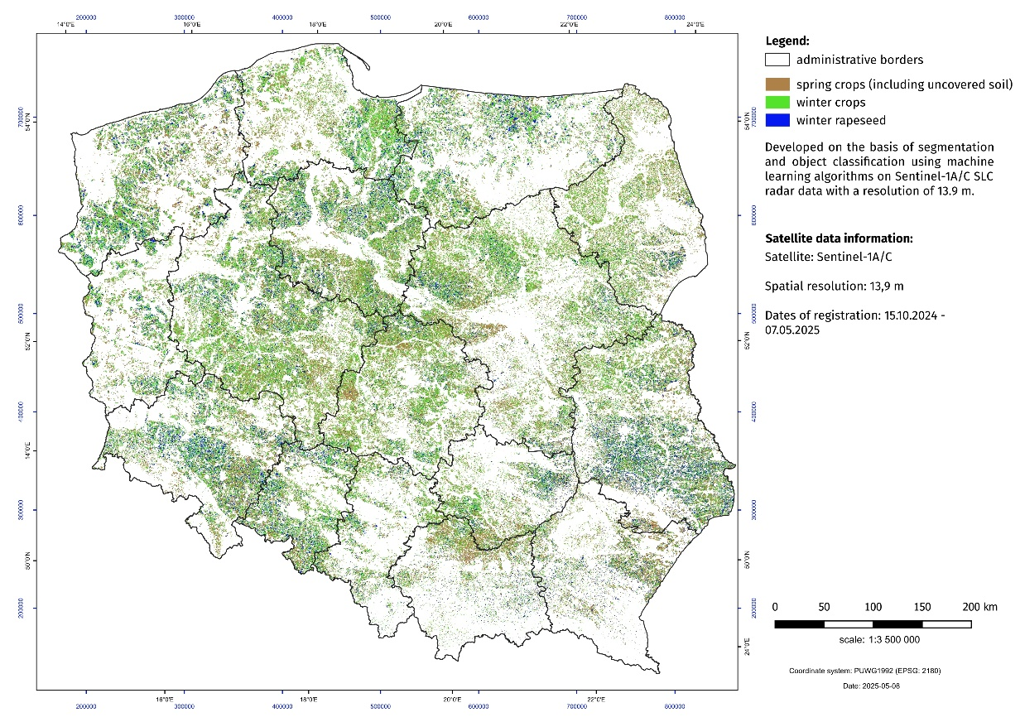

In the field of work on forecasting the area of agricultural and horticultural crops, activities are carried out aimed at using satellite imagery. The new data acquisition system is the basis of a new methodology for agricultural research.
Within the framework of the "Spring assessment of the condition of agricultural and horticultural crops", an estimation of the sown area of winter crops (without distinguishing between crop species) and winter rape and turnip rape was made using satellite remote sensing methods.
Sentinel-1A/C radar images (observation period from 15.10.2024 to 07.05.2025) formed the basis for the estimation. The estimation was based on segmentation and object based classification of the T2 coherence matrix and the parameters of the polarymetric H/α decomposition using machine learning algorithms (Random Forest). Classification accuracy was validated using photointerpretation data. A total of 510 satellite scenes of 250 km wide SLC (Single Look Complex) radar data were used. A crop database developed using photointerpretation methods based on Sentinel-2 data was used to teach the system and perform the classification.

In case of quoting Statistics Poland data, please provide information: “Source of data: Statistics Poland”, and in case of publishing calculations made on data published by Statistics Poland, please include the following disclaimer: “Own study based on figures from Statistics Poland”.
Prepared by:  Agriculture and Environment Department  Director Marta Wojciechowska  Phone: (+48 22) 608 31 28 | Issued by:  Press Office  Mobile +48 695 255 032  Phone +48 22 608 38 04, +48 22 449 41 45,  +48 22 608 30 09  e-mail: obslugaprasowa@stat.gov.pl

www.stat.gov.pl/en/

@StatPoland

@GlownyUrzadStatystyczny

gus_stat

glownyurzadstatystycznygus

glownyurzadstatystyczny
Related information
Production of agricultural and horticultural crops in 2024

Data available in databases
BDL: Sown area

Terms used inn official statistics

BDL: Agricultural crops

The information includes the results of the spring crop condition assessment conducted in the first half of May 2025. The assessment was based on expert opinions of Statistics Poland's field appraisers prepared on the basis of vetting of fields, meadows and orchards. The spring crop condition assessment also includes an estimate of the sown area of major agricultural crops using satellite remote sensing methods and an estimate of winter and spring losses.

