Labour cost index in the quarters of 2024
In the fourth quarter of 2024, the labour cost index increased by 9.4% compared with the first quarter of the same year, and it was 4.4% higher compared with the third quarter of 2024.
13.9%
Increase in the labour cost index in the fourth quarter of 2024 compared with the fourth quarter of 2023
In 2024, labour costs increased in Poland and the number of hours worked decreased slightly. In the fourth quarter of 2024, the number of hours worked was 0.9% lower than in the fourth quarter of 2023, while labour costs rose by 12.3% over the same period. Between the first and fourth quarters of 2024, there was a 9.4% increase in the labour cost index. The LCI reached its lowest value in the first quarter of 2024, while in the second and third quarters of 2024, the index values were 3.4% and 4.7% higher than in the first quarter of 2024.
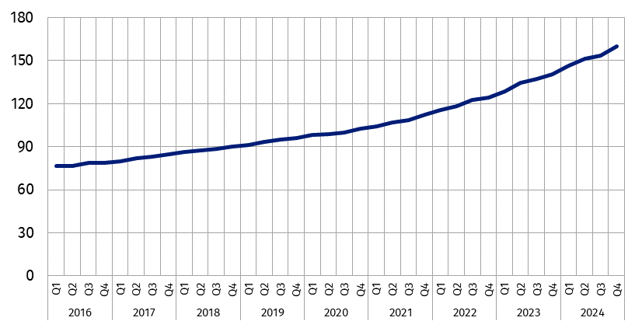
Chart 1. Labour cost index
In the fourth quarter of 2024 increase in the labour cost index was observed in all analysed kinds of activity and ranged from 3.7% in the section Transportation and storage to 27.6% in the section Mining and quarrying.

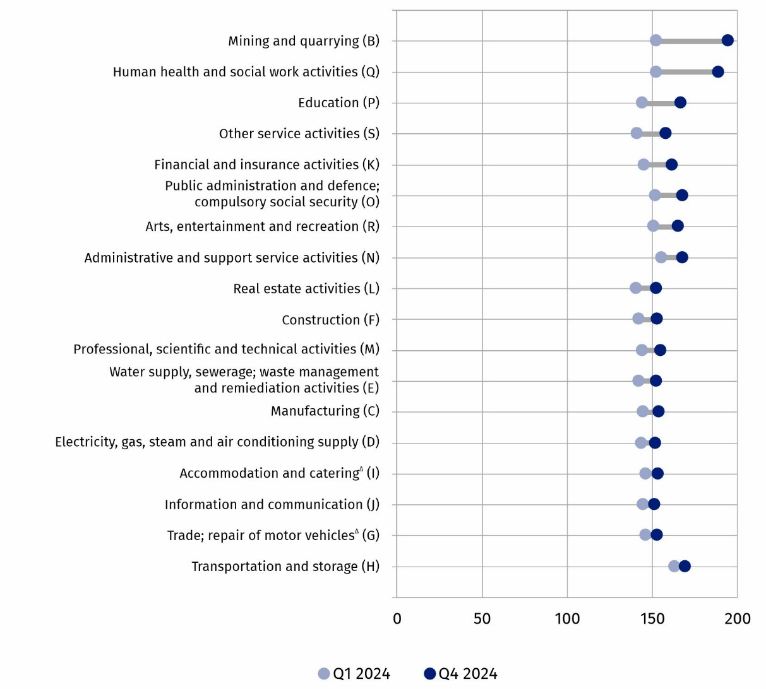
Chart 2. Labour cost index by PKD 2007/NACE Rev. 2 section (B-S)ª in Q1 2024 and Q4 2024
a PKD/NACE sections sorted by the difference in LCI values between the fourth and first quarters of 2024
Poland compared to the European Union
The labour cost index makes it possible to compare labour cost dynamics across European Union Member States. Poland is in the group of countries with the highest LCI. In the fourth quarter of 2024, Poland's labour cost index was 160.2. The lowest value of the LCI among EU countries was recorded in Italy – 107.5, and the highest in Bulgaria – 167.0.

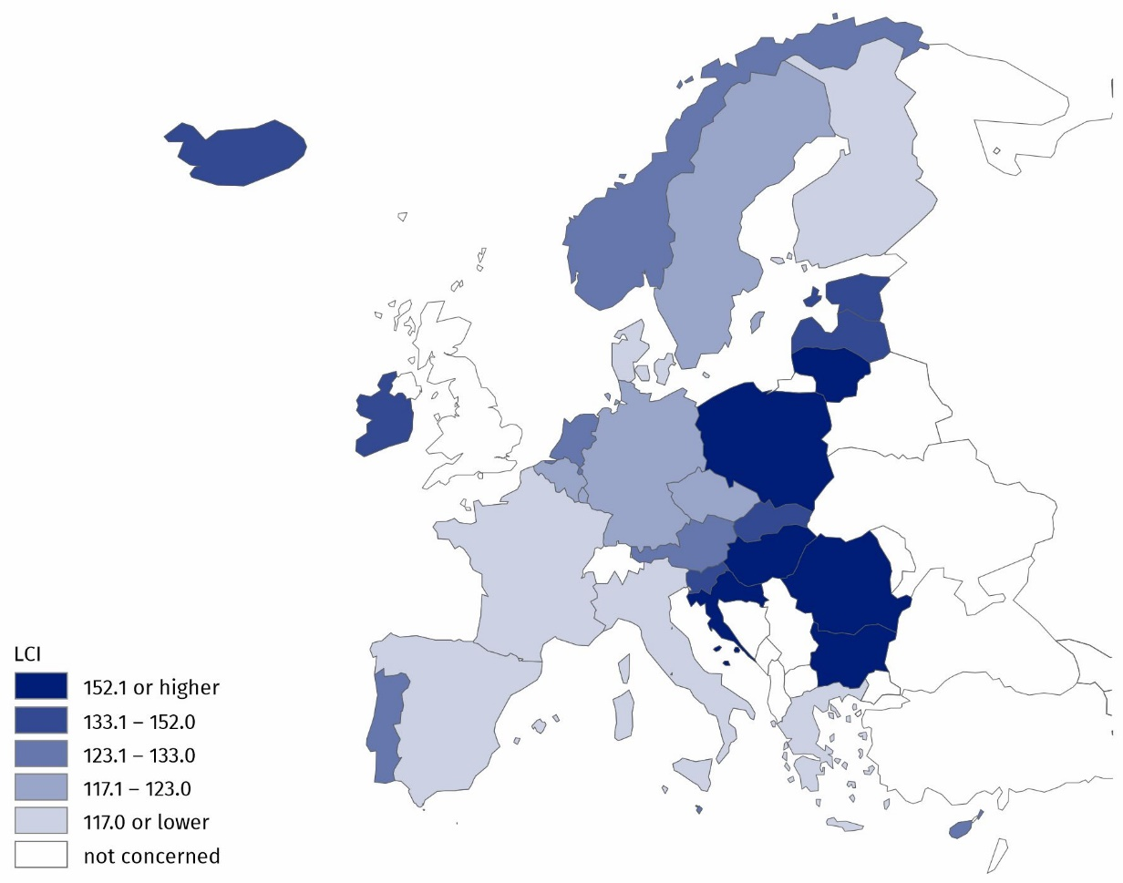
Map 1. Labour cost index for selected European countries in Q4 2024
In the fourth quarter of 2024, Poland was among the European Union Member States with the highest values of the labour cost index
Source of data: Eurostat.
There is a greater variation in the value of the labour cost index by kind of activity in Poland than in the European Union. In the last quarter of 2024, in sections B-S, the labour cost index was higher than the average value for the 27 EU countries. In the section Human health and social work activities, the labour cost index is 57.8% higher than the EU average – this is the largest difference in the value of the index among PKD 2007/NACE Rev. 2 sections between Poland and the European Union. The smallest difference was recorded in the section Information and communication (24.2%).

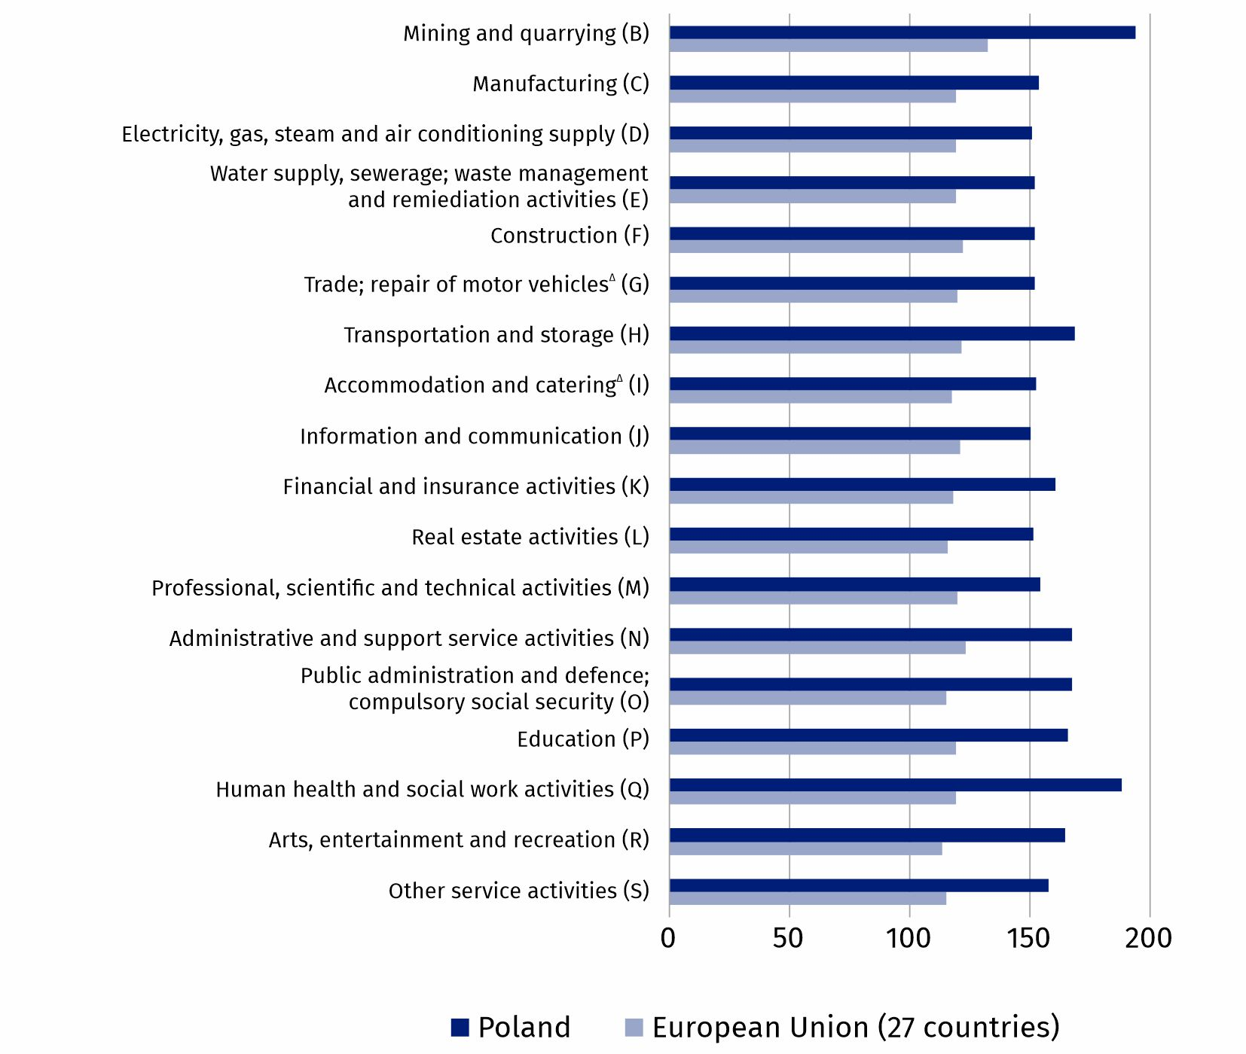
Chart 3. Labour cost index by PKD 2007/NACE Rev. 2 section (B-S) in Q4 2024 for Poland and the European Union
Source of data: Eurostat.

Methodological notes
Labour cost index is a Euro indicator, one of the Principal European Economic Indicators (PEEIs), which describe the current macroeconomic situation of the European Union

The labour cost index (LCI) is the Laspeyres index of hourly labour costs recorded in the reference quarter in relation to hourly costs in the base year. The base year is modified cyclically every four years. Currently, the base year for the calculation of the index is 2020. Due to the impact of calendar effects and seasonal fluctuations on employment and time worked, the LCI indicators are subject to the procedure of working-day adjustment and seasonal adjustment.
The labour cost index shows the development of labour costs borne by employers. Labour costs consist of wages and salaries and non-wage costs, such as social security contributions and taxes paid by the employer, less subsidies received.
$$Labour cost index =\frac{ \frac{labour cost in the current period}{number of hours worked in the current period} }{\frac{labour cost in the base period}{number of hours worked in the base period}} ∙100$$

In this news release abbreviated names of PKD 2007/NACE Rev. 2 sections were used. Abbreviations are marked with a ‘Δ’ symbol. Full names are available on the Eurostat website at: https://ec.europa.eu/eurostat/web/metadata/classifications
In the case of quoting Statistics Poland data, please provide information: ‘Source of data: Statistics Poland’, and in the case of publishing calculations made on data published by Statistics Poland, please provide information: ‘Own work based on Statistics Poland data.’
Prepared by:  Statistical Office in Bydgoszcz  Director Wiesława Gierańczyk, Ph.D.  Phone: (+48 52) 366 93 90 | Issued by:  Press Office  Mobile phone: +48 695 255 032  Landline phones: +48 22 608 38 04, +48 22 449 41 45, +48 22 608 30 09  e-mail: obslugaprasowa@stat.gov.pl

www.stat.gov.pl/en/

@StatPoland

@GlownyUrzadStatystyczny

gus_stat

glownyurzadstatystycznygus

glownyurzadstatystyczny

Data available in databases
Eurostat Database – Labour market
Knowledge Databases

Terms used in official statistics
Labour cost index
Time worked
Labour costs

